Study Guide 4.1 Activity

OUTPUT:

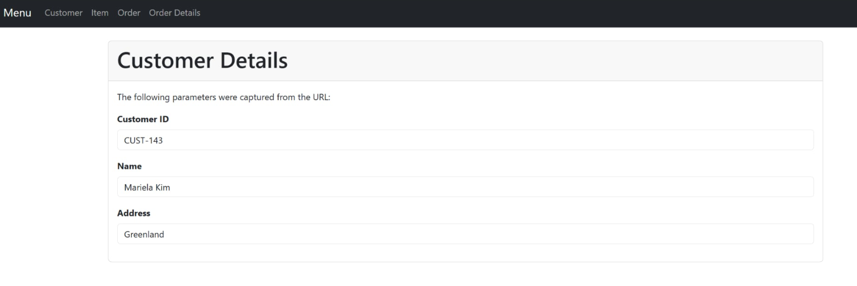

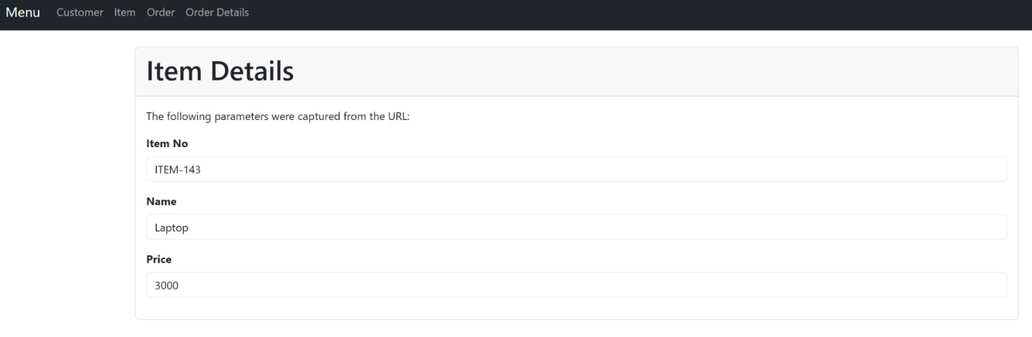

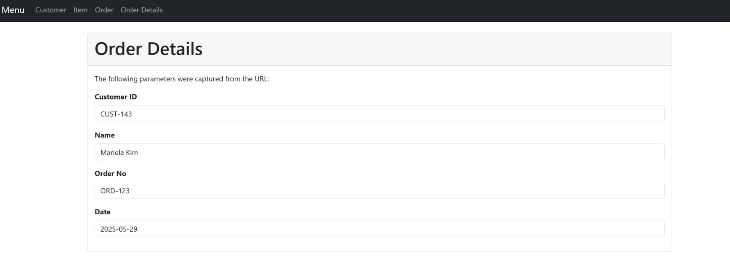

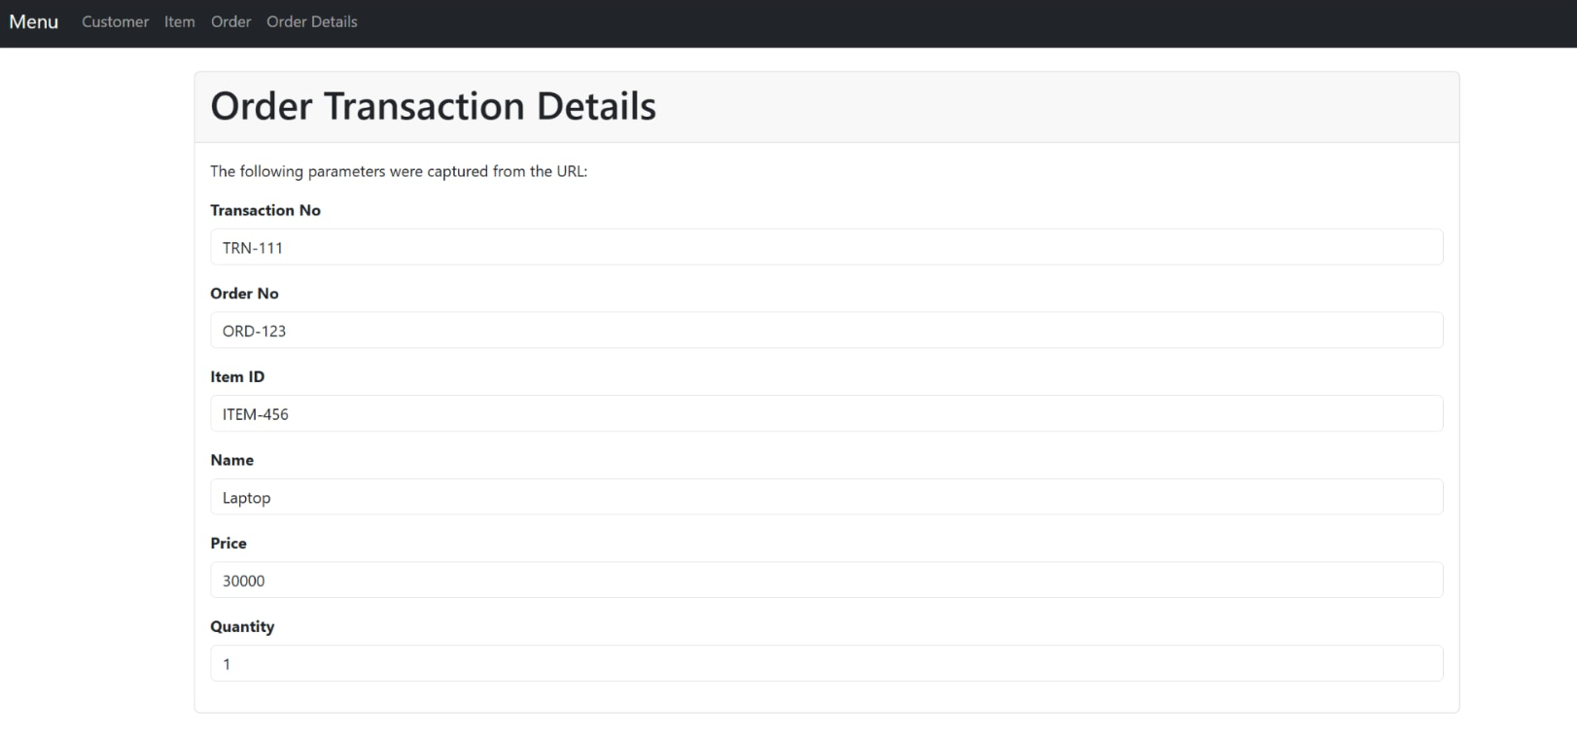

Codes:

OrderController.php

App.blade.php

Show-details.blade.php

Web.php

