„Slepé vzorečky“:
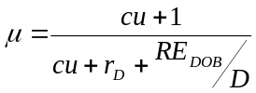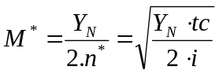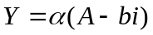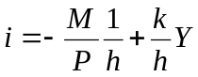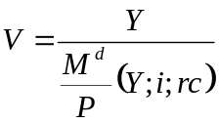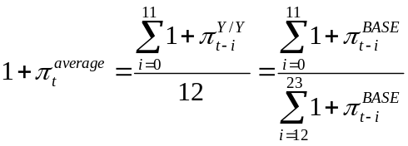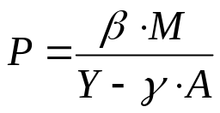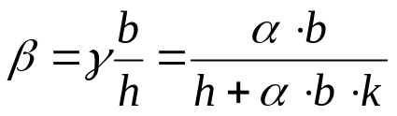
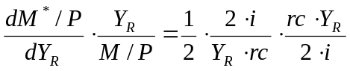C + S_{D} + TA_{D} = W + π_{R} + TR +BI M^{D} = k × P × Y

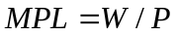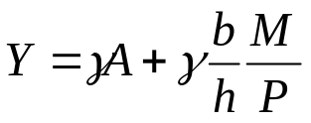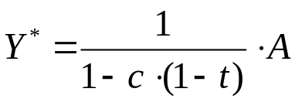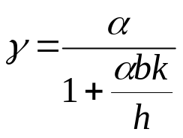
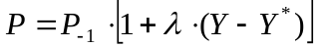HDP = C+I+G+NX= W + π_{R} + π_{N} +odpisy+ TA_{F} 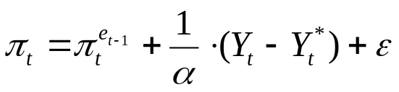 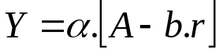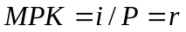 APC=C/Y=c+ C_{A} /Y M^{D} × V ^{T}= P × T M ^{d}/P = M ^{d}/P (Y ^{P}; E_{B} - E_{M} ; E_{S} - E_{M} ; π ^{e} - E_{M} )

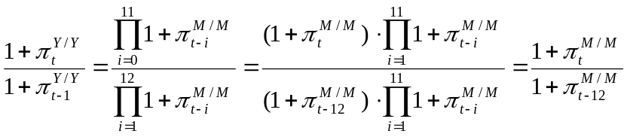 A=C_{A}+I_{A}+G_{A}+c.TR_{A}
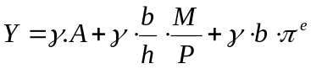 I = S_{D} +S_{F} - B_{D} +deprec.- NFI 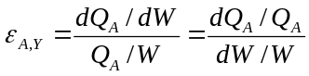

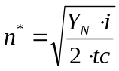YD ≡ C + S_{D} = W + p_{R} + TR - TA_{D} +BI 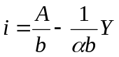 BS = t.Y – G – TR

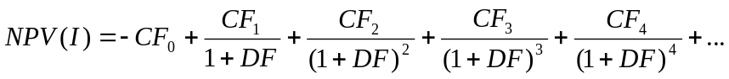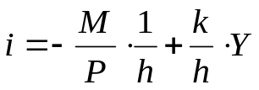
g_{W}= - ε . (u - u*) 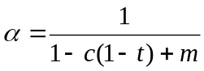 M ^{d} =(1- σ_{P}* / σ_{B}).W TC= i . Y_{N}/(2.n)+ n . tc

