Useful links:

Escape Room game

<https://docs.google.com/presentation/d/1HnJjEttlGuFyTK1s5_P6lKKqtsU90nem9yZd3kJCbvU/present?slide=id.p> (the password is here – change the font colour: * THESIS *)

Academic writing

<https://www.phrasebank.manchester.ac.uk/>

<https://writing-point.fsv.cuni.cz/>

https://www.grammarly.com/citations

Useful language:

**Hedging**

**Introductory verbs:**e.g. seem, tend, look like, appear to be, think, believe, doubt, be sure, indicate, suggest

**Certain lexical verbs:**e.g. believe, assume, suggest

**Certain modal verbs:**e.g. will, must, would, may, might, could

**Adverbs of frequency:**e.g. often, sometimes, usually

**Modal adverbs:**e.g. certainly, definitely, clearly, probably, possibly, perhaps, conceivably,

**Modal adjectives:**e.g. certain, definite, clear, probable, possible

**Modal nouns:**e.g. assumption, possibility, probability

**That clauses**e.g. It could be the case that…, It might be suggested that…, There is every hope that… .

**To-clause + adjective:**e.g. It may be possible to obtain…, It is important to develop…, It is useful to study… .

Source: http://www.uefap.com/writing/feature/hedge.htm

**Literature Review sample**

While it was initially **found** that the relationship between income and happiness only holds within and not across countries—the so-called ‘Easterlin effect’— more recent econometric studies by Deaton (2008) and Stevenson and Wolfers (2008) based on new data collected worldwide by the Gallup Organization have **challenged** this view, **finding** that income exerts strong effects on happiness across the board. Sacks et al. (2010) **suggest** that there is a close relationship between material living standards and life satisfaction and that countries that experience a rapid economic growth also get an equivalent increase in life satisfaction levels.

While income levels matter for happiness, work by Graham (2008) **finds** the relationship between the two is relative. Noting the paradox of the ‘happy peasant and the miserable millionaire’, Graham **contends** that although people can adapt to be happy at low levels of income, they are far less happy when there is uncertainty over their future wealth. Thus, the income effect on happiness is not only based on individual perceptions but also on the social and economic context in which individuals are embedded. The effects of unemployment on happiness tend to be larger in places where unemployment is generally low, while the effect is weaker if the individual lives in a place with high unemployment and thus the future is more uncertain. Helliwell (2003) **suggests** that happiness is affected by institutional factors such as governmental stability or effectiveness more so than economic ones. Helliwell and Putnam (2004) **note** [a] strong connection between social capital and happiness, beyond income effects. Deaton (2008) **examines** the relationship between income and life satisfaction and **concludes** that there is a strong relationship between the two. Deaton does, however, **question** the usefulness of health or health satisfaction as happiness measures, as he **finds** such measures have little relation with life satisfaction as a whole.

There is a substantial literature **documenting** the transformation from industrial to post-industrial economies and societies. Nearly a half-century ago, Machlup (1962) **identified** the rise of the knowledge economy. Drucker (1967) coined the term ‘knowledge worker’ to refer to the emerging social group of workers who understand how to apply knowledge to productive use. This construct was later expanded to one of a ‘knowledge society’ (Drucker, 1993) where the traditional means of production are replaced by human capital and new institutional structures. Bell (1973) **predicted** the rise of a ‘post-industrial society’ led by a class of highly educated scientists and technocrats. …

(Mellander, Florida and Rentfrow, 2012)

*Source: Oxford Learner’s Dictionary of Academic English (2014). OUP*

**Abstract samples**

I. Working-class and middle-class mothers of Cuban heritage **were questioned** about their modes of accommodation to America in terms of language proficiencies. **Specifically**, they were asked about their own language fluency, in both Spanish and English, and that of their children.  
 **The focus was on** the within-family dynamics of the accommodation process, and the links between mothers' and children's language fluencies and children's school performance.  
 **Two distinct patterns emerged**. For working-class mothers, the emphasis was more on encouraging their children to learn English in order to ‘succeed’ in America, especially in school—a ‘subtractive’ form of bilingualism and biculturalism where advances in English appear to be at the expense of Spanish fluency and heritage culture maintenance. **In contrast,** for middle-class mothers, success was associated more with the encouragement of Spanish competence, not English—a form of ‘additive’ bilingualism where the heritage language and culture are protected as the process of Americanization runs its course.   
(Lambert and Taylor, 1996)

II. **This paper investigates** the deposition of the tear film on the cornea of the human eye. The tear film is laid down by the motion of the upper eyelid and then subsequently flows and thins. Of particular interest is the stability of the tear layer and the development of dry patches on the cornea.  
 **While there has been significant research on** the behaviour of tear films between blinks, **this paper focuses on** understanding the mechanisms which control the shape and thickness of the deposited film and how this affects the subsequent film behaviour.  
 **Numerical and analytical methods are applied to** a lubrication model which includes the effects of surface tension, viscosity, gravity and evaporation.  
 **The model reveals the importance of** the eyelid velocity, motion of the surface lipid layer and the storage of tear film between blinks.   
(Jones et al., 2005)  
Source: Oxford Learner’s Dictionary of Academic English (2014)

**Abstract – Useful Phrases  
Introductory sentences**This study (dissertation, research)   
aims to illuminate?  
examines the role of...  
explores why...  
investigates the effects of...  
assesses the impact of...on...  
developed and tested the idea that...

In this study (dissertation, research) I...  
investigated the role of...  
outline how...  
introduce the concept of...  
extend prior work on...  
examine the relationship between...and...  
identify...  
evaluate these...by...  
propose a model of...

**Leading with research questions**  
This study (dissertation, research)...  
is motivated by two research questions: (1) *[Insert research question one]*? (2) *[Insert research question two]*? To examine these questions, the study…  
"*[Insert a research question]*"? is a fundamental question in *[the name of your area of interest]*. We suggest/argue that a new generation of research in this area needs to address the extended question: *[Insert your research question]*?

**Leading with research hypotheses**  
This study (dissertation, research)...  
…offers two hypotheses: (1) *[insert research hypothesis one]*; and (2) *[insert research hypothesis two]*.  
…tested hypotheses regarding the relationship between...and...  
It was  
hypothesized that *[insert variable]* is negatively *[positively]* related to...  
hypothesized that *[insert variable]* is more negatively *[positively]* related to *[insert variable]* than *[insert variable]*.

**Leading with a dissertation aim or goals**  
This study (dissertation, research)...  
has three goals: (1) *[insert goal one]*, (2) *[insert goal two]*, and (3) *[insert goal three]*.

**Literature component**  
Previous research (extent research, previous studies, or prior studies)...  
indicates that...  
offers a descriptive account of...  
has shown that...  
Literature on *[insert area of the literature]* has focused almost exclusively on...  
Synthesizing *[e.g., name of theories]*, this research built and tested a theoretical model linking...  
This model addresses X *(e.g., 2)* major gaps in the literature.  
Drawing on *[insert name]* research, we argue that...  
In bridging the two literature gaps, a model of [insert text] is proposed.

**Significance of the study**  
We develop theory to explain how...  
Our most important contribution is...  
This study advances our understanding of...  
To date, no systematic investigation has considered...  
We examine how organisations use [insert text] to overcome...

**Components of research strategy**We conducted...in-depth case studies of *[X number of private/public]* enterprises in *[country]*.a laboratory experiment and a field study to test our hypotheses.an inductive study of...

We employed...multiple methods to test...

Using... a sample of *[X number of people, firms, data, objects, e.g., doctors, banks, songs]*, we collected data from three sources *[e.g., X, Y and Z]*.comparative case analysis, this research explored the role of...To illustrate these ideas, *[insert company name or type]* was used as a case study to show how...We tested these hypotheses using [e.g., student test score] data to measure [e.g., teacher performance].We developed a 9-item scale to measure...Using data from...  
**Major findings**The findings from the research...illustrate how...show that the impact of *[insert text]* on *[insert text]* is more complex than previously thought/assumed.address a controversial belief among practitioners that...illustrate the antecedents and consequences of *[insert text]* and *[insert text]* in...suggest that the effect of *[variable X]* on *[variable Y]* was moderated over time when...Contrary to our expectations...

**Conclusion**The results, implications for managers, and future research are discussed.Theoretical contributions and managerial implications of the findings are discussed.The findings...provide support for the key arguments.support the prediction that...support the model:offer insights into...prompt a re-thinking of [insert your area of interest]

We conclude that...

Source: <http://dissertation.laerd.com/how-to-structure-your-dissertation-abstract.php>

Session class handout with the answer key:

**Literature review**

1. Few would argue that student learning ______ a university setting takes place when there is active participation by professor and student; and the roles _______ each are heterogeneous. The professor has the formidable task _______ delivering course material _______ students, and the students are expected to master the material. **IN, TO, FROM, OF, OF**

2. A novel study, done by Trueman and Hartley (2006), focused ______ time –management skills and their reationship to a student’s age. In their study, first-year undergraduates at a British university were divided _______ three age groups: traditional-entry students (under 21 years of age); borderline mature students ( _____ 21 and 25 years of age); and older mature students (greater than 25 years ______ age). **WITH, BETWEEN, ON, INTO, OF**   
3. The results _______ their study indicate that there are significant differences in the time management skills among the age groups, _______ the older mature students making the greatest use ______ time-management strategies. **ABOUT, OF, OF, WITH**

4. Unfortunately, merely requiring students to attend time-management workshops is inadequate, _______ indicated _______ the results ______ a study undertaken ________ Horstmanshof and Zimitat (2007). Optimality _______ time use is eroded when non-academic activities serve ______ distractions from study time.   
**TO, BY, BY, OF, OF, AS, AS**

**Answer key:  
1.** in, of, of, to  
2. on, into, between, of  
3. of, with, of  
4. as, by, of, by, of, as

**Methods section**

This is an extract from a method section describing a survey of parental attitudes towards public school education in Tokyo. Find the parts of the text where the author is:  
a) listing steps, variables or categories  
b) using verbs to describe the research project  
c) showing how a particular result was achieved  
d) connecting the research to other research in the field

When considering which methodology to apply, we were drawn to target profiling, a method used primarily in fields such as marketing science and psychology. In target profiling, members of a sample are classified into several groups based on shared characteristics. The degree of divergence between groups is revealed by comparing their responses to a set of questions.  
We conducted our target profiling in two main stages. First, using cluster analysis and attribute data compiled from parents, we categorized parents into several groups and uncovered the distinct characteristics of each group. Second, we assessed how much these groups differed from one another in their responses to questions on school education.

**Discussion section**

Compare:

|  |  |
| --- | --- |
| **From the Results section** | **From the Discussion section** |
| Table 1 provides summary statistics for each variable for men, women, and women with dependent children. | We also find some evidence that low levels of community trust and reciprocity among men with children may in part be explained by the resource constraints they impose. |
| Our first finding is that marital status is an important predictor of community group membership, trust and reciprocity for men. | Our finding is consistent with more recent Australian research by Hughes and Black (2009), which found that community trust was lower among people with children, particularly pre-school and primary-school-age children. |

Claims and other ideas in the Discussion section often include hedging language. Underline the hedges in these extracts.

1. We also find some evidence that low levels of community trust and reciprocity among men with children may in part be explained by the resource constraints they impose.

2. We would argue that full-time employment is likely to be associated with low levels of community trust and reciprocity among women with dependent children.

3. It is possible that some of these non-family relationships substitute for family relationships.

**Abstract**

Match the following sentences with the type of information. Note the use of tenses.

1. Providing background information  
2. Presenting the aims  
3. Explaining the methods  
4. Summarising the results  
a) Current smoking significantly **declined** in males as age increased (P < 0.001).  
b) While language aptitude **has been investigated** actively, **there is a current dearth** of research on …  
c) This paper **estimates** the effects on earnings of ‘gap years’ between school and university.  
d) Clinical and lifestyle factors **were assessed** using standard questionnaires and procedures.  
  
Sources: Hewings, M. & Thaine, C. (2012). *Cambridge Academic English*. CUP  
Oxford Learner’s Dictionary of Academin English (2014). OUP

Key: 1. b, 2. c, 3. d, 4. a

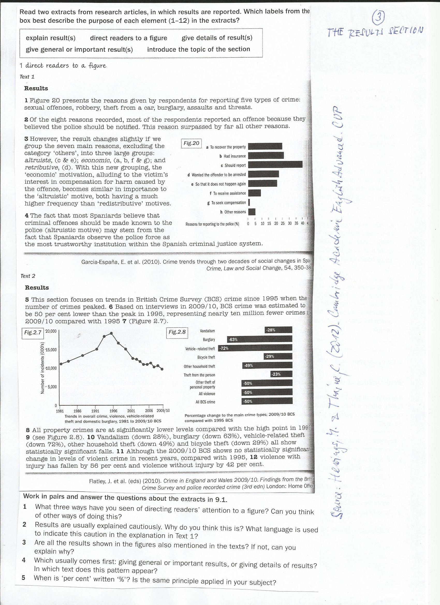

Key:   
2 general results

3 details

4 explain results

5 introduce the topic

6 general results

7 direct to a figure

8 general results

9 direct to a figure

10 details

11 general results

12 details

Questions:  
1. See 1, 7 and 9. You can also use the passive form: ...is presented in Fig. 20.

2. may stem, should be made known - hedging

3. only selected ones

4. Giving general or important results first.

5. per cent in the main text, % in brackets and notes