Semantic Segmentation Evaluator
QGIS Plugin
Installation & User Manual • v1.0
Based on analysis code by Marek Bundzel, TU Košice
marek.bundzel@tuke.sk

1. Overview
The Semantic Segmentation Evaluator plugin assesses the quality of binary segmentation masks (GeoTIFF rasters containing only 0 and 1) against a Ground Truth mask. It is designed primarily for archaeological LiDAR data but works with any binary semantic segmentation task.

The plugin produces:
- Error map raster — a GeoTIFF saved alongside the prediction file, automatically added to the QGIS project above the Prediction layer with colour-coded symbology.
- Pixel-level statistics — Accuracy, Balanced Accuracy, TPR, TNR, PPV, NPV, F1, MCC, IoU (foreground, background, average), and MOR10R.
- Per-object analysis — connected-component analysis: how many GT objects were detected, size statistics, TP/FP object counts, plus a size histogram.
- Publication-quality histogram — embedded in the plugin dialog, exportable as PNG (≥ 600 DPI) or vector SVG / PDF.

Quality measures are described in section 4.5 of: Bundzel et al. (2020), Remote Sensing 12(22):3685

2. System Requirements

Component | Requirement
QGIS version | 3.16 or newer (LTR recommended)
Operating system | Windows 10/11, macOS 12+, Linux (Ubuntu 20.04+)
Python | 3.9 or newer (bundled with QGIS — do not install separately)
RAM | 4 GB minimum; 16 GB recommended for large rasters

3. Dependencies
The plugin uses only libraries that are either already bundled with QGIS or require a one-time installation.

Library | Status & Notes
osgeo.gdal | Bundled with QGIS — no installation needed. Used for all GeoTIFF reading and writing.
numpy | Bundled with QGIS — no installation needed.
matplotlib | Bundled with QGIS — no installation needed.
cv2 (opencv-python) | Must be installed once. Used for connected-component analysis and morphological dilation.

Note: The plugin does not depend on rasterio. All raster I/O uses osgeo.gdal, which is always present inside QGIS's own Python interpreter.

3.1 Installing opencv-python
Follow the instructions for your operating system. You must install the package into QGIS's own Python interpreter, not your system Python.

Windows
- Open the OSGeo4W Shell (Start menu → search for "OSGeo4W Shell").
- Run the following command (copy and paste exactly): python -m pip install opencv-python
- Wait for the installation to complete. You should see a line ending with "Successfully installed".
- Close the OSGeo4W Shell.

Note: The OSGeo4W Shell sets environment variables so that pip writes directly into QGIS's Python installation. Never use a regular Command Prompt or PowerShell for this step.

⚠ If you see "error: Microsoft Visual C++ 14.0 is required", install a pre-built wheel instead. Download the matching .whl from https://www.lfd.uci.edu/~gohlke/pythonlibs/ (choose cp3xx matching your QGIS Python version, e.g. cp312), then run: pip install path\to\opencv_python-xxx.whl

macOS
- Locate the QGIS Python executable. For a standard installation it is at:
/Applications/QGIS.app/Contents/MacOS/bin/python3
- Open Terminal and run (adjust path if QGIS is installed elsewhere): /Applications/QGIS.app/Contents/MacOS/bin/python3 -m pip install opencv-python
- Wait for "Successfully installed", then close Terminal.

Linux
- Open a terminal and run: python3 -m pip install opencv-python --break-system-packages
- If QGIS uses a conda/mamba environment, activate it first: conda activate qgis && pip install opencv-python

Note: If pip is unavailable, try the system package manager: sudo apt install python3-opencv (Debian/Ubuntu) or sudo dnf install python3-opencv (Fedora).

Alternative — QGIS Python Console (all platforms)
- In QGIS: Plugins → Python Console.
- Click the Show Editor button (pencil icon).
- Paste and run:
import subprocess, sys
result = subprocess.run(
[sys.executable, '-m', 'pip', 'install', 'opencv-python'],
capture_output=True, text=True
)
print(result.stdout)
print(result.stderr)
- Look for "Successfully installed" in the output panel, then restart QGIS.

Verify the installation
In the QGIS Python Console, run:
import cv2
print(cv2.__version__)
A version number (e.g. 4.9.0) printed without error confirms opencv-python is correctly installed.

4. Installing the Plugin
The plugin is distributed as a ZIP file: SemanticSegEval.zip. No internet connection is required after downloading.

4.1 Install from ZIP (recommended)
- In QGIS, open Plugins → Manage and Install Plugins.
- Click the "Install from ZIP" tab on the left.
- Click the "…" button and browse to the downloaded SemanticSegEval.zip.
- Click Install Plugin.
- QGIS will extract and register the plugin.
- Go to the Installed tab, find Semantic Segmentation Evaluator, and make sure its checkbox is ticked.

4.2 Manual installation (alternative)
- Locate your QGIS plugin folder. On Windows: %APPDATA%\QGIS\QGIS3\profiles\default\python\plugins
- On macOS / Linux: ~/.local/share/QGIS/QGIS3/profiles/default/python/plugins
- Extract SemanticSegEval.zip so that a folder named SemanticSegEval appears directly inside the plugins directory.
- Restart QGIS.
- Enable via Plugins → Manage and Install Plugins → Installed → tick Semantic Segmentation Evaluator.

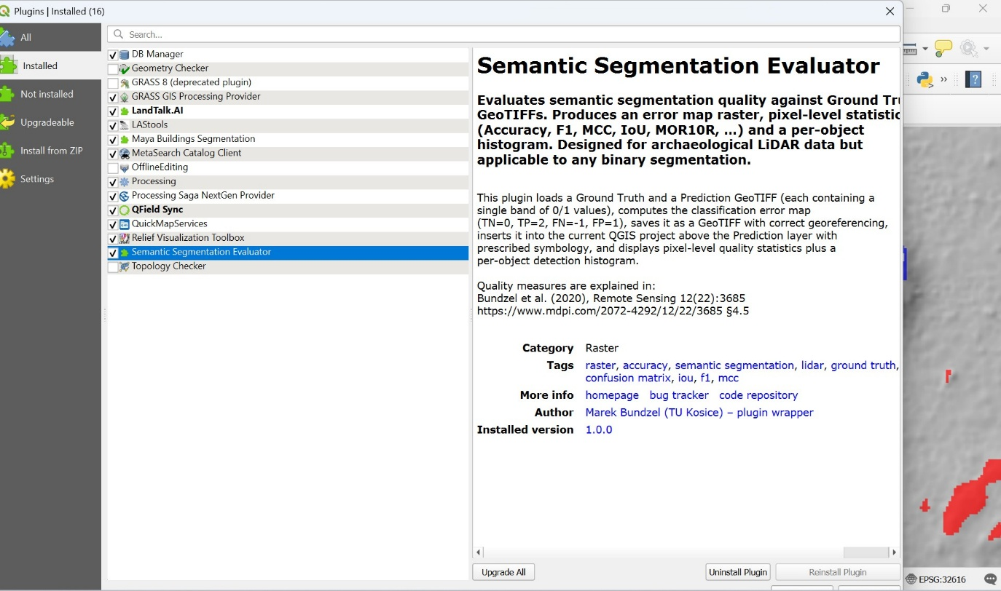

5. Using the Plugin
Open the plugin via Raster → Semantic Seg Eval → Semantic Segmentation Evaluator, or click its toolbar button.

5.1 Inputs & Run tab
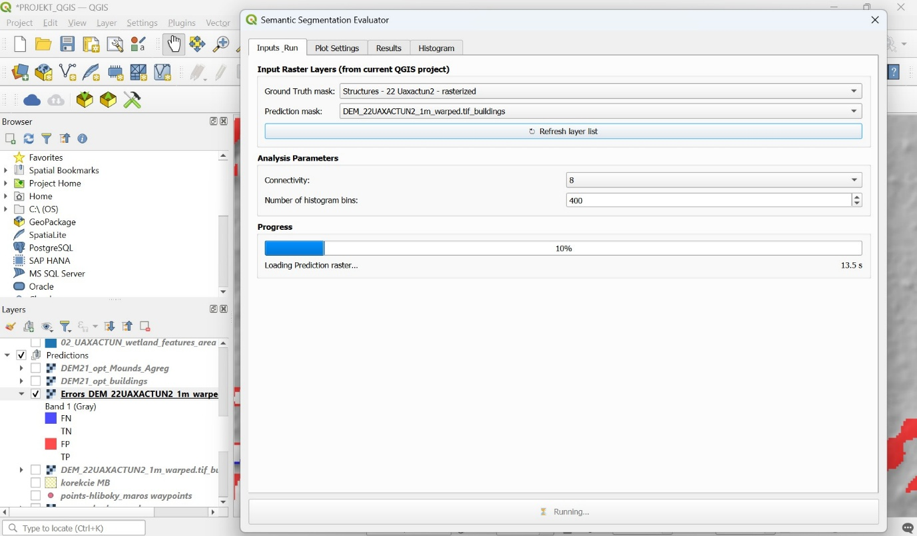

This tab is used to select inputs, set parameters, and monitor progress.
Control | Description
Ground Truth mask | Drop-down listing all raster layers currently loaded in the project. Select the reference segmentation layer (single band, values 0 and 1 only).
Prediction mask | Drop-down listing all raster layers. Select the model output layer. Must have the same shape and CRS as the Ground Truth.
↻ Refresh layer list | Updates the dropdowns if layers have been added or removed since the dialog was opened.
Connectivity | Choose 4 (cross-shaped neighbourhood) or 8 (including diagonals) for connected-component analysis.
Number of histogram bins | Controls the bin count of the object-size histogram (default 400).
Progress bar | Shows overall progress from 0 to 100 %. The step label describes the current operation; the elapsed-time counter updates every 0.5 s.

Click ▶ Run Analysis to start. The analysis runs in a background thread so QGIS stays responsive.

5.2 Plot Settings tab
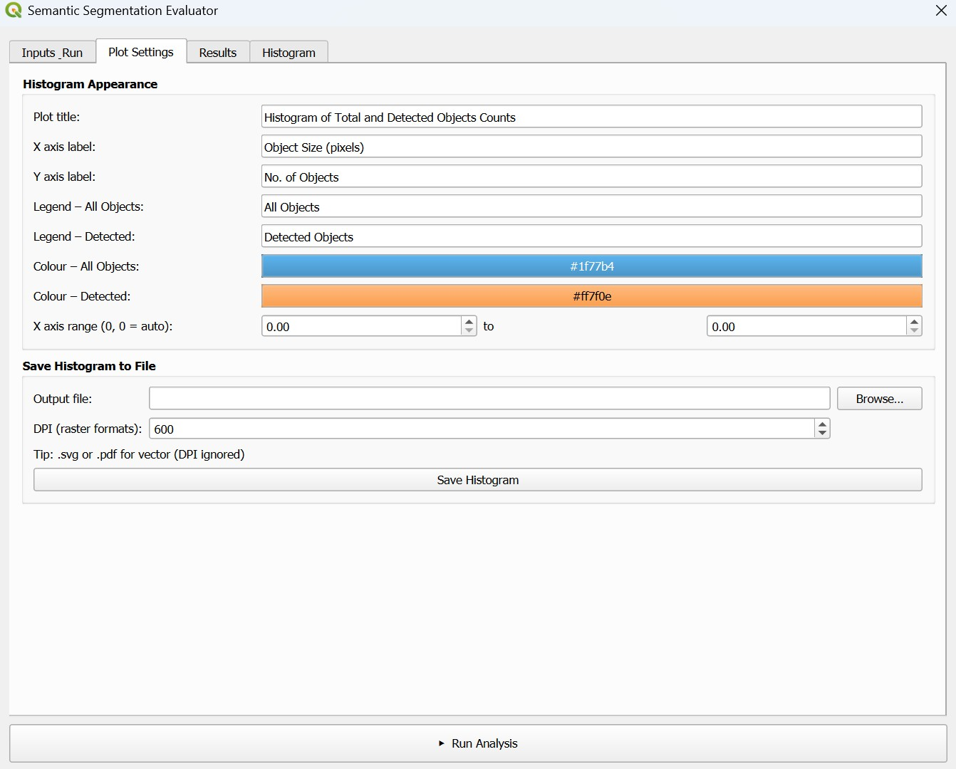
Customise the histogram appearance before or after running. Changes take effect the next time you run the analysis.

Control | Description
Plot title | Free-text title shown above the histogram.
X / Y axis labels | Free-text labels for the axes.
Legend entries | Labels for the two histogram series (All Objects and Detected Objects).
Colour buttons | Click to open a colour picker for each series.
X axis range | Set min and max to zoom in on a size range. Leave both at 0 for automatic scaling.
Output file | Path for saving the histogram. Use .png for raster, .svg or .pdf for vector.
DPI | Resolution for raster formats (default 600). Ignored for SVG and PDF.
Save Histogram | Saves the current figure with the chosen DPI. Labels are never clipped.

5.3 Results tab

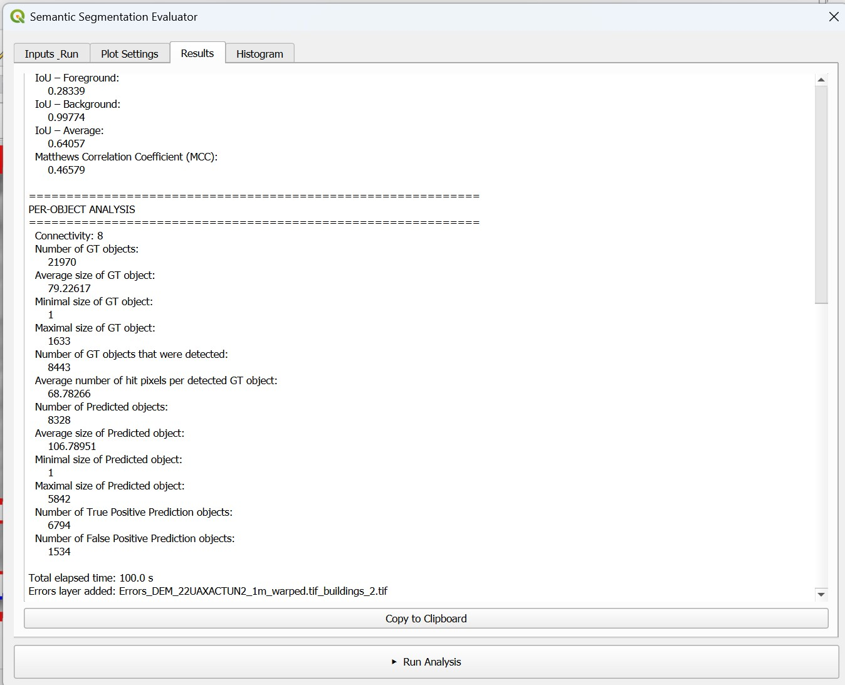
Displays all computed metrics after a successful run.
- Pixel-level statistics — 16 metrics, each on its own line with 5 decimal places where appropriate. A link to the paper explaining MOR10R is shown at the top.
- Per-object analysis — GT object count, size statistics, number of detected GT objects, average hit pixels, Prediction object count and TP/FP breakdown.
- Total elapsed time — shown at the bottom of the output.

Click Copy to Clipboard to copy the full text for pasting into a spreadsheet or paper.

5.4 Histogram tab
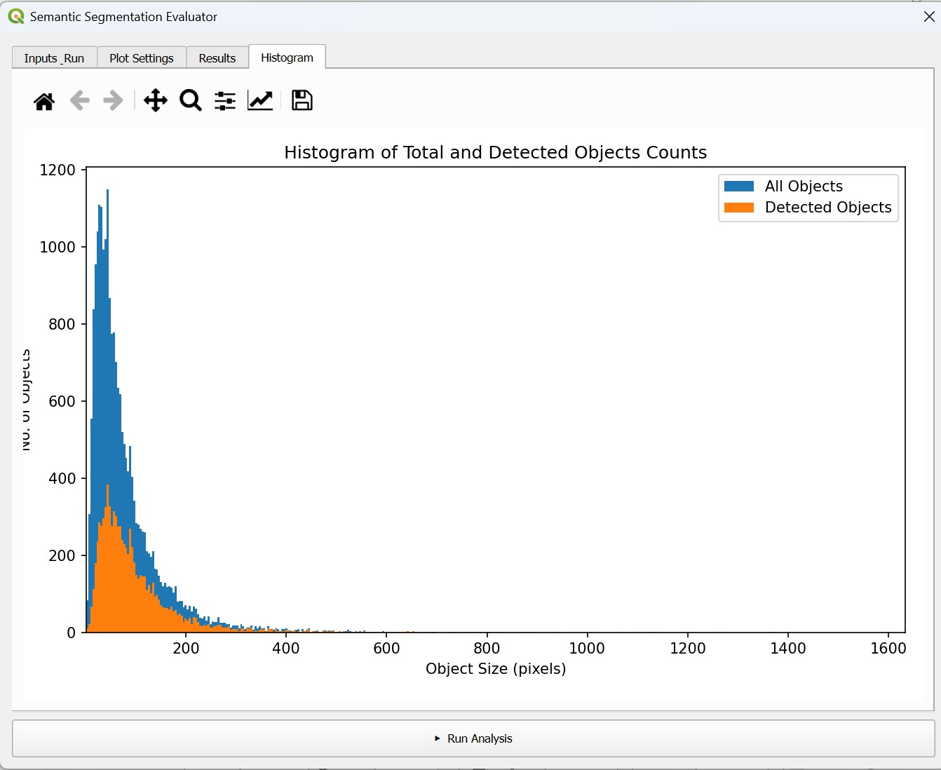

Shows the embedded, resizable histogram. The matplotlib navigation toolbar at the top provides zoom, pan, and a built-in save button. The histogram can also be saved at publication quality via the Save Histogram button on the Plot Settings tab.

5.5 Output error map

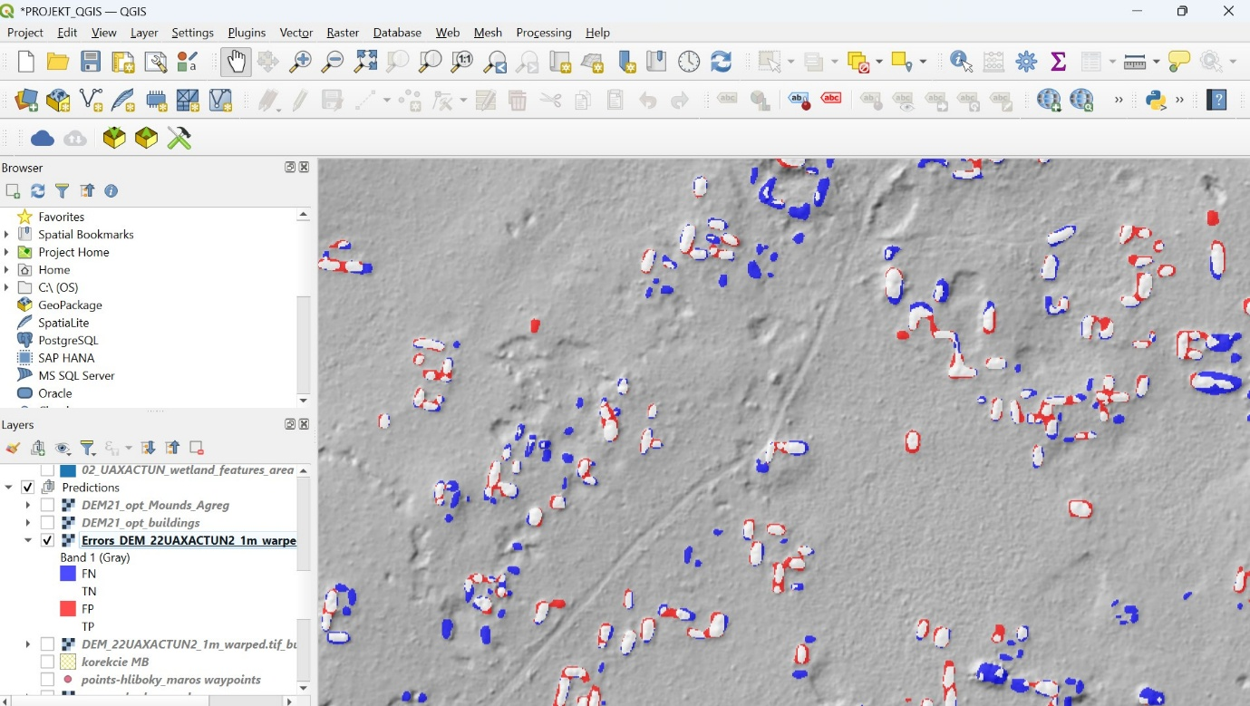

The error map is saved alongside the Prediction GeoTIFF as Errors_<prediction_filename>.tif. If a file with that name is already loaded in the project, an index suffix (_1, _2, …) is appended automatically to avoid overwriting a GDAL-locked file.

The layer is inserted directly above the Prediction layer in the layer tree with the following symbology:

Value | Class / Legend label / Colour
0 | True Negative (TN) — black, fully transparent
2 | True Positive (TP) — white, 70 % opacity
-1 | False Negative (FN) — blue, 70 % opacity
1 | False Positive (FP) — red, 70 % opacity

6. Input Data Format
Both the Ground Truth and Prediction rasters must satisfy all of the following:
- Single-band GeoTIFF — the plugin validates this on load and reports an error if the file has more than one band.
- Binary pixel values — only 0 (background) and 1 (object). If your prediction is a probability map (0–255 or 0.0–1.0), binarise it first with the QGIS Raster Calculator.
- Identical extent, resolution, and CRS — the two rasters must have exactly the same shape. Use Raster → Projections → Warp to align them if needed.

7. Troubleshooting

Problem | Solution
"No module named cv2" error | opencv-python is not installed in QGIS's Python. Follow Section 3.1 and make sure you used the OSGeo4W Shell (Windows) or the QGIS Python executable (macOS/Linux).
"No module named osgeo" error | This should not occur in a standard QGIS installation. Try reinstalling QGIS.
Plugin not in Raster menu | Open Plugins → Manage and Install Plugins → Installed, find Semantic Segmentation Evaluator, and tick the checkbox.
No raster layers in dropdowns | Load your Ground Truth and Prediction GeoTIFFs into the QGIS project first (Layer → Add Layer → Add Raster Layer), then click ↻ Refresh layer list.
"GT shape ≠ Prediction shape" error | The two rasters have different pixel dimensions. Use Raster → Projections → Warp (Reproject) to align them first.
"Raster must contain only 0 and 1" error | Your raster contains values other than 0 and 1 (e.g. 255). Use the Raster Calculator to binarise it: ("layer@1" > 0) * 1
Error map file not added to project | This should not occur in v1.0. If it does, verify that the output directory is writable and that no other process has the file locked.
Saved histogram has wrong resolution | Make sure the DPI field in Plot Settings is set to 600 or higher before clicking Save Histogram. The default is 600.
Analysis takes a very long time | Connected-component analysis on rasters larger than 50 M pixels can take several minutes. The progress bar and elapsed timer remain active; QGIS stays responsive throughout.

8. Reference
If you use this plugin in a scientific publication, please cite:

Bundzel, M.; Jaščur, M.; Kováč, M.; Lieskóvský, T.; Malíček, T.; Šimkovič, M. Semantic Segmentation-Based Automatic Extraction of Archaeological Sites from Airborne Laser Scanning Data. Remote Sensing 2020, 12, 3685. https://doi.org/10.3390/rs12223685

In particular, section 4.5 explains all quality measures computed by this plugin, including the non-standard MOR10R (Misclassified Outside Radius 10 Rate) metric.

