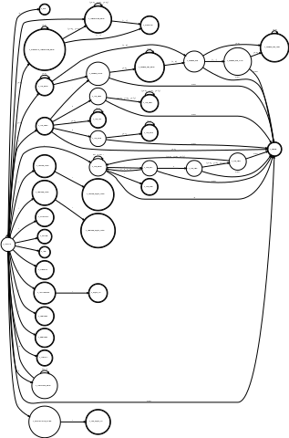
<program> -> def id <parameters> EOL <statement> end EOL

<parameters> -> ( <argument> <argument_other> )
<parameters> -> <argument> <argument_other>
<parameters> -> ε

<argument> -> id
<argument_other> -> , id

<program> -> <statement>
<program> -> <program>

<statement> -> id = id <parameters> EOL <statement>
<statement> -> id <parameters> EOL <statement>
<statement> -> id = <expression> EOL <statement>
<statement> -> <expression> EOL <statement>
<statement> -> if <expression> then EOL <statement> end EOL <statement>
<statement> -> while <expression> do EOL <statement> end EOL <statement>
<statement> -> ε

