Ver. :2020.08.27 MK possible results to place the manuscript,

An update : 2020.08.27
Test set:
****************************** TEST ******************************
Dice: max=0.9871, min=0.8545, | mean=0.9778, std=0.0131
Jaccard: max=0.9745, min=0.7460, | mean=0.9569, std=0.024
Hausdorff max=47.3709, min=2.2361, | mean=5.6711, std=4.7215
**********************************************************************

********************************* IXI ********************************
Dice: max=0.9856, min=0.8838, | mean=0.9791, std=0.0076
Jaccard: max=0.9715, min=0.7918, | mean=0.9591, std=0.0139
Hausdorff: max=52.8583, min=2.0000, | mean=5.7811, std=5.4826
**********************************************************************

Voxel spacing:
**************************
*** ixi (exams: 581) ***
**************************
cnt dimension
0 576 [1.2, 0.9, 0.9]
1 5 [1.2, 1.0, 1.0]

****************************
*** adni (exams: 7921) ***
****************************
cnt dimension
2 3977 [1.2, 1.0, 1.0]
0 2208 [1.2, 0.9, 0.9]
4 520 [1.2, 1.2, 1.2]
5 407 [1.2, 1.2, 1.3]
6 402 [1.2, 1.3, 1.2]
7 212 [1.2, 1.3, 1.3]
3 99 [1.2, 1.1, 1.1]
1 84 [1.2, 0.9, 1.0]
9 9 [1.2, 1.4, 1.4]
8 1 [1.2, 1.3, 1.4]
10 1 [1.3, 0.9, 0.9]
11 1 [1.4, 1.2, 1.2]

***************************
*** aibl (exams: 726) ***
***************************
cnt dimension
0 726 [1.2, 1.0, 1.0]

***************************
*** ppmi (exams: 752) ***
***************************
cnt dimension
0 749 [1.0, 1.0, 1.0]
1 3 [1.2, 1.1, 1.1]

****************************
*** slim (exams: 1036) ***
****************************
cnt dimension
0 1036 [1.0, 1.0, 1.0]

***************************
*** sald (exams: 493) ***
***************************
cnt dimension
0 493 [1.0, 1.0, 1.0]

*************************
*** cc (exams: 359) ***
*************************
cnt dimension
1 242 [1.0, 1.0, 1.0]
2 60 [1.3, 1.0, 1.0]
0 57 [1.0, 0.9, 0.9]

Image sizes:
**************************
*** ixi (exams: 581) ***
**************************
cnt dimension
4 498 [150, 256, 181]
2 74 [146, 256, 181]
3 5 [150, 256, 174]
0 2 [130, 256, 181]
1 2 [140, 256, 181]

****************************
*** adni (exams: 7921) ***
****************************
cnt dimension
56 2127 [176, 240, 170]
17 1028 [160, 192, 136]
78 1005 [196, 256, 167]
37 752 [170, 256, 170]
33 727 [166, 256, 180]
.. ... ...
47 1 [170, 288, 184]
49 1 [172, 256, 167]
50 1 [176, 192, 136]
51 1 [176, 192, 137]
40 1 [170, 256, 173]

[80 rows x 2 columns]

***************************
*** aibl (exams: 726) ***
***************************
cnt dimension
0 726 [160, 240, 170]

***************************
*** ppmi (exams: 752) ***
***************************
cnt dimension
4 600 [176, 240, 170]
6 93 [176, 256, 170]
8 23 [192, 240, 170]
7 17 [176, 256, 174]
1 4 [160, 240, 170]
2 4 [175, 240, 170]
10 4 [256, 240, 170]
3 3 [176, 240, 161]
9 2 [192, 256, 170]
0 1 [144, 240, 170]
5 1 [176, 248, 170]

****************************
*** slim (exams: 1036) ***
****************************
cnt dimension
433 545 [176, 256, 170]
434 13 [176, 256, 174]
402 3 [176, 184, 170]
396 3 [175, 200, 170]
412 3 [176, 197, 170]
.. ... ...
146 1 [164, 182, 167]
145 1 [164, 180, 131]
144 1 [164, 179, 170]
143 1 [164, 175, 161]
217 1 [166, 199, 170]

[435 rows x 2 columns]

***************************
*** sald (exams: 493) ***
***************************
cnt dimension
0 493 [176, 256, 170]

*************************
*** cc (exams: 359) ***
*************************
cnt dimension
27 63 [192, 256, 170]
31 60 [224, 256, 170]
24 55 [180, 240, 170]
36 52 [256, 196, 170]
29 47 [200, 256, 170]
1 32 [150, 288, 191]
23 5 [180, 224, 173]
8 4 [160, 288, 191]
20 3 [176, 256, 170]
5 3 [158, 288, 191]
19 2 [172, 256, 170]
16 2 [170, 288, 191]
34 2 [256, 186, 170]
9 2 [161, 288, 191]
15 2 [168, 288, 191]
30 1 [212, 256, 170]
35 1 [256, 192, 170]
32 1 [256, 168, 170]
33 1 [256, 174, 170]
28 1 [196, 256, 170]
37 1 [256, 200, 170]
38 1 [256, 204, 170]
26 1 [188, 256, 170]
25 1 [184, 256, 170]
0 1 [150, 288, 178]
22 1 [179, 288, 191]
21 1 [176, 288, 191]
18 1 [171, 288, 191]
17 1 [171, 256, 170]
14 1 [165, 288, 191]
13 1 [165, 288, 186]
12 1 [164, 288, 191]
11 1 [164, 256, 170]
10 1 [162, 288, 191]
7 1 [160, 288, 183]
6 1 [159, 288, 191]
4 1 [157, 288, 191]
3 1 [156, 288, 191]
2 1 [154, 288, 191]
39 1 [256, 208, 170]

An update : 2020.08.24
IXI_TEST
**********************************************************************
Dice: max=0.986, min=0.884, | mean=0.979, std=0.008
Jaccard: max=0.972, min=0.792, | mean=0.959, std=0.014
Haus.sm: max=548.036, min=249.983, | mean=311.723, std=27.756
Haus.av: max=3.224, min=1.470, | mean=1.834, std=0.163
**********************************************************************
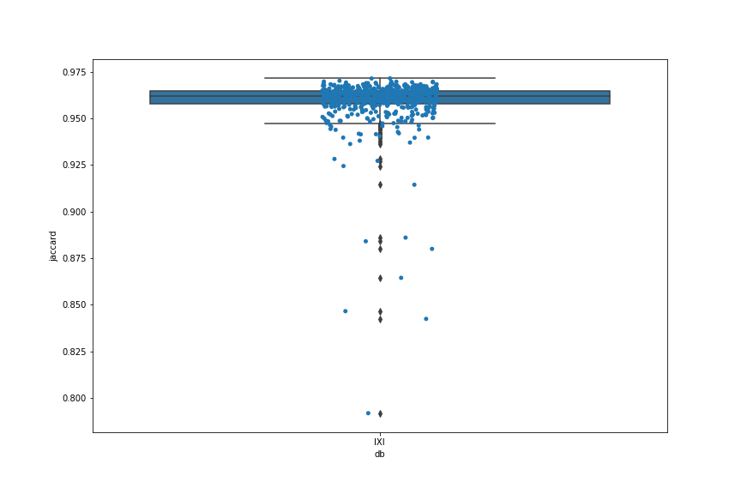

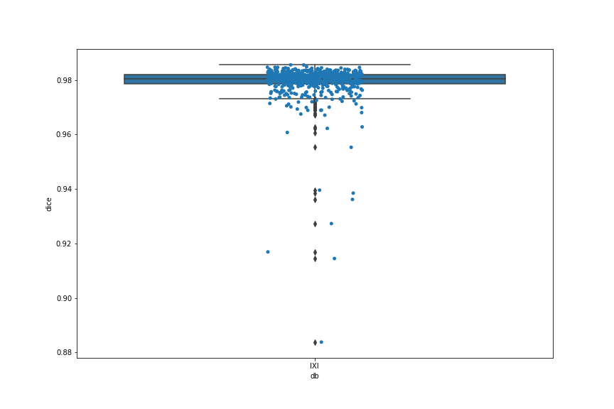
IXI464-IOP-1029-T1.anat (T1_biascorr_iso) J=0.792
IXI443-HH-2215-T1.anat (T1_biascorr_iso) J=0.844
Identification of patient (examination) with the smallest dice/jaccard coefficient

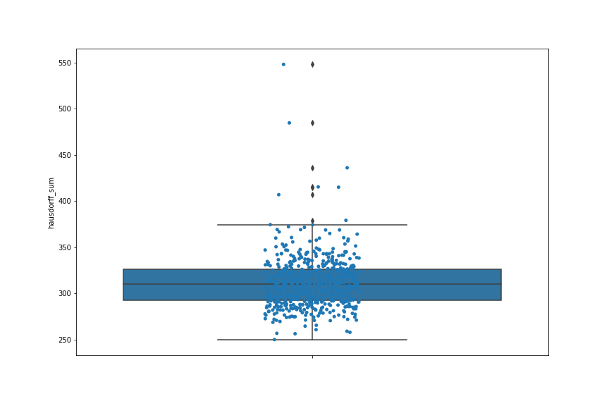
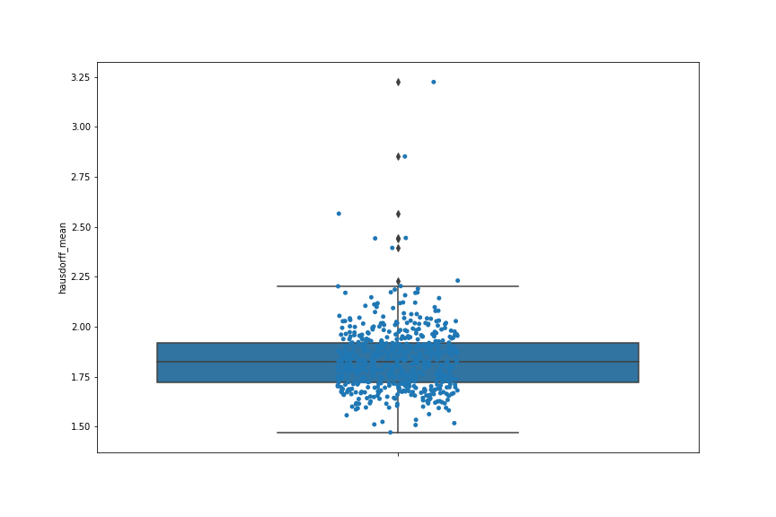

TEST

******************* Dice ********************  | max, min | mean, std  GLOB. | 0.987, 0.855, | 0.978, 0.013  *********************************************  ADNI: | 0.984, 0.855, | 0.974, 0.017  AIBL: | 0.984, 0.932, | 0.981, 0.005  CC : | 0.985, 0.936, | 0.981, 0.009  PPMI: | 0.984, 0.949, | 0.981, 0.007  SALD: | 0.987, 0.942, | 0.979, 0.009  SLIM: | 0.987, 0.968, | 0.982, 0.003  ********************************************* | ****************** Jaccard ******************  | max, min | mean, std  GLOB. | 0.974, 0.746, | 0.957, 0.024  *********************************************  ADNI: | 0.968, 0.746, | 0.951, 0.030  AIBL: | 0.969, 0.873, | 0.963, 0.010  CC : | 0.970, 0.879, | 0.962, 0.016  PPMI: | 0.969, 0.903, | 0.962, 0.014  SALD: | 0.974, 0.891, | 0.959, 0.016  SLIM: | 0.974, 0.937, | 0.966, 0.006  *********************************************
*************** Hausdorff sum ***************  | max, min | mean, std  GLOB. | 587.527, 218.005, | 320.214, 44.789  *********************************************  ADNI: | 587.527, 252.922, | 333.036, 51.546  AIBL: | 424.172, 234.168, | 308.478, 26.099  CC : | 390.534, 251.416, | 298.810, 26.656  PPMI: | 417.122, 274.011, | 320.320, 35.508  SALD: | 360.534, 218.005, | 287.257, 28.581  SLIM: | 382.096, 236.005, | 308.899, 32.303  ********************************************* | ************** Hausdorff mean ***************  | max, min | mean, std  GLOB. | 3.456, 1.282, | 1.891, 0.269  *********************************************  ADNI: | 3.456, 1.488, | 1.959, 0.303  AIBL: | 2.495, 1.377, | 1.815, 0.154  CC : | 2.297, 1.479, | 1.758, 0.157  PPMI: | 2.454, 1.612, | 1.884, 0.209  SALD: | 2.121, 1.282, | 1.690, 0.168  SLIM: | 2.470, 1.388, | 1.854, 0.232  *********************************************

Top row: Dice, middle row: Jaccard
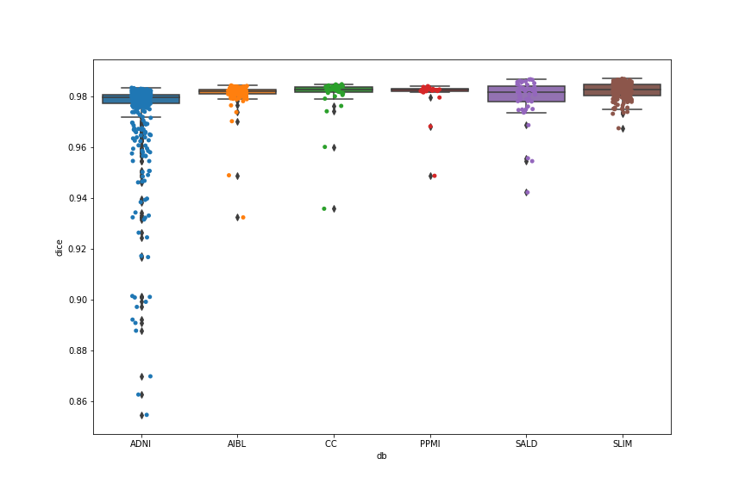 | 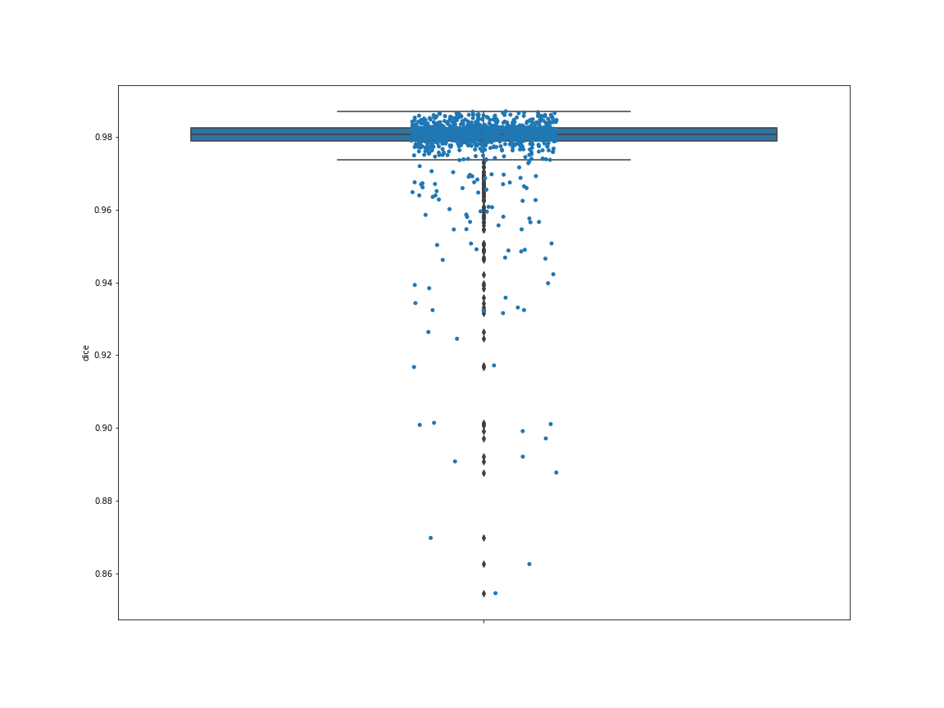
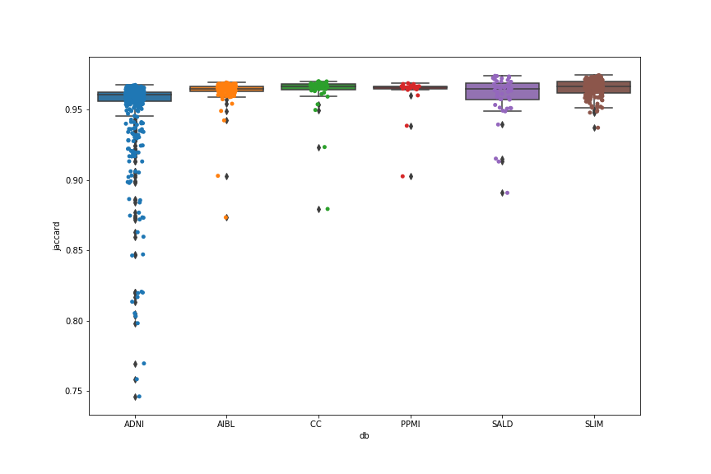 | 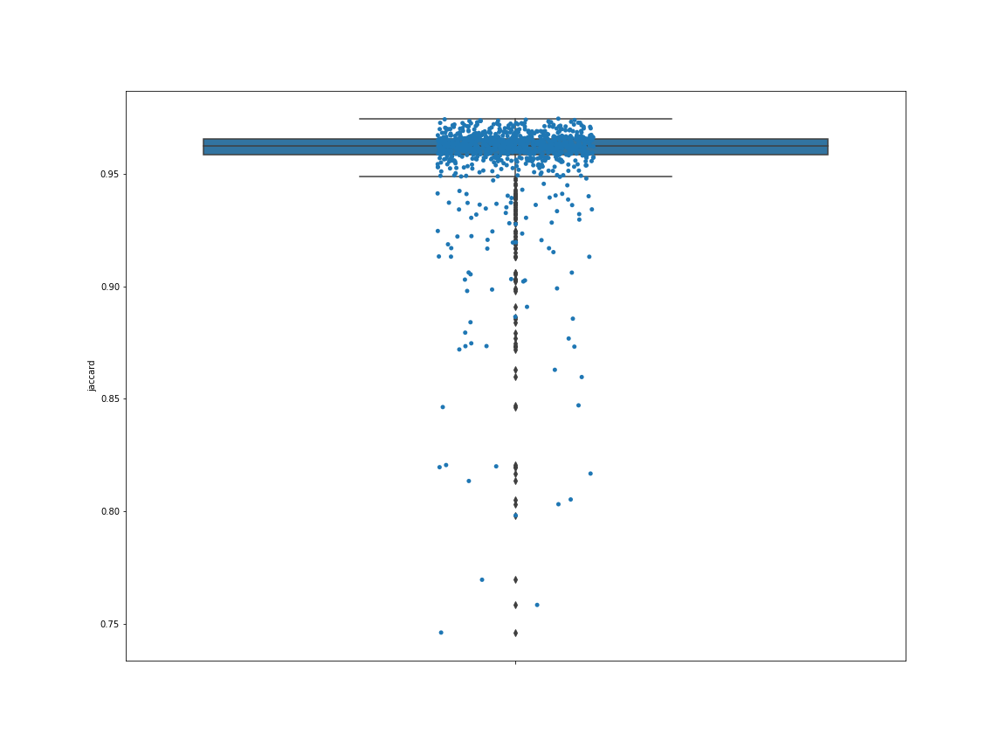
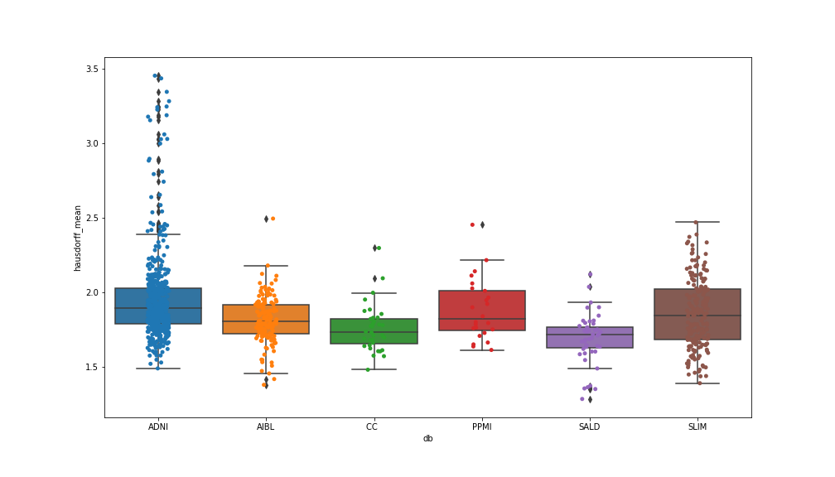 | 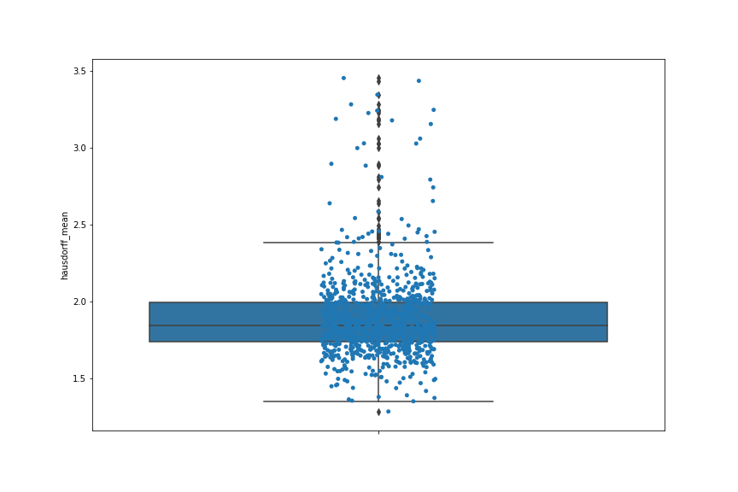
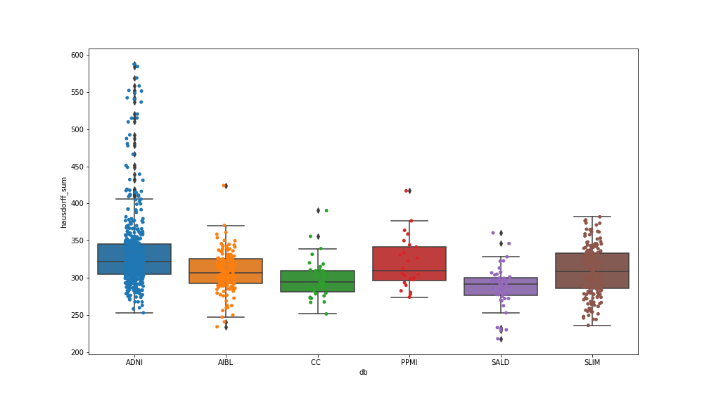 | 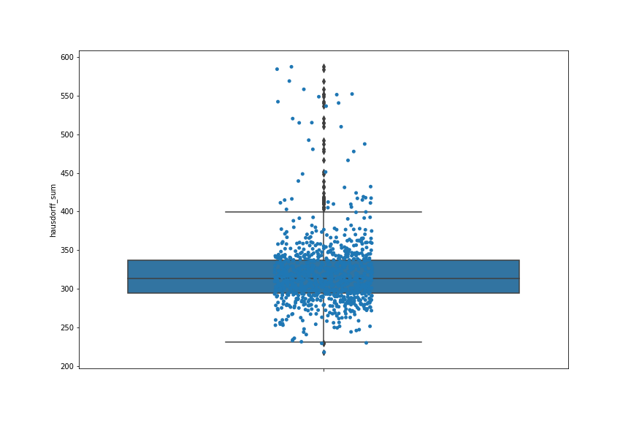

Visualization (matplotlib, ITK-Snap)

Image IXI464-IOP-1029-T1.anat (T1_biascorr_iso) J=0.792, with the lowest dice coef. value.

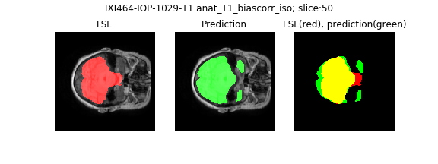
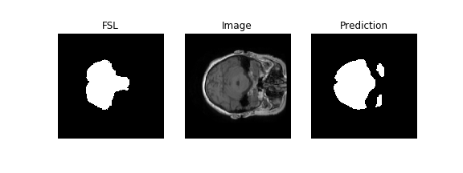

Save as nifti files
Image:I XI464-IOP-1029-T1.anat (T1_biascorr_iso) J=0.792

Prediction FSL output
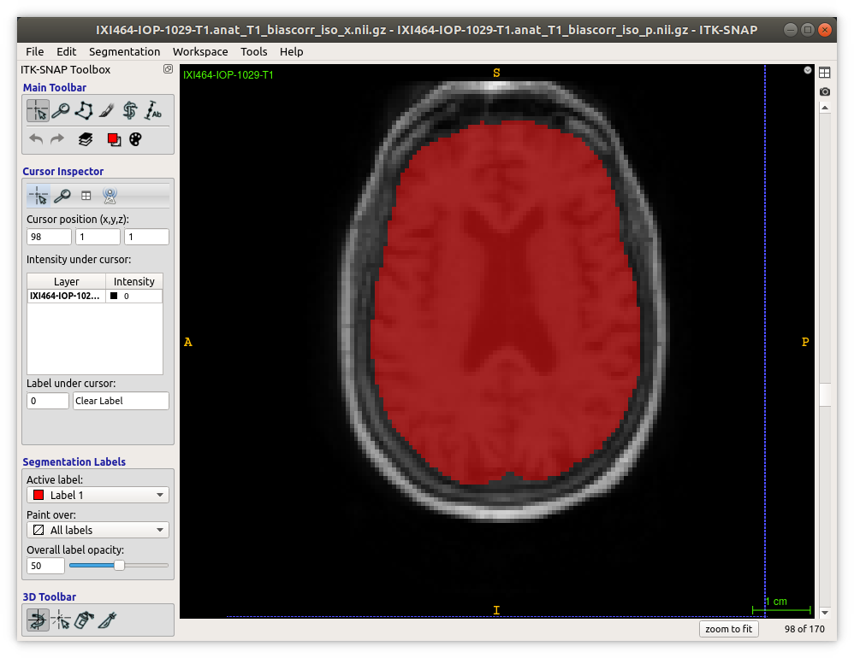
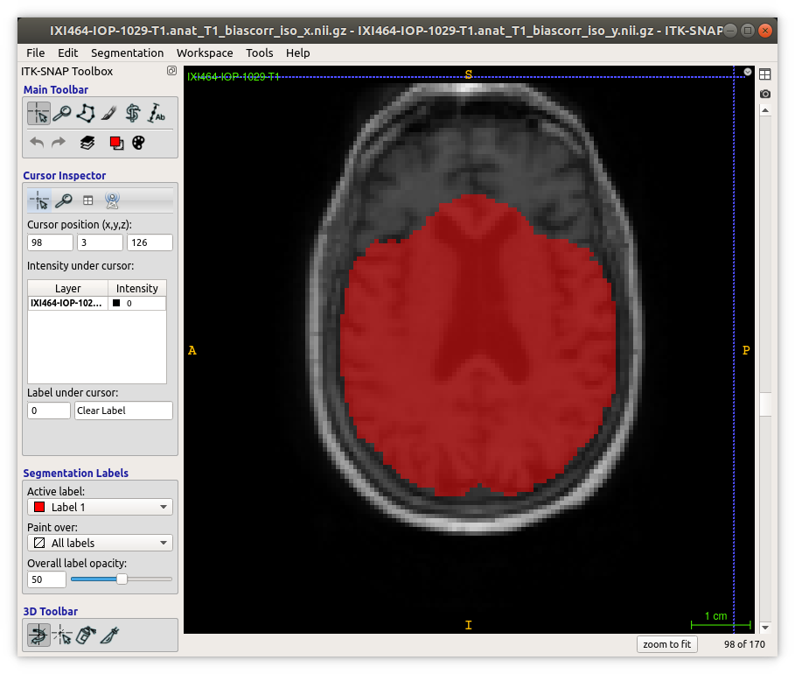

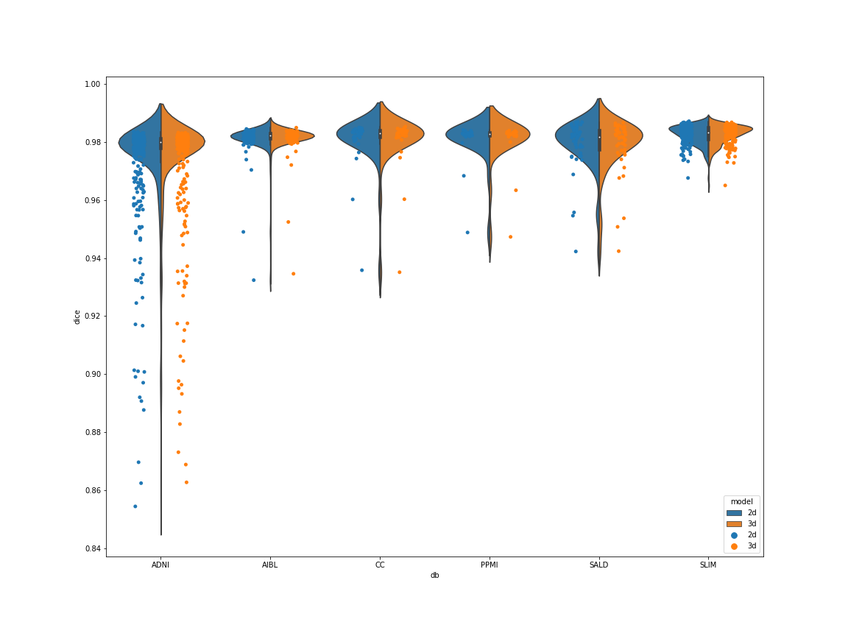
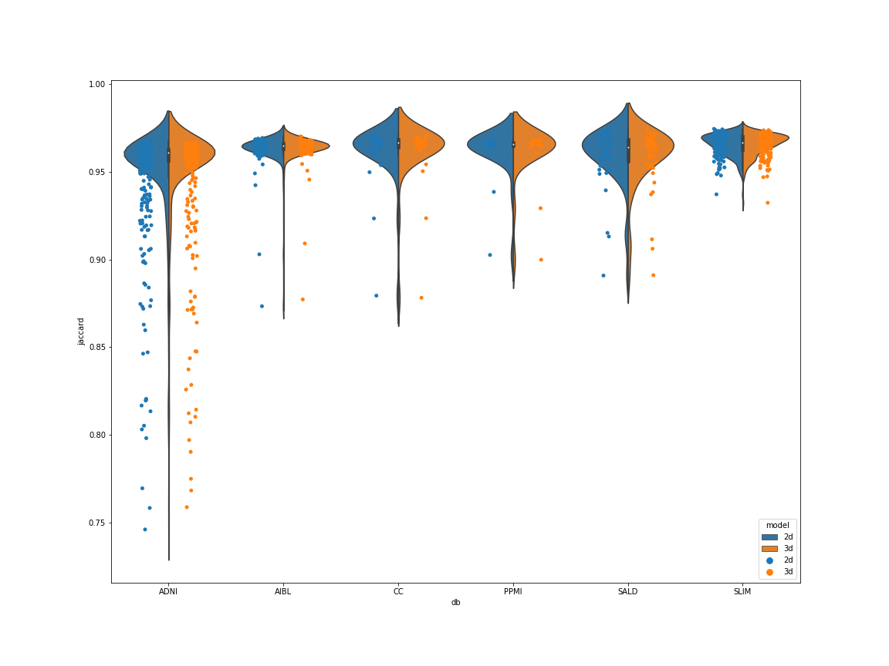
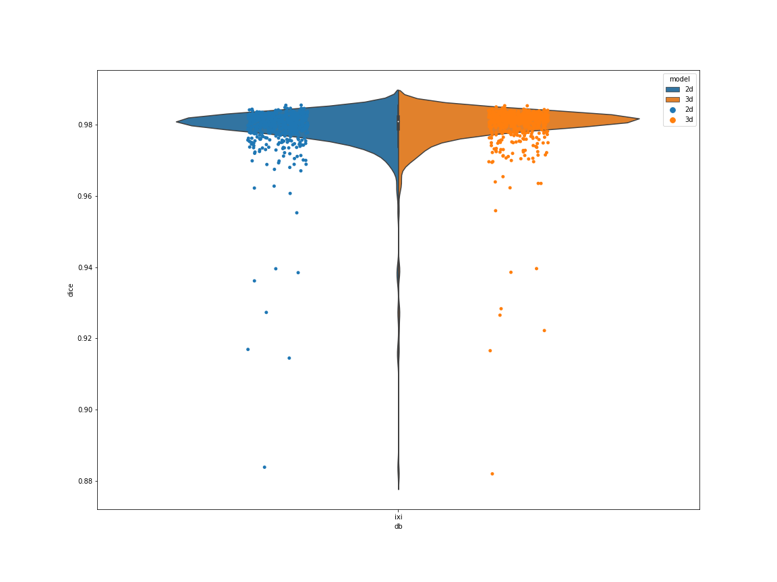
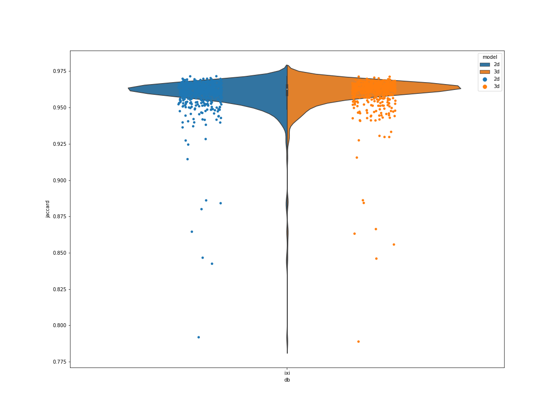

Some characteristic of ISO images.

ADNI 3D isotropic images
*** Total number of ADNI images: 25935 ***
*** Number of unique shape values: 162 ***
*** Unique shape and its counts:
(211, 240, 170) 6381
(192, 240, 170) 3445
(235, 260, 170) 3015
(204, 256, 170) 2256
(200, 240, 170) 699
...
(191, 239, 170) 3
(154, 240, 170) 3
(174, 240, 169) 3
(211, 240, 171) 3
(181, 239, 170) 3

AIBL 3D isotropic images
*** Total number of AIBL images: 2173 ***
*** Number of unique shape values: 1 ***
*** Unique shape and its counts:
(192, 240, 170) 2173

IXI 3D isotropic images
*** Total number of IXI images: 1743 ***
*** Number of unique shape values: 5 ***
*** Unique shape and its counts:
(180, 240, 170) 1494
(175, 240, 170) 222
(180, 250, 170) 15
(156, 240, 170) 6
(168, 240, 170) 6

PPMI 3D isotropic images
*** Total number of PPMI images: 2250 ***
*** Number of unique shape values: 11 ***
*** Unique shape and its counts:
(176, 240, 170) 1794
(176, 256, 170) 279
(192, 240, 170) 69
(176, 250, 170) 51
(256, 240, 170) 12
(160, 240, 170) 12
(175, 240, 170) 12
(211, 253, 170) 9
(192, 256, 170) 6
(144, 240, 170) 3
(176, 248, 170) 3

SALD 3D isotropic images
*** Total number of SALD images: 1472 ***
*** Number of unique shape values: 1 ***
*** Unique shape and its counts:
(176, 256, 170) 1472

SLIM 3D isotropic images
*** Total number of SLIM images: 1472 ***
*** Number of unique shape values: 1 ***
*** Unique shape and its counts:
(176, 256, 170) 1472

