Chapter 1. What is climate change?
Тексты страницы в порядке следования на сайте. Блоки, которые на сайте повторяются (мобильная и десктопная версии), приведены один раз. Тексты на изображениях также необходимо перевести.

Main text
“What’s happening today?” – that’s weather. “How likely is this to happen?” – that’s climate. Let’s explore why individual records do not invalidate long-term trends and how to tell weather and climate apart.

Weather
Weather describes atmospheric conditions at a particular place and time. It can change rapidly: it may be raining in the morning, with the sun coming out by lunchtime. Meteorology is the science that studies and forecasts the weather.
Even the ancient Greeks wrote about the weather. Aristotle, for example, sought natural explanations for weather phenomena in his Meteorologica.

Climate
Climate is the range of conditions across all components of the climate system – the atmosphere, hydrosphere, biosphere, cryosphere, and the upper layer of the lithosphere – that are characteristic of a particular area. Climate change is a process that takes place over decades and sometimes even millennia.
As early as 400 BC, Greek philosophers were studying how climate influenced the development of societies and differences between peoples.
Weather describes current atmospheric conditions, while climate describes the conditions typically experienced in a particular region over a long period of time.

Earth’s climate
Earth’s climate has changed throughout the planet’s history. Our planet has experienced ice ages and periods of warming, while the configuration of the continents, the composition of the atmosphere, and plant and animal life have also changed over time.

Air temperature on Earth
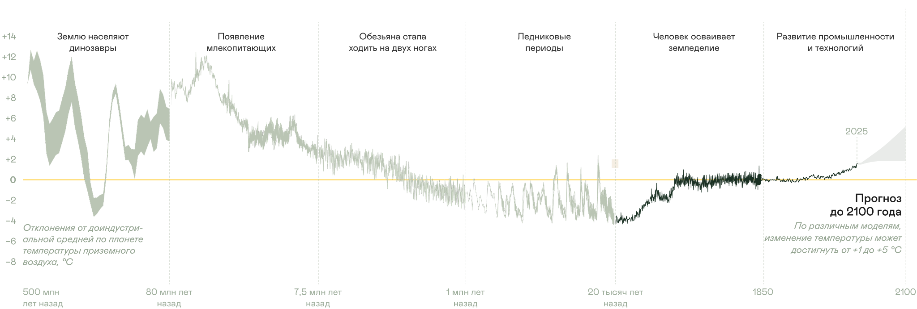
Землю населяют динозавры | Dinosaurs inhabit Earth
Появление млекопитающих | Mammals emerge
Обезьяна стала ходить на двух ногах | Early hominins begin walking on two legs
Ледниковые периоды | Ice ages
Человек осваивает земледелие | Humans take up farming
Развитие промышленности и технологий | Development of industry and technology
Отклонения от доиндустриальной средней по планете температуры приземного воздуха, °C | Global mean near-surface air temperature anomaly relative to the pre-industrial average, °C
Прогноз до 2100 года | Forecast to 2100
По различным моделям, изменение температуры может достигнуть от +1 до +5 °C | Depending on the model, temperatures could rise by between 1 °C and 5 °C
500 млн лет назад | 500 million years ago
80 млн лет назад | 80 million years ago
7,5 млн лет назад | 7.5 million years ago
1 млн лет назад | 1 million years ago
20 тысяч лет назад | 20 thousand years ago

The Greenhouse effect
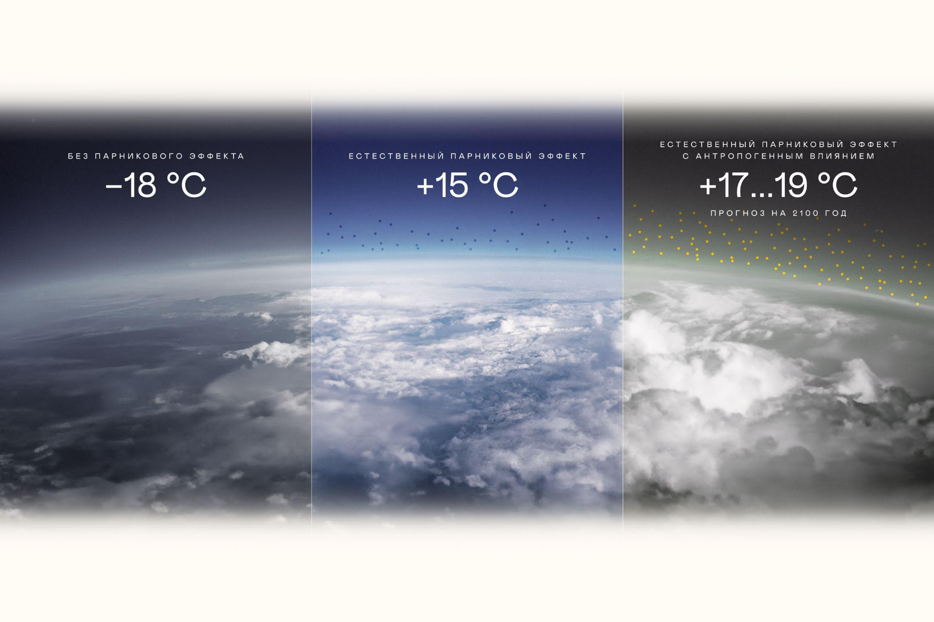
Без парникового эффекта | Without the greenhouse effect
−18 °C | −18 °C
Естественный парниковый эффект | Natural greenhouse effect
+15 °C | +15 °C
Естественный парниковый эффект с антропогенным влиянием | Human-enhanced greenhouse effect
+17...19 °C | +17 °C to +19 °C
Прогноз на 2100 год | 2100 forecast

Earth’s atmosphere naturally regulates the planet’s temperature. It retains heat and creates the conditions necessary for life. The planet’s temperature is determined not only by its distance from the Sun but also by the greenhouse gases in the atmosphere.
Greenhouse gases trap infrared radiation emitted by Earth’s surface, preventing all of it from escaping into space. This causes air temperatures to rise.
Thanks to the greenhouse effect, Earth’s average air temperature remains at a comfortable level of around +15 °C. Without it, Earth’s average temperature would be −18 °C.
Intensive human industrial activity increases greenhouse gas concentrations in the atmosphere, amplifying the greenhouse effect.
As greenhouse gas concentrations grow, the greenhouse effect becomes stronger and air temperatures in the lower atmosphere rise. This leads to global warming.
The terms “global warming” and “climate change” are often confused or used interchangeably, but they mean different things.
Global warming is the increase in the combined near-surface air and sea surface temperatures averaged across the globe over a 30-year period.
Earth’s average surface temperature has risen by 1.5 °C
The chart clearly shows that global warming is accelerating. While temperatures changed relatively little until the mid-20th century, the past 50 years have seen an unprecedentedly rapid rise.
The warmest period in the past 100,000 years
Climate change encompasses a much broader range of changes, with global warming being only one part of it. These changes have been taking place since the mid-19th century, driven by rising greenhouse gas emissions from human activities.
Human activities – agriculture, industry, deforestation, and urbanisation – place increasing pressure on the environment
This leads to higher concentrations of greenhouse gases (CH₄, CO₂, N₂O) and disrupts the carbon cycle
As a result, the greenhouse effect intensifies, trapping more heat in the atmosphere
This drives changes in climate, including warming temperatures, changing precipitation patterns, ice loss, rising sea levels, and shifts in ocean currents
These changes, in turn, have serious consequences, including urban flooding, mounting damage, disasters, disease, and biodiversity loss
Different sectors of the economy generate different greenhouse gases in varying amounts. This depends on the technologies and resources they use.
The energy sector is the largest source of carbon dioxide (CO₂). Agriculture primarily generates methane (CH₄). Nitrous oxide (N₂O) and fluorinated gases make up a significant share of emissions from the chemical industry.
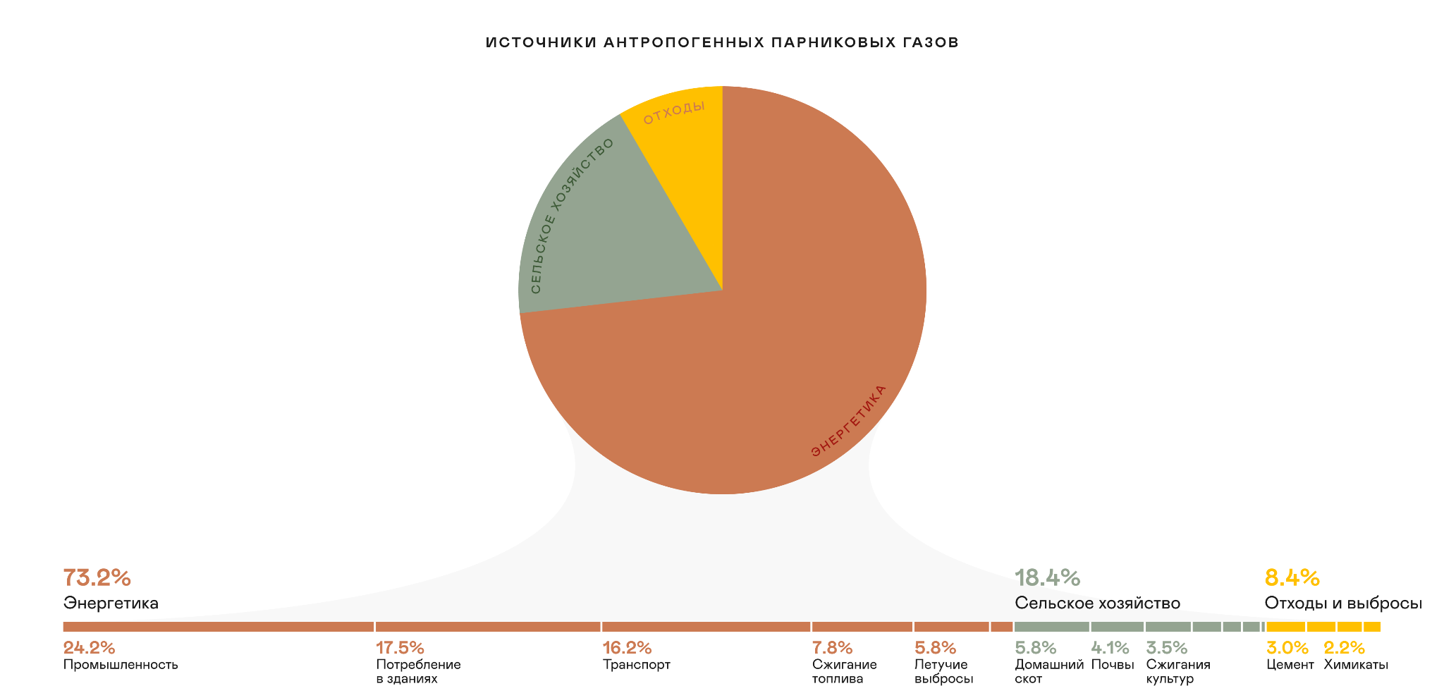
Источники антропогенных парниковых газов | Sources of anthropogenic greenhouse gases
Отходы | Waste
Сельское хозяйство | Agriculture
Энергетика | Energy
Энергетика | Energy
Промышленность | Industry
Потребление в зданиях | Energy use in buildings
Транспорт | Transport
Сжигание топлива | Fuel combustion
Летучие выбросы | Fugitive emissions
Сельское хозяйство | Agriculture
Домашний скот | Livestock
Почвы | Soils
Сжигания культур | Crop burning
Отходы и выбросы | Waste and emissions
Цемент | Cement
Химикаты | Chemicals
Source: Our World in Data

Can we predict climate change?
Climate change can be projected, and scientists have developed global climate models for this purpose. To improve the reliability of projections, scientists use ensembles of models. One widely used initiative is the World Climate Research Programme’s Coupled Model Intercomparison Project (CMIP). Among the models used in the project is a climate model developed by the Institute of Numerical Mathematics of the Russian Academy of Sciences.
At the heart of a climate model is a system of equations describing interactions between the atmosphere, oceans, land, glaciers, and the biosphere. Based on physical, chemical, and biological processes, the models calculate key climate variables such as temperature, pressure, humidity, and wind.
Law of conservation of energy
Energy does not disappear but is converted from one form to another
Stefan–Boltzmann law
Describes how radiation depends on temperature and helps explain the greenhouse effect
Clausius–Clapeyron equation
Shows how water vapour pressure depends on temperature
Navier–Stokes equations
Describe the motion of fluids and gases in the atmosphere and ocean
To assess how well a climate model performs, its outputs are compared with actual data from a selected historical period. This helps determine the model’s accuracy and whether its parameters need to be refined.
Scientists around the world test model calculations against actual observations and compare the results. Repeated validation of this kind increases confidence in climate models.

What goes into a climate model?
The accuracy of a climate model depends on how comprehensively it represents the real world. Models incorporate a wide range of complex natural processes and features to produce reliable projections.
Vegetation
Chemical processes
Carbon cycle
Volcanic activity
Ocean biogeochemical cycles
Anthropogenic aerosol emissions
Ocean circulation
Solar radiation
Rivers, lakes, and wetlands
Anthropogenic greenhouse gas emissions
Aerosols
Ocean dynamics
Land surface effects
Snow cover, mountain glaciers, and ice sheets
Clouds and precipitation
Atmospheric dynamics
Turbulence
Atmospheric electricity
Since the 1970s, climate models have evolved to incorporate an increasing number of factors and have become progressively more accurate. The 2021 Nobel Prize in Physics was awarded for the physical modelling of Earth’s climate, quantifying variability, and reliably predicting global warming.

Modern climate science in Russia
The Russian scientific community has also made a major contribution to the development of climate science. The development of climate science in Russia began long before the advent of computer models and has involved a number of outstanding scientists.
Boris Alisov
1891–1976
In the mid-20th century, he developed a regional classification of climates in the Soviet Union and identified the country’s main climate zones. He studied how air masses influence climate and weather.
Mikhail Budyko
1920–2001
One of the pioneers of research into the thermal structure of Earth’s atmosphere and water balance. He developed the well-known theory of the positive ice–albedo feedback in the climate system. He studied global warming from the mid-20th century onwards.
Alexander Voeikov
1842–1916
The founder of Russian climate science. He was the first in the world to publish a scientific work on the subject. He also pioneered large-scale studies of Russia’s climate and introduced the concept of climatic zoning.
Georgy Golitsyn
1935–2026
A member of the Russian Academy of Sciences who made an internationally significant contribution to the development of the theory of “nuclear winter”. His research into the physics of planetary atmospheres and the theory of turbulence helped improve our understanding of how large-scale disasters can affect Earth’s climate.
Sergey Gulev
Born in 1958
A specialist in ocean–atmosphere interactions. His research focuses on how processes in the global ocean influence long-term climate variability and the development of destructive marine storms.
Yuri Izrael
1933–2014
Established the national environmental monitoring system in the Soviet Union and Russia. Helped shape international initiatives on climate and environmental protection, led the State Committee for Hydrometeorology and Environmental Monitoring, and served as Vice-Chair of the IPCC and Vice-President of the WMO.
Vladimir Kotlyakov
Born in 1931
A leading glaciologist who recovered Antarctic ice cores revealing the relationship between temperatures and greenhouse gas concentrations.
Sergei Lappo
1938–2006
An oceanographer who demonstrated the crucial role of the North Atlantic in the global ocean “conveyor belt” of currents. Studied how heat exchange between the ocean and atmosphere in energy-active zones influences climate change across the planet.
Gury Marchuk
1925–2013
An outstanding mathematician who developed numerical methods for weather forecasting and climate modelling. Established the mathematical foundations of modern computer models used to project climate change. Served as President of the USSR Academy of Sciences.
Nikita Moiseyev
1917–2000
A mathematician and thinker who led the development of a mathematical model of “nuclear winter”. Formulated the principles of co-evolution – the joint development of humanity and the biosphere – and demonstrated the need to protect the climate system.
Andrei Monin
1921–2007
Co-author of the fundamental Monin–Obukhov similarity theory, which describes processes in the atmospheric surface layer. His work on the theory of turbulence and ocean dynamics underpins modern climate models.
Igor Mokhov
1950–2025
A leading expert in climate change diagnostics and modelling. Studied the causes of extreme weather events and the dynamics of global warming and succeeded Georgy Golitsyn as head of the Institute of Atmospheric Physics of the Russian Academy of Sciences (IAP RAS).
Alexander Obukhov
1918–1989
Founder and first director of the IAP RAS, which now bears his name. Developed the fundamental theory of the local structure of turbulence, which underpins modern calculations of air-mass motion.
Sergei Khromov
1904–1977
Author of textbooks and monographs on synoptic meteorology and climatology. Developed a number of methods for analysing and interpreting meteorological data.
Hover over the card
Several leading institutions in Russia conduct research into climate change. Here are just some of them.

Leading Institutions
MGO
Voeikov Main Geophysical Observatory
IAP RAS
Obukhov Institute of Atmospheric Physics of the Russian Academy of Sciences
IGCE
Yu. A. Izrael Institute of Global Climate and Ecology
MSU
Lomonosov Moscow State University
INM RAS
Institute of Numerical Mathematics of the Russian Academy of Sciences
IMCES SB RAS
Institute of Monitoring of Climatic and Ecological Systems, Siberian Branch of the Russian Academy of Sciences
Now that we have explored the science behind climate change, we can turn to its visible effects. In the next chapter, we will look at how glaciers are melting, how the ocean is changing, and what is happening to permafrost.
Chapter 2

What climate change looks like

Interactive elements

Term tooltips
Global warming: Definition by the Intergovernmental Panel on Climate Change (IPCC).

Image alt text
Не видны на странице, читаются экранными дикторами и показываются, если картинка не загрузилась.

- Weather – atmospheric conditions at a particular place and time
- Climate – long-term patterns in atmospheric conditions
- Changes in air temperature throughout Earth’s history
- Earth from space – the natural greenhouse effect
- Earth – comfortable temperatures
- Earth – an enhanced greenhouse effect
- Rise in Earth’s average surface temperature
- Human activities
- Rising greenhouse gas concentrations
- Enhanced greenhouse effect
- Climate change
- Impacts on people and nature
- Greenhouse gas emissions by sector

Page metadata (tab title, meta description, and social media description)
Tab title: What is climate change? – Nornickel
Description: Weather and climate, the greenhouse effect, and global warming – explore the fundamentals of climate change with Nornickel.
Social media description: Weather and climate, the greenhouse effect, and global warming – explore the fundamentals.

