Chapter 2. What climate change looks like
Тексты страницы в порядке следования на сайте. Блоки, которые на сайте повторяются (мобильная и десктопная версии), приведены один раз. Тексты на изображениях также необходимо перевести.

Main text
We keep hearing that the planet’s climate is changing. But how can we tell that these changes are real and not simply short-term variations in the weather? Let’s look at the most visible signs that the climate is changing and why it is important to pay attention to them.

The Arctic is warming
The Arctic is warming about four times faster than the rest of the world. This is due to a combination of factors – sea ice loss, changes in atmospheric and ocean circulation, and increases in cloud cover and water vapour. Climate change and its impacts are particularly pronounced in the Arctic.

Arctic amplification of climate change
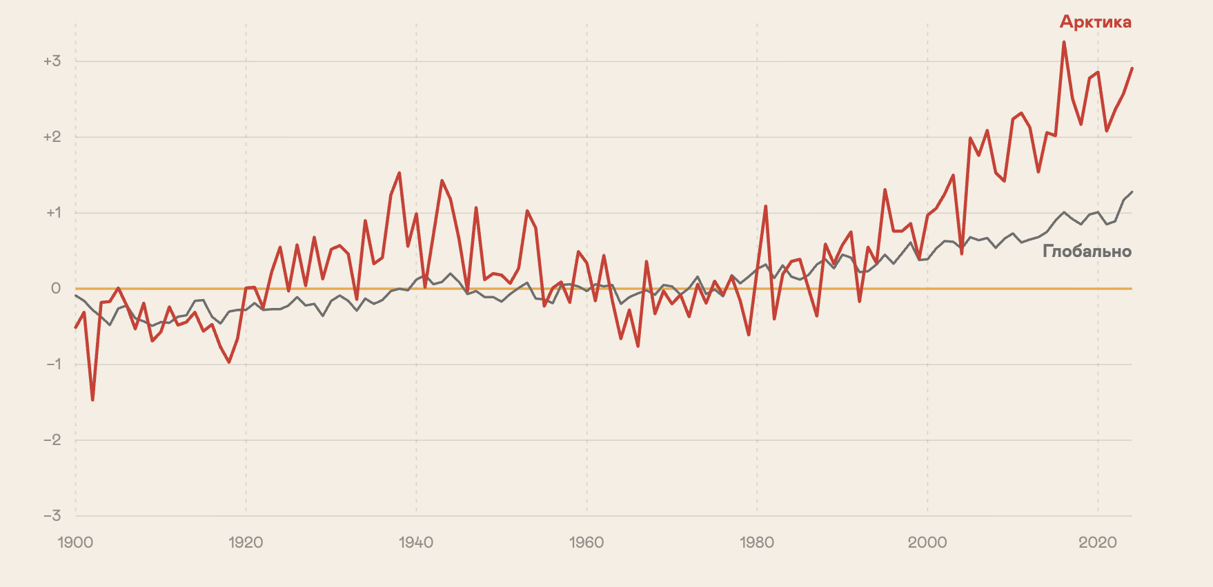
Арктика | Arctic
Глобально | Global
Source: NASA GISS Surface Temperature Analysis (GISTEMP v4)

Sea ice is melting
Sea ice in the Arctic Ocean is a key component of the Arctic climate and acts as Earth’s “natural refrigerator”. Its high albedo allows it to reflect most of the Sun’s energy back into space.
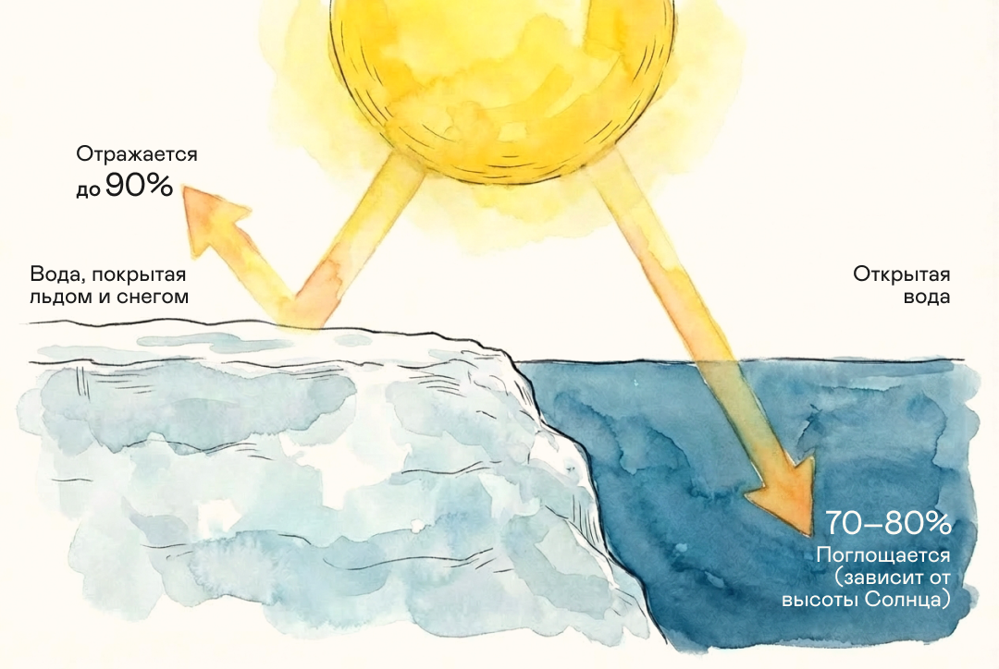
Отражается до 90% | Up to 90% reflected
Вода, покрытая льдом и снегом | Ice- and snow-covered water
Открытая вода | Open water
70—80% Поглощается (зависит от высоты Солнца) | 70%–80% absorbed (depending on the Sun’s elevation)

Dark ocean water has a much lower albedo than ice, so it absorbs more solar energy than it reflects. As a result, ocean temperatures rise and even more ice melts. This creates a positive ice–albedo feedback that accelerates warming.
Maximum in 1979
Satellite observations since 1979 show that sea ice extent has been steadily declining by about 13% per decade. The lowest summer extent was recorded in September 2012.
According to projections by the Intergovernmental Panel on Climate Change, the Arctic could become temporarily ice-free during the warm season as early as the middle of the 21st century. The consequences for local ecosystems would be catastrophic.

Ocean currents and wind patterns are changing
If all Arctic sea ice becomes seasonal rather than perennial, temperatures will rise even further. Atmospheric and ocean circulation patterns are also changing. Temperatures in the Northern Hemisphere will rise further. Greenland’s glaciers and Arctic Ocean sea ice will continue to melt, making the surface waters of the northern Atlantic Ocean fresher.
This will slow deep-ocean circulation in the region. As a result, the entire global ocean conveyor belt of currents could be disrupted.
This could alter the climate in different parts of the world: some regions could become colder, while others could experience changes in precipitation and the frequency of extreme weather events.
Temperatures in the Northern Hemisphere rise further
Greenland’s glaciers and Arctic Ocean sea ice continue to melt
As a result, the surface waters of the northern Atlantic Ocean become fresher
Fresh water is less dense than salt water, so it does not sink as readily to greater depths. This will slow deep-ocean circulation in the region
If this happens, the entire global ocean conveyor belt of currents could be disrupted

Glaciers and permafrost are thawing
Sea ice is not the only thing thawing rapidly in the Arctic – permafrost is thawing too. It used to be known in Russian as “eternal frost”, but today specialists increasingly use the more precise term “perennially frozen ground”. Such ground can remain frozen for decades or centuries, but it is not frozen forever and can thaw as temperatures rise. Around 4 million people live in the permafrost zone. Another 10 million live in regions where infrastructure relies on the stability of frozen ground. Around 70% of infrastructure assets – buildings, roads, and pipelines – depends on the ground remaining frozen. When it thaws, the ground can literally collapse.
The Batagaika crater is the world’s largest permafrost crater. It is a growing depression 1 km long and up to 100 m deep. Located in Yakutia, the crater began forming in the 1960s.
Reconstruction of what the area looked like in the mid-20th century (left) and the crater today (right)

Water resources and food security are at risk
Rising temperatures are disrupting precipitation patterns and the planet’s entire water cycle.
Floods and droughts are becoming more severe. Higher global temperatures increase the amount of moisture the atmosphere can hold. On the one hand, this leads to more intense but less frequent extreme rainfall; on the other, it contributes to severe droughts as more water evaporates from the land surface. Changes in atmospheric circulation also contribute to these effects. Projections suggest that the risks of drought and flooding will continue to increase with every degree of global warming.
Available freshwater resources are declining. Floods and droughts increase water pollution from sediment, pathogens, and pesticides. Sea-level rise will cause groundwater to become more saline. Fresh water will become less accessible to people and ecosystems in coastal areas. Together, these changes lead to growing water scarcity around the world and an increase in natural disasters.
Crop yields are declining. Soil quality is deteriorating, soils are becoming more saline, crop pests are expanding their ranges, and droughts are becoming more severe in some regions. All of this reduces crop yields, and scientists project that losses could become even greater as temperatures continue to rise.

Ecosystems are being degraded, and biodiversity is declining
Human activity has a major impact on biodiversity, primarily through the use of land for agriculture. More than 70% of the world’s ice-free land has already been altered by such activities.
Climate change is now having an increasing impact on nature. It alters plant and animal habitats, forces species to migrate to cooler areas, damages ecosystems such as coral reefs, and increases the frequency of extreme weather events.
Species extinction and ecosystem degradation
Shifts in species ranges and species migration
Disruption of food chains
Threats to rare species
Disease incidence and parasites
It is important to remember that the relationship between climate and biodiversity works both ways. Climate affects nature, while healthy ecosystems help mitigate climate change. Forests, grasslands, and wetlands absorb carbon dioxide and reduce the damage caused by extreme weather. Protecting and restoring natural ecosystems and their biodiversity is therefore an important way to tackle climate change.

As the climate changes, so does life for all of humanity
The economy is increasingly affected by extreme weather events – hurricanes, floods, droughts, and cyclones. They threaten people, animals, and plants and cause serious economic damage in countries around the world. International organisations consider global warming one of the major economic risks of this decade.
The vulnerability of countries and regions to extreme weather events depends on climatic, social, economic, and geographical factors.

What is changing

Economic impact

Who will be affected first
Sea-level rise
Threatens coastal areas, causing infrastructure and property losses
Small island states and less developed coastal countries
More frequent weather- and climate-related disasters
Increased recovery costs and diminished investment attractiveness
Areas at high risk of floods, hurricanes, or earthquakes
More frequent droughts
Rising food prices, worsening hunger and inflation
Areas with depleted land resources and growing populations
Rising temperatures and extreme heat
Increased mortality, reduced labour productivity, and higher healthcare costs
People living in poverty and regions with hot climates

How climate change affects human health
Higher mortality in large cities due to heatwaves. According to the Russian Federal Service for Hydrometeorology and Environmental Monitoring (Rosgidromet), Russia is warming at an average rate of 0.45 °C per decade – 2.5–2.8 times faster than the rest of the world. This is leading to more frequent periods of extreme heat in megacities, causing sharp increases in mortality from cardiovascular and respiratory diseases. For example, during the 2010 heatwave, mortality from strokes among people over 65 in cities with a distinctly continental climate increased by 49%, while mortality from hypertension rose by 84% (source).
Worsening allergies and the spread of infections. In Russia, milder winters and shifting seasonal patterns are increasing the risk of tick-borne infections, such as Lyme disease. In addition, warming and rising CO₂ concentrations are extending the flowering season and increasing pollen levels, making life more difficult for people with allergies and increasing the risk of asthma.
Health risks for children and newborns. Extreme temperatures can adversely affect pregnancy – heat increases the risk of preterm birth by 5% for every 1 °C rise in temperature and by up to 16% during extreme heatwaves (source). Today, deaths from cold still significantly outnumber deaths from heat in most countries, including Russia. However, global warming will inevitably increase the risks associated with extreme summer heatwaves.

Climate tipping points
It may seem that climate-related risks are increasing slowly and that we will have enough time to adapt. However, change can also happen much more rapidly. A climate tipping point is a theoretical critical threshold at which the global or regional climate shifts from one stable state to another. Such a shift may be irreversible.
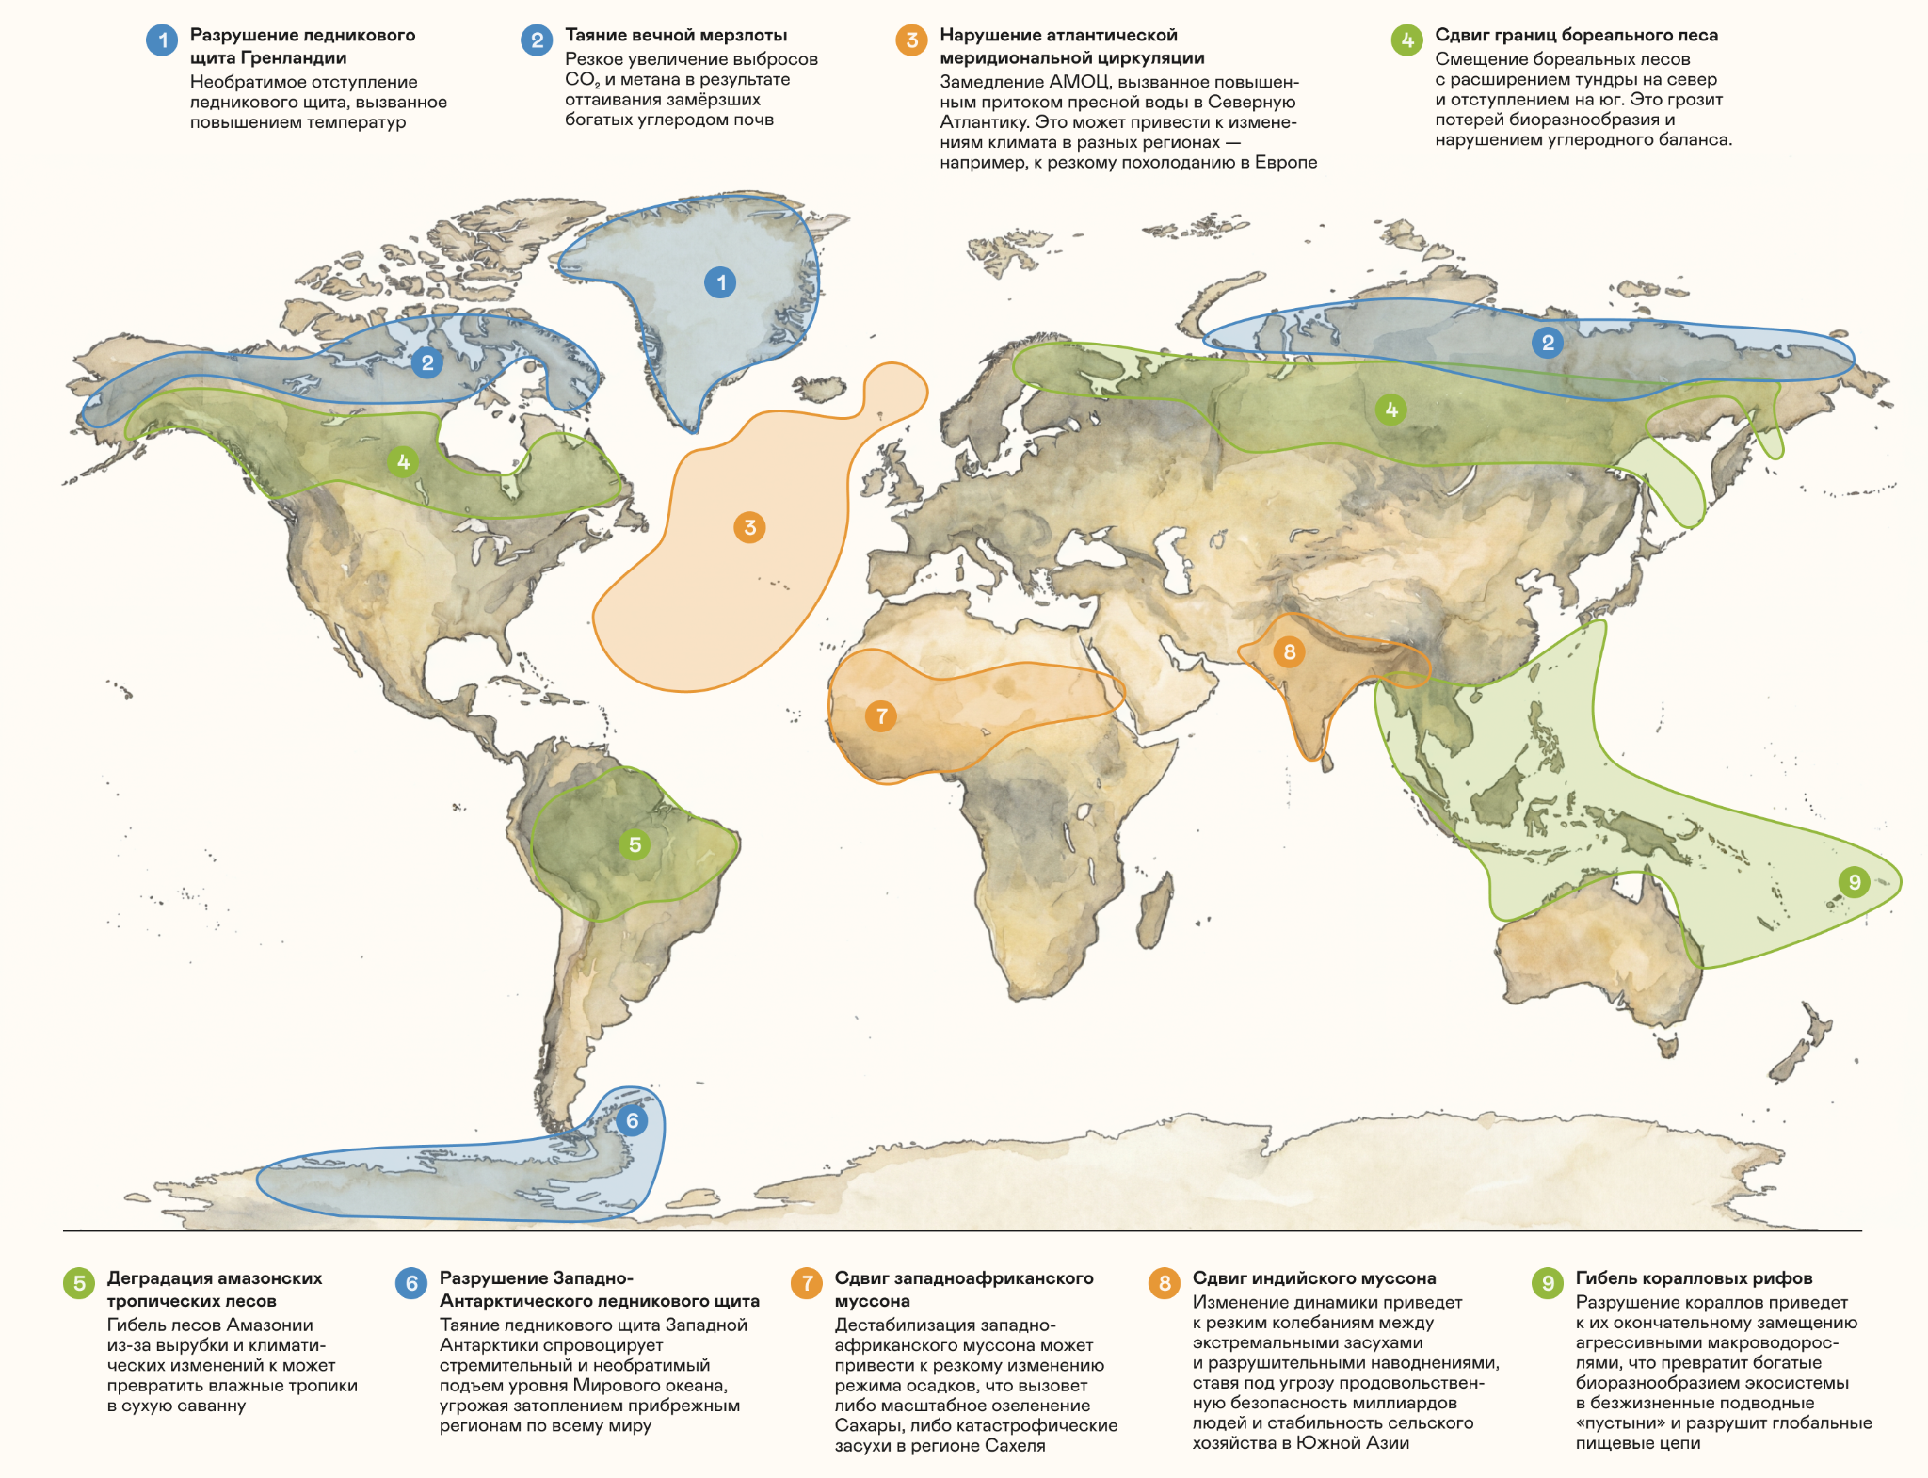
Разрушение ледникового щита Гренландии  Необратимое отступление ледникового щита, вызванное повышением температур | Collapse of the Greenland Ice Sheet  Irreversible retreat of the ice sheet caused by rising temperatures
Таяние вечной мерзлоты  Резкое увеличение выбросов CO₂ и метана в результате оттаивания замёрзших богатых углеродом почв | Permafrost thawing  A sharp increase in CO₂ and methane emissions as frozen, carbon-rich soils thaw
Нарушение атлантической меридиональной циркуляции  Замедление АМОЦ, вызванное повышенным притоком пресной воды в Северную Атлантику. Это может привести к изменению климата в разных регионах — например, к резкому похолоданию в Европе | Disruption of the Atlantic Meridional Overturning Circulation  A slowdown of the AMOC caused by increased freshwater inflow into the North Atlantic. This could alter the climate in different regions – for example, causing a sharp cooling in Europe
Сдвиг границ бореального леса  Смешение бореальных лесов с расширением тундры на север и отступлением на юг. Это грозит потерей биоразнообразия и нарушением углеродного баланса. | Shift in boreal forest boundaries  Northward shift of boreal forests, with expansion into tundra areas in the north and retreat in the south. This could lead to biodiversity loss and disrupt the carbon balance
Деградация амазонских тропических лесов  Гибель лесов Амазонии из-за вырубки и климатических изменений к может превратить влажные тропики в сухую саванну | Amazon rainforest dieback  Dieback of the Amazon rainforest due to deforestation and climate change could transform tropical rainforest into dry savanna
Разрушение Западно-Антарктического ледникового щита  Таяние ледникового щита Западной Антарктики спровоцирует стремительный и необратимый подъем уровня Мирового океана, угрожая затоплением прибрежным регионам по всему миру | Collapse of the West Antarctic Ice Sheet  Melting of the West Antarctic Ice Sheet could trigger rapid and irreversible global sea-level rise, threatening coastal regions around the world with flooding
Сдвиг западноафриканского муссона  Дестабилизация западноафриканского муссона может привести к резкому изменению режима осадков, что вызовет либо масштабное озеленение Сахары, либо катастрофические засухи в регионе Сахеля | Shift in the West African monsoon  Destabilisation of the West African monsoon could cause dramatic changes in precipitation patterns, resulting either in large-scale greening of the Sahara or catastrophic droughts in the Sahel
Сдвиг индийского муссона  Изменение динамики приведет к резким колебаниям между экстремальными засухами и разрушительными наводнениями, ставя под угрозу продовольственную безопасность миллиардов людей и стабильность сельского хозяйства в Южной Азии | Shift in the Indian monsoon  Changes in monsoon dynamics could lead to dramatic swings between extreme droughts and devastating floods, threatening food security for billions of people and the stability of agriculture in South Asia
Гибель коралловых рифов  Разрушение кораллов приведет к их окончательному замещению агрессивными макроводорослями, что превратит богатые биоразнообразием экосистемы в безжизненные подводные «пустыни» и разрушит глобальные пищевые цепи | Coral reef die-off  The loss of coral reefs could lead to their permanent replacement by aggressive macroalgae, turning biodiversity-rich ecosystems into lifeless underwater “deserts” and disrupting global food chains
Enlarge map

How to prepare for climate change and protect nature and the economy
Climate change gives rise to climate risks – potentially harmful consequences for nature, society, and the economy. These risks fall into two categories: physical risks arising from the direct impacts of natural disasters such as hurricanes, floods, and wildfires, and transition risks arising from the transformation of the economy to reduce greenhouse gas emissions. Transition risks include new legislation, market changes, and the adoption of new technologies.
Climate risks need to be carefully assessed to identify the best solutions and reduce threats. The ideal solution would be to eliminate our impact on the climate system altogether through mitigation. This would slow warming and, in the best-case scenario, could even stop it.
However, climate change is already happening, so mitigation alone will not be enough, particularly without ambitious climate action at the national or international level. We will have to adapt to the current and future impacts of climate change.
Climate adaptation means adjusting environmental, social, and economic systems to cope with actual or expected changes and their impacts. Approaches to adaptation vary depending on the country, region, or organisation – there is no one-size-fits-all solution.
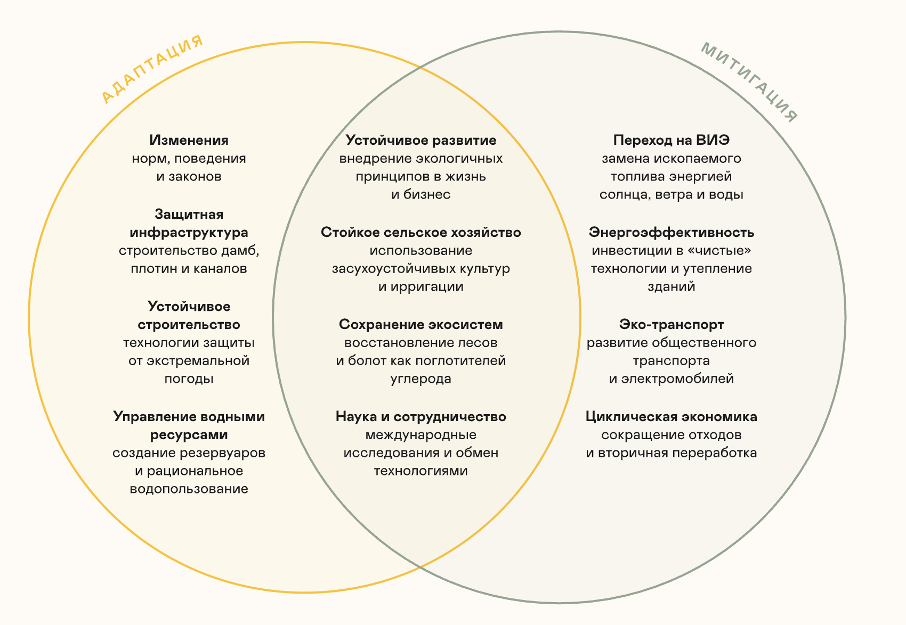
Адаптация | Adaptation
Изменения норм, поведения и законов | Changes in norms, behaviour, and legislation
Защитная инфраструктура  строительство дамб, плотин и каналов | Protective infrastructure  Building dykes, dams, and canals
Устойчивое строительство  технологии защиты от экстремальной погоды | Climate-resilient construction  Using technologies that protect against extreme weather
Управление водными ресурсами  создание резервуаров и рациональное водопользование | Water management  Building reservoirs and using water sustainably
Устойчивое развитие  внедрение экологичных принципов в жизнь и бизнес | Sustainable development  Integrating environmentally responsible practices into everyday life and business
Стойкое сельское хозяйство  использование засухоустойчивых культур и ирригации | Climate-resilient agriculture  Using drought-resistant crops and irrigation
Сохранение экосистем  восстановление лесов и болот как поглотителей углерода | Ecosystem conservation  Restoring forests and wetlands as carbon sinks
Наука и сотрудничество  международные исследования и обмен технологиями | Science and collaboration  International research and technology sharing
Митигация | Mitigation
Переход на ВИЭ  замена ископаемого топлива энергией солнца, ветра и воды | Transition to renewable energy  Replacing fossil fuels with solar, wind, and hydro
Энергоэффективность  инвестиции в «чистые» технологии и утепление зданий | Energy efficiency  Investing in clean technologies and building insulation
Эко-транспорт  развитие общественного транспорта и электромобилей | Sustainable transport  Expanding public transport and the use of electric vehicles
Циклическая экономика  сокращение отходов и вторичная переработка | Circular economy  Reducing waste and increasing recycling

Both mitigation and adaptation are therefore essential. Mitigation can help avoid the highest levels of risk, while adaptation can help us cope with moderate levels of risk.
In the next chapter, you will learn how climate change affects the economy, what a carbon footprint is, and why the world is talking about decarbonisation.
Chapter 3

How climate change affects the economy

Interactive elements

Term tooltips
Albedo: Albedo is a measure of how much light a surface reflects rather than absorbs. Snow has a high albedo: it reflects sunlight well, while asphalt has a low albedo and absorbs most of the sunlight that reaches it.
The Arctic: National Plan for the Second Stage of Adaptation. Instruction of the Russian Government No. 559-r dated 11 March 2023.

Quiz (questions and answers)
Question 1: How many people worldwide lack access to fresh water?
Answer: Around 2 billion people lack access to clean drinking water
Question 2: What percentage of all the water on Earth is fresh water?
Answer: Fresh water accounts for only about 2.5% of all the water on Earth, and only around 1.2% of that is relatively accessible surface water, such as rivers, lakes, and soil moisture
Question 3: What percentage of the world’s population depends on water from mountain glaciers?
Answer: Around one in six people worldwide depends on water from mountain glaciers
Question 4: What percentage of all fresh water is used in agriculture?
Answer: Around 70% of fresh water consumed is used in agriculture
Question 5: How many litres of water are needed to produce enough food for one person for one day?
Answer: Producing enough food for one person for one day requires between 2 thousand and 5 thousand litres of water
Question 6: By what percentage have floods become more frequent over the past 20 years?
Answer: The number of floods has increased by around 134% over the past 20 years compared with the previous two decades
Message after the quiz: ${q.fact}

Image alt text
Не видны на странице, читаются экранными дикторами и показываются, если картинка не загрузилась.
- Arctic amplification of climate change: temperature anomalies in the Arctic and the global average from 1900 to 2024
- Diagram showing the albedo of ice and dark water
- Decline in sea ice extent since 1979
- Temperatures rise
- Glaciers melt
- Water becomes fresher
- Circulation slows
- The global ocean conveyor belt is disrupted
- Batagaika crater, 1962
- Batagaika crater, 1968
- Batagaika crater, 1975
- Batagaika crater, 1980
- Batagaika crater, 1991
- Batagaika crater, 1999
- Batagaika crater, 2002
- Batagaika crater, 2007
- Batagaika crater, 2010
- Batagaika crater, 2013
- Batagaika crater, 2015
- Batagaika crater, 2018
- The crater today
- The area in the mid-20th century
- Species extinction
- Species migration
- Disease incidence
- Map of climate tipping points
- Diagram of climate change mitigation and adaptation

Page metadata (tab title, meta description, and social media description)
Tab title: What climate change looks like – Nornickel
Description: How ice loss, changing ocean currents, permafrost, and climate tipping points affect nature and humanity.
Social media description: The Arctic, glaciers, permafrost, and biodiversity – key signs of a changing climate.

