Chapter 3. How climate change affects the economy
Тексты страницы в порядке следования на сайте. Блоки, которые на сайте повторяются (мобильная и десктопная версии), приведены один раз. Тексты на изображениях также необходимо перевести.

Main text
Climate change not only causes direct economic losses but also drives the development of new markets. On the one hand, natural disasters are becoming more frequent, damaging infrastructure and slowing economic growth. On the other, they are creating demand for innovations that help businesses adapt to new conditions and use resources more efficiently.

The economy is adapting
Climate change is prompting businesses and governments to take action – adopting greener production methods, changing logistics, and developing markets for green products. As a result, new business opportunities are emerging and technological breakthroughs are being made.
The simplest measures
- Reducing food waste
- Promoting plant-based diets and reducing meat consumption
- Promoting public transport, cycling, and walking
Moderately challenging measures
- Investing in clean energy and energy efficiency
- Upgrading and decarbonising buildings
- Switching to electric vehicles
- Restoring land and halting deforestation
The most challenging measures
- Phasing out coal-fired power plants
- Reducing emissions from cement, steel, and plastics production
- Reducing emissions from aviation and shipping
Source: IPCC’s Sixth Assessment Report, World Resources Institute (WRI)

Alternative and renewable energy
Climate change is driving the world away from conventional energy sources – coal, oil, and natural gas. To reduce their carbon footprint and slow global warming, countries and companies are actively developing alternative energy. Renewable energy sources are becoming a key focus for the entire energy sector.
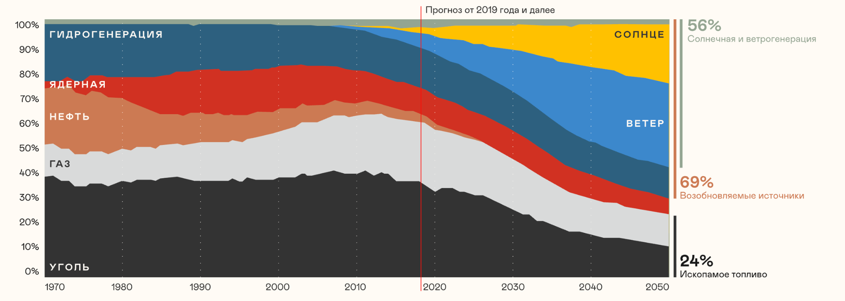
Гидрогенерация | Hydro
Ядерная | Nuclear
Нефть | Oil
Газ | Gas
Уголь | Coal
Солнце | Solar
Ветер | Wind
Прогноз от 2019 года и далее | Forecast from 2019 onwards
Солнечная и ветрогенерация | Solar and wind
Возобновляемые источники | Renewables
Ископаемое топливо | Fossil fuels
Source: BloombergNEF, IEA
According to projections by BloombergNEF and the IEA, the world is set to undergo a major energy transformation by 2050. The share of renewables could rise to 69%, driven by rapid growth in solar and wind, while the share of fossil fuels could fall almost threefold.
The terms “alternative” and “renewable” energy sources are often used interchangeably. However, there is a difference between them.
Alternative energy sources are any alternatives to conventional energy sources such as coal, oil, and gas. They include both renewable sources and finite alternatives such as nuclear energy, hydrogen, biogas, and synthetic fuels.
Renewable energy sources are those that are naturally replenished and considered environmentally friendly. Examples include solar, wind, hydro, bioenergy, and geothermal energy.

Low-carbon technologies in transport
To reduce emissions and improve air quality, the transport sector is adopting new standards. Key focus areas include low-carbon fuels, battery power, more efficient engines, and innovative technologies.
Hover over the card
Aircraft
Aviation is looking for ways to reduce its environmental impact. Key focus areas include switching to sustainable aviation fuel (SAF) and developing hybrid and fully electric propulsion systems. Aircraft designs are also becoming more aerodynamic to reduce fuel consumption.
Train
Trains are becoming even more environmentally friendly. Locomotives are switching to hydrogen and battery power, while carriages are becoming more energy-efficient. Railways are increasingly powered by renewable energy, while digital systems help optimise train operations.
Cargo ship
Maritime transport is also going green. Cargo vessels are switching to battery-electric propulsion and alternative fuels. Solar panels are also increasingly being installed to power onboard systems.
River ferry
River transport is becoming cleaner. Ferries are increasingly being equipped with electric and hybrid propulsion systems and using cleaner fuels such as liquefied natural gas (LNG) and biomethane.
Electric vehicle
The key advantage of an electric vehicle is that it produces no direct emissions. Using renewable energy keeps its carbon footprint to a minimum. It also requires fewer service fluids, reducing waste generated during operation.
Car
Electric vehicles are not the only way to make transport greener. Other options include hydrogen-powered and gas-powered vehicles and hybrids. Another important focus area is car sharing, which helps reduce the overall number of cars on city streets.
Bus
Public transport is becoming increasingly green. Diesel buses are being replaced by electric buses, gas-powered models, and hybrids. This helps significantly improve air quality in cities.
Bicycle and scooter
These are among the most environmentally friendly modes of transport, powered entirely by your own energy. They produce no direct emissions, help reduce congestion and pressure on urban infrastructure, and are also a great way to stay fit.
Delivery drone
Drones, particularly in logistics, could become part of a greener future. They run on electricity, while smart algorithms calculate the shortest and most energy-efficient routes. This is an important part of the smart city concept.

Business and climate: from risks to opportunities
Recognising the inevitability of global climate change, companies are developing corporate climate policies, strategies, roadmaps, and other measures. Businesses are setting ambitious goals to reduce their environmental footprint, make their operations more resilient, increase revenues, and strengthen their competitiveness in the market.

Nornickel’s approach
The Company has built a comprehensive climate change management system:
- Its Climate Change Policy lays out the principles guiding the Company’s activities and commitments under the climate agenda.
- The Company’s Environmental and Climate Change Strategy sets the key targets for these efforts.
- The Key Focus Areas of Carbon Neutrality have been approved, establishing promising areas for reducing gross greenhouse gas emissions and the carbon footprint of products.
- A corporate Climate Change Adaptation Plan has been developed, covering physical and transition risks, the methodology for assessing these risks, and relevant training.
- The Supplier Code of Conduct has also been approved, setting out the Company’s greenhouse gas emissions reduction requirements for suppliers.
- The Company publishes reports on its climate change performance.

Why does climate change matter to business?
The most direct and obvious impact of climate change is the risk of disruption to infrastructure. However, climate change presents opportunities for companies as well as risks.

Adapting urban areas
Severstal: supplies low-temperature rolled steel and protective structures for construction in climate-vulnerable regions of the Arctic and the Russian Far East.

Monitoring the impacts of climate change on forest ecosystems
ROSCOSMOS: detects wildfire hotspots using satellite monitoring, with near-instant access to thermal imagery.
Segezha Group: monitors forest use in real time through its SegezhaLes digital system.
Skoltech: uses mathematical modelling to predict the likelihood of wildfires.

Climate-resilient agriculture
LUKOIL: monitors water bodies to protect its facilities against flooding and extremely low water levels.
EN+ GROUP: adapts the operation of the Angara cascade of hydropower plants to changes in annual river runoff and drought risks.
RusHydro: reinforces hydropower dams to protect against flooding and restores water to degraded land in its regions of operation.

Adaptation strategies in permafrost regions
Nornickel: monitors the structural stability of buildings in Norilsk using a permafrost monitoring system.
Gazprom: provides technical supervision of production facilities under changing permafrost and ground conditions.
NOVATEK: uses 4D modelling and digital twins of facilities to assess risks associated with permafrost thawing.
ROSATOM: supplies power to Arctic infrastructure through the Akademik Lomonosov floating nuclear power plant.

Carbon accounting and reporting
To manage its impact on the climate, a company first needs to measure it. That is where carbon accounting comes in – a system for measuring all greenhouse gas emissions. It helps companies comply with legislation, plan emissions reductions, and implement climate projects.
Since 2025, large companies in Russia emitting more than 50,000 tonnes of CO₂ equivalent annually have been required to report their greenhouse gas emissions. Other companies can report voluntarily, for example, to enhance their reputation and attract investors.
Reports are submitted through a dedicated government service – the GHG Emissions Registry. The registry forms part of the State Information System "Energy Efficiency".

How can you tell whether your company needs to report?
The easiest way is to estimate your company’s emissions. You can do this using the calculator available through the State Information System "Energy Efficiency".
To determine whether your company is required to report, refer to Resolution of the Russian Government No. 355 dated 14 March 2022. Actual greenhouse gas emissions are calculated using the methodology approved by Order No. 371 of the Russian Ministry of Natural Resources and Environment dated 27 May 2022.

How to offset your carbon footprint
Contrary to popular belief, simply planting a tree is not always the best way to offset your carbon footprint. Trees take decades to mature and begin absorbing significant amounts of CO₂. There is also no guarantee that they will survive droughts or wildfires or avoid being cut down.
That is why it is important to support offset projects whose effectiveness has been independently verified. These may include ecosystem restoration, carbon capture and storage, waste recycling, energy efficiency improvements or, in some cases, renewable energy development – provided they deliver demonstrable additional emissions reductions and would not have gone ahead without such support.
It is important to remember that offsetting is no substitute for reducing your own emissions. The priority should be to reduce your carbon footprint first and offset only those emissions that cannot yet be avoided.

How do industrial companies reduce their carbon footprint?
- Switching to renewable energy to power their operations.
- Introducing energy-efficient technologies to reduce resource consumption.
- Streamlining logistics to reduce transport-related emissions.
- Developing new products and technologies designed to use less energy from the outset.
Project examples
TATNEFT
Injects CO₂ into oil wells to enhance oil recovery and introduces methane capture systems.
RusHydro
Generates more than 80% of its electricity from renewable sources, including hydro, solar, and wind power.
ROSATOM
Builds nuclear power plants and wind farms to supply consumers with low-carbon energy.
NOVATEK
Develops low-carbon hydrogen production technologies and sets up CO₂ storage facilities.
Gazprom
Captures methane during maintenance of trunk pipelines using mobile compressor stations.
Severstal
Introduces green steelmaking technologies and increases the use of natural gas in blast furnaces.
RUSAL
Produces low-carbon aluminium under the ALLOW brand using hydropower.
Nornickel
Produces metals for environmentally friendly technologies and incorporates climate-related requirements into supplier assessments.
ALROSA
Studies enhanced weathering of kimberlite rocks in tailings storage facilities, where the rocks naturally absorb CO₂ from the air during ore processing.

How can you reduce your carbon footprint in everyday life?
- Save electricity and heating energy at home.
- Use public transport, cycle, or walk more often.
- Buy locally produced food to reduce emissions from transportation.
- Sort your waste and recycle unwanted items.

Climate projects and carbon credits
In 2021, Russia introduced new rules for businesses under Federal Law No. 296-FZ. Companies can now launch climate projects to reduce their carbon footprint. A climate project is any initiative that helps reduce greenhouse gas emissions or increase their absorption.

Types of climate projects
Here are some examples of climate projects:

Technology-based
- Building renewable energy facilities
- Switching from hydrocarbon-based energy sources to green energy
- Capturing carbon from the atmosphere
- Improving energy efficiency
- Converting greenhouse gases into solid materials

Nature-based
- No-till farming
- Reforestation
- Rewetting wetlands
- Soil carbon sequestration
- Agroforestry
- Reducing methane emissions from cattle
- Preventing deforestation
Climate projects are recorded in dedicated registries. One example is the Russian Carbon Units Registry.

What does it take for a project to qualify as a climate project?
- Comply with legislation. The project must comply with federal and regional laws.
- Avoid shifting emissions elsewhere. Reducing emissions at one plant must not result in higher emissions from a contractor or in a neighbouring region.
- Go beyond mandatory requirements. The project must be voluntary and go beyond what the company is already required to do by law.
- Reduce emissions through technology, not lower production. A company cannot simply shut down a plant and claim to have reduced emissions.
- Demonstrate that the results are attributable to the project. If emissions fall because of a warm winter or lower demand, the reduction cannot be credited to the project.
For successfully implementing a climate project, a company receives carbon credits – certificates confirming that it has reduced greenhouse gas emissions.

CARBON CREDITS IN PRACTICE
Preparing project documentation
Project expert review
Project registration
Project implementation and monitoring
Validation of results
Issuance of carbon credits
Trading and retirement of carbon credits
Companies that cannot eliminate all their emissions can buy carbon credits from companies implementing climate projects.

Why do companies buy carbon credits?
- To offset their emissions. This helps companies manage their carbon footprint and work towards carbon neutrality.
- To meet regulatory requirements. For example, to participate in regional climate programmes such as the Sakhalin Experiment, comply with international regulations such as the EU Carbon Border Adjustment Mechanism (CBAM), or meet other government requirements.
- To support important climate projects. Many initiatives, such as building new solar power plants or restoring forests, would not go ahead without this financial support.
If Russia introduces a compliance carbon market in the future, carbon credits will likely be used to cover emissions exceeding government-imposed limits. They could also be used to pay carbon taxes, as is already common practice internationally.

Climate regulation instruments
In late 2021, Russia approved its Low-Carbon Development Strategy until 2050. The strategy aims to reduce greenhouse gas emissions by 60% from 2019 levels (and by 80% from 1990 levels) by 2050 and achieve carbon neutrality by 2060.

Reducing greenhouse gas emissions in Russia
A key condition is to achieve these targets without sacrificing economic growth. Meeting these targets requires robust regulatory mechanisms.
Market-based instruments, which put a price on carbon, are considered the most flexible. The idea is simple: make companies pay for their greenhouse gas emissions. This puts a monetary value on environmental damage and factors it into product prices.
Carbon tax
A direct tax is imposed on each tonne of emissions. This encourages companies to reduce their environmental impact.
Emissions trading system
The government sets an overall emissions cap and allocates or sells emissions allowances to companies. Companies that keep their emissions below their allocated quotas can sell the surplus to those that exceed their limits.
Voluntary carbon market
Companies can voluntarily finance climate projects and receive carbon credits to offset their own carbon footprint.
Essentially, a carbon market provides a way to finance climate projects that would not otherwise be commercially viable. The commodity traded on this market is carbon credits, which are generated through efforts to reduce emissions. Because carbon credits are intangible, the main challenge is to establish clear, fair rules for all market participants and provide accessible trading infrastructure.

The two types of carbon markets
Compliance market
The government sets the rules. Companies must participate to comply with the law. Carbon credit prices in this market depend directly on how stringent the requirements are.
Voluntary market
Companies participate on their own initiative to achieve their sustainability goals. Demand is driven not by legislation but by customers and business partners seeking to work with environmentally responsible companies.

Global practice
The global carbon market began to take shape in 2005, when the Kyoto Protocol entered into force. The Protocol established three key mechanisms for countries with emissions reduction commitments.
Direct trading in emissions allowances
Countries could buy and sell emissions allowances among themselves.
Clean Development Mechanism
Developed countries could finance climate projects in developing countries, such as building solar power plants, and receive carbon credits towards meeting their emissions reduction commitments.
Joint Implementation
This worked in a similar way, but projects were carried out in other developed countries that had also made emissions reduction commitments.
Since 2006, these mechanisms have helped generate around 3 billion carbon credits, most of them from projects in developing countries.
Emissions trading systems
An emissions trading system (ETS) is a compliance market that operates on a cap-and-trade basis within a country or region.
- Cap. The government sets an overall limit, or cap, on emissions from one or more sectors of the economy.
- Trade. Companies must hold an allowance for every tonne of emissions. They can obtain allowances from the government or buy them from other companies that have reduced their emissions and have excess carbon allowances.
In Asia, a key market for Russian products, such systems are still in their early stages but are developing rapidly. With carbon regulation incorporated into the national strategies of most countries in the region, these markets are expected to grow.

How emissions trading systems are introduced
Countries generally take a phased approach. Before launching a national system, they often pilot it in a particular region or for a limited period. Russia’s Sakhalin Experiment is one such pilot carbon market.

The price of carbon (CO₂ equivalent)
The amount a company must pay to the government or through the market for each tonne of greenhouse gases it emits. The market price of carbon credits generally tends towards the prevailing price of CO₂ emissions.
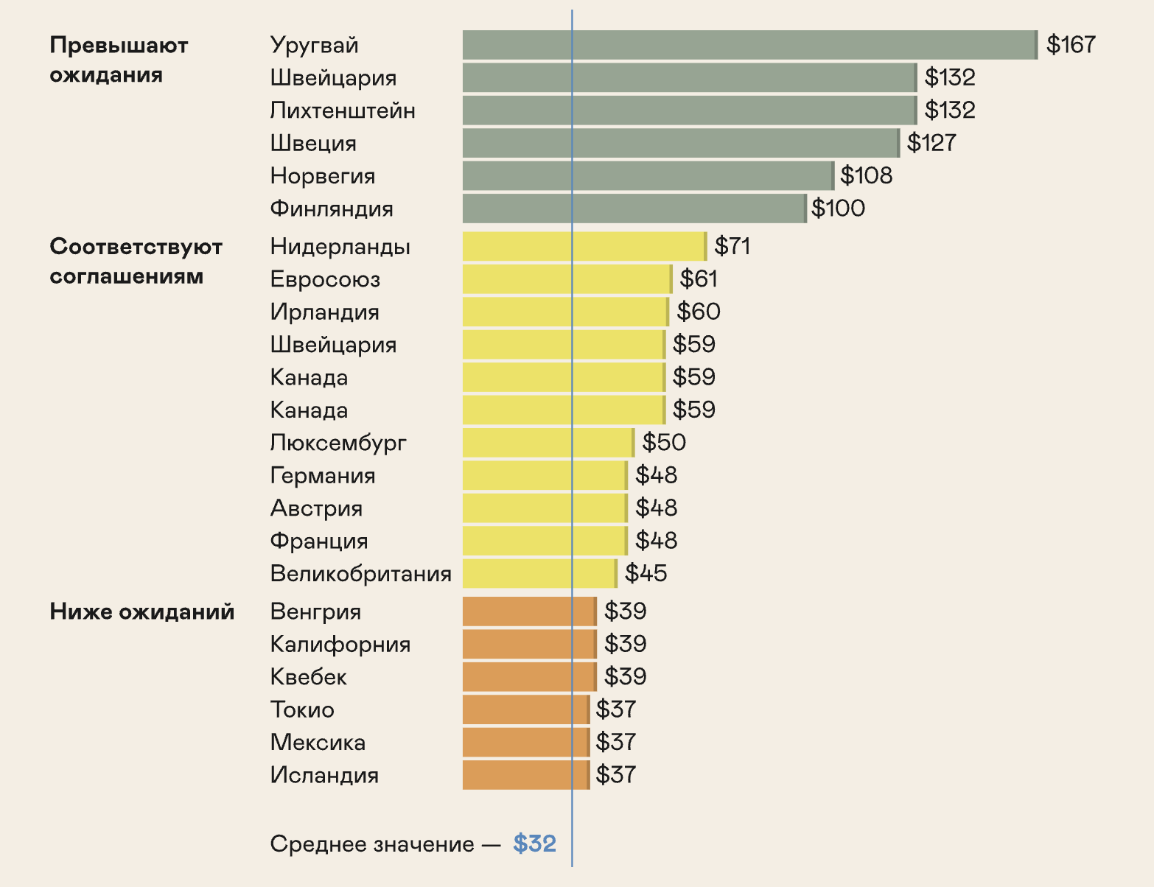
Превышают ожидания | Exceeds target
Уругвай | Uruguay
Швейцария | Switzerland
Лихтенштейн | Lichtenstein
Швеция | Sweden
Норвегия | Norway
Финляндия | Finland
Соответствуют соглашениям | Meets target
Нидерланды | Netherlands
Евросоюз | EU
Ирландия | Ireland
Швейцария | Switzerland
Канада | Canada
Канада | Canada
Люксембург | Luxemburg
Германия | Germany
Австрия | Austria
Франция | France
Великобритания | UK
Ниже ожиданий | Below target
Венгрия | Hungary
Калифорния | California
Квебек | Quebec
Токио | Tokyo
Мексика | Mexico
Исландия | Iceland
Среднее значение — $32 | Average price – $32
Source: Visual Capitalist
Economic measures and technology solutions are important levers.
But for them to work on a global scale, we need common rules and political will. The next chapter explores how the international community is trying to reach agreement and which international agreements underpin climate policy.
Chapter 4

How the world is responding to climate change

Interactive elements

Term tooltips
CBAM: Carbon Border Adjustment Mechanism (CBAM) is the European Union’s carbon border adjustment mechanism, essentially a carbon tax on imports.

Image alt text
Не видны на странице, читаются экранными дикторами и показываются, если картинка не загрузилась.
- Alternative energy: outlook to 2050
- Renewable energy – wind and solar power plants
- Preparing project documentation
- Trading and retirement of carbon credits
- The price of carbon credits around the world

Page metadata (tab title, meta description, and social media description)
Tab title: How climate change affects the economy – Nornickel
Description: Climate change not only causes direct economic losses but also drives the development of new markets. Alternative energy, carbon footprint, and carbon credits.
Social media description: Alternative energy, carbon footprint, carbon credits, and climate regulation instruments.

