The game was implemented using Unity 5 and C# scripts. Most of scripts derive from MonoBehavior, which allows them to be parts of GameObjects.

Example 01: *StatueInteractionController*

* This component is responsible for interacting with statue when player input is given
* Method Interact first gets all objects with tag *Statue*
* If a statue is in range, method from LevelChanger is called to load the minigame

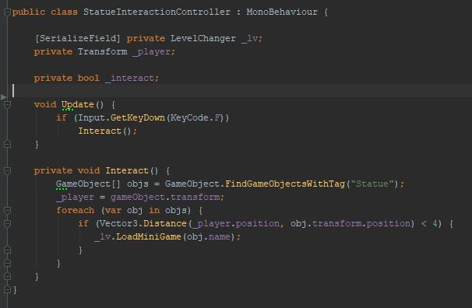

Example 02: LevelChanger

* This class is responsible for loading levels and minigames
* Method FadeToLevel takes build index of scene to load as argument
* Before loading next scene, animation to fadeout is triggered
* Minigame to load is determined by the statue name

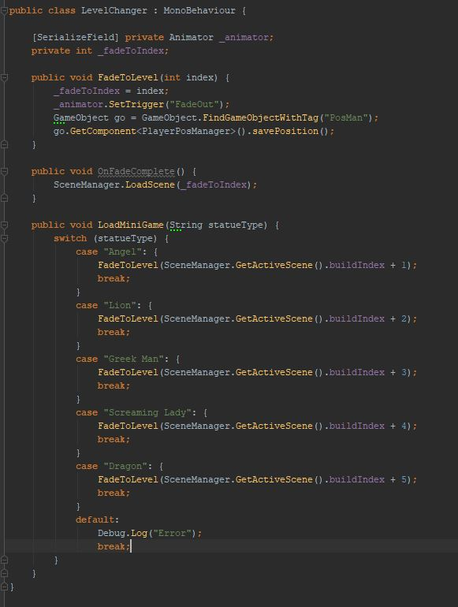

Example 03: PlayerPositionManager

* This class is responsible for saving and loading players position when minigames are loaded
* Position is stored as Vector3 and saved from LevelChanger when next scene is loaded
* When Level scene is loaded, method to load position is triggered

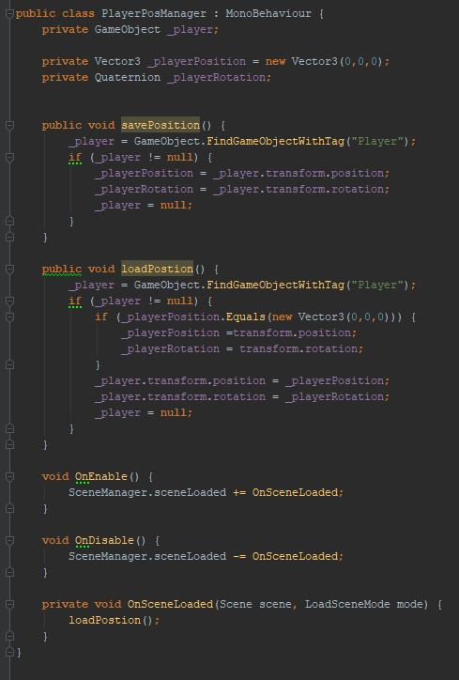

Example 04: MinigameWinController

* Each minigame has either WinController, or contains Win method somewhere in its main script
* Method Win grants a fire point to the player and then loads level from which minigame has been loaded

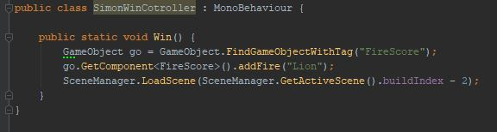

Example 05: TempleFireController

* This class is responsible for checking whether the player has collected 5, or more Fire points
* When sufficient amount of point is collected, the lights and a flame in next level temple are activated, which allows player to enter and finish the level

