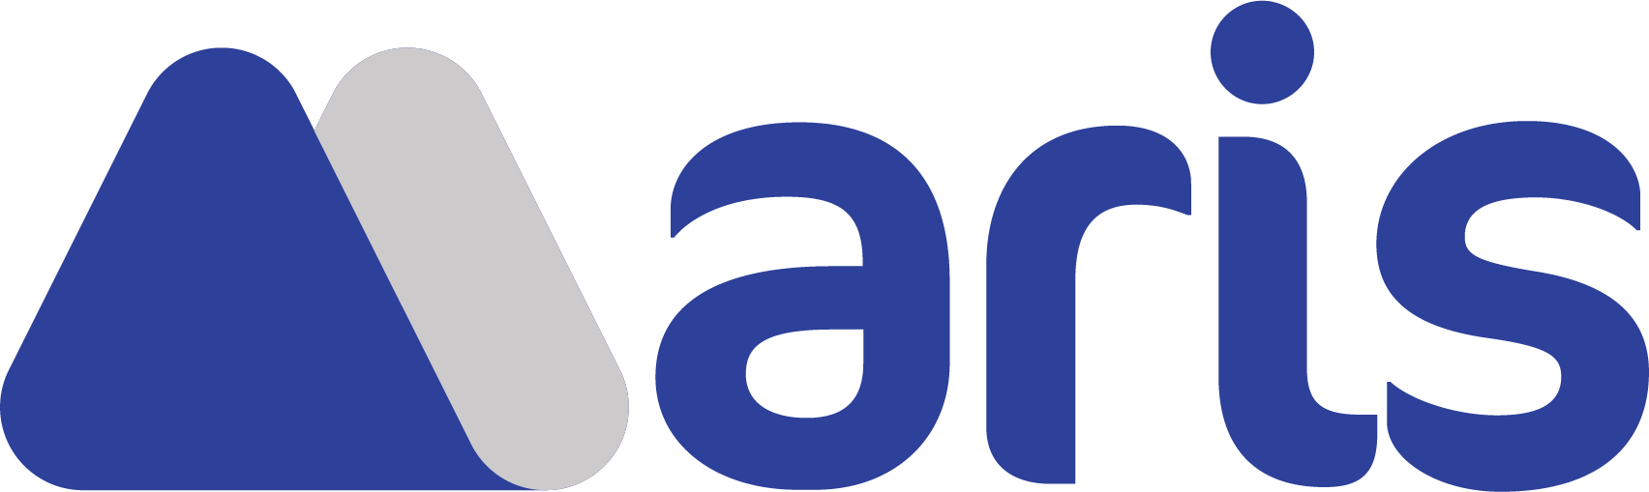
MAREK SAGAN • PROJECT MANAGER
Email (preferred) marek.sagan@protonmail.com
Phone 0048737878782
Address Äussere Weberstr 57, 02763 Zittau, Germany, EU
Availability Immediate

Hands on Project Management and web development experience. Self driven, dedicated and problem solving professional. Passionate and creative about software.

SKILLS
Skills (years of experience) (4) Agile Development, Lean Methodology, Teamwork, Networking, Software Engineering, Communication Skills, Open Source, Web Technologies, Microsoft Office, Microsoft Excel, Microsoft Teams, Information Technology / IT, Artificial Intelligence / AI, Data Science, Data Sources, Google Cloud, Google App Engine, Alibaba Cloud, Ethereum blockchain, Analytical Skills, Attention To Detail, Multicultural Understanding, Organizational Skills, Time Management Skills, Presentation Skills, Verbal Communication Skills, Interpersonal Skills, Collaboration, Negotiation Skills, Market Research, Search Engine Optimization / SEO
(3) Microsoft Dynamics CRM, Atlassian JIRA, Atlassian Confluence, Unified Modelling Language / UML, Product Design & Architecture, Leadership Skills, Kanban, Data Analytics, Ability To Work Independently, Ability to Prioritize, Mentorship Skills, Coaching Skills, Operations Research, Distributed Computing, Distributed Systems, Web Applications
(2) Domain Driven Design / DDD, Project Management Skills, Product Management Skills / PM, Quality Assurance / QA, Quality Engineering, Technical Support, User Experience / UX, Recruitment, Software Development Life Cycle / SDLC Methodologies, Technical Design, Product Development
Certification Professional Scrum Master I, Prince2 Foundation, Learn JIRA with Real-World Examples, TOEFL, TestDaF
Spoken languages English (proficient), German (proficient), Czech (proficient), Polish (native)

PERSONAL DATA
Citizenship Poland (European Union)
Interests Sports, health, climate change

WORK EXPERIENCE

06/2022 – 03/2023 Circle K – Warsaw, Poland
- Supporting the management in Scrum implementation
- Close and strong cooperation with diverse multinational teams and overcoming outsourcing challenges such as complex bug fixing and missing documentation within available business capabilities

07/2021 – 06/2022 WorkFusion – Warsaw, Poland
- Developing Proof of Concepts and working with multiple teams on advanced domain systems implementation, including the security team and vulnerabilities heuristics
- Decoupling micro services to promote good separation of concerns in order to meet client expectations

12/2019 – 04/2020 E.STRADIS GmbH – Augsburg, Germany
- Involved in building and debugging the features with focus on the analytics and project management side according to the industry regulations and business requirements / standards compliance
- Communication and proactively follow up on the solutions, maintaining partnerships with the management / customer representatives from the finance sector
- Writing and updating technical documentation for improved customer experience
- Participating in the digital transformation innovation of the company
- Remote work experience in a dynamic environment

EDUCATION
2023 – 2025 The Power Business School
Master of Business Administration, MBA
2021 – 2022 Warsaw School of Computer Science
IT Project Management, Postgraduate Studies
2014 – 2018 Warsaw School of Computer Science
Computer Science, Bachelor of Science

