1. Configure job
2. 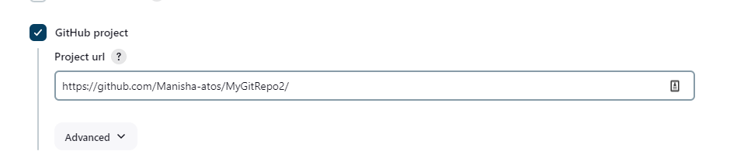

1. Configure github

To communicate the commit to Jenkins server

Github—settings—webhook—add webhook

To publish local host over internet so that it will be accessible by Github use application NGRok

[ngrok | Unified Application Delivery Platform for Developers](https://ngrok.com/)

download the setup

Once download start ngrok

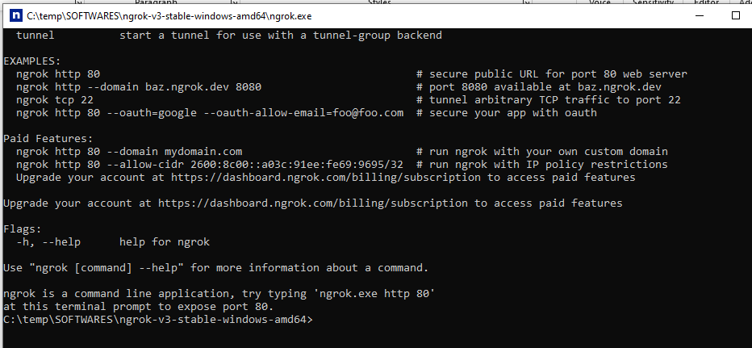

Create a Authtoken

ngrok config add-authtoken 2fG4v6NiWoLig8ZowaCE9JXJsKc_6DfP266uyqBq7csCpzs54

Expose the local host

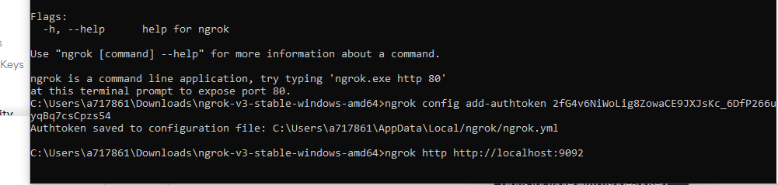

ngrok http http://localhost:9092

For execution copy forwarding link to payload

https://35f6-103-113-136-46.ngrok-free.app/github-webhook/