**Pizza Sales**

The aim of the project is to provide insights into customer behaviour and preferences. This project will inform the business owner about which days are most profitable and whether there are any seasonal or monthly trends. The insights gained will support business decision-making and improve customer satisfaction. Identifying the most popular pizzas will also assist with planning and managing stock more effectively.

**Dataset**

Below is a table of the original dataset received with detailed information about every column.

|  |  |  |
| --- | --- | --- |
| **Column Name** | **Data Type** | **Description** |
| pizza_id | float | A unique identifier assigned to each distinct pizza variant available for ordering. |
| order_id | float | A unique identifier for each order made, which links to multiple pizzas. |
| pizza_name_id | nvarchar(50) | An identifier linking to a specific name of the pizza. |
| quantity | float | The number of units of a specific pizza variant ordered within an order. |
| order_date | date | The date when the order was placed. |
| order_time | time(7) | The time when the order was placed. |
| unit_price | float | The cost of a single unit of the specific pizza variant. |
| total_price | float | The aggregated cost of all units of a specific pizza variant in an order. |
| pizza_size | nvarchar(50) | Represents the size of the pizza (e.g., small, medium, large). |
| pizza_category | nvarchar(50) | Indicates the category of the pizza, such as vegetarian, non-vegetarian, etc. |
| pizza_ingredients | nvarchar(100) | Provides a list or description of the ingredients used in the pizza. |
| pizza_name | nvarchar(50) | Specifies the name of the specific pizza variant ordered. |

**KPI’s**:

Analysis of the key performance indicators give us an insight on how the business is doing.

* Total Revenue
* Total Orders
* Total Pizzas Sold
* Average Order Value
* Average Pizzas per Order

**Analysis Methods:**

* SQL
* Power BI

**SQL:**

* Total Revenue

|  |  |
| --- | --- |
| SELECT  SUM(total_price)  AS  Total_Revenue  FROM  pizza_sales_converted; |  |

* Total Orders

|  |  |
| --- | --- |
| SELECT  COUNT(DISTINCT(order_id))  AS  Total_Orders  FROM  pizza_sales_converted; |  |

* Total Pizzas Sold

|  |  |
| --- | --- |
| SELECT  SUM(quantity)  AS  Total_pizza_sold  FROM  pizza_sales_converted; |  |

* Average Order Value

|  |  |
| --- | --- |
| SELECT  (SUM(total_price) / COUNT(DISTINCT order_id))  AS  Avg_order_Value  FROM  pizza_sales_converted; |  |

* Average Pizzas per Order

|  |  |
| --- | --- |
| SELECT  ROUND(CAST(SUM(quantity) AS FLOAT) / CAST(COUNT(DISTINCT order_id) AS FLOAT),2)  AS  Avg_Pizzas_per_order  FROM  pizza_sales_converted; |  |

* Total Orders by Month

|  |  |
| --- | --- |
| SELECT  DATENAME(MM, order_date) AS order_month,  COUNT(DISTINCT(order_id)) AS total_orders  FROM  pizza_sales_converted  GROUP BY  DATENAME(MM, order_date)  ORDER BY  total_orders DESC |  |
|  |  |

* Revenue of Orders by Month

|  |  |
| --- | --- |
| SELECT  DATENAME(MM, order_date) AS order_month,  ROUND(SUM(total_price),2) AS Total_Revenue  FROM  pizza_sales_converted  GROUP BY  DATENAME(MM, order_date)  ORDER BY  Total_Revenue DESC |  |
|  |  |

* Total Pizzas Orders per Weekday

|  |  |
| --- | --- |
| SELECT  DATENAME(W, order_date) AS order_day,  COUNT(DISTINCT(order_id)) AS total_orders  FROM  pizza_sales_converted  GROUP BY  DATENAME(W, order_date)  ORDER BY  total_orders DESC; |  |
|  |  |

* Total Pizzas Orders per Hour

|  |  |
| --- | --- |
| SELECT  DATENAME(hh, order_time) AS order_time,  COUNT(DISTINCT(order_id)) AS total_orders  FROM  pizza_sales_converted  GROUP BY  DATENAME(hh, order_time)  ORDER BY  total_orders DESC; |  |

* Total Orders per Pizza Category

|  |  |
| --- | --- |
| SELECT  pizza_category AS category,  COUNT(DISTINCT(order_id)) AS total_orders  FROM  pizza_sales_converted  GROUP BY  pizza_category  ORDER BY  total_orders DESC |  |
|  |  |

* Quantity of Pizzas sold per Category

|  |  |
| --- | --- |
| SELECT  pizza_category AS Category,  SUM(quantity) AS Total_quantity_sold  FROM  pizza_sales_converted  GROUP BY  pizza_category  ORDER BY  Total_quantity_sold DESC |  |

* Pizza popularity by size

|  |  |
| --- | --- |
| SELECT  pizza_size AS Pizza_Size,  COUNT(quantity) AS Quantity  FROM  pizza_sales_converted  GROUP BY  Pizza_Size  ORDER BY  Quantity DESC |  |

* Pizza popularity by Revenue

|  |  |
| --- | --- |
| SELECT  pizza_category,  CAST(SUM(total_price) AS DECIMAL(10,2)) as Total_Revenue,  CAST(SUM(total_price) * 100 / (SELECT SUM(total_price) from pizza_sales_converted) AS DECIMAL(10,2)) AS Percentage  FROM  pizza_sales_converted  GROUP BY  pizza_category |  |

|  |  |
| --- | --- |
| SELECT  Top 5  pizza_name,  SUM(total_price) AS Total_Revenue  FROM  pizza_sales_converted  GROUP BY  pizza_name  ORDER BY  Total_Revenue DESC |  |

* Top 5 Pizzas by Revenue
* Bottom 5 Pizzas by Revenue

|  |  |
| --- | --- |
| SELECT  Top 5  pizza_name,  ROUND(SUM(total_price),2) AS Total_Revenue  FROM  pizza_sales_converted  GROUP BY  pizza_name  ORDER BY  Total_Revenue ASC |  |

* Top 5 Pizzas by Quantity

|  |  |
| --- | --- |
| SELECT  Top 5  pizza_name,  SUM(quantity) AS Quantity  FROM  pizza_sales_converted  GROUP BY  pizza_name  ORDER BY  Quantity DESC |  |

* Bottom 5 Pizzas by Quantity

|  |  |
| --- | --- |
| SELECT  Top 5  pizza_name,  SUM(quantity) AS Quantity  FROM  pizza_sales_converted  GROUP BY  pizza_name  ORDER BY  Quantity ASC |  |

* Top 5 Pizzas by Total Orders

|  |  |
| --- | --- |
| SELECT  Top 5  pizza_name,  SUM(DISTINCT(order_id)) AS Total_orders  FROM  pizza_sales_converted  GROUP BY  pizza_name  ORDER BY  Total_orders DESC |  |

* Bottom 5 Pizzas by Total Orders

|  |  |
| --- | --- |
| SELECT  Top 5  pizza_name,  SUM(DISTINCT(order_id)) AS Total_orders  FROM  pizza_sales_converted  GROUP BY  pizza_name  ORDER BY  Total_orders ASC |  |

**Visualizations:**

The pizza sales database can be found at:

<https://app.powerbi.com/view?r=eyJrIjoiYzE2Mzg1NGMtZWFhZS00YzAxLTkyMzEtYjRmYzk0MjJlZjc2IiwidCI6ImNhOWE4YjhjLTNlYTMtNDc5OS1hNDNlLTU1MTAzOThlN2EzYiIsImMiOjh9>

Power BI is used to make an interactive dashboard with an overview tab and a performance tab. Each tab gives the KPI’s so that every selection clearly shows the influence on the KPI’s.

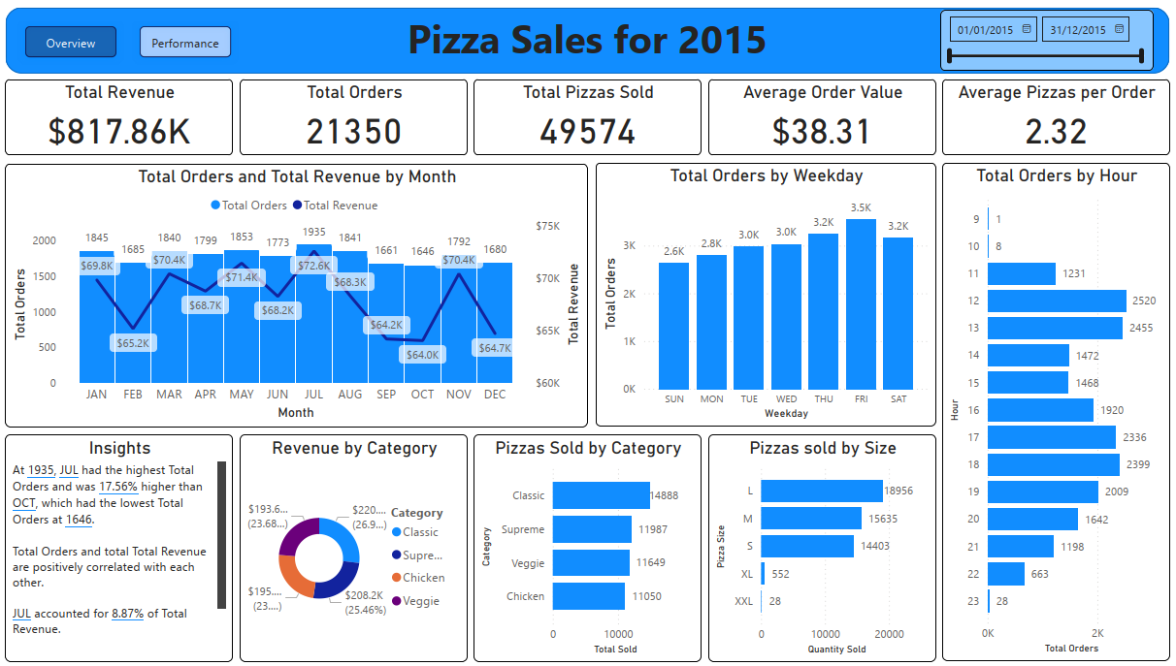

The second performance tab shows the 5 best and worst performing pizzas by revenue, quantity and total orders.

