Broken Crystals – GraphiQL / GraphQL Introspection Assessment

GraphQL Schema Introspection

1. Target Environment
Application: Broken Crystals
Deployment: Docker
URL: http://localhost:3000
Tools: Burp Suite Community Edition, Firefox, GraphiQL

2. Attack Name
Exposed GraphQL Schema Introspection

3. Identification
During testing, the GraphiQL interface was accessed and a GraphQL introspection query was submitted. The query used the special __schema field to request the available schema types and their field names. The server returned HTTP 200 OK and a structured JSON response containing schema information, confirming that introspection was enabled for the tested endpoint.
The returned data included a type named Testimonial and exposed fields including name, title, and message. This confirms that the endpoint was not simply accepting the syntax; it was processing the introspection request and disclosing information about the application's GraphQL schema.

4. Tools Used
• Burp Suite Community Edition
• Firefox Browser
• GraphiQL
• Broken Crystals

5. Detailed Testing Process

Step 1 – Open the GraphiQL Interface
The GraphiQL interface available in the Broken Crystals application was opened for testing. GraphiQL provides a browser-based editor for submitting GraphQL operations and displaying the server response. The initial test shown in the evidence contains an incomplete mutation operation, which results in a GraphQL parser error.
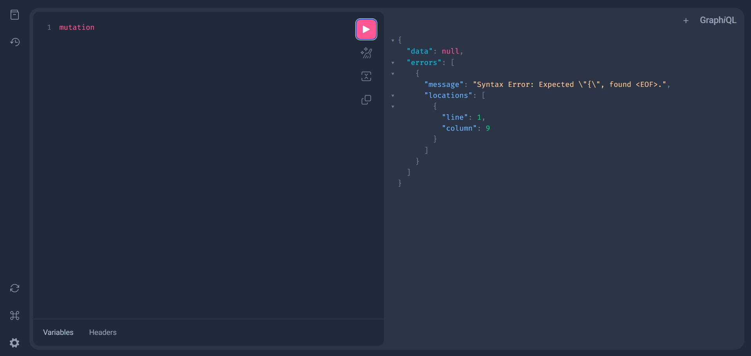
Step 1 – GraphiQL Interface and Initial GraphQL Parser Response

Step 2 – Submit the Introspection Query
The GraphQL editor was then used to submit the introspection query. The query begins with __schema, which is GraphQL's built-in schema introspection field. Inside __schema, the types selection requests the schema's types, while name requests the name of each type. The nested fields selection then requests the fields belonging to each type, and the final name requests the name of each field.
In simple terms, the query asks the server: “Tell me what types exist in your GraphQL schema, and for each type, tell me the names of its fields.” It is therefore a schema-discovery request rather than a normal request for a particular application record.
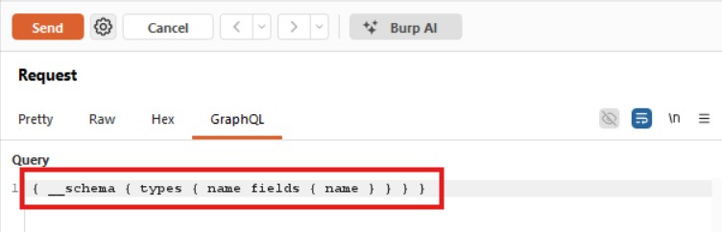
Step 2 – GraphQL Introspection Query Captured in Burp Suite

Step 3 – Capture the GraphQL Request in Burp Suite
The request was captured in Burp Suite and sent to the /graphql endpoint using an HTTP POST request. The request body contains JSON, with the GraphQL operation stored in the query property. This is important when reviewing the request in Burp because the GraphQL query is contained inside the JSON body rather than being supplied as a normal URL parameter.
The captured request demonstrates that the application accepts the introspection operation through its GraphQL API. The request can therefore be independently reviewed and replayed during a penetration test to confirm the server-side behaviour.
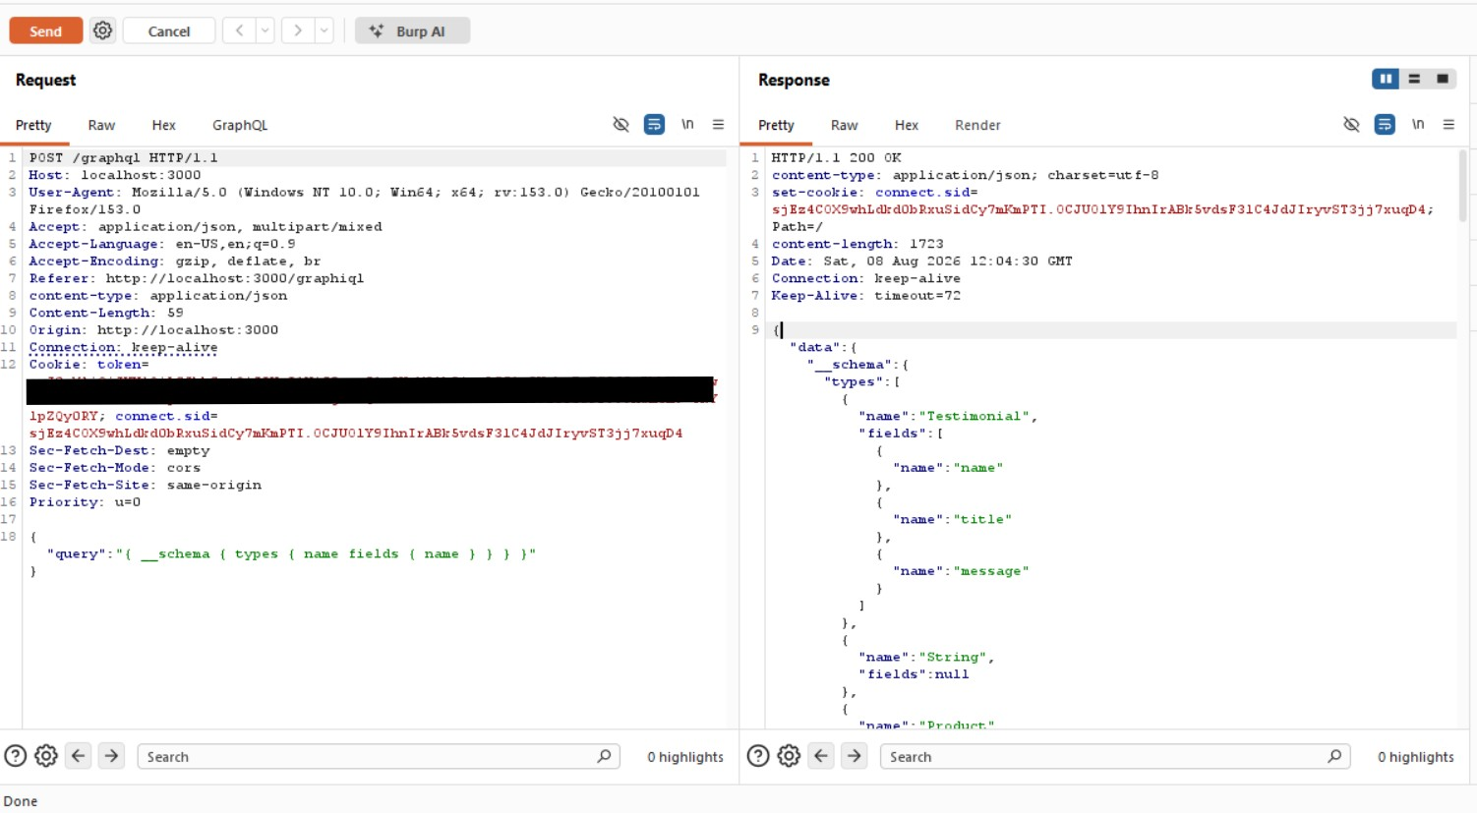
Step 3 – Burp Suite Request and Introspection Response

Step 4 – Analyze the Introspection Response
The response shown in Burp Suite returns HTTP/1.1 200 OK and contains JSON data under the data object. Within that object, the __schema result contains a types array. The response shown in the evidence includes a Testimonial type and lists fields named name, title, and message.
This response is the key evidence for the finding. It demonstrates that the server processed the introspection request and returned information describing the GraphQL schema. The tester can use this information to understand which application objects and fields are exposed through the GraphQL API.

6. Payload Explanation
The introspection query is structured from the outside inward. The outer braces define the GraphQL selection set. The __schema field tells GraphQL that the request is asking for information about the schema itself rather than ordinary business data.
The types section asks the server to return the collection of types defined in the schema. The first name field then asks for the name of each type. The fields section goes one level deeper and asks what fields belong to each returned type. Finally, the nested name asks for the names of those fields.
For example, when the response contains a type called Testimonial and fields called name, title, and message, the response is effectively describing the structure of that GraphQL object. The query does not request the actual testimonial values; it requests the names of the schema elements.

7. Observations
The Broken Crystals GraphQL endpoint accepted the introspection query and returned schema information. The response disclosed type and field names, including the Testimonial type with the fields name, title, and message.
The GraphiQL interface also provided GraphQL-specific parser feedback when an incomplete operation was submitted. Together, the screenshots demonstrate that the GraphQL service is active, reachable, and capable of processing schema introspection requests.

8. Affected Endpoint
POST /graphql
Content-Type: application/json
GraphQL query: { __schema { types { name fields { name } } } }

9. Impact
Exposed schema introspection can reduce the effort required to map a GraphQL API. An unauthorized client may be able to discover object types and field names that would otherwise require manual enumeration or application analysis.
The practical impact depends on how the GraphQL endpoint is deployed and protected. Introspection by itself does not bypass authentication or authorization, and the supplied evidence does not demonstrate access to protected data solely because introspection is enabled. The demonstrated issue is the disclosure of GraphQL schema structure to the tested client.

10. Remediation
If detailed schema introspection is not required for production users, restrict or disable introspection for untrusted clients in the production environment. Development environments can retain GraphiQL and introspection where they are needed for development and testing.
Authentication and authorization should still be enforced for every sensitive GraphQL query and mutation. Disabling introspection should not be treated as a replacement for access control, because a client may still interact with known GraphQL operations if those operations are otherwise reachable.
Where introspection must remain available, consider restricting it to authenticated or trusted users, internal environments, or administrative tooling. Logging and monitoring GraphQL requests can also help identify unexpected schema-enumeration activity.

11. Conclusion
The assessment confirms that the Broken Crystals application exposes GraphQL schema introspection through the /graphql endpoint. The supplied introspection query successfully returned schema information, including the Testimonial type and its name, title, and message fields.
The Burp Suite evidence confirms that the request was transmitted to the GraphQL endpoint and that the server returned HTTP 200 OK with structured schema data. This demonstrates that an authorized tester can enumerate at least part of the GraphQL schema through introspection.
The appropriate remediation is to restrict or disable unnecessary introspection in production while maintaining strong authentication and authorization controls over GraphQL operations. The risk should be evaluated according to the application's deployment model and whether the disclosed schema contains sensitive or privileged functionality.

