Broken Crystals – ID Enumeration and Broken Level Function Authorization Assessment

ID Enumeration and Broken Level Function Authorization (BLFA)

1. Target Environment
Application: Broken Crystals
Deployment: Docker
URL: http://localhost:3000
Tools: Burp Suite Community Edition, Firefox Browser, Docker Desktop, Broken Crystals

2. Attack Name
ID Enumeration and Broken Level Function Authorization (BLFA)

3. About the Attack
ID Enumeration occurs when an application exposes predictable object identifiers and allows a user to request another user's object by changing the identifier in the URL.
Broken Level Function Authorization (BLFA) occurs when the server does not correctly enforce authorization checks for the requested object or function. A user may therefore access data that should be restricted to another account.
In this assessment, the user-profile API accepts a user ID in the URL. The supplied requests show that changing the identifier changes which user's profile is returned, demonstrating insufficient object-level authorization.

4. Identification
The issue was identified while testing the Broken Crystals user profile functionality. Burp Suite HTTP History showed requests to the user API, including GET /api/users/id/1 and requests using another identifier.
The responses returned profile information for the requested IDs. The supplied evidence shows ID 1 returning the administrator profile and ID 2 returning the regular user profile. This demonstrates that predictable IDs can be used to enumerate profiles and that authorization is not sufficiently enforced.

5. Tools Used
- Burp Suite Community Edition
- Firefox Browser
- Docker Desktop
- Broken Crystals

6. Detailed Exploitation Process

Step 1 – Open the User Profile
Log into Broken Crystals and open the user profile page. The profile interface provides the normal application context in which the user API is called.
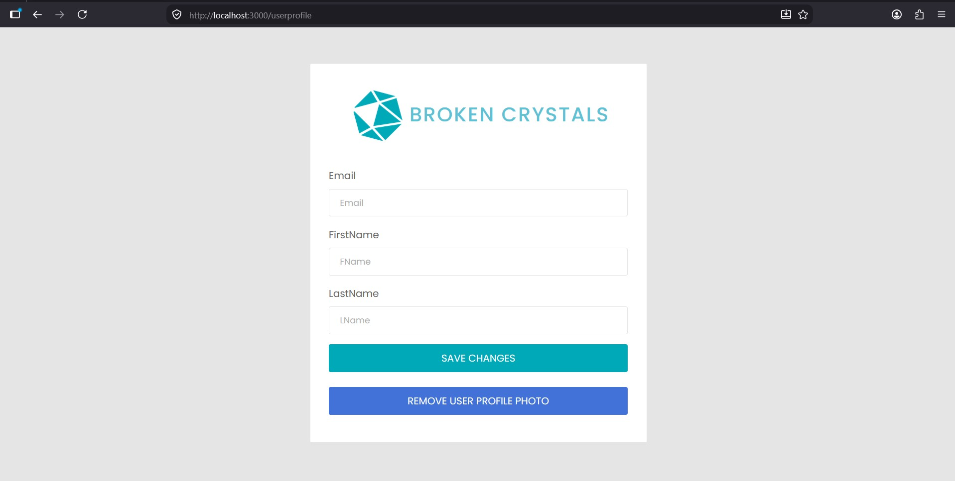
Step 1 – Broken Crystals user profile page

Step 2 – Identify the User-ID Endpoint
Use Burp Suite HTTP History to observe the request made by the application. The captured request uses a user identifier in the URL:
GET /api/users/id/1 HTTP/1.1
Because the identifier is visible and predictable, it can be tested for object-level authorization.
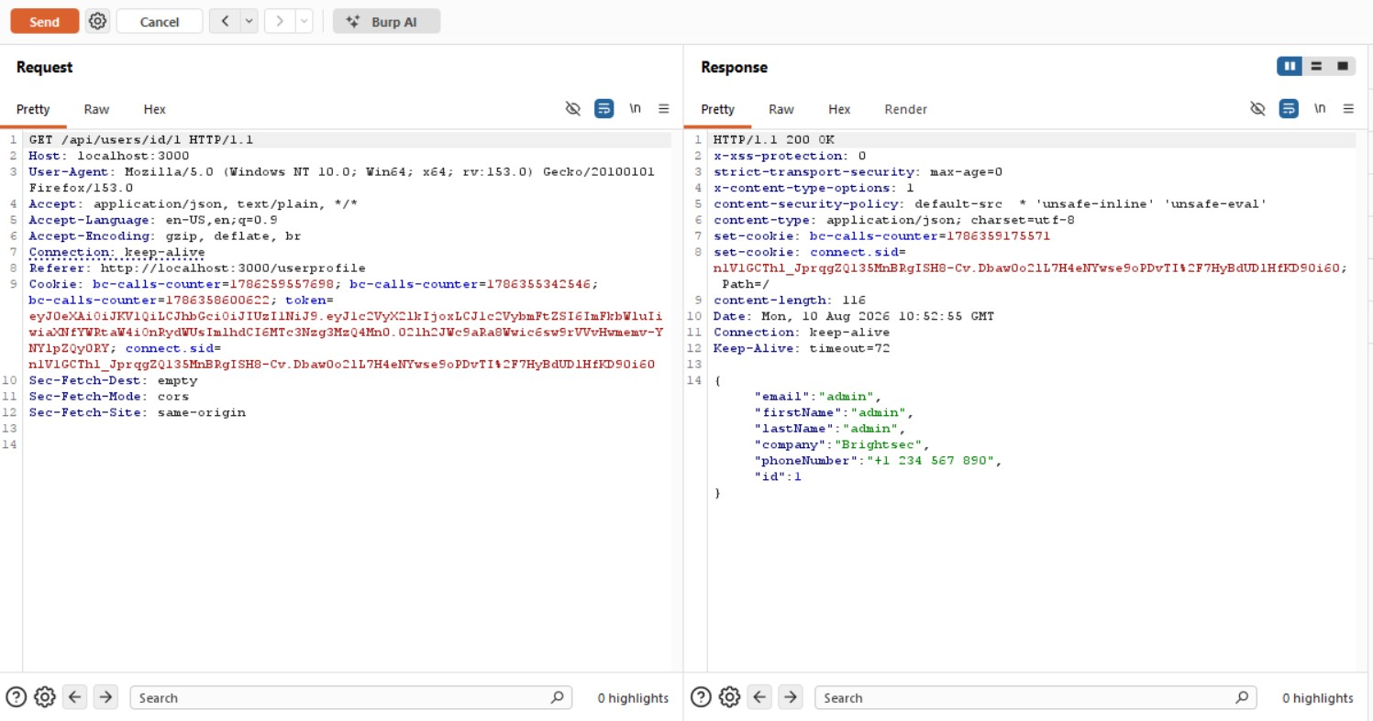
Step 2 – Burp Suite request for a user ID

Step 3 – Change the User ID
Send the request to Burp Suite Repeater and change the ID in the URL. The test compares the response for one identifier with the response for another identifier.
Changing the requested identifier from 1 to 2 causes the server to return a different user's profile.
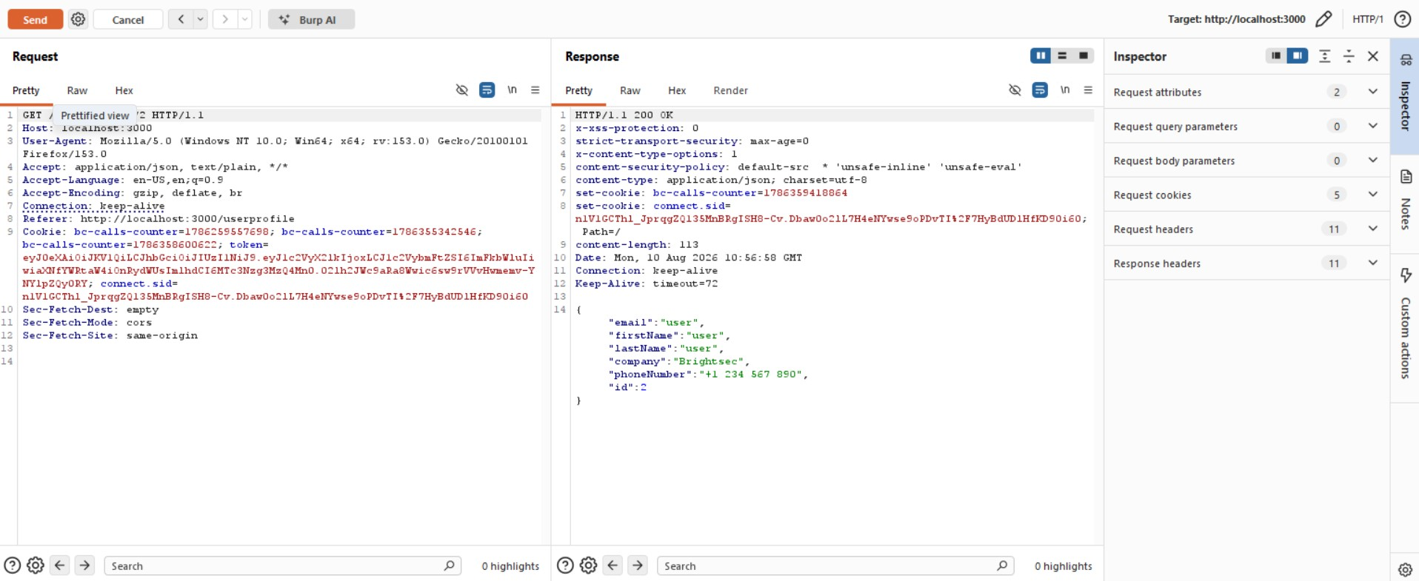
Step 3 – Response showing a different user profile

Step 4 – Verify Through HTTP History
Review Burp Suite HTTP History to confirm the requests generated during testing. The highlighted entries show requests to the user API with different identifiers, demonstrating that the resource ID is directly controllable by the client.
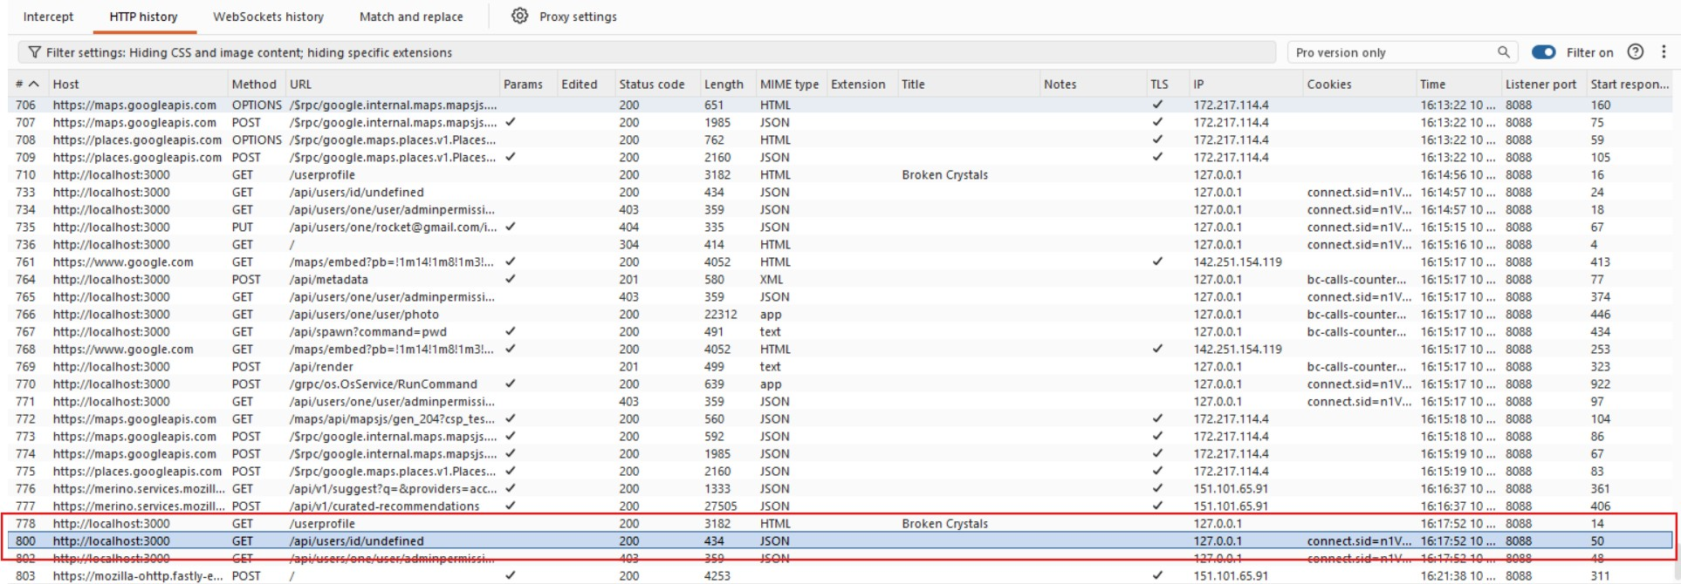
Step 4 – Burp Suite HTTP History showing user API requests

Parameter Explanation
`/api/users/id/1` – The URL identifies the user object being requested. The identifier is predictable and can be changed by the client.
`1` – The supplied evidence shows this identifier returning the administrator profile.
`2` – The supplied evidence shows this identifier returning the regular user profile.
HTTP 200 OK – The server successfully returned the requested profile instead of denying access.
Profile data – The response exposes fields such as email, name, company and phone number for the requested user.

7. Observations
The user identifier is exposed in the request URL and can be modified by the client.
Different identifiers return different user profiles. The supplied evidence shows ID 1 returning an administrator profile and ID 2 returning a regular user profile.
The successful HTTP 200 responses indicate insufficient object-level authorization.

8. Affected Endpoint
GET /api/users/id/{id}
Parameter: id
Function: Retrieve a user profile

9. Impact
An attacker who can enumerate predictable IDs may access profile information belonging to other users.
The supplied evidence directly demonstrates unauthorized profile retrieval. Broader modification privileges are not established by these screenshots.

10. Remediation
Enforce Object-Level Authorization: Verify on every request that the authenticated user is authorized to access the requested user object.
Do Not Trust the URL ID: Treat the supplied identifier as untrusted input and perform an authorization check before returning the record.
Use the Authenticated Identity: Where appropriate, derive the target user from the authenticated session instead of allowing arbitrary user IDs.
Use Non-Predictable Identifiers Carefully: UUIDs can reduce simple enumeration, but they must not replace authorization checks.
Test Authorization Boundaries: Test access to other users' profiles and functions with different identifiers and roles.

11. Conclusion
The assessment demonstrates an ID Enumeration and Broken Level Function Authorization issue in the Broken Crystals user-profile API. The client can control the user ID in the request URL, and the server returns the profile associated with the supplied identifier.
The supplied screenshots show the testing flow from the user-profile page through Burp Suite request analysis and response comparison. Server-side object-level authorization should prevent an authenticated user from retrieving another user's profile merely by changing the ID.

