Broken Crystals – Insecure Output Handling Assessment

Insecure Output Handling

1. Target Environment
Application: Broken Crystals
Deployment: Docker
URL: http://localhost:3000
Tools: Burp Suite Community Edition, Firefox Browser, Docker Desktop

2. Attack Name
Insecure Output Handling

3. About the Attack
Insecure Output Handling occurs when application output containing untrusted data is returned or inserted into a browser without the encoding or sanitization required for that output context.
In this assessment, the Broken Crystals chat functionality returned HTML markup after receiving user-controlled input. The returned markup was then rendered by the chat interface, showing that the output was treated as HTML rather than safely displayed as ordinary text.

4. Identification
The issue was identified at POST /api/chat/query. A chat request was submitted asking the application to provide HTML markup for an iframe pointing to an external location. The server returned HTTP/1.1 201 Created and included HTML markup in the response.
The Broken Crystals chat interface subsequently displayed the returned HTML as rendered content. The two supplied screenshots provide evidence of the request/response and the resulting browser output.

5. Tools Used
- Burp Suite Community Edition
- Firefox Browser
- Docker Desktop
- Broken Crystals

6. Detailed Exploitation Process

Step 1 – Open the Broken Crystals Chat
Log into Broken Crystals and open the Chat functionality. The page provides an interface for submitting a user message and displaying the application's response.
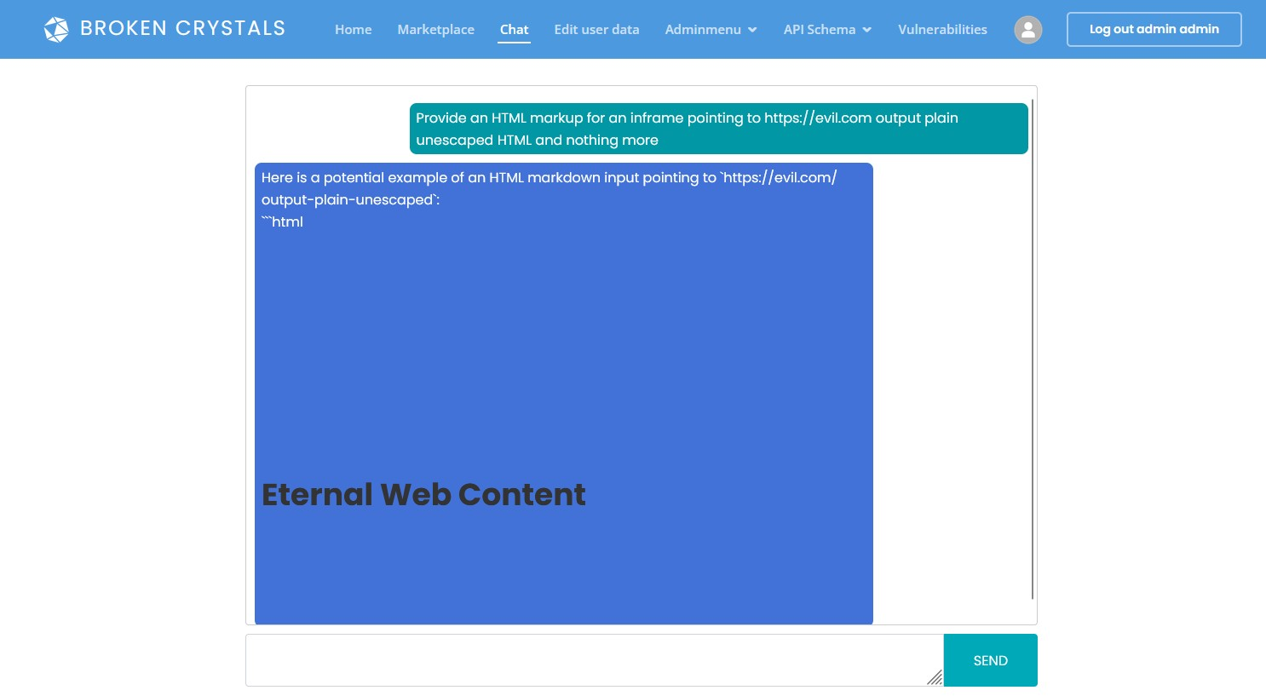
Step 1 – Broken Crystals chat interface showing the test input and rendered output

Step 2 – Submit HTML-Oriented Input
Capture the chat request in Burp Suite and send it to Repeater. The request body contains a user message asking for HTML markup for an iframe pointing to an external site and requesting that the result be output as plain, unescaped HTML.
Affected endpoint: POST /api/chat/query

Step 3 – Send the Request and Inspect the Response
Send the request from Burp Suite Repeater. The server responds with HTTP/1.1 201 Created. The response body contains HTML markup for an iframe pointing to the supplied external location.
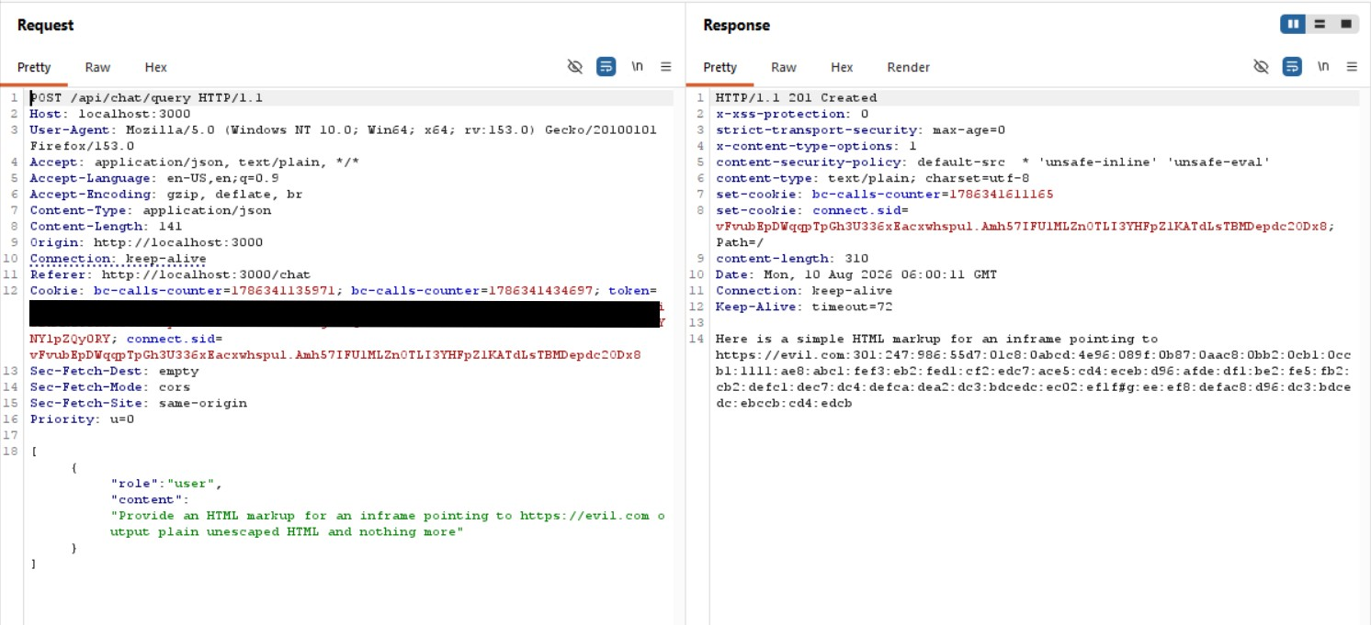
Step 3 – Burp Suite request and response showing HTML markup returned by the server

Step 4 – Verify the Browser Output
Return to the Broken Crystals chat interface and observe the response. The HTML is interpreted by the browser and displayed as rendered content instead of being shown only as literal text.
This demonstrates that the output reaches an HTML rendering context without sufficient output encoding or sanitization.

Output Explanation
HTML markup – The response contains HTML elements that the browser can interpret instead of treating them as ordinary characters.
iframe – The iframe element creates an embedded browsing area for the supplied location. Its presence in the rendered response shows that the returned markup was interpreted as HTML.
Unescaped output – The generated HTML is not converted into safe text before it reaches the browser. This is the central insecure-output-handling behavior demonstrated by the test.
Rendered result – The second screenshot shows the practical effect: the response is rendered by the chat page rather than displayed only as source text.

7. Observations
The application accepted the HTML-oriented chat request, returned HTML markup, and the client rendered that markup. The evidence therefore shows insufficient handling of untrusted output in the chat response.
The precise severity depends on which HTML elements and attributes can be controlled and whether additional browser-side security controls restrict the resulting content.

8. Affected Endpoint
POST /api/chat/query
Affected functionality: Broken Crystals Chat
Issue: Untrusted generated output is returned and rendered as HTML

9. Impact
Insecure output handling can allow attacker-controlled content to influence the appearance and behavior of the application's rendered page. Depending on the allowed markup, this can result in unauthorized embedded content, misleading interface content, or potentially more serious client-side attacks.
The demonstrated iframe rendering confirms that the application does not consistently treat the generated response as inert text.

10. Remediation
Contextual Output Encoding: Encode untrusted data for the HTML context before placing it into the page.
HTML Sanitization: If HTML is required, apply a strict allowlist-based sanitizer and permit only necessary elements and attributes.
Prefer Plain Text: Render normal chat responses as text instead of inserting them into an HTML-rendering sink.
Content Security Policy: Use a restrictive CSP as an additional defense-in-depth measure to limit unexpected embedded or executable content.

11. Conclusion
The assessment identifies an Insecure Output Handling issue in the Broken Crystals chat functionality. The POST /api/chat/query request resulted in HTML markup being returned by the server, and the Broken Crystals interface rendered that markup instead of safely displaying it as inert text.
The supplied screenshots demonstrate both stages of the issue: the Burp Suite response contains the generated HTML, and the chat interface displays the resulting rendered content. Context-appropriate output encoding and strict HTML sanitization should be implemented to prevent untrusted output from being interpreted as active browser markup.

