Broken Crystals – SQL Injection Assessment
SQL Injection (Multiple Attack Vectors)
1. Target Environment
Application: Broken Crystals
Deployment: Docker
URL: http://localhost:3000
Tools: Burp Suite Community Edition, Firefox Browser, Docker Desktop
2. Attack Name
SQL Injection – Header-Based Blind SQLi, Schema Data Extraction SQLi and Time-Based Blind SQLi
3. About the Attack
SQL Injection occurs when untrusted input is incorporated into SQL statements without parameterized queries or adequate validation. An attacker can influence the query processed by the database and, depending on database privileges, enumerate schema information, retrieve sensitive records, modify data or invoke database functions. In Broken Crystals, SQL injection was demonstrated through both a custom HTTP header and a query parameter against PostgreSQL.
4. Identification
Requests were captured in Burp Suite, modified and replayed against the application. Three successful validation cases were documented: a Boolean SQL condition through the x-product-name header, schema enumeration through the query parameter of /api/testimonials/count, and a PostgreSQL timing function through the same query parameter. The returned table count and measurable delay provide direct evidence of SQL execution.
5. Tools Used
• Burp Suite Community Edition
• Firefox Browser
• Docker Desktop
• Broken Crystals
6. Detailed Exploitation Process
Step 1 – Header-Based Blind SQL Injection
SQLi Type: Header-Based Blind SQL Injection. This form of SQL Injection places attacker-controlled data in an HTTP header rather than a URL parameter or form field. It is considered blind because the application does not directly expose the full database query or result; successful manipulation is inferred from the application's response behaviour.
The first vulnerable input was the x-product-name custom HTTP header on /api/products/views. During testing, the normal product name was replaced with the Boolean SQL expression ' OR 1=1-- and the request was replayed through Burp Repeater. The purpose of this test was to determine whether the header value was inserted directly into a backend SQL statement.
The single quote attempts to close the application's existing quoted SQL value. OR introduces an alternative condition, while 1=1 is a condition that evaluates as true. The double hyphen begins a SQL comment, which can cause the remaining portion of the original SQL statement to be ignored. If the application safely parameterized the header, these characters would be treated as ordinary data rather than SQL syntax.
The modified request was accepted and returned HTTP 200 OK without a database error. This behaviour demonstrates that the header value reached SQL processing and that the application did not adequately separate untrusted data from SQL instructions.
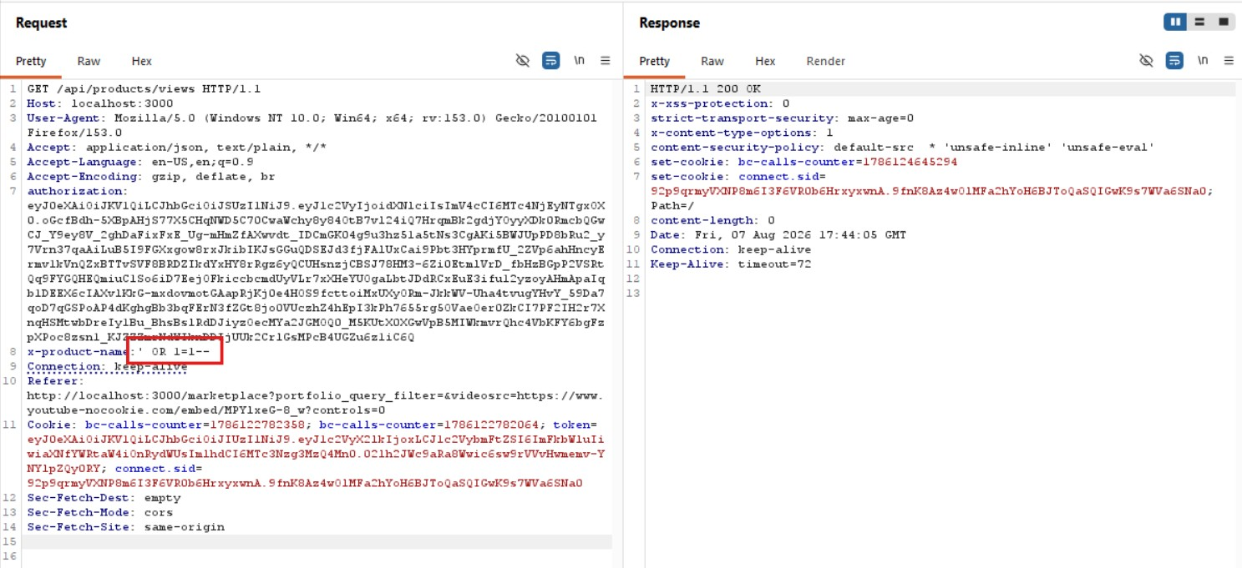
Step 1 – Header-Based Blind SQL Injection
Step 2 – Schema Data Extraction SQL Injection
SQLi Type: Schema Enumeration / Data Extraction SQL Injection. This technique uses an injectable SQL statement to obtain information about the database structure. In this case, PostgreSQL's information_schema.tables metadata view is queried to determine the number of tables accessible to the database account.
The second vulnerability was identified at /api/testimonials/count through the query parameter. The test used a SELECT statement against PostgreSQL's information_schema.tables metadata view. This view contains information about tables accessible to the database user and is commonly used for understanding database structure.
The expression COUNT(table_name) counts the table-name records returned by the metadata view, while AS count gives the resulting value a readable column alias. By requesting this database-generated value through the vulnerable parameter, the test determines whether attacker-controlled SQL is being executed rather than treated as ordinary text.
The application returned the value 214. This is significant because the response contains a result generated by the injected database query rather than a generic application value. The result therefore demonstrates successful schema enumeration and confirms that internal database metadata can be queried through the vulnerable parameter.
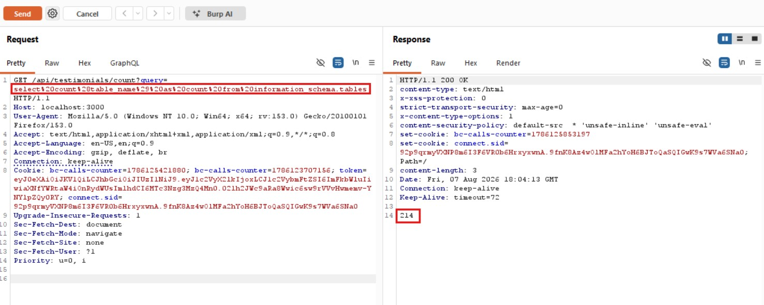
Step 2 – Schema Data Extraction – Burp Request
Step 2 – Schema Data Extraction Result
The same result was observed in the browser, where the application displayed 214. This independently confirms that the database-derived value is returned by the application itself. The result represents the number of table-name entries returned by the PostgreSQL metadata query used during validation.
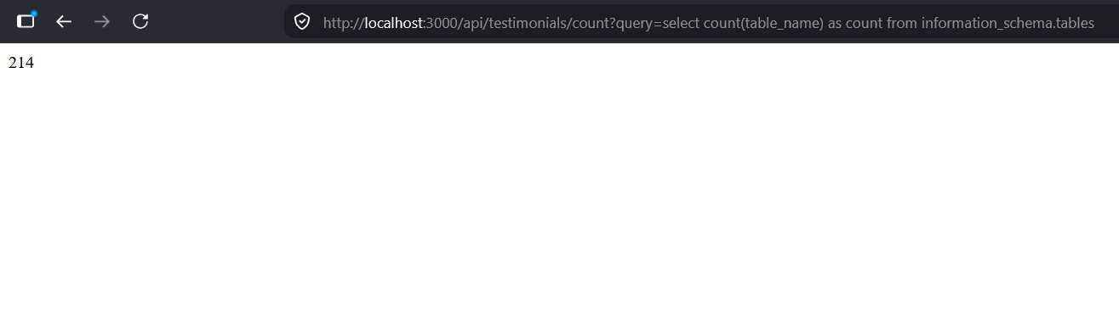
Step 2 – Schema Data Extraction Result

Step 3 – Time-Based Blind SQL Injection
SQLi Type: Time-Based Blind SQL Injection. This technique determines whether injected SQL is executed by measuring a predictable database response delay rather than relying on returned database contents. A consistent delay indicates that the injected database function was evaluated.
The third SQL Injection vector used the /api/testimonials/count query parameter to test whether the PostgreSQL backend would execute a database timing function. The test incorporated PG_SLEEP(10), which instructs PostgreSQL to pause execution for approximately ten seconds.
Time-Based Blind SQL Injection is useful when an application does not expose database errors or query results directly. Instead, the tester observes a predictable difference in response time. If the database executes the injected sleep function, the HTTP request remains pending for the specified interval before the application completes the response.
The captured request showed the deliberate delay followed by HTTP 200 OK. The timing behaviour provides evidence that the database processed the injected PostgreSQL function. This confirms SQL execution even without relying on visible database output.
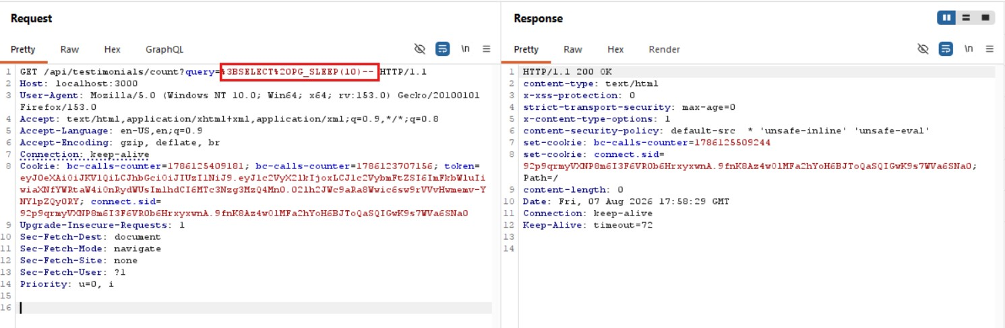
Step 3 – Time-Based Blind SQL Injection
7. Observations
Multiple SQL Injection vectors were confirmed across two endpoints. The x-product-name header influenced SQL processing at /api/products/views, while the query parameter at /api/testimonials/count permitted database metadata access and execution of a timing function. The application therefore does not consistently separate request data from SQL syntax.
8. Affected Endpoints
GET /api/products/views
Header: x-product-name
GET /api/testimonials/count
Parameter: query

9. Impact
Successful SQL Injection can allow an attacker to interact with the database beyond the application's intended functionality. The demonstrated schema enumeration exposes database structure, while the time-based technique allows SQL execution to be confirmed even when results are hidden. Depending on database privileges and other vulnerable queries, the impact may extend to sensitive-data disclosure, unauthorized modification or deletion of records, and database resource exhaustion.
10. Remediation
Use parameterized queries or prepared statements for every database operation and never concatenate request-derived values into SQL syntax. Apply this protection to query parameters, HTTP headers and other user-controlled inputs. Enforce least-privilege database accounts, validate inputs server-side, suppress detailed database errors, monitor suspicious database activity, and retest every affected endpoint after remediation.
11. Conclusion
The assessment confirms multiple SQL Injection vulnerabilities in Broken Crystals. Header-Based Blind SQL Injection was demonstrated through x-product-name at /api/products/views, while /api/testimonials/count allowed schema data extraction and Time-Based Blind SQL Injection. The returned value of 214 and the observed PostgreSQL execution delay provide concrete evidence that attacker-controlled SQL reached the database.
These findings demonstrate inadequate separation between application data and SQL instructions. Implementing parameterized queries throughout the affected code paths, together with strict validation and least-privilege database access, is essential to protect the confidentiality and integrity of application data.

