Broken Crystals – Server-Side Request Forgery (SSRF) Assessment
Server-Side Request Forgery (SSRF)

1. Target Environment
Application: Broken Crystals
Deployment: Docker
Target URL: http://localhost:3000
Testing Tools: Burp Suite Community Edition, Firefox Browser, Swagger UI and Docker Desktop.
The assessment was performed against the locally deployed Broken Crystals application in a controlled testing environment.

2. Attack Name
Server-Side Request Forgery (SSRF)

3. About the Attack
Server-Side Request Forgery (SSRF) is a web application vulnerability that allows an attacker to influence the server into requesting resources on behalf of the application. Instead of restricting requests to trusted file locations, the application processes user-controlled input and attempts to retrieve the supplied resource. If proper validation is missing, an attacker may abuse the server to communicate with internal services or unintended destinations.

4. Identification
During assessment, the Files Controller endpoint exposed through Swagger accepted a user-controlled 'path' parameter. After capturing the request in Burp Suite and modifying the value, the server successfully processed the altered request. This behaviour confirmed that the application trusted user input without sufficiently validating the requested resource.

5. Tools Used
• Burp Suite Community Edition
• Firefox Browser
• Swagger UI
• Docker Desktop

6. Detailed Validation Process

Step 1 – Identify the Vulnerable Endpoint
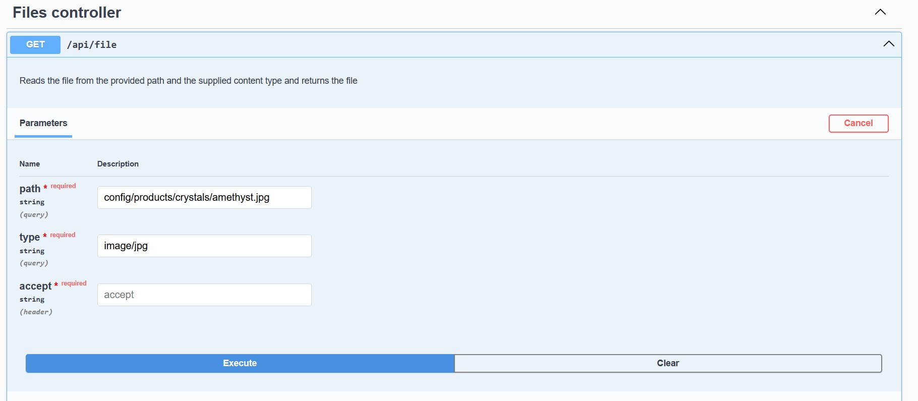
Open the API Swagger interface and locate the Files Controller endpoint. Review the GET /api/file operation and observe that it accepts a user-controlled 'path' parameter together with a content type. Since the server reads files based on this value, the endpoint becomes a suitable candidate for SSRF validation.

Step 2 – Capture the Original Request
Execute the endpoint using the default values and intercept the generated request in Burp Suite. Send the request to Repeater to understand the application's normal behaviour. The request contains the expected file path pointing to a legitimate image within the application.
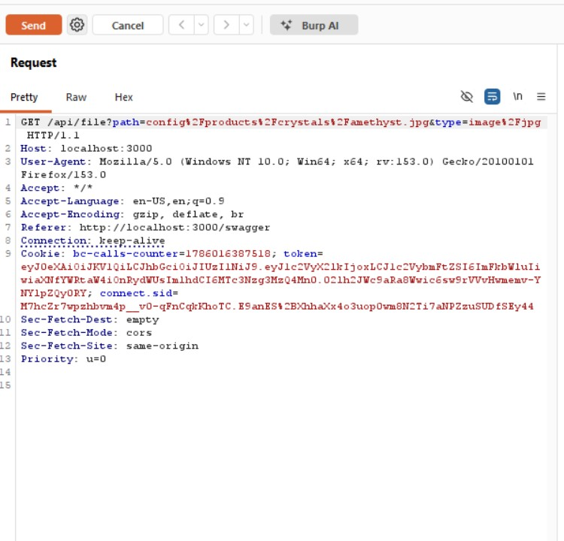

Step 3 – Modify the Request
Within Burp Repeater, replace the original file path parameter with the alternate value used during testing and adjust the content type accordingly. Keeping the remaining request unchanged allows the assessment to determine whether the server validates or blindly trusts the supplied path.
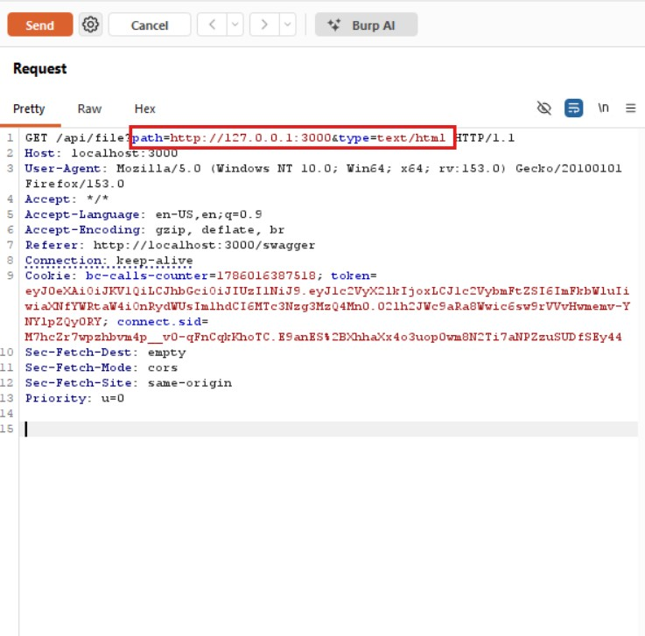

Step 4 – Verify the Server Response
Replay the modified request and inspect the server response. The application returns HTTP/1.1 200 OK, indicating that the modified path was successfully processed. This confirms that the application accepted the manipulated server-side request and demonstrates the SSRF vulnerability in the training application.
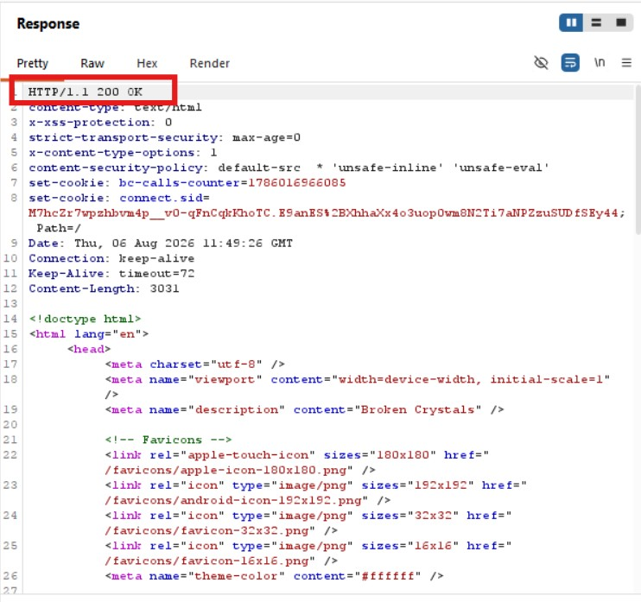

7. Observations
The application accepted user-controlled input for the file retrieval operation and processed the modified request without enforcing sufficient validation. The successful HTTP 200 response demonstrates that server-side resource access can be influenced through the request parameter.

8. Affected Endpoint
GET /api/file (Files Controller)

9. Impact
If exploited in a production environment, SSRF may enable access to internal network services, cloud metadata endpoints, or other restricted resources reachable only by the server. This could lead to information disclosure or provide a foothold for further attacks depending on the deployment architecture.

10. Remediation
Restrict the path parameter to approved resources using a strict allow-list, reject external URLs where unnecessary, validate and normalize user input, and implement outbound network restrictions. Logging and monitoring of server-side requests should also be enabled to detect misuse.

11. Conclusion
The assessment confirms the presence of a Server-Side Request Forgery vulnerability in the Files Controller endpoint. By modifying the user-controlled path parameter and replaying the request through Burp Suite, the application accepted the manipulated input and processed the request successfully. Proper input validation, allow-listing, and server-side access controls are recommended to mitigate this issue.

