Broken Crystals – SSTI & Remote Code Execution Assessment

Server-Side Template Injection (SSTI) leading to Remote Code Execution (RCE)

1. Target Environment
Application: Broken Crystals
Deployment: Docker
URL: http://localhost:3000
Tools: Burp Suite Community Edition, Firefox Browser, Docker Desktop

2. Attack Name
Server-Side Template Injection (SSTI) leading to Remote Code Execution (RCE)

3. About the Attack
Server-Side Template Injection occurs when user-controlled input is interpreted as template code on the server instead of being treated as ordinary text. In this application, the /api/render endpoint accepts plain-text input and renders it through the doT.js template engine.
The test demonstrated that template expressions could access the Node.js runtime and execute an operating-system command. This turns the template injection into server-side code execution and, in the tested environment, Remote Code Execution (RCE).

4. Identification
The /api/render endpoint was identified through the Broken Crystals Swagger interface. The endpoint is a template-rendering route that expects plain text as the request body. A template expression was supplied through the request body, and the response returned the resulting operating-system command output, confirming that the supplied input was evaluated on the server.

5. Tools Used
- Burp Suite Community Edition
- Firefox Browser
- Docker Desktop
- Broken Crystals

6. Detailed Exploitation Process

Step 1 – Open the Interactive API Interface
Open the Broken Crystals Swagger UI at http://localhost:3000/swagger. Locate the POST /api/render endpoint and select the option to test the endpoint interactively.
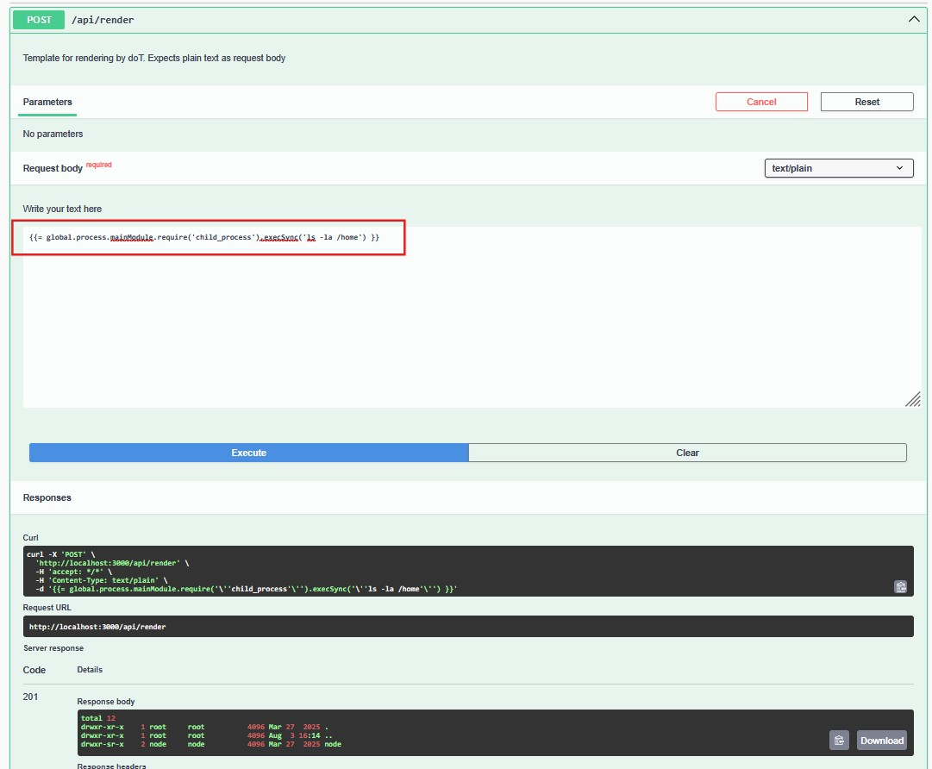
Step 1 – Swagger UI /api/render endpoint

Step 2 – Enter the Template Expression
The endpoint accepts a text/plain request body. The following template expression was entered into the Request Body field to determine whether the server-side template engine could access the Node.js runtime and invoke the child_process module.
{{= global.process.mainModule.require('child_process').execSync('ls -la /home') }}
The {{= ... }} portion is the doT.js evaluation syntax. The expression then reaches the Node.js process object, loads child_process, and invokes execSync to execute the directory-listing command on the server.

Step 3 – Execute the Request
Click Execute in Swagger to send the request to POST /api/render. The server processes the supplied text as a template instead of returning the expression literally. The captured response shows successful processing and includes the output produced by the operating-system command.
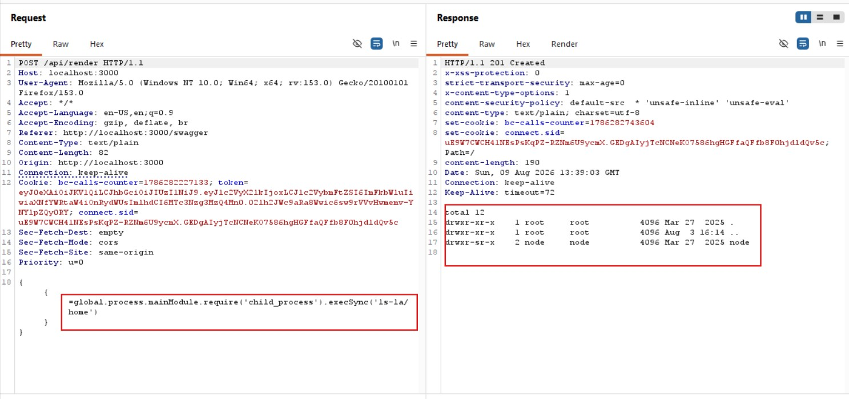
Step 3 – Burp Suite request and response showing command execution

Step 4 – Verify Command Output
The response body contains the directory listing produced by ls -la /home. The presence of actual server-side filesystem output demonstrates that the template expression was evaluated by the application and that JavaScript execution reached the operating-system command execution function.
The screenshot shows the returned directory entries in the response panel, providing direct evidence that the command was executed on the Broken Crystals server/container rather than being displayed as ordinary template text.

Payload Explanation
{{= ... }} – This is the doT.js template evaluation syntax. It tells the template engine to evaluate the JavaScript expression during rendering instead of treating it as ordinary text.
global.process – This accesses the Node.js process object belonging to the running server. Reaching this object exposes the server-side JavaScript runtime to the template expression.
mainModule.require('child_process') – This dynamically loads Node.js's child_process module, which provides functionality for starting operating-system processes.
execSync('ls -la /home') – This executes the supplied operating-system command synchronously and returns its output. The returned directory listing was then included in the HTTP response.

7. Observations
The application evaluates attacker-controlled template syntax through the /api/render endpoint. The test expression was not returned literally; instead, it was executed and its command output was returned by the server.
The successful command execution demonstrates SSTI with server-side JavaScript execution and OS command execution. In the tested Docker environment, this provides Remote Code Execution within the privileges available to the application process.

8. Affected Endpoint
POST /api/render
Content-Type: text/plain

9. Impact
An attacker who can submit template content to the affected endpoint may be able to execute arbitrary server-side JavaScript. If the template runtime exposes Node.js functionality such as process or child_process, the attacker may also execute operating-system commands.
Successful exploitation can lead to unauthorized access to application files and environment data, modification of server-side resources, execution of commands with the application's privileges, and potentially further compromise of the hosting environment.

10. Remediation
Pre-compile Static Templates: Avoid dynamically compiling templates from raw user-controlled input at runtime. Use fixed, pre-compiled templates whenever possible.
Strict Data Binding: Treat user input only as data and pass it into trusted template variables. Do not insert untrusted strings into the template source itself.
Sandbox Execution: If dynamic templating is unavoidable, use a properly isolated execution environment and prevent access to sensitive Node.js capabilities such as process, require, and child_process.
Input Validation: Restrict the accepted template syntax and reject server-side expressions or executable template constructs when they are not required by the application's functionality.

11. Conclusion
The assessment confirms that the Broken Crystals /api/render endpoint is vulnerable to Server-Side Template Injection. The supplied doT.js expression was evaluated by the server and successfully reached Node.js's child_process functionality.
The resulting command output was returned in the HTTP response, demonstrating SSTI leading to Remote Code Execution in the tested environment. The application should prevent user-controlled template compilation, enforce strict data binding, and isolate any unavoidable dynamic rendering from sensitive server-side functionality.

