Broken Crystals – Cross-Site Scripting (XSS) Assessment

Cross-Site Scripting (XSS)

1. Target Environment
Application: Broken Crystals
Deployment: Docker
Target URL: http://localhost:3000
Testing Tools: Burp Suite Community Edition, Firefox Browser, Docker Desktop
The assessment was performed against the locally deployed Broken Crystals application in a controlled testing environment.

2. Attack Name
Cross-Site Scripting (XSS)

3. About the Attack
Cross-Site Scripting (XSS) occurs when an application includes user-supplied data in a web page without applying appropriate output encoding or sanitization. As a result, browser-interpreted content may execute in the context of the application. Successful exploitation can expose client-side information, manipulate page content, or execute unauthorized actions within the user's browser session.

4. Identification
During testing, multiple input fields accepted user-controlled content that was later rendered by the application without sufficient filtering. Validation confirmed that JavaScript execution was possible in both the Maps Contact section and the Marketplace Testimonials section, demonstrating that output encoding was not properly enforced.

5. Tools Used
• Burp Suite Community Edition
• Firefox Browser
• Docker Desktop
• Broken Crystals Application

6. Detailed Validation Process

Step 1 – Capture Request
Capture the HTTP request in Burp Suite and review the parameters submitted by the application.
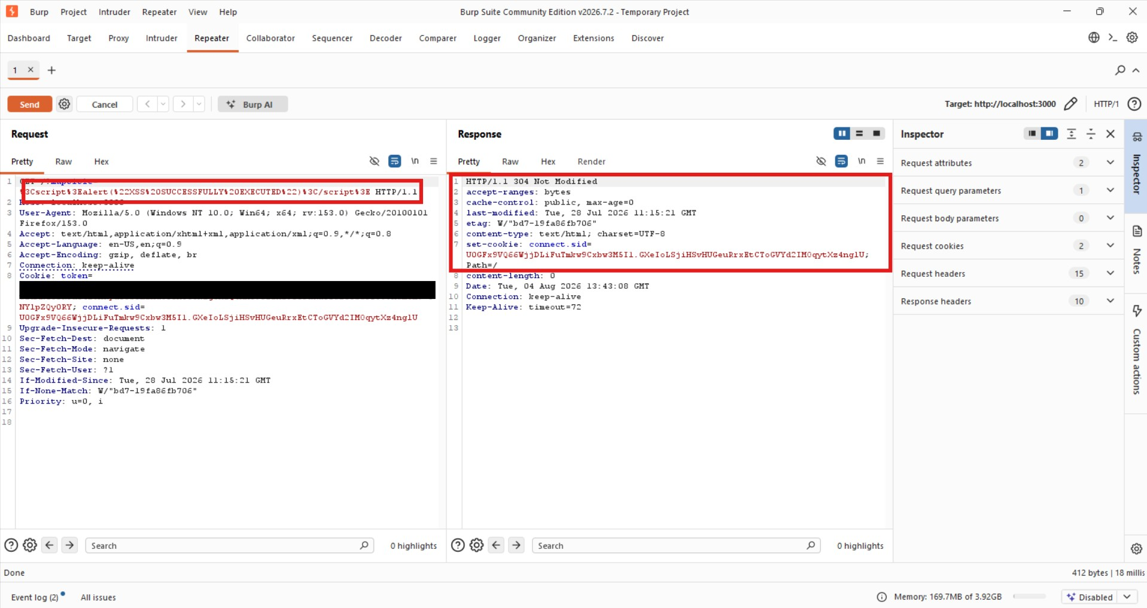

Step 2 – Maps Contact Form
Navigate to the Maps Contact section, populate the available fields, submit the request, and observe how the application reflects the supplied content.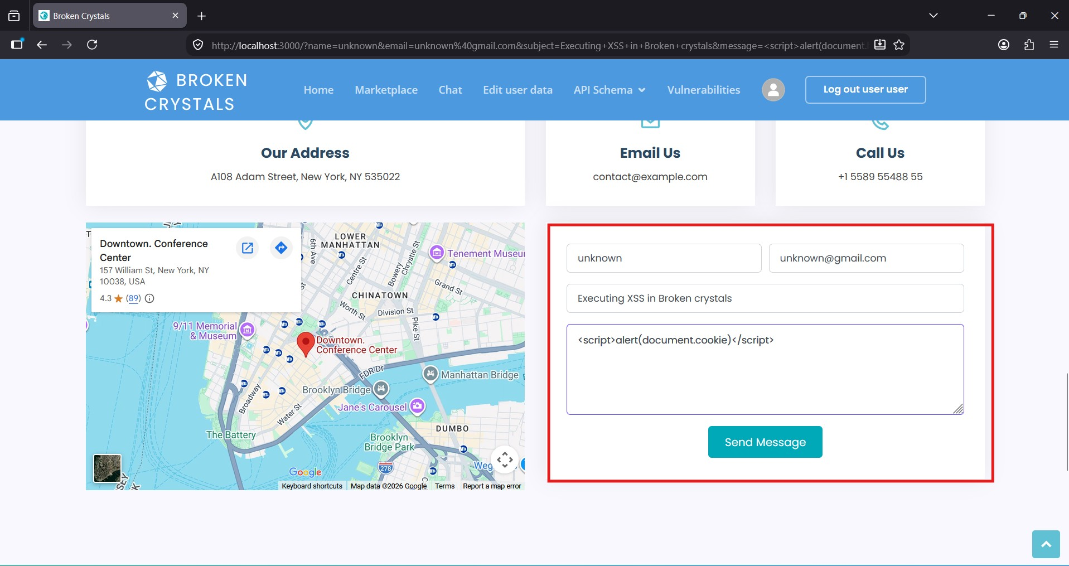

Step 3 – Maps Validation Result
After processing the request, the browser executed the injected JavaScript, confirming that the application failed to neutralize active content before rendering it.
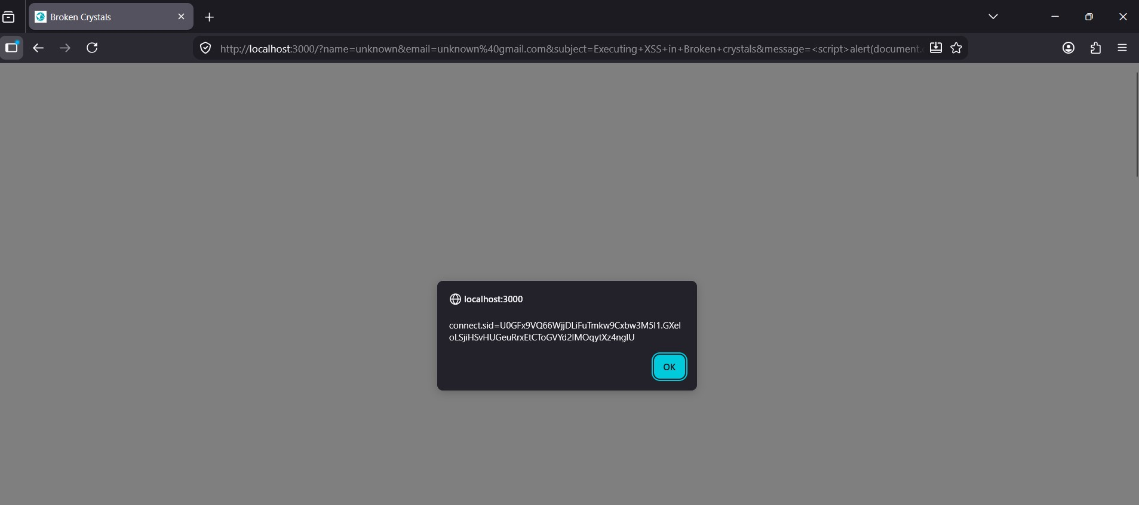

Step 4 – Marketplace Testimonials
Repeat the same validation process in the Marketplace Testimonials section and verify that the application again reflects user-controlled content.
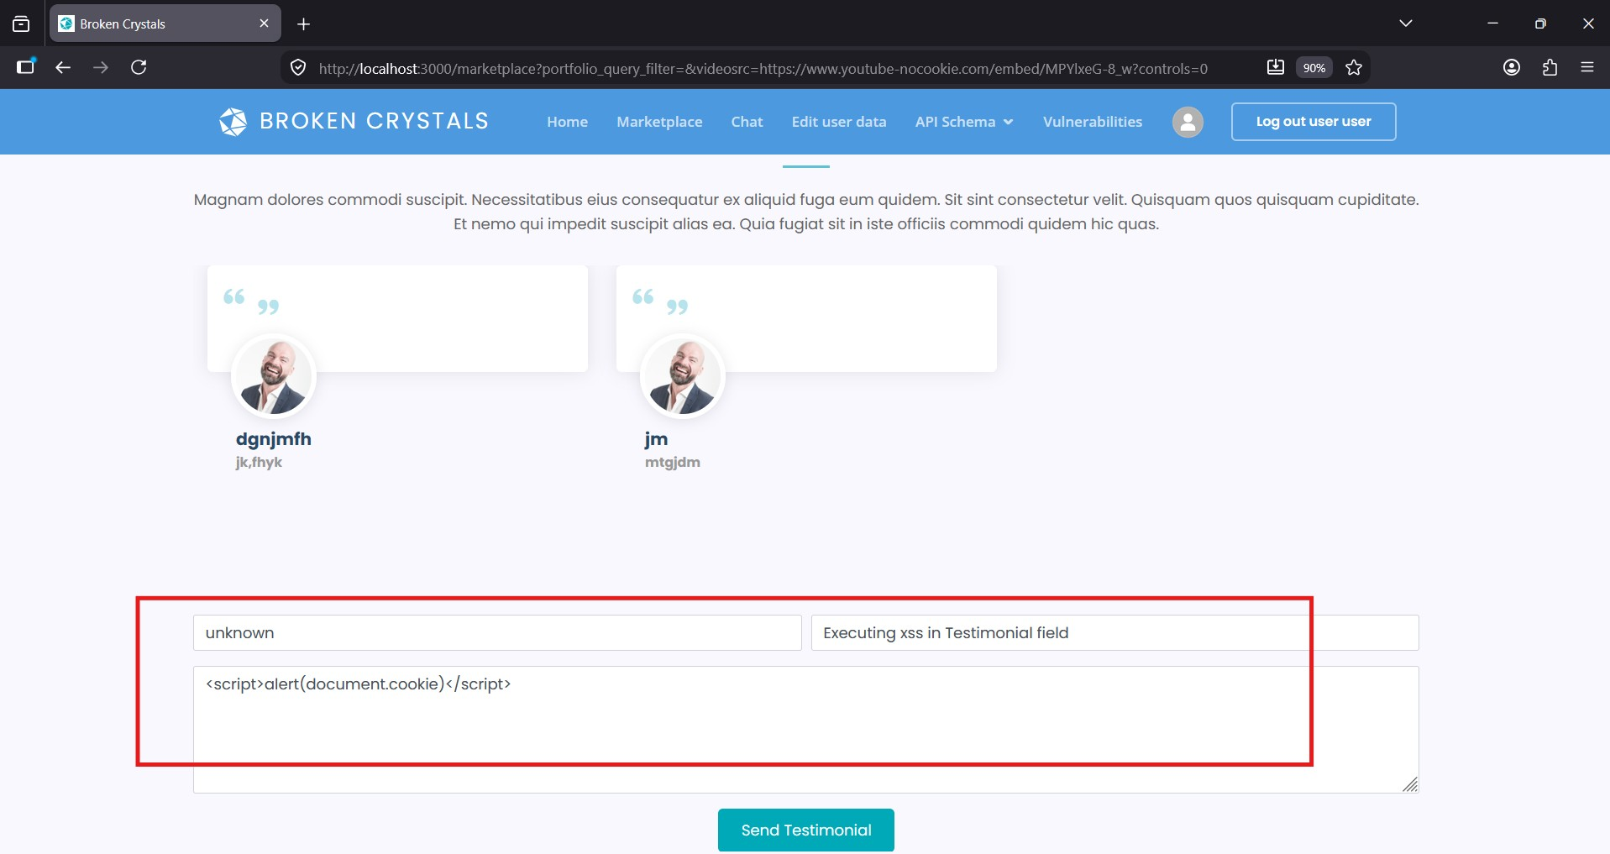

Step 5 – Testimonials Validation Result
The browser executed the injected JavaScript in the Testimonials section as well, confirming that multiple components are affected by the same weakness.
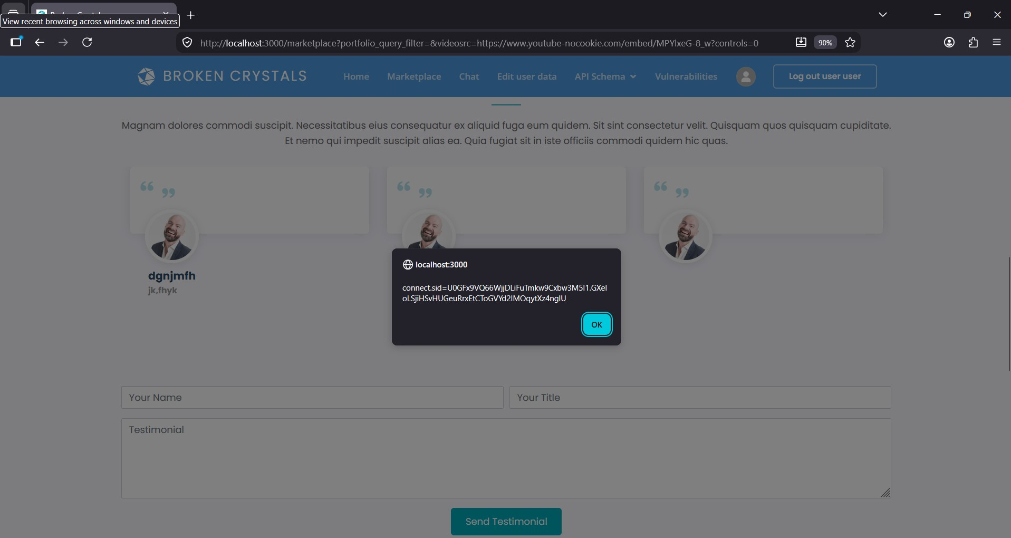

7. Observations
The application consistently rendered user-controlled content without applying adequate output encoding. The same behavior was identified in multiple locations, indicating that the issue is not isolated to a single component but affects several input-processing functions.

8. Affected Components
• Maps Contact Form
• Marketplace Testimonials Form
Both components accept user input and later render it back to the browser without sufficient protection.

9. Impact
Successful exploitation could allow execution of arbitrary client-side JavaScript in another user's browser. Depending on the application context, this may lead to exposure of client-side information, manipulation of displayed content, or execution of actions on behalf of authenticated users.

10. Remediation
Implement strict server-side input validation, perform context-aware output encoding before rendering user input, sanitize any HTML content that must be accepted, and deploy a strong Content Security Policy (CSP). Security testing should be repeated after remediation to verify that user-controlled content is no longer executable.

11. Conclusion
The assessment confirms the presence of Cross-Site Scripting (XSS) vulnerabilities in multiple areas of the Broken Crystals application. The issue results from insufficient handling of user-controlled input before it is rendered in the browser. Addressing this vulnerability requires a combination of secure input validation, contextual output encoding, sanitization, and defense-in-depth mechanisms such as Content Security Policy.

