Broken Crystals – CSRF & CORS Security Assessment

Cross-Origin Request & Cross-Site Request Forgery Testing

1. Target Environment
Application: Broken Crystals
Deployment: Docker
URL: http://localhost:3000
Tools: Burp Suite Community Edition, Firefox Browser

2. Attack Names
Scenario 1 – CORS Misconfiguration & Wildcard Origin
Scenario 2 – Unauthenticated Email Subscription Form CSRF

3. About the Attacks
Scenario 1 tests whether the application accepts requests from an arbitrary external origin and allows the browser to treat the API as accessible across origins. The key security control is the server's CORS policy, particularly the Access-Control-Allow-Origin response header.
Scenario 2 tests whether a state-changing subscription request can be submitted from another origin without an unpredictable Anti-CSRF token. A successful cross-origin form submission can cause the application to create a subscription without interaction with the application's own interface.

4. Identification
During testing, the /api/subscriptions endpoint was identified as a state-changing endpoint. Two separate tests were performed. The first used an explicit external Origin value and a JSON request to examine the CORS policy. The second used a local HTML form that automatically submitted a POST request with Origin: null, allowing the CSRF behavior to be observed.

5. Tools Used
- Burp Suite Community Edition
- Firefox Browser
- Broken Crystals
- Local HTML file for the CSRF form test

6. Detailed Testing Process

Scenario 1 – CORS Misconfiguration & Wildcard Origin
Objective: To verify whether the backend improperly accepts cross-origin requests from arbitrary external domains and exposes the subscription API through a wildcard CORS policy.

Step 1 – Prepare the Cross-Origin Request
A POST request was prepared for the /api/subscriptions endpoint in Burp Suite. The request included an Origin header set to an external domain, representing a request that originates outside Broken Crystals. A test email address was supplied in the JSON body so that server-side processing could also be observed.
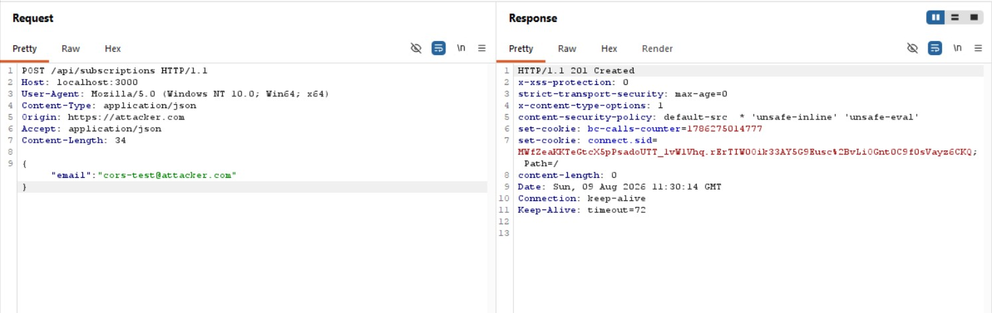
Scenario 1 – Burp Suite request with an external Origin header

Step 2 – Send the Request to the Application
The request was sent to http://localhost:3000/api/subscriptions. The application processed the request and returned HTTP/1.1 201 Created. This demonstrates that the endpoint accepted the cross-origin request at the application layer.
The response headers were examined as part of the CORS assessment. The tested configuration used a wildcard Access-Control-Allow-Origin policy, meaning the application was configured to permit arbitrary origins rather than restricting access to a defined set of trusted domains.

Step 3 – Interpret the CORS Result
The important finding is the combination of successful cross-origin processing and an overly permissive CORS policy. A wildcard origin removes the intended browser-side origin restriction and can expose API responses to websites outside the application's trusted domain.

Scenario 2 – Unauthenticated Email Subscription Form CSRF
Objective: To determine whether the public email subscription endpoint requires an Anti-CSRF token before performing a state-changing action.

Step 1 – Create the Cross-Origin Form
A local HTML file named csrf_subscribe.html was created with a hidden form whose action pointed to http://localhost:3000/api/subscriptions. The form used POST and supplied a test email address. JavaScript automatically submitted the form when the page loaded, so no manual interaction with the Broken Crystals subscription form was required.
<form id="csrfSubscribe" action="http://localhost:3000/api/subscriptions" method="POST">
<input type="hidden" name="email" value="csrf-test@attacker.com" />
</form>
<script>document.getElementById('csrfSubscribe').submit();</script>
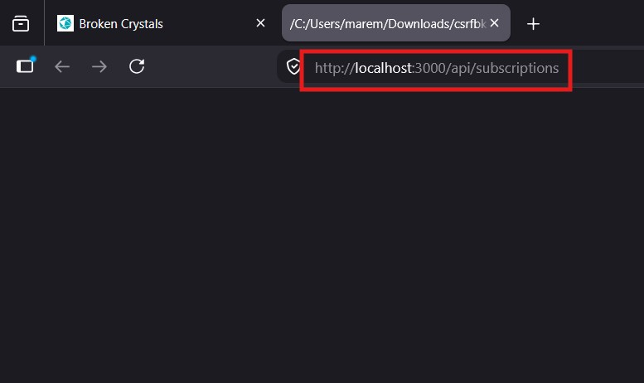
Scenario 2 – Local CSRF test page targeting the subscription endpoint

Step 2 – Trigger and Capture the Request
The local HTML file was opened in Firefox. Loading the file automatically submitted the form to the Broken Crystals endpoint. The request was captured in Burp Suite for inspection. Because the submission originated from a local file, the request contained Origin: null rather than the application's own origin.
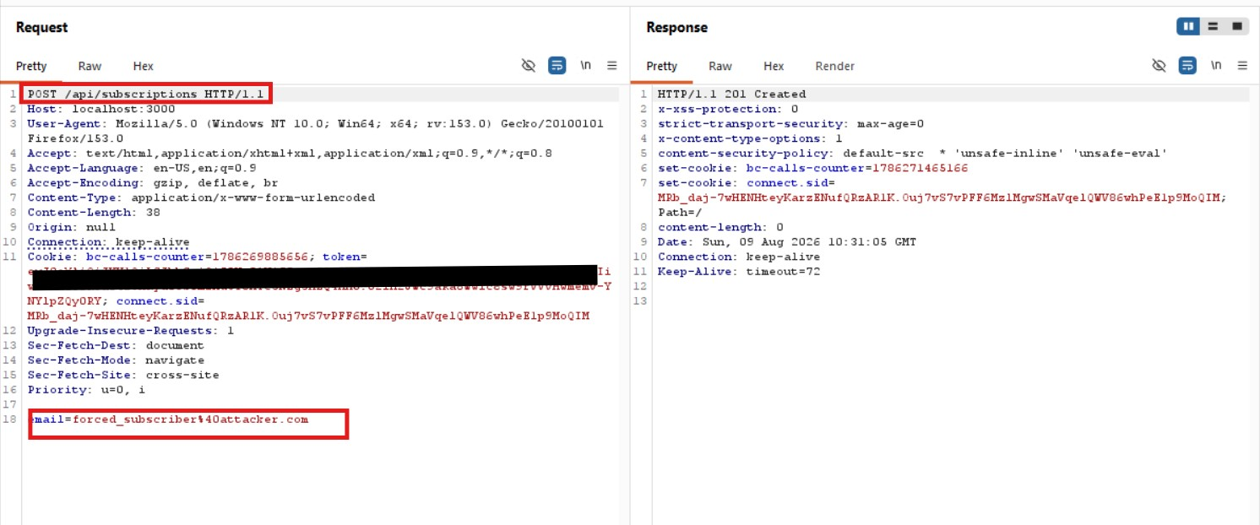
Scenario 2 – Burp Suite capture showing Origin: null and the subscription request

Step 3 – Verify Server-Side Processing
The captured request used application/x-www-form-urlencoded and did not contain an Anti-CSRF token in the request body or headers. The server nevertheless processed the request and returned HTTP/1.1 201 Created. This indicates that the state-changing subscription operation was not dependent on a CSRF token.

Step 4 – Confirm the Result
The result was verified in the Broken Crystals application by checking the subscriber data. The test address csrf-test@attacker.com was added successfully. This provides application-level confirmation that the cross-origin form submission reached the endpoint and caused the intended state change.

7. Observations
Scenario 1: The subscription endpoint accepted a request carrying an external Origin value, and the tested configuration used a wildcard CORS policy. This indicates that the application does not restrict cross-origin access to a controlled set of trusted origins.
Scenario 2: The subscription endpoint accepted a POST request originating from a local file with Origin: null without requiring a CSRF token. The server returned 201 Created and the test subscription was created.

8. Affected Endpoint
POST /api/subscriptions
Content-Type: application/json or application/x-www-form-urlencoded

9. Impact
The CORS weakness can allow untrusted origins to interact with an API that should be restricted to trusted web origins. Depending on the endpoint and browser credential behavior, overly broad CORS policies can expose sensitive responses to malicious websites.
The CSRF weakness allows a third-party page to cause a state-changing subscription request without a dedicated Anti-CSRF token. In this test, the attack resulted in creation of a new subscriber entry without direct interaction with the Broken Crystals subscription form.

10. Remediation
Scenario 1 – CORS: Replace the wildcard Access-Control-Allow-Origin configuration with an explicit whitelist containing only trusted application origins. Avoid allowing arbitrary origins and review credential-related CORS settings so that cross-origin responses are not unnecessarily exposed.
Scenario 2 – CSRF: Implement unpredictable, per-session Anti-CSRF tokens for state-changing requests. Validate the token on the server before processing POST, PUT and DELETE operations. Where appropriate, also enforce SameSite cookie protections and validate the request Origin or Referer as an additional defense.

11. Conclusion
The assessment identified two separate cross-origin security weaknesses in the Broken Crystals subscription functionality. The first scenario demonstrated an overly permissive CORS configuration associated with a wildcard origin policy. The second demonstrated that the subscription endpoint could be triggered through a cross-origin form submission without an Anti-CSRF token.
Together, the tests show that the application needs stronger origin controls and server-side request integrity checks for state-changing operations. Restricting CORS to trusted origins and implementing robust CSRF protection would significantly reduce the demonstrated attack surface.

