Broken Crystals – File Upload Vulnerability Assessment

Malicious File Upload

1. Target Environment
Application: Broken Crystals
Deployment: Docker
URL: http://localhost:3000
Tools: Burp Suite, Firefox, Docker

2. Attack Name
Unrestricted File Upload / Malicious File Upload

3. About the Vulnerability
A file upload vulnerability occurs when an application accepts files without adequate validation. It becomes risky when active content such as HTML or script can be uploaded and later interpreted by a browser.
The captured request accepted test.html as text/html containing script content, and the server returned HTTP 200 OK. This shows the upload was accepted rather than rejected.
The supplied browser screenshots show the application before and after the upload. They provide supporting evidence of a change in the highlighted area.

4. Identification
The issue was identified by intercepting the multipart upload in Burp Suite. The request contains the user file parameter, filename test.html, Content-Type text/html, and HTML script content.
The response returned HTTP 200 OK with no visible upload-validation error. This confirms acceptance of the submitted file.

5. Tools Used
- Burp Suite Community Edition
- Firefox Browser
- Broken Crystals
- Docker

6. Detailed Exploitation Process

Step 1 – Capture the Application Before the Upload
The application was first captured in its normal state. This screenshot is used as the baseline for comparison.

Step 1 – Application State Before File Upload

Step 2 – Prepare and Submit the File Upload Request
Burp Suite captured a multipart/form-data request containing test.html in the user parameter and declaring Content-Type: text/html.
The security concern is that an active HTML file was accepted. File type and content should be validated on the server instead of trusting the supplied filename or MIME type.
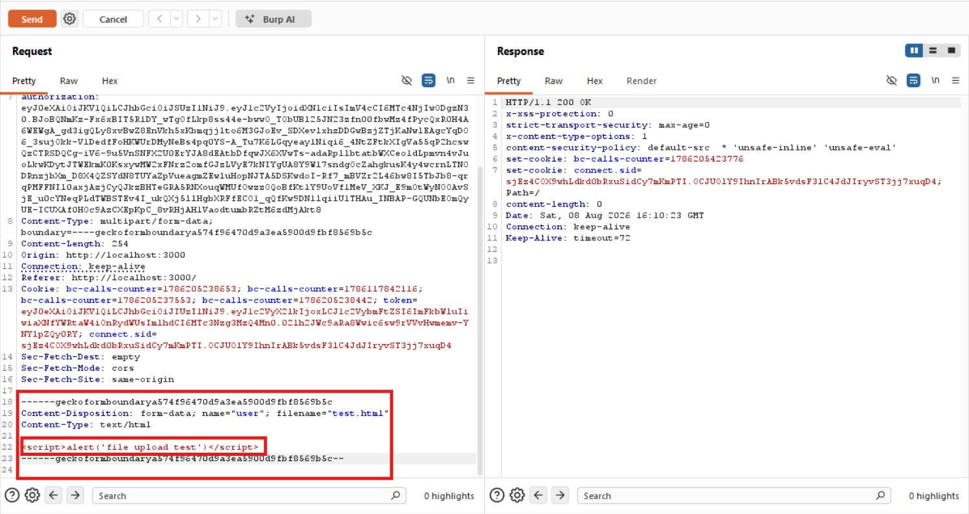
Step 2 – Burp Suite Captured File Upload Request and HTTP 200 Response

Step 3 – Review the Uploaded File Content
The uploaded file is named test.html, uses text/html, and contains a script element. HTML is active browser content, so accepting it without proper controls can create client-side risk.
If the uploaded HTML is later served from the application's origin, a browser may interpret it as active content. The evidence demonstrates acceptance of the file, not server-side code execution.

Step 4 – Compare the Application After the Upload
After the upload, the application was revisited and the highlighted area differed from the baseline screenshot.
The before-and-after screenshots support the finding. They do not by themselves prove the exact server-side cause of the visual change.

Step 4 – Application State After File Upload

7. Payload / Request Explanation
The relevant multipart upload contains the following file information:
Content-Disposition: form-data; name="user"; filename="test.html"
Content-Type: text/html
<script>alert('file upload test')</script>
filename="test.html" identifies the file, Content-Type: text/html declares it as HTML, and the body contains script content.
The test checks whether the application rejects active file types. HTTP 200 OK shows that the upload request was accepted.

8. Observations
The application accepted test.html as text/html with script content and returned HTTP 200 OK.
The screenshots also show a difference in the highlighted area after the upload, providing supporting evidence.

9. Affected Functionality
Upload parameter: user
Test file: test.html
Content type: text/html

10. Impact
If arbitrary HTML is stored in a web-accessible location, it may be interpreted by a victim's browser and create client-side security risks.
The evidence specifically shows acceptance of HTML containing script content. It does not demonstrate server-side executable-file upload.

11. Remediation
Allow only required file types and validate them server-side. Do not rely only on the filename or client-supplied MIME type.
Store uploads outside executable web directories, use generated filenames, and prevent untrusted HTML from being treated as active content.
Use safe response headers, access controls, file-size limits, and content validation for uploaded files.
If HTML uploads are required, isolate them from the application's primary origin.

12. Conclusion
The assessment identified insufficient file-upload restrictions. The application accepted test.html as text/html with script content and returned HTTP 200 OK.
The browser screenshots provide supporting before-and-after evidence. The finding is that active HTML content is being accepted by the upload functionality.
Remediation: restrict file types, validate uploads server-side, use safe filenames and storage, and prevent untrusted HTML from executing in the application's origin.

