Broken Crystals – Brute Force Authentication Assessment
Brute Force Authentication Attack
1. Target Environment
- Application: Broken Crystals
- Deployment: Docker
- URL: http://localhost:3000
- Tools: Burp Suite Community Edition, Firefox
2. Attack Name
Brute Force Authentication Attack
3. About the Attack
A brute force attack repeatedly attempts different password combinations until valid credentials are discovered. The Broken Crystals application does not implement rate limiting or account lockout, allowing automated password guessing using Burp Suite Intruder.
4. Identification
Testing showed that invalid passwords consistently returned HTTP 401 Unauthorized. Multiple password payloads were then supplied automatically using Burp Intruder. One payload returned HTTP 201 Created, confirming successful authentication through brute force.
5. Tools Used
- Burp Suite Community Edition
- Firefox Browser
- Docker Desktop
- Broken Crystals
6. Detailed Exploitation Process
Step 1 – Capture Login Request
Intercept the POST /api/auth/login request with an incorrect password. The response returns HTTP 401 Unauthorized and the message 'Invalid credentials', confirming failed authentication.
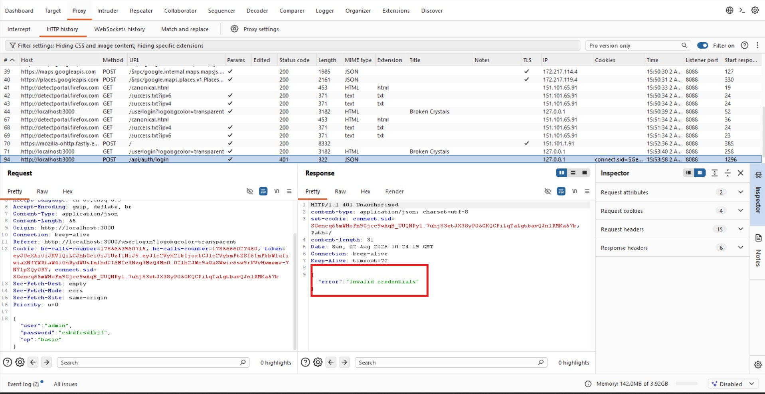
Step 1 – Capture Login Request
Step 2 – Send to Intruder
Send the intercepted request to Burp Intruder. Select the password parameter as the payload position, choose the Sniper attack type, and load a custom list of password guesses.
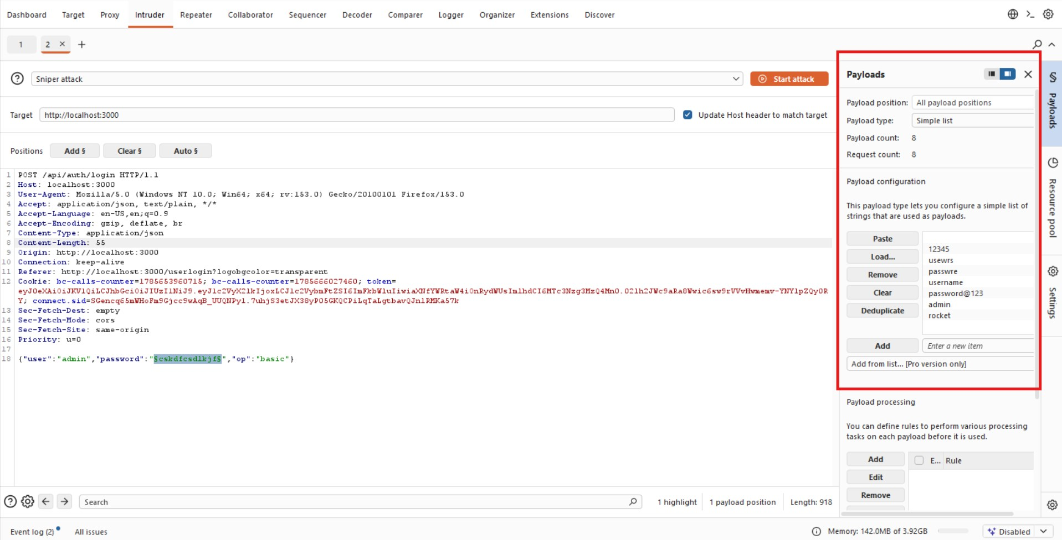
Step 2 – Configure Burp Intruder
Step 3 – Launch Intruder Attack
Start the Intruder attack. Burp automatically sends one request for each payload and records the status code, response length, and response time. Compare the results to identify anomalies.
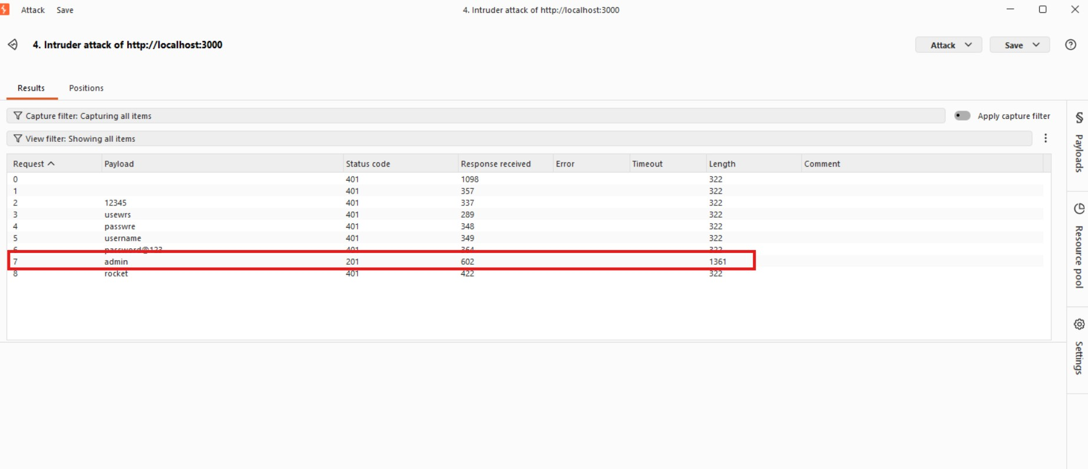
Step 3 – Successful Brute Force Attack
7. Observations
The application permits unlimited authentication attempts without rate limiting or account lockout. Successful credentials can be identified by changes in HTTP status code and response length.
8. Affected Endpoint
POST /api/auth/login
9. Impact
Attackers can compromise weak accounts, gain unauthorized access, impersonate legitimate users, and potentially escalate privileges.
10. Remediation
Implement account lockout after repeated failures, enforce rate limiting, deploy CAPTCHA, require strong passwords, enable multi-factor authentication, and monitor repeated failed login attempts.
11. Conclusion
The assessment confirms that Broken Crystals is vulnerable to brute force authentication attacks because repeated login attempts are allowed without adequate protections. By using Burp Suite Intruder, valid credentials were successfully identified through automated password guessing. Implementing standard authentication controls such as account lockout, rate limiting, CAPTCHA, and MFA will significantly reduce the risk of account compromise.

