Broken Crystals – Business Constraint Bypass Assessment

Business Constraint Bypass

1. Target Environment
Application: Broken Crystals
Deployment: Docker
URL: http://localhost:3000
Tools: Burp Suite Community Edition, Firefox Browser, Docker Desktop, Broken Crystals Swagger UI

2. Attack Name
Business Constraint Bypass

3. About the Attack
A business constraint is a rule that limits how an application should behave, such as restricting the number of records returned by an endpoint. A Business Constraint Bypass occurs when a user can manipulate a request parameter so that the server does not enforce the intended rule.
In this Broken Crystals assessment, GET /api/products/latest is documented to return the latest three products. The limit parameter is client-controlled. By changing it to a much larger value, the server returned a larger product set instead of enforcing the documented limit.

4. Identification
The issue was identified by reviewing the Swagger documentation and then modifying the limit parameter in Burp Suite Repeater.
The Swagger interface shows a default limit of 3. The intercepted request was changed to limit=1000. The server returned HTTP/1.1 200 OK with a large product list, demonstrating that the intended business constraint was not enforced server-side.

5. Tools Used
- Burp Suite Community Edition
- Firefox Browser
- Docker Desktop
- Broken Crystals Swagger UI

6. Detailed Exploitation Process

Step 1 – Identify the Business Constraint
Open the Broken Crystals Swagger UI and locate GET /api/products/latest. The documentation states that the endpoint returns the latest 3 products and exposes limit as a query parameter with a default value of 3.
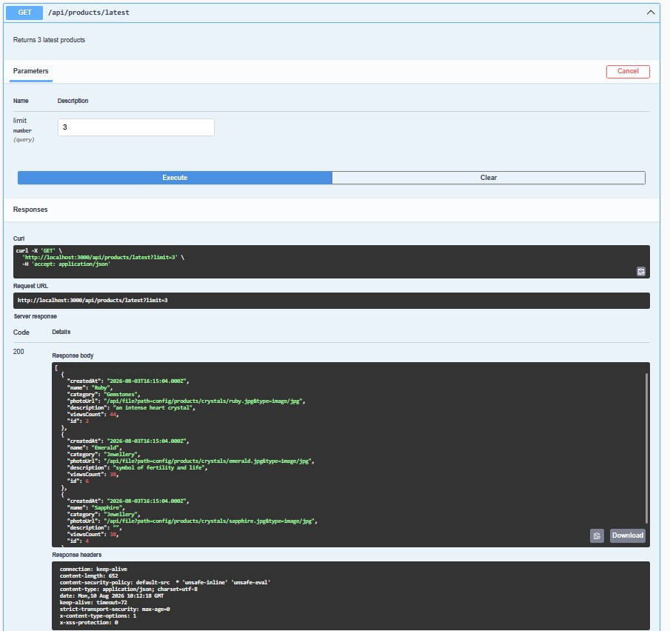
Step 1 – Swagger documentation showing the limit parameter and default value of 3

Step 2 – Modify the Request
Send the request to Burp Suite Repeater and change the limit value from 3 to 1000. The purpose is to test whether the server validates the maximum allowed value or simply trusts the client-supplied parameter.
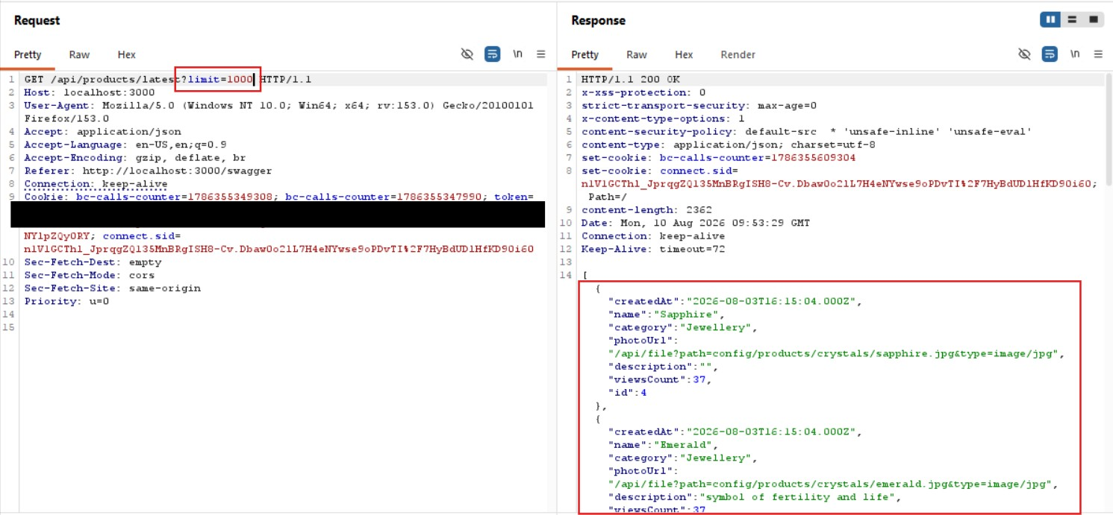
Step 2 – Burp Suite request showing the increased limit value

Step 3 – Inspect the Response
Send the modified request and inspect the response. The server returns HTTP/1.1 200 OK and provides many product records rather than enforcing the documented three-product restriction.
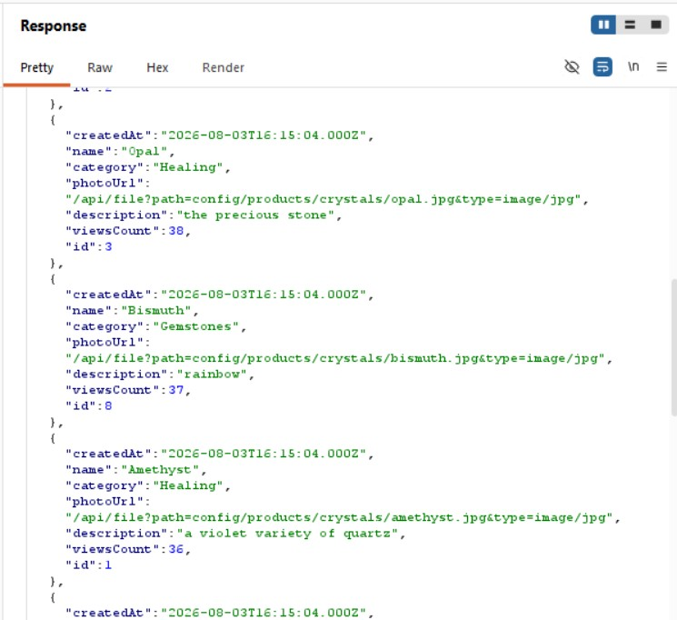
Step 3 – Server response showing multiple product records

Parameter Explanation
limit=3 – The documented/default value. It represents the intended three-product business rule.
limit=1000 – An intentionally excessive client-supplied value used to test whether the server enforces the maximum.
HTTP 200 OK – The server accepts the modified request instead of rejecting or capping the excessive value.
Multiple product records – The response demonstrates that the requested limit was honored beyond the documented business constraint.

7. Observations
The endpoint accepts a client-controlled limit that exceeds the documented maximum. The response contains more than three products, confirming that the business constraint is not adequately enforced on the server.

8. Affected Endpoint
GET /api/products/latest
Parameter: limit
Documented/default constraint: 3 products

9. Impact
A Business Constraint Bypass can allow a user to operate beyond limits intended by the application's business logic. Here, an excessive limit allows more product records to be returned than intended, which can increase resource usage and expose more data than the business rule permits.

10. Remediation
Enforce the maximum limit server-side rather than relying on the client or Swagger default.
Validate and reject, or safely cap, values that exceed the permitted business limit.
Apply the same rule to every client and API path, including direct HTTP requests.
Test boundary values such as normal, zero, negative, and excessively large limits.

11. Conclusion
The assessment confirms a Business Constraint Bypass in GET /api/products/latest. Although the endpoint is documented to return the latest three products, the client-controlled limit can be increased substantially and the server still returns a larger result set.
The supplied screenshots show the complete flow: the intended limit is identified in Swagger, the request is modified in Burp Suite, and the server returns multiple records after the constraint is exceeded. The maximum permitted value should therefore be validated and enforced server-side.

