Broken Crystals – JWT Authentication Bypass Assessment

Broken JWT Authentication (alg:none Bypass)

1. Target Environment
Application: Broken Crystals
Deployment: Docker
URL: http://localhost:3000
Tools: Burp Suite Community Edition, Firefox, jwt.io

2. Attack Name
Broken JWT Authentication (alg:none Bypass)

3. About the Attack
JWT authentication should verify the token signature before trusting its contents. In this application the server accepts a JWT whose header algorithm is changed to 'none' and whose signature is removed, allowing authentication bypass.

4. Identification
During testing, the login request returned a JWT. The token was decoded, modified and replayed. The application accepted the unsigned token, confirming improper JWT validation.

5. Tools Used
• Burp Suite Community Edition
• Firefox Browser
• jwt.io
• Docker Desktop
• Broken Crystals

6. Detailed Exploitation Process

Step 1 – Capture Login Request
Log into Broken Crystals and intercept POST /api/auth/login in Burp Suite (Proxy → HTTP History). The response contains the Authorization JWT.
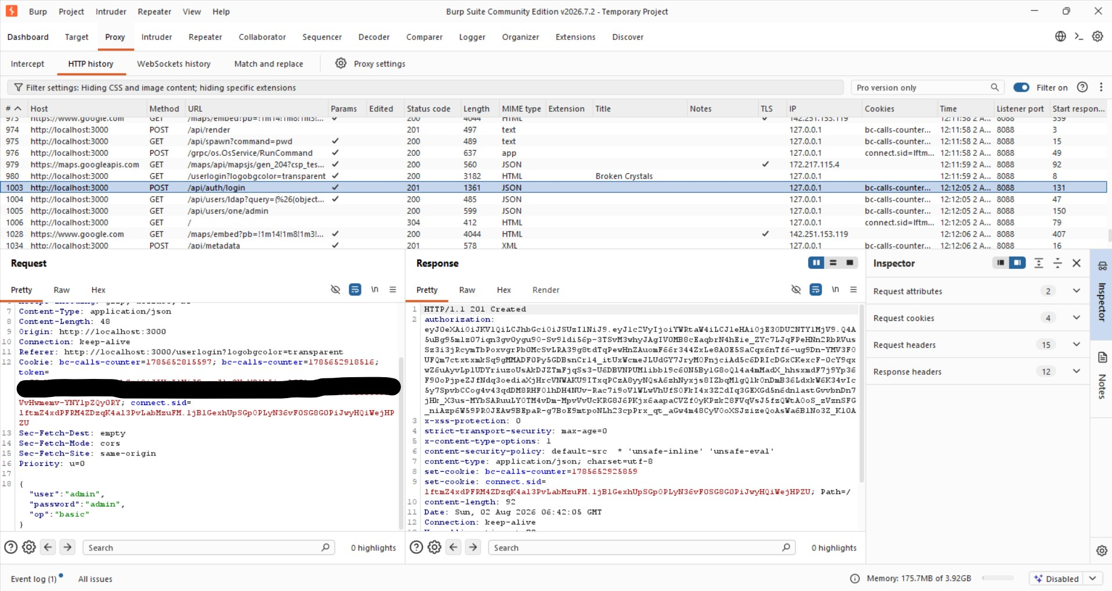
Step 1 – Capture Login Request

Step 2 – Send to Repeater
Send the captured request to Burp Repeater so it can be modified and replayed.
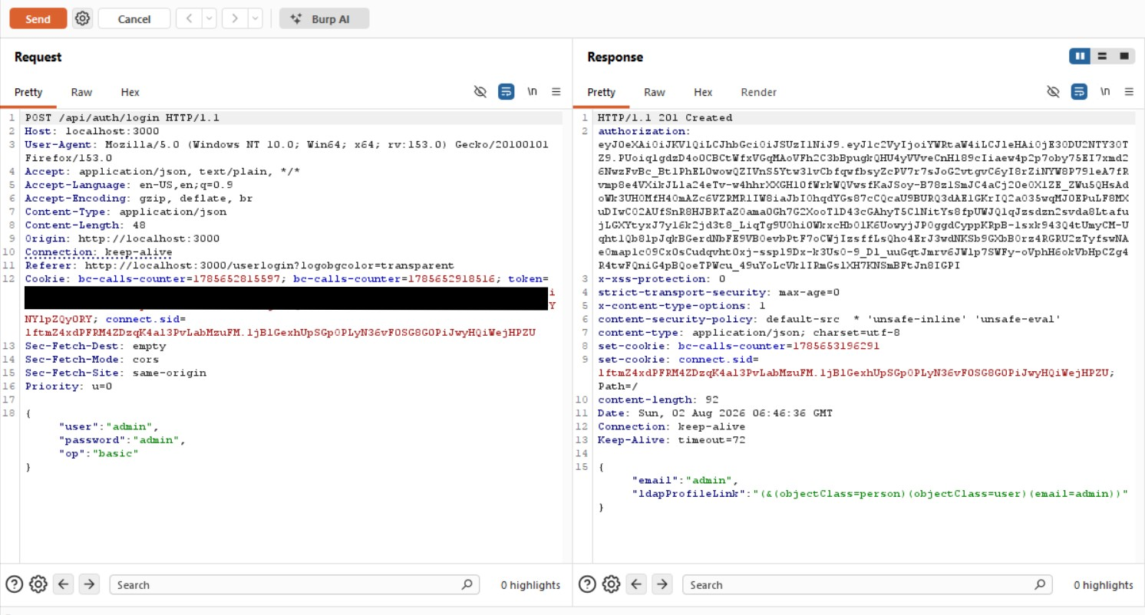
Step 2 – Send to Repeater

Step 3 – Modify the JWT
Copy the JWT into jwt.io. Change the JWT header from HS256 to alg:none and remove the signature while leaving the payload unchanged.
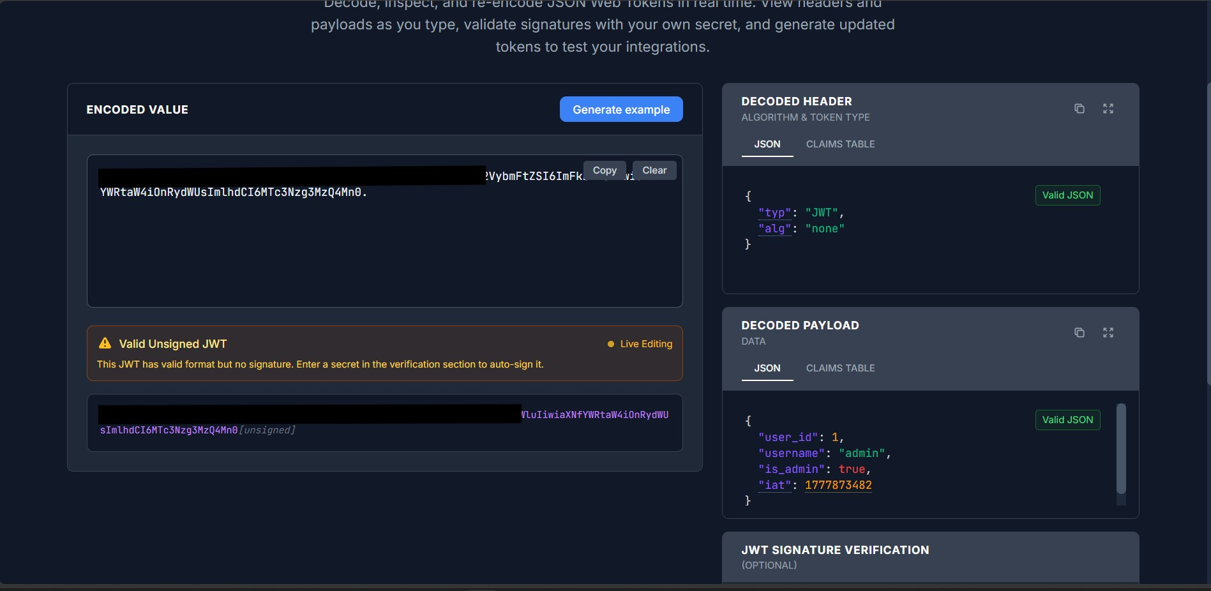
Step 3 – Modify the JWT

Step 4 – Replay the Modified Request
Replace the Authorization token in Burp Repeater with the unsigned JWT and click Send. The server returns HTTP/1.1 201 Created, proving that the unsigned token is accepted.
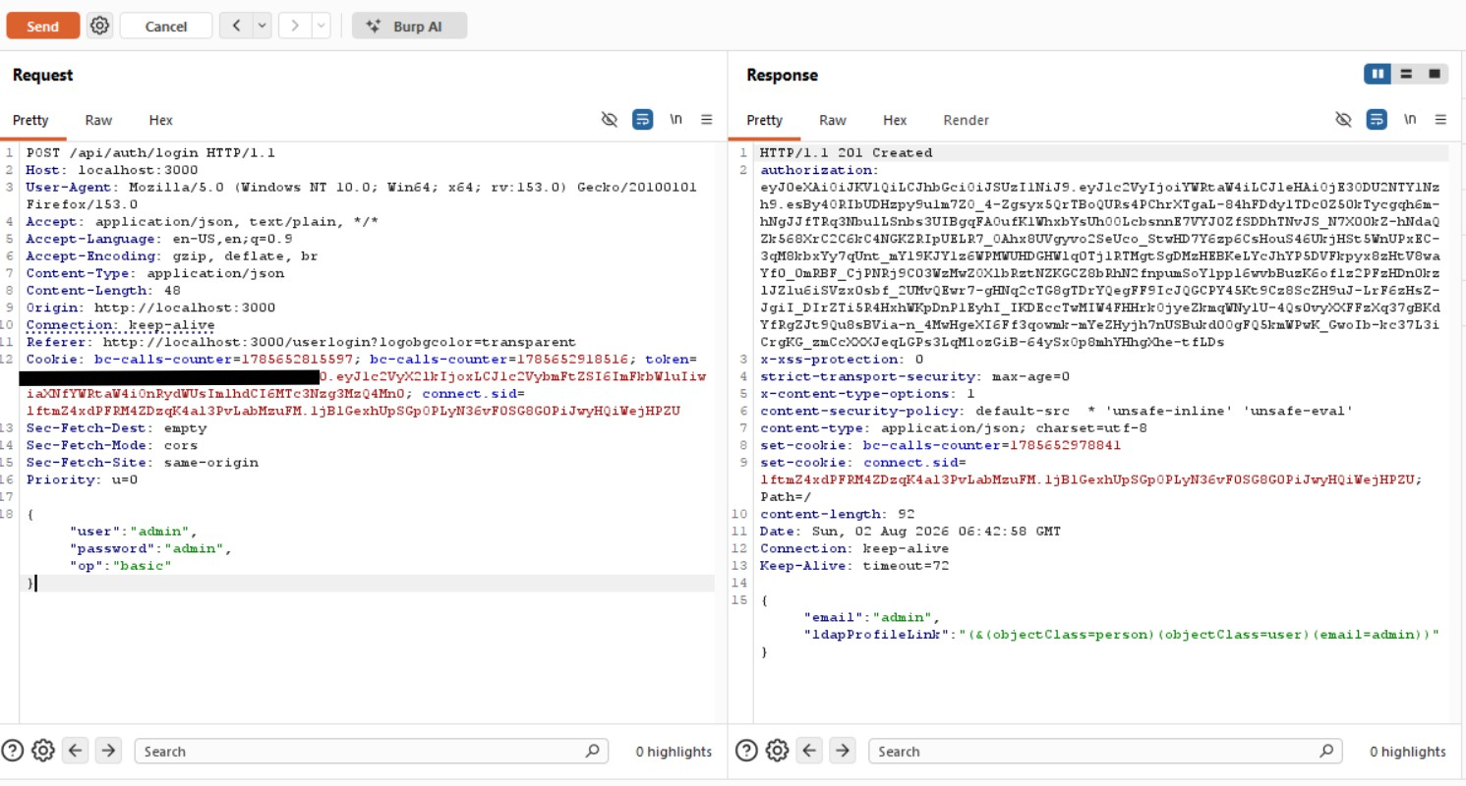
Step 4 – Replay the Modified Request

7. Observations
The application validates unsigned JWTs and does not enforce signature verification.

8. Affected Endpoint
POST /api/auth/login
Authorization: Bearer <JWT>

9. Impact
Attackers can forge tokens, bypass authentication, impersonate privileged users and gain unauthorized access.

10. Remediation
Reject alg:none, enforce signature verification, whitelist approved algorithms, validate issuer, audience and expiration, rotate secrets.

11. Conclusion
The assessment confirms that the Broken Crystals application is vulnerable to Broken JWT Authentication through acceptance of unsigned JSON Web Tokens using the 'alg:none' algorithm. By modifying the JWT header and removing the signature, authentication was successfully bypassed, demonstrating that the server does not properly validate token integrity. This vulnerability can allow attackers to impersonate legitimate users and gain unauthorized access. Implementing strict JWT signature verification, rejecting the 'none' algorithm, and validating all token claims are essential to mitigate this risk.

