Broken Crystals – OS Command Injection Assessment
OS Command Injection

1. Target Environment
Application: Broken Crystals
Deployment: Docker
URL: http://localhost:3000
Testing Tools: Burp Suite Community Edition, Firefox Browser, Docker Desktop.
The assessment was performed against the locally deployed Broken Crystals application in a controlled laboratory environment.

2. Attack Name
OS Command Injection

3. About the Attack
OS Command Injection is a critical vulnerability that occurs when an application executes operating system commands using user-controlled input without proper validation or sanitization. If the supplied input is passed directly to the operating system, an attacker may influence the command executed by the server. This can expose sensitive files, disclose server information, or allow unauthorized interaction with the underlying operating system. Proper validation and the use of secure APIs are essential to prevent this class of vulnerability.

4. Identification
During testing, the endpoint GET /api/spawn was identified as accepting a user-controlled 'command' parameter. Different requests produced different operating system outputs, indicating that the application executed the supplied input on the server. The returned output confirmed insufficient validation of user-controlled data and verified the presence of an OS Command Injection vulnerability.

5. Tools Used
• Burp Suite Community Edition
• Firefox Browser
• Docker Desktop
• Broken Crystals

6. Detailed Validation Process

Step 1 – Identify the Vulnerable Endpoint
Open the Broken Crystals application and identify the endpoint responsible for spawning operating system processes. The endpoint accepts a user-controlled command parameter which is processed by the server. This endpoint was selected for validation because it exposes direct interaction with the operating system.
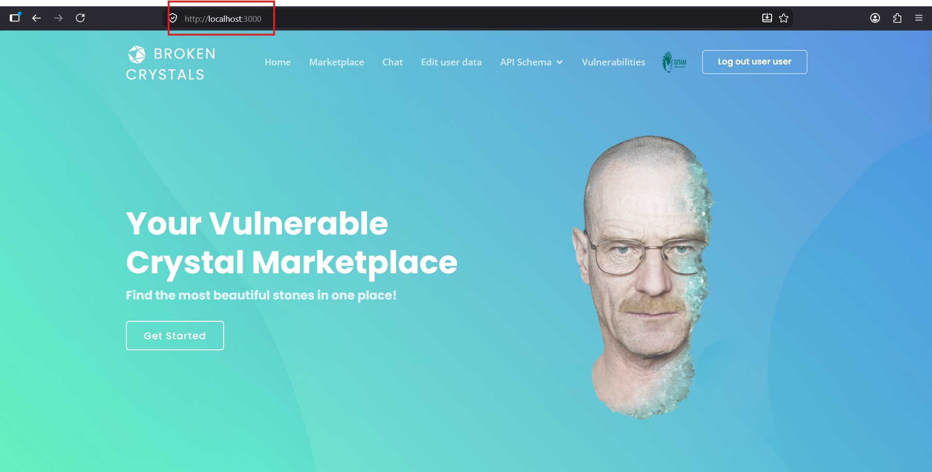

Step 2 – Validate System File Access
Access the vulnerable endpoint and observe that the server returns the contents of a system file. The successful response demonstrates that the application processes the supplied command and discloses operating system output instead of restricting execution to predefined functionality.
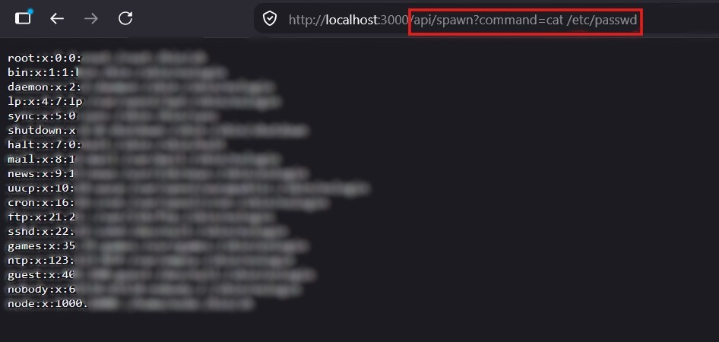

Step 3 – Validate Directory Enumeration
Continue testing by requesting directory information through the same endpoint. The application returns the directory listing generated by the operating system, confirming that multiple commands can be processed and executed through the vulnerable parameter.
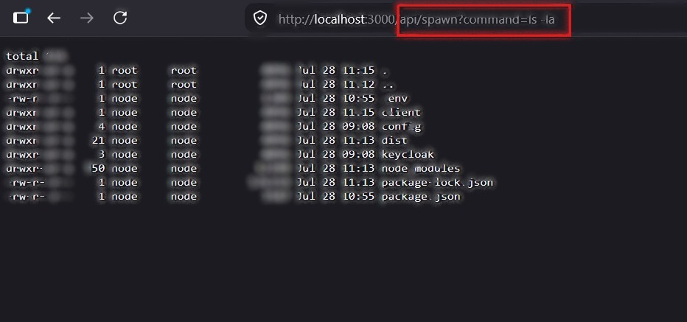

Step 4 – Verify Execution Context
Finally, verify the operating system execution context. The application successfully returns the account under which the server process is running. This confirms that arbitrary operating system commands are executed and their output is returned to the client.
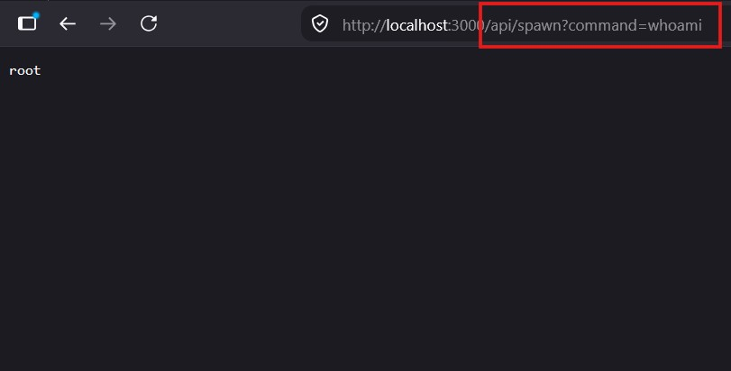

7. Observations
The application directly executes user-controlled input supplied through the command parameter without implementing sufficient validation or restrictions. Multiple operating system outputs were successfully returned to the browser, demonstrating that server-side command execution is exposed to user input. This behaviour confirms insecure command handling within the application.

8. Affected Endpoint
GET /api/spawn
Parameter: command

9. Impact
A successful OS Command Injection vulnerability may allow attackers to execute arbitrary operating system commands, access sensitive files, enumerate server directories, disclose confidential information and potentially compromise the underlying host depending on the privileges assigned to the application process.

10. Remediation
Avoid executing operating system commands directly with user-controlled input. Where command execution is unavoidable, implement strict allow-list validation, use secure APIs instead of invoking the system shell, apply the principle of least privilege, restrict server permissions and continuously monitor command execution for suspicious activity.

11. Conclusion
The assessment confirms that Broken Crystals is vulnerable to OS Command Injection through the GET /api/spawn endpoint. The application accepts user-controlled commands and executes them on the underlying operating system without sufficient validation. Implementing secure input validation, removing direct shell execution and following secure coding practices are recommended to mitigate this vulnerability.

