Broken Crystals – Email Header Injection Assessment

Email Header Injection (SMTP Injection)

1. Target Environment
Application: Broken Crystals
Deployment: Docker
URL: http://localhost:3000
Tools: Burp Suite Community Edition, Firefox Browser, Docker Desktop

2. Attack Name
Email Header Injection (SMTP Injection)

3. About the Attack
Email Header Injection occurs when attacker-controlled input is inserted into an email message without safely handling newline characters. Because email headers are separated by line breaks, an attacker may attempt to introduce an additional header into a message generated by the application.
In Broken Crystals, the support-email functionality accepts user-controlled email information. The test supplied a URL-encoded newline followed by a Cc header. The server accepted the request and the response reflected the injected recipient/header content, demonstrating unsafe handling of email-header input.

4. Identification
The affected functionality was identified at GET /api/email/sendSupportEmail. A request was captured in Burp Suite and modified so that an email-related parameter contained an encoded newline followed by a Cc header. The server returned HTTP/1.1 200 OK and confirmed successful processing.

5. Tools Used
- Burp Suite Community Edition
- Firefox Browser
- Docker Desktop
- Broken Crystals

6. Detailed Exploitation Process

Step 1 – Open the Email Support Functionality
Open Broken Crystals and navigate to the support/contact email form. The form provides fields for the recipient name, email address, subject and message. This functionality generates an email request to the server.
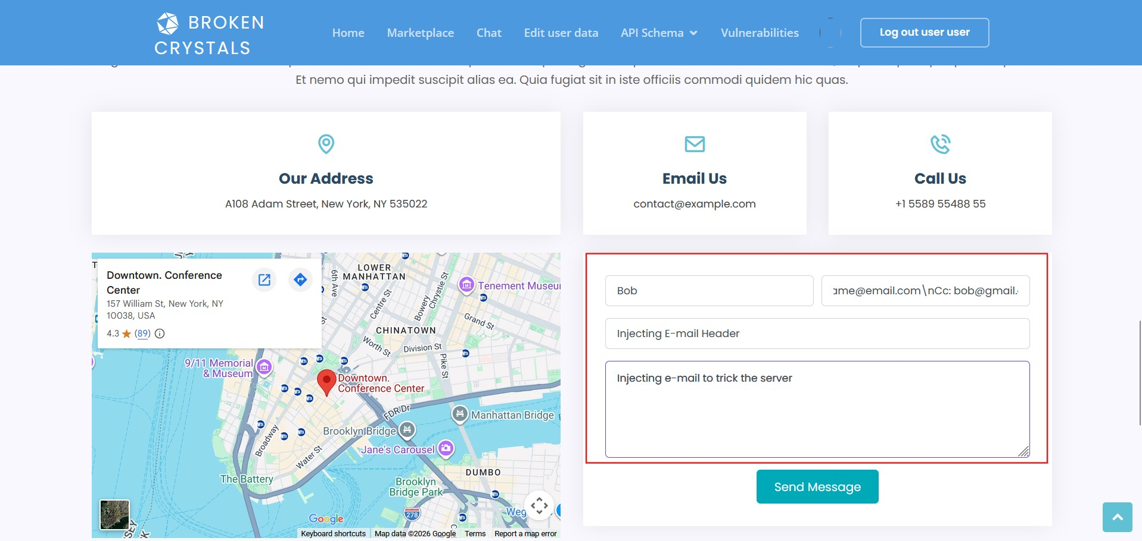
Step 1 – Broken Crystals email support form

Step 2 – Inject a New Email Header
Capture the request and send it to Burp Suite Repeater. Modify the email-related parameter so it contains a URL-encoded newline followed by a Cc header.
Tested input:
username@email.com%0aCc:%20bob@gmail.com
The purpose is to determine whether the application treats the newline as ordinary input or interprets it as a separator between email headers.

Step 3 – Send the Modified Request
Send the modified GET request to /api/email/sendSupportEmail. The server returns HTTP/1.1 200 OK and a JSON response stating that the email was successfully processed.
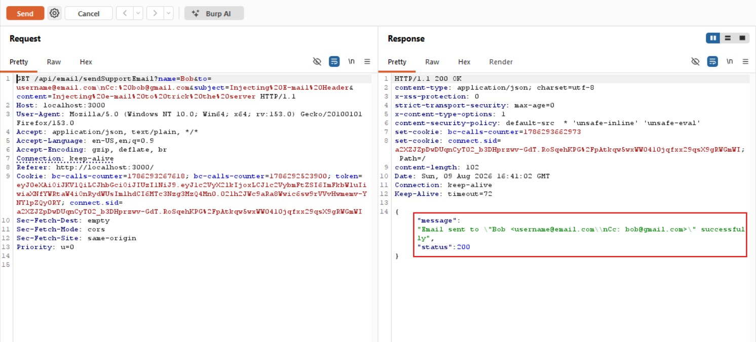
Step 3 – Burp Suite request and response showing the injected Cc header

Step 4 – Verify the Injected Header
The response reflects the supplied email value together with the injected Cc information. This shows that the newline and additional header were accepted instead of being rejected or removed.
The screenshot provides the main evidence: the request contains the encoded line break and Cc header, while the response confirms successful processing. This behavior is consistent with email header injection.

Payload Explanation
%0a – URL-encoded line-feed newline character. It is used to attempt to end the existing header value and start another header.
Cc: – The email carbon-copy header. When placed after the injected newline, it may be interpreted as a separate email header.
%20 – URL-encoded space character. It separates the Cc header name from the recipient address.
Combined effect – The sequence attempts to place a new Cc header inside attacker-controlled input. If the value is later used to construct raw email headers, the attacker may influence the recipients of the outgoing message.

7. Observations
The application accepted attacker-controlled newline characters in the email-related parameter and processed the request successfully. The response reflected the injected Cc information rather than rejecting the input.
This demonstrates insufficient protection around email-header construction. The final impact depends on how the backend passes these values to its email/SMTP component.

8. Affected Endpoint
GET /api/email/sendSupportEmail
Injection mechanism: URL-encoded newline (%0a) followed by an additional email header

9. Impact
Email Header Injection can allow manipulation of email headers generated by an application. Depending on the mail implementation, an attacker may add unauthorized recipients, redirect copies of messages, or alter other email metadata.
It may also be abused for unwanted email delivery or to interfere with the application's intended communication flow.

10. Remediation
Reject CR/LF Characters: Validate email-related input and reject carriage-return and line-feed characters before placing values into email headers.
Use Structured Mail APIs: Provide recipients, Cc, Bcc and subject through dedicated mail-library fields rather than constructing raw headers from user-controlled strings.
Validate Email Addresses: Apply strict server-side email-address validation and reject values containing header syntax.
Normalize Before Validation: Decode and normalize input before validation so encoded newline representations cannot bypass filtering.

11. Conclusion
The assessment confirms that the Broken Crystals email-support functionality is vulnerable to Email Header Injection (SMTP Injection). A URL-encoded newline followed by a Cc header was accepted as part of attacker-controlled input and reflected in the processed email information.
The captured request and response demonstrate unsafe handling of header-separating characters. Strict CR/LF validation and structured email APIs should be implemented to prevent attacker-controlled input from creating additional email headers.

