**SEidahoweather.com**

**Site Name:**

SEidahoweather.com

**Site Purpose:**

The purpose of this website is to inform the audience of the current and upcoming weather in the Southeast Idaho Region. Temperature, Climate, Windchill, and other conditions will be easy to find. This website will also be used in a CIT 230 class to demonstrate different styles, skills, organization, and elements.

**Target Audience & Scenarios:**

**Who:** Residents, visitors, or travelers in the Southeast Idaho region. **Age:** 12+ **Technology:** Laptops, desktop computers, mobile devices, tablets **Motivation:** To be informed about the current and future weather situation.

**Name: Brenna Gibson**

**Occupation:** Stay-at-home Mom  
**Demographics and Education:** 34 years old. Bachelor’s degree in Child Psych.  
**Goals and motivation for using the site:** Plan out her daily/ weekly schedule and plan accordingly.

**Name: Richard Smith**

**Occupation:** Contractor  
**Demographics and Education:** 50 years old. Independent contractor.

**Motivation for using the site:** To be informed of the weather conditions to direct his crews if they can work on projects that day/ week.

**Scenarios:**

1. Will I need to dress the kids warm for today’s soccer game?
2. Will my crew need to postpone a working on the roof of a house today?
3. Is it too cold for the kids to go out and play?
4. Should my crew bring tarps for today’s project?
5. When will the sun set today?

**Site Map:**

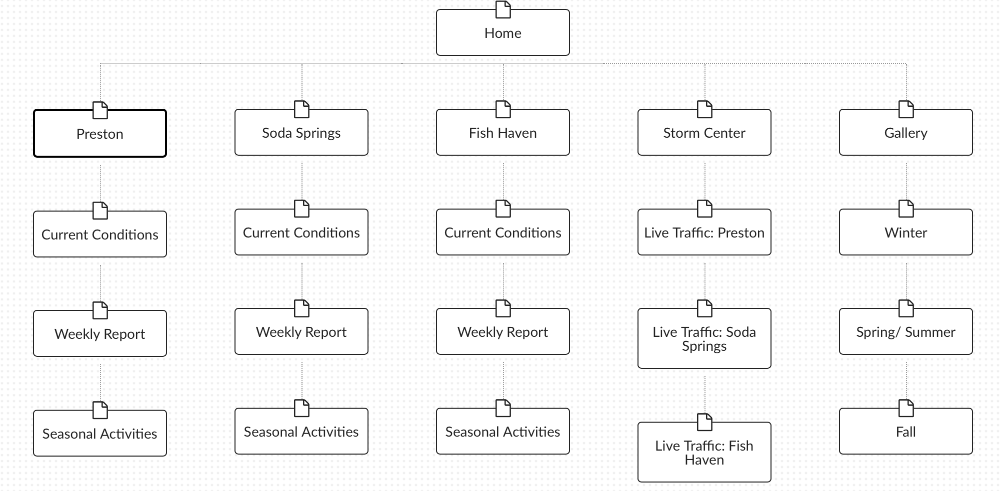

**Color Scheme:**

Dark Slate Grey: #2F4F4F

Black: #000000

Steele Blue: #4682B4

White: #FFFFFF

**Typography:**

Font: Helvetica

Site Header: 40 px

Primary Navigation: 30 px

Footer Navigation: 20 px

H1: 30 px

H2: 25 px

Paragraph text: 16 px