Question 1.

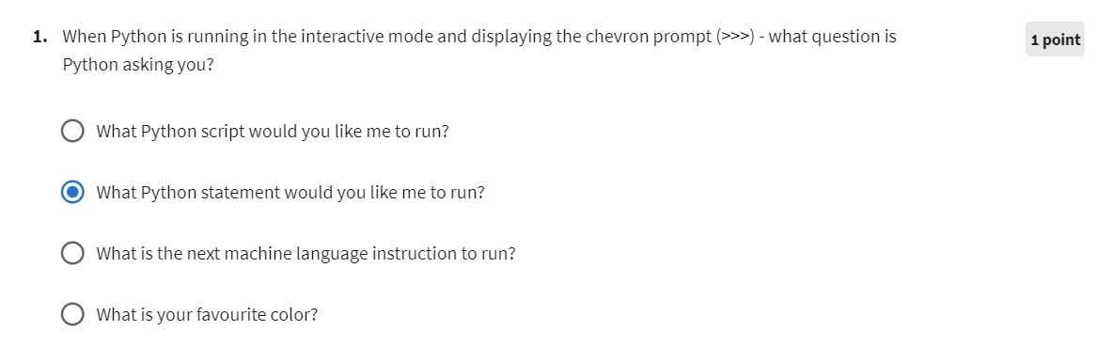

Question 2.

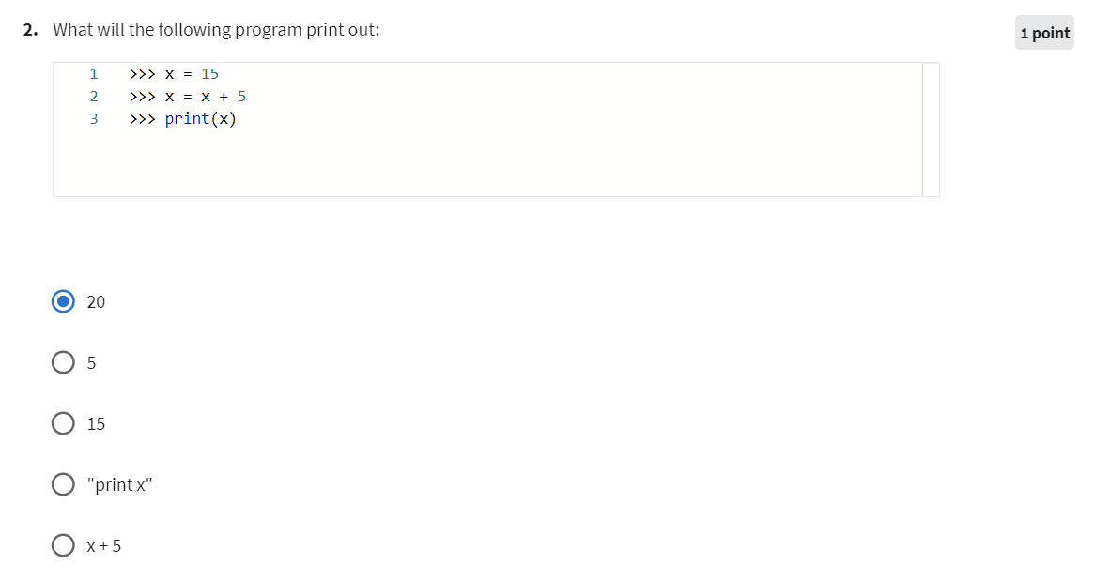

Question 3.

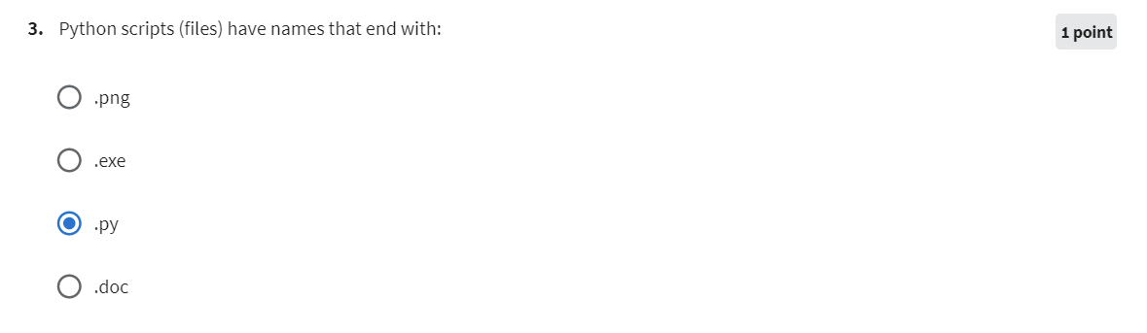

Question 4.

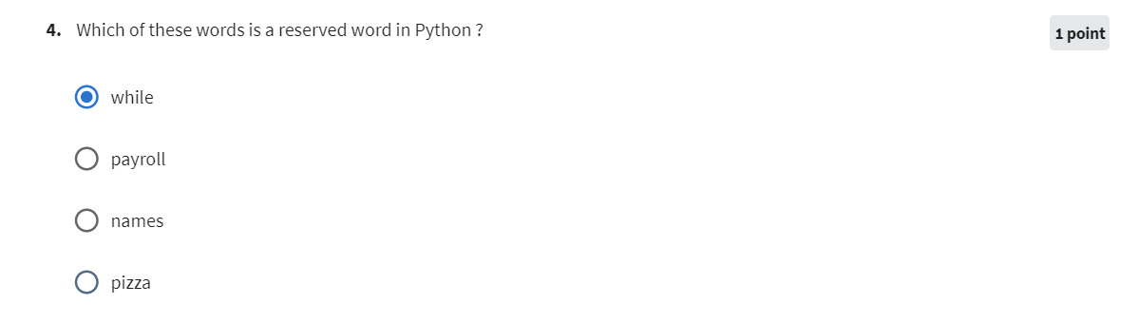

Question 5.

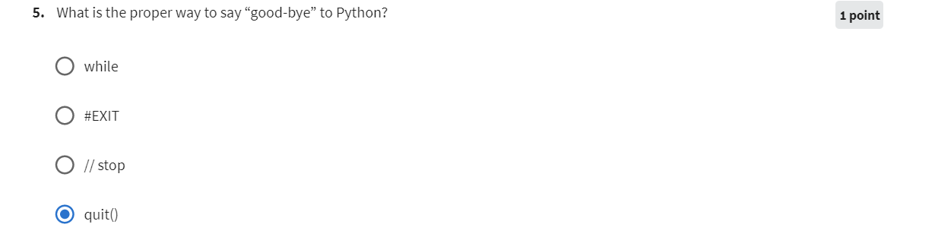

Question 6.

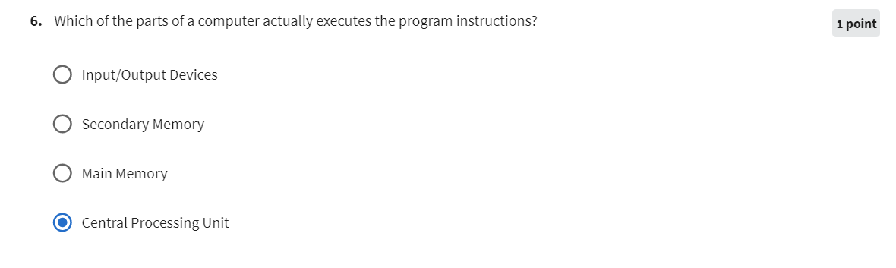

Question 7.

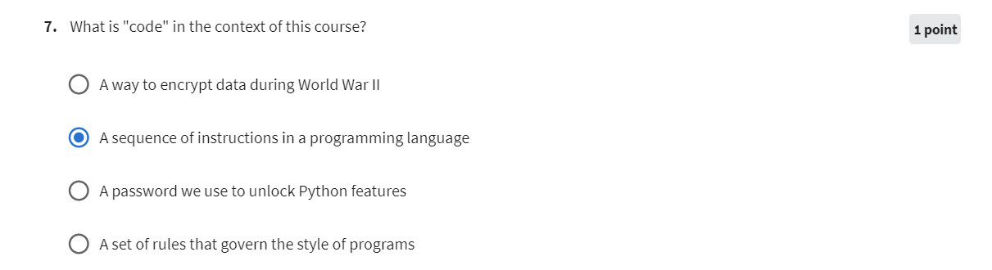

Question 8.

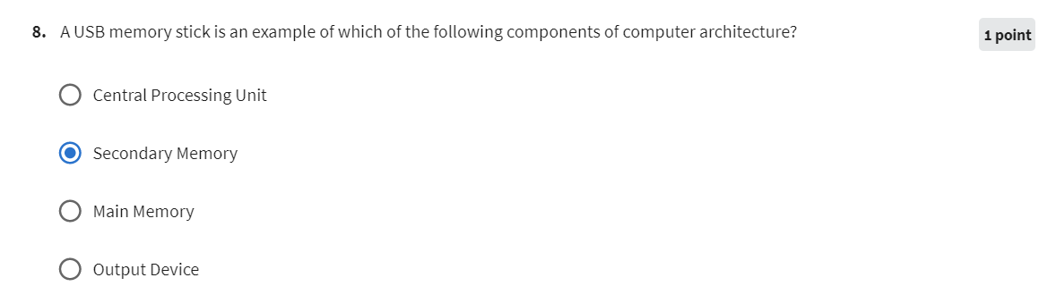

Question 9.

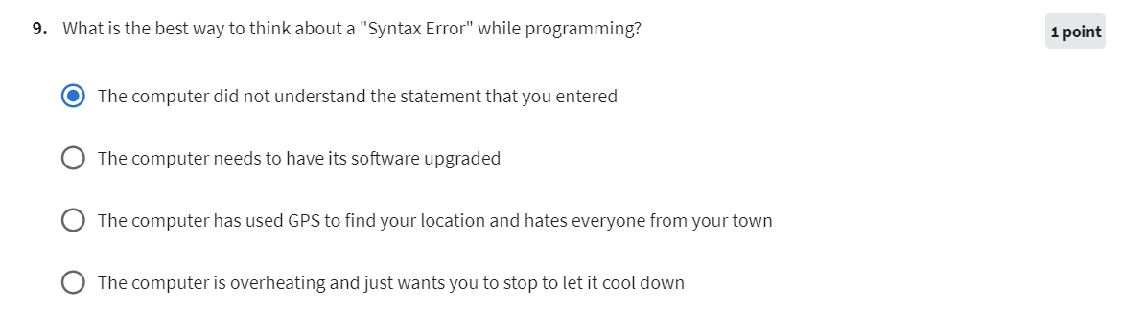

Question 10.

