Exercise 1.

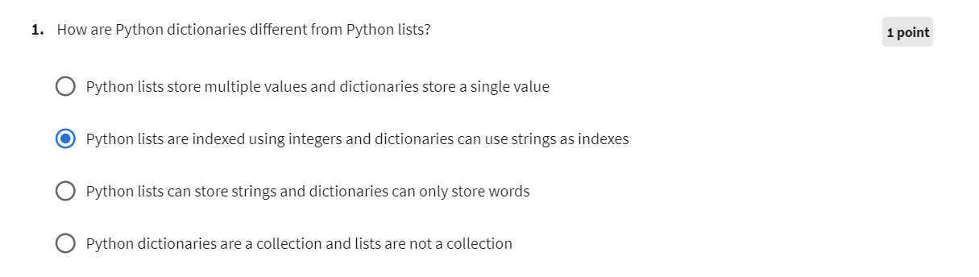

Exercise 2.

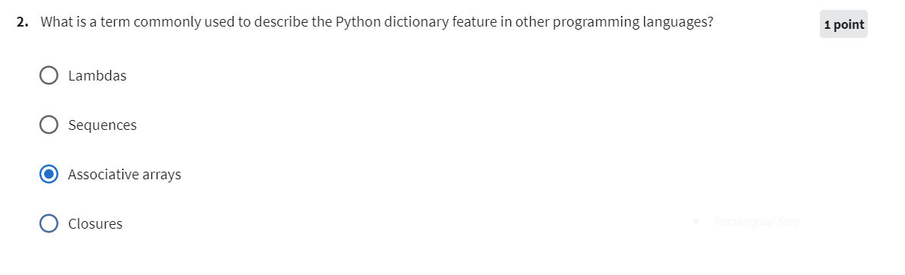

Exercise 3.

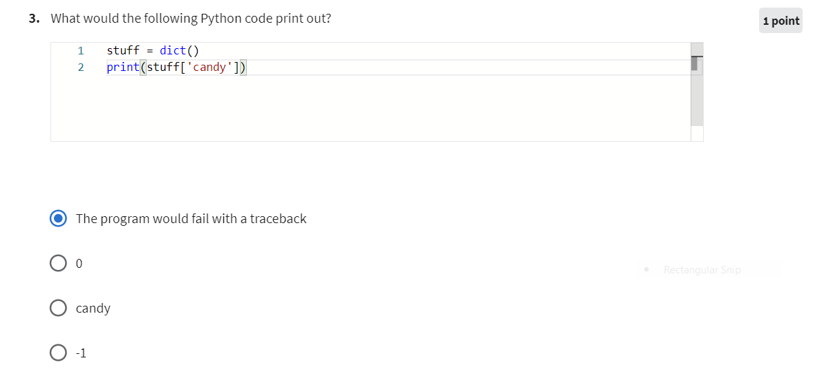

Exercise 4.

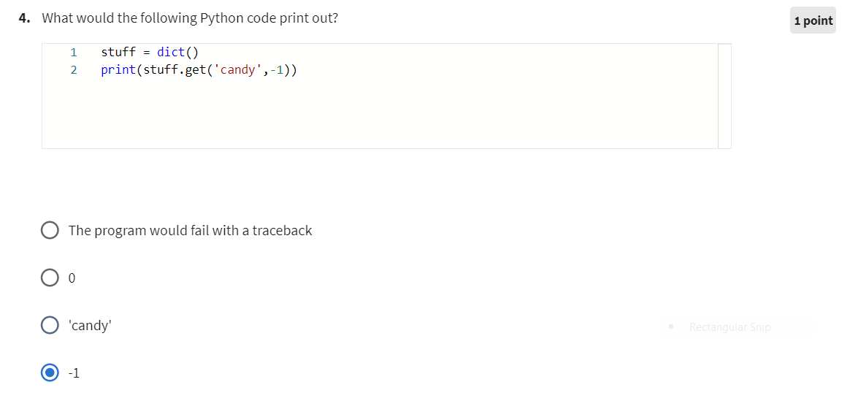

Exercise 5.

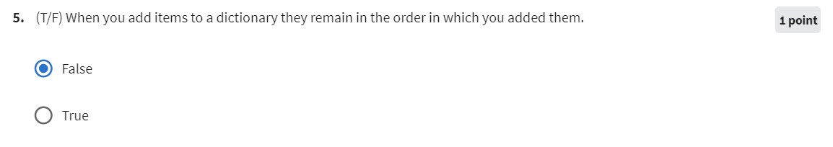

Exercise 6.

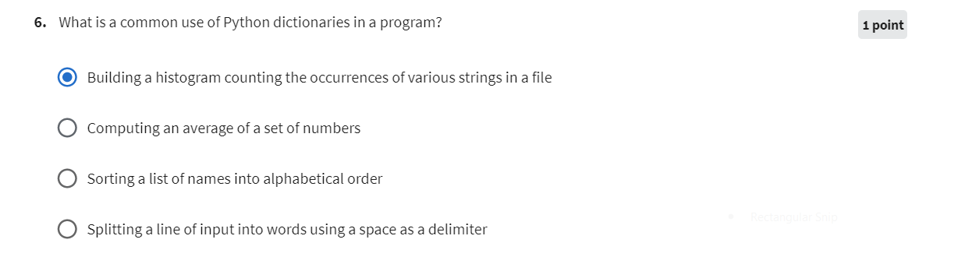

Exercise 7.

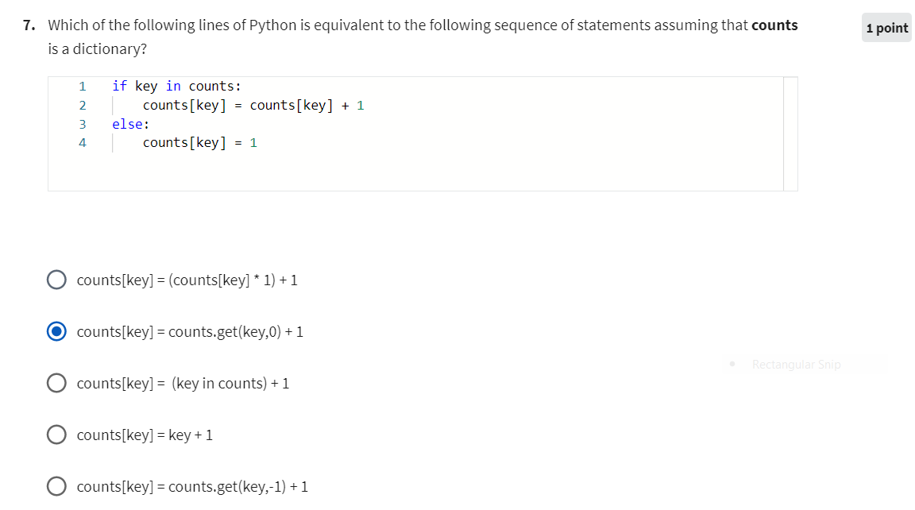

Exercise 8.

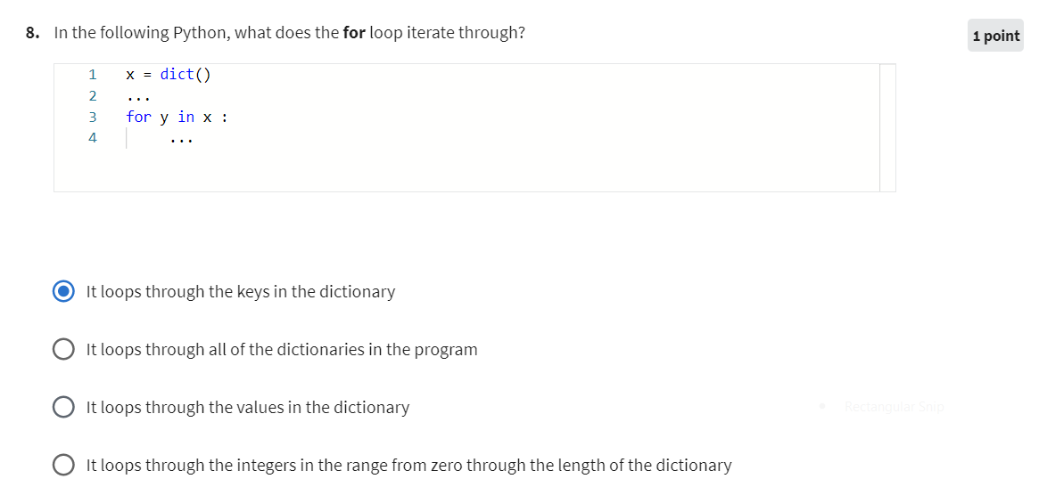

Exercise 9.

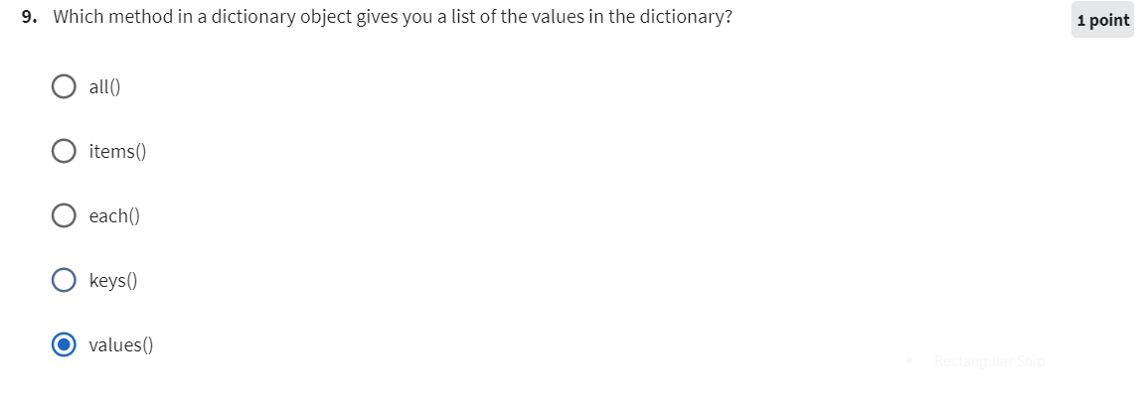

Exercise 10.

