**Faculty Activity Database Application**

User Documentation

*Kim Desorcie, Jess Dopkant and Pawel Baltaziuk*

# Main Functions

## Login

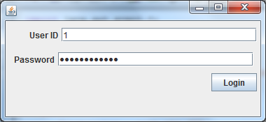

To log in, enter your user ID and your password, and click “login”. If your login credentials are correct, the main view will open. Else, the following prompt will appear:

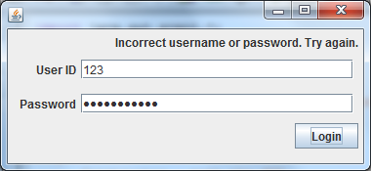

**Main Window**

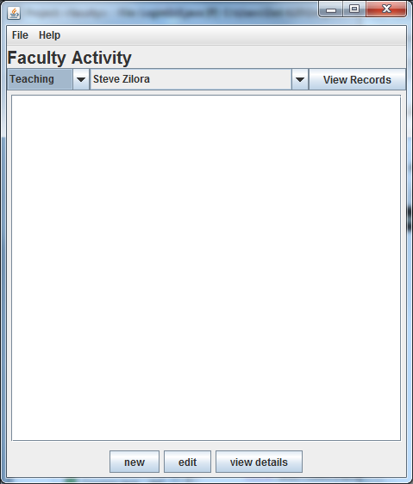

## View Records

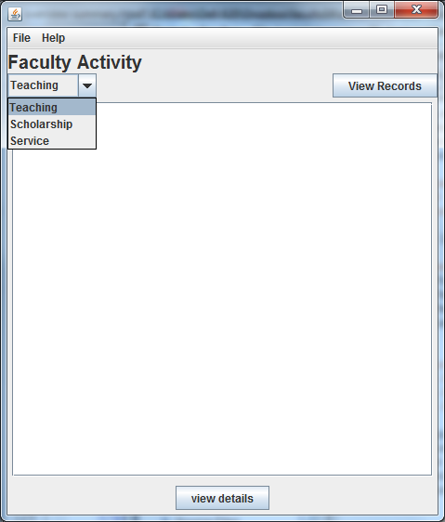

Use the drop-down list at the top left to select a type of record to view and click “view records”. For faculty members and administrative assistants, this dropdown has the options “teaching”, “service” and “scholarship”. The chair will see the additional options “kudos” and “users”.

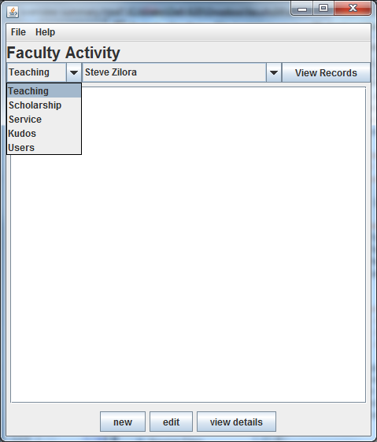

If you are a regular faculty member, simply clicking “view records” will display a table of all records of the selected type that pertain to you.

If you are an administrative assistant or the chair, you will see a second drop-down that lists all faculty members. To see any single faculty member’s records, select their name from the second drop-down before clicking “view records”.

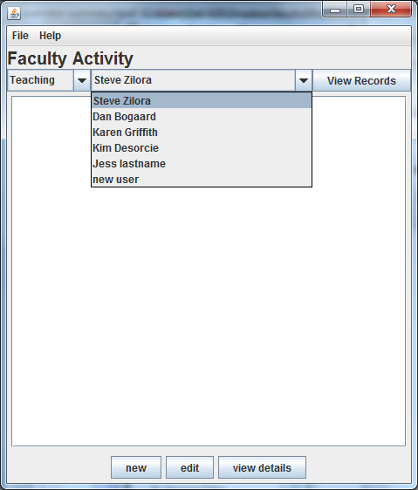

## Help

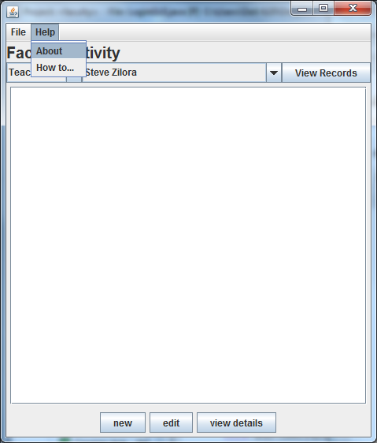

To get help after logging in, select “help” from the top bar, and then choose the “How to...” item. Help information on how to view records, make a new record, or edit an existing record will appear in a popup window. When you are done, just close this window - it will not affect your session.

## Record Detail View/Add/Edit Page

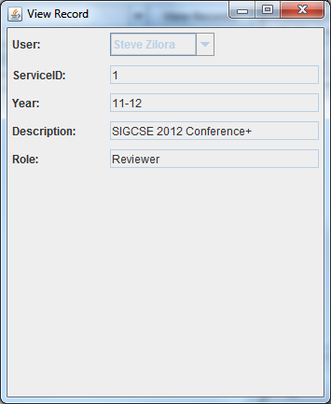

Upon selecting one of the records from the list view, there will be an option to view the record details in a separate window. This will allow the user to view the complete contents of the record which in some cases may be cut off in the full table view.

Depending on the user’s permissions, the the ability to add or edit a record of the specified type will also be available. The page is similar to the view details page but with editable fields and and option to save the new or updated record.  
Note, if you try to click the view or edit button without a record selected, the following error message will popup:  
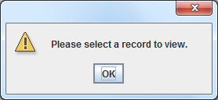

# Admin Functions

Only the chair and administrative assistants can use the admin-only functions.

## Edit Records

To edit a record, select it in the main view, and then click the “edit” button in the lower right. This will open a new window with the record info preloaded into the fields for you. Change the information you want, then click ‘save’ in the lower right.

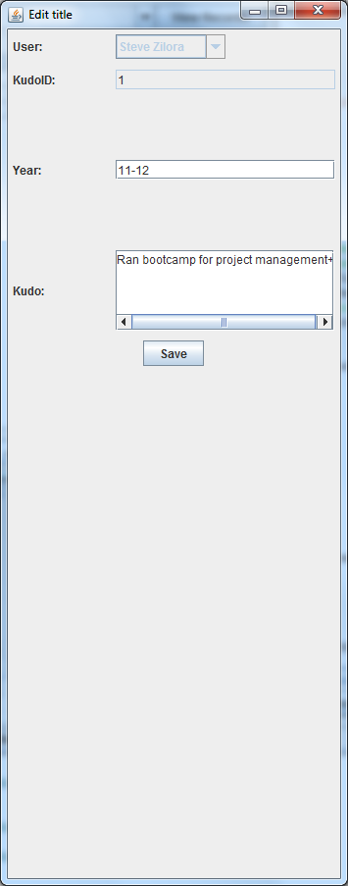

## Add New Records

To add a new record, first load the table list with the record type that you are adding, and then click the “new” button in the lower right. This will open a new window with each of the different record type attributes given an empty text field to enter the info into. To fill out a new record for a different user, select their name from the drop-down list. Simply click ‘save’ when done.

