BRGY. KANLURAN
POBLACION 1
City of Sta. Rosa
HISTORY
In May 1903 Census, there were 14 barrios namely Aplaya, Balibago, Caingin, Dita, Dila, Ibaba, Macabling, Malitlit, Pook, Pulong Santa Cruz, Santo Domingo, Sinalhan and Tagapo. An additional barrio was curved out of Barrio Santo Domingo on November 5, 1964.

INFORMATION
Kanluran is a quarter in Santa Rosa, Laguna and has about 4,790 residents. Kanluran is situated nearby to the quarter Malusak and the neighborhood Baynosa Compound.

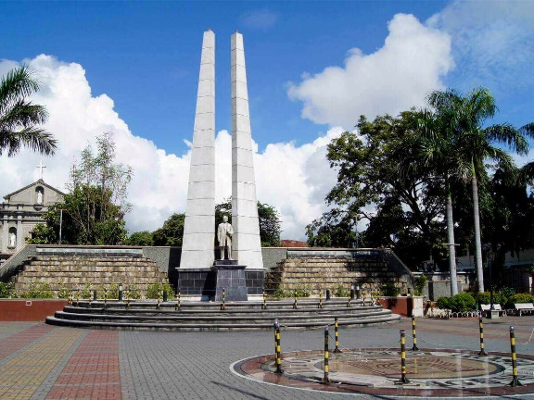
TOURIST ATTRACTIONS
AND PROMINENT PLACES
Sta. Rosa Plaza
It is in the city proper where the tallest pylon in the Philippines (behind the statue of Dr. Jose Rizal), with a length of 18.3 meters off the ground, is located.

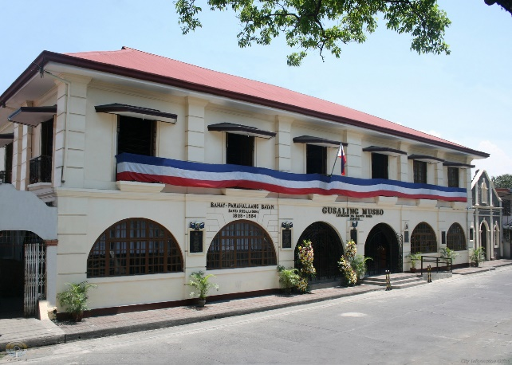
Museo De Sta. Rosa
Gusaling Museo (primarily a “Bahay-Pamahalaan”) is a two-story building which was built in 1828 during the Spanish period as government building under the reign of Hon. Don Bernardo Zavalla, refitted in 1954, became Museum on January 17, 2006 (soft opening), the old government building of Santa Rosa was redesignated as the “City of Sa nta Rosa Museum” a nd inaugurated on August 23, 2006

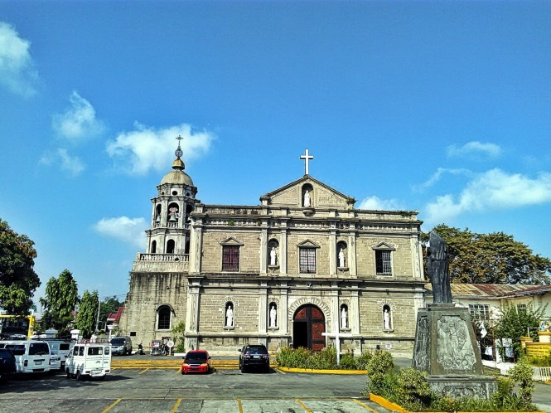
Sta.Rosa de Lima Parish
The church of Santa Rosa Laguna was built sometime in 1796, and its first curo paracco or parish priest was Padre Francisco Favier. The church, which was built during the Hispanic era, is made of adobe, bricks and stone. And just like the typical church built during the colonial era, The Santa Rosa de Lima church sits right in front of a large plaza. One of the highlights of this church is ist hexagonal-shaped belfry with a globe on top of it. Other important details are its doors with its intricate carvings.
Construction of the Santa Rosa de Lima Parish Church begun in 1796. The citizenry helped in the procurement of materials. They supplied albumin (egg white) which when mixed with lime and mortar served as cement that cohered the adobe stones firmly. After 16 years, the church was completed. The Zavalla Manuscripts disclosed that the church was blessed on August 4, 1812 and the first holy mass with homily was celebrated on August 30, 1812.
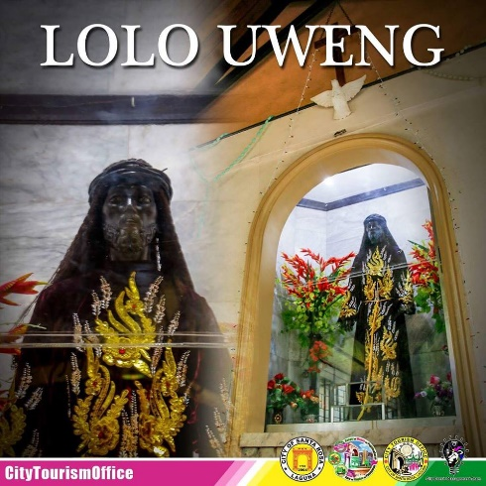
Lolo Uweng
One of the most visited places in Brgy. Kanluran

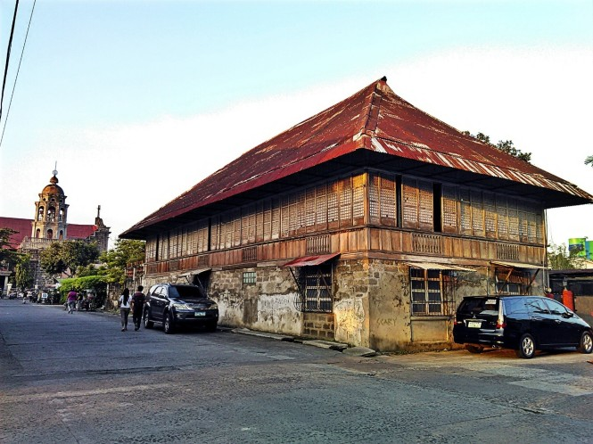
Ancestral Houses
Andres B. Savalla
Situated in Barangay Kanluran just near the Santa Rosa de Lima Parish Church, the Zavalla ancestral house or known as Andres B. Zavalla house has been the home of Andres Barroma, a former gobernadorcillo

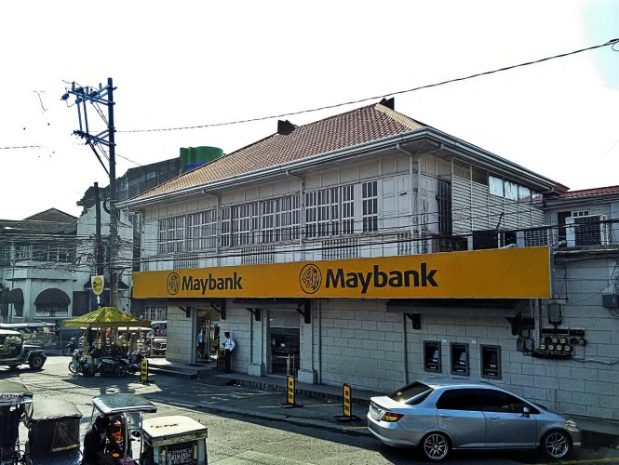
Gomez Residence
One of the ancestral houses
This has been a high school building between 1950’s-1980’s

Canossa School
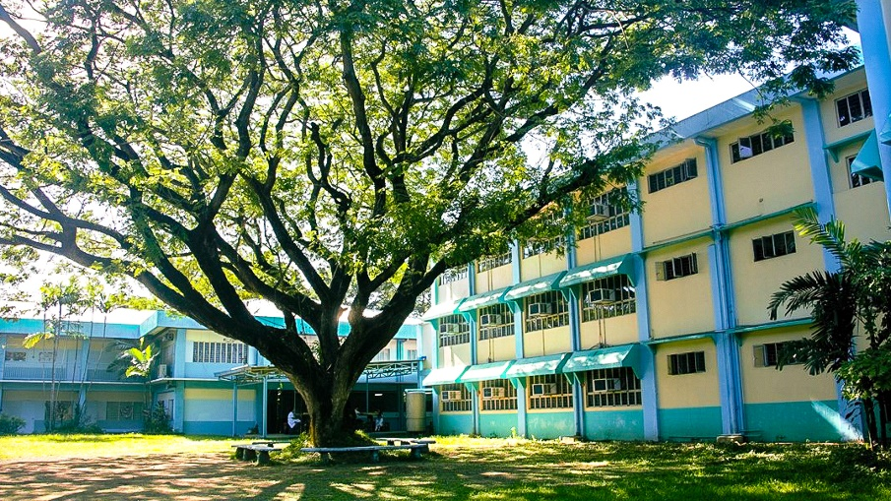
Canossa School opened its doors on June 14, 1954
The school was named in honor of their foundress St. Magdalene of Canossa.
Canossa School opened its doors on June 14, 1954, they completed the first group of Canossian Sisters in the Philippines. This first community was composed of: M. Carolina Colombo, the Superior, M. Anna Bautista, M. Miriam Tavecchio, the school principal, M. Cecilia Pereira, M. Zita Bereta, M. Teresina Cantu, the kindergarten teachers and with 4 lay teachers namely: Ms. Ida Tiongco, Ms. Eufrocina Custodio, Salome Sanchez, Dolores Rodriguez and Mrs. Agulto. The school was named in honor of their foundress St. Magdalene of Canossa whose main goal in the educational and pastoral work as to fulfill the mission, “to make Christ known that He may be loved.”
It is one of the four schools owned and administered by the Canossian Sisters, who belong to the religious congregation named the Canossian Daughters of Charity which originated in Verona, Italy. They came to the Philippines in 1954 from the Canossian Province of Hong Kong to open apostolic missions

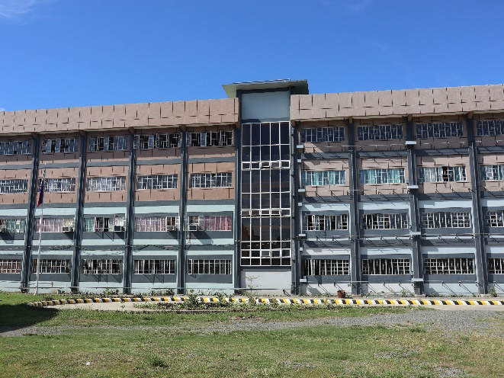
POLY TECHNIC UNIVERSITY OF THE PHILIPPINES


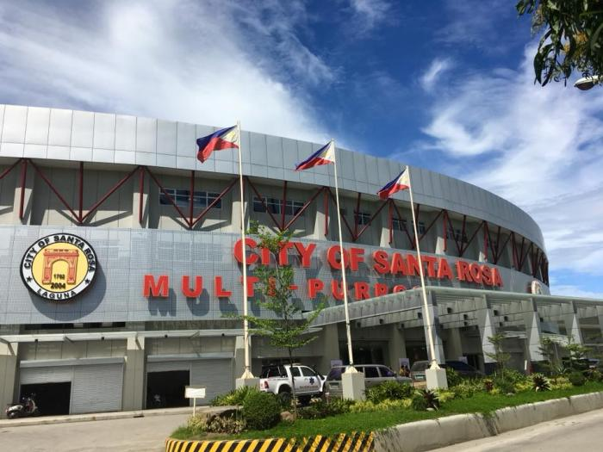
Sta. Rosa Multi-Purpose Complex

CHANGES AND PROJECTS
1950’s
- no electricity yet
- few houses
- The place was mainly farmland
- lots of star apple and bananas trees
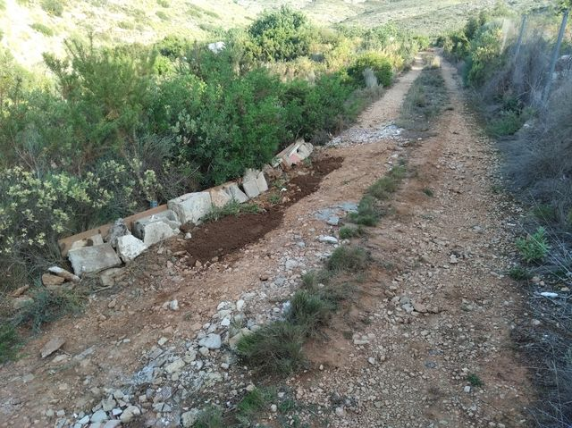
- A vast field of rice also existed
- farm animals like carabaos, goats,
cows, and hogs owned by the residents roamed around the area.
- Their means of transportation was calesa or walking.
- The streets were not concrete and they used to walk on “escombro” type of soil then.
1960’s
- the place was beginning to be occupied by the chlidren of the residents who got married and built their houses on the lands they have acquired through inheritance.
- Their houses were usually located at the side or the back of their parent’s or grandparent’s houses.
1970’s
- During the 70’s more development came like the concreting of the roads, which was under the administration of MAYOR TIONGCO.
- As times passed by there were many developments. Hundred percent of the community land area were occupied. Some of the old houses were renovated gradually from woods to concrete type of houses.
PRESENT
- SOME OF THE OLD HOUSES WERE RENOVATED AND BECAME BUSINESS CENTERS
- YOU CAN FIND MANY FOOD OUTLETS ACROSS THE STREETS OF BRGY. KANLURAN,
- TESDA Mobile Training Bus Plus Goes to Sta. Rosa City
Barangay Kanluran, Sta. Rosa City is the new venue of the Mobile Training Bus Plus. According to TESDA Laguna Provincial Director Al Arriola, the program will start on September 26 with the following courses: Cellphone Repair, Computer Hardware Servicing, Mechatronics, Sheet Metal Arc Welding, Beauty Care, and Massage Therapy. The mobile training progam, a pet project of Secretary Joel Villanueva will train a total of 157 youths and unemployed adults.

POPULATION
Historical population
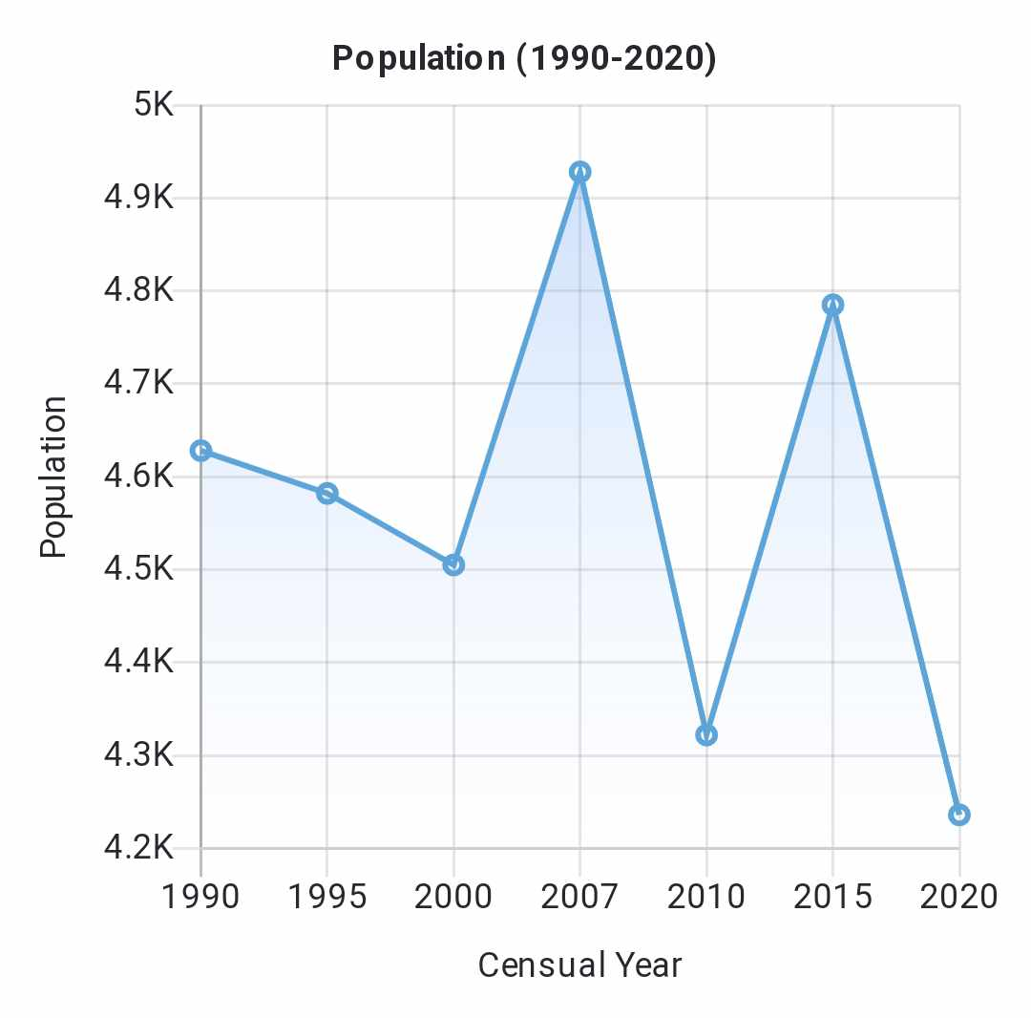
The population of Kanluran fell from 4,628 in 1990 to 4,236 in 2020, a decrease of 392 people over the course of 30 years. The latest census figures in 2020 denote a negative growth rate of 2.53%, or a decrease of 549 people, from the previous population of 4,785 in 2015.

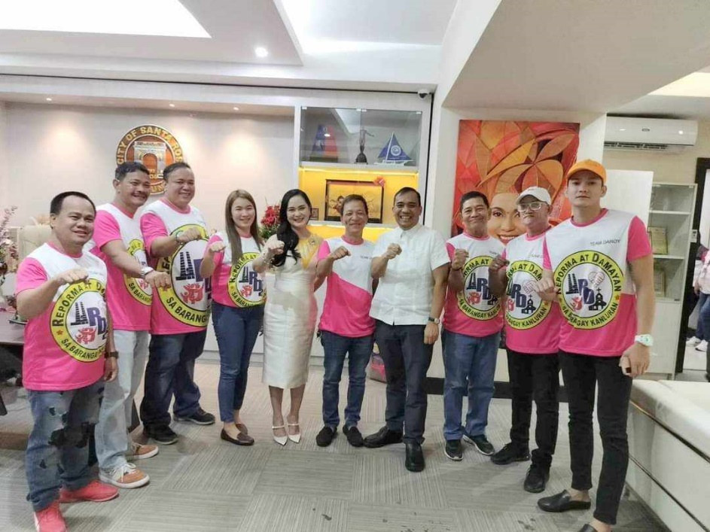
BRGY. OFFICIALS
- Barangay Chairperson(Captain)
HON. RONALDA A. DAROY
- Roderick Barriga
- Rodwen Recuenco Santiago
- Jayson League
- Nhe Rie Penales
- Paulo Beato Papagayo
- Agit Yambao
- Benson Fampulme

