QUIZ ARENA SYSTEM DOCUMENTATION

CHAPTER 2: CRUD OPERATIONS

Administrator CRUD
User Accounts – C, R, U, D (Teachers & Students)
System Settings – C, R, U
Leaderboard – R, U, D (reset rankings)
Rewards – C, R, U, D
Results Archive – R, D

Teacher CRUD
Quiz – C, R, U, D
Question Bank – C, R, U, D
Student Results – R
Issue Rewards – C, R
Leaderboard Viewing – R

Student CRUD
Profile – R, U
Quiz Attempt – C
View Results – R
View Leaderboard – R
View Rewards – R

CHAPTER 3: DATA FLOW DIAGRAMS

Level 0 DFD
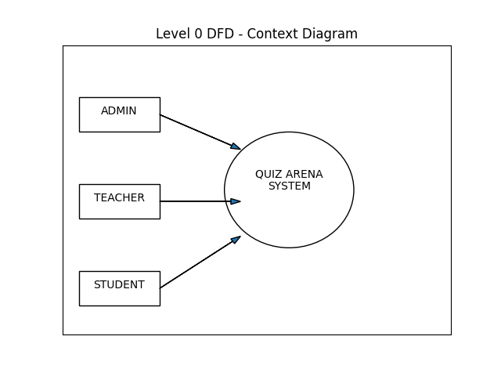

Level 1 DFD
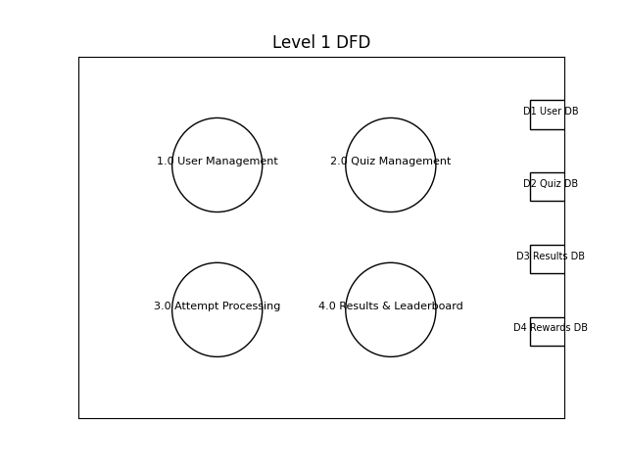

Level 2 DFD
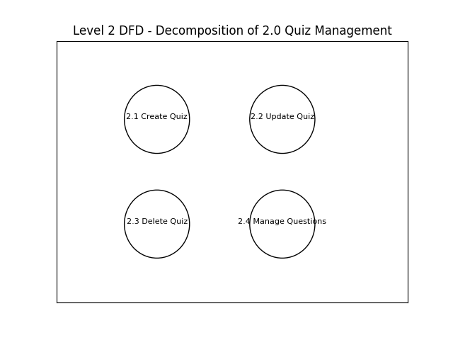

CHAPTER 4: DATA DICTIONARY
USER TABLE
user_id (PK) – Unique identifier
full_name – Complete legal name
username – Login credential
password_hash – Encrypted password
role – Admin/Teacher/Student
avatar_url – Profile image path
created_at – Account creation date
QUIZ TABLE
quiz_id (PK) – Unique quiz ID
title – Quiz title
description – Quiz description
teacher_id (FK) – Creator reference
time_limit – Time duration
created_at – Date created
QUESTION TABLE
question_id (PK) – Unique question ID
quiz_id (FK) – Related quiz
question_text – Question content
option_a/b/c/d – Choices
correct_answer – Correct option
difficulty – Easy/Medium/Hard
RESULT TABLE
result_id (PK) – Attempt ID
student_id (FK) – Student reference
quiz_id (FK) – Quiz reference
score – Points earned
completion_time – Time spent
date_taken – Attempt date
LEADERBOARD TABLE
leaderboard_id (PK) – Ranking ID
student_id (FK) – Student reference
total_points – Accumulated points
rank_position – Current rank
last_updated – Update timestamp
REWARDS TABLE
reward_id (PK) – Reward ID
badge_name – Name of badge
description – Badge details
student_id (FK) – Owner
issued_by (FK) – Teacher/Admin ID
date_issued – Date granted

