QUIZ ARENA SYSTEM

Data Flow Diagrams

Level 0 DFD - Context Diagram
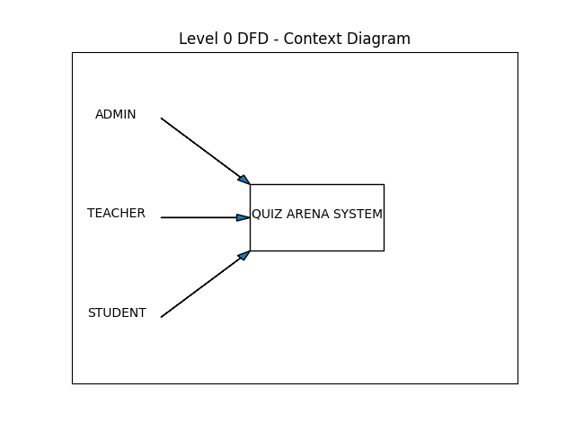

Level 1 DFD
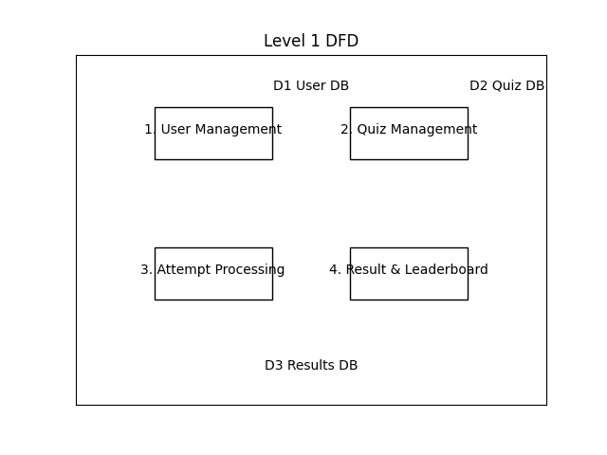

Level 2 DFD - Quiz Management Decomposition
