LISP (LISt Processing) is a family of programming languages designed for symbolic computation.

a. Different LISP Structures and Data
- Atoms:
  - Atoms are the simplest elements in LISP. They can be symbols or numbers.
  - Symbols: These are identifiers that represent variables or functions. For example, x, foo, and car are symbols.
  - Numbers: LISP supports various numeric types, including integers and floating-point numbers.
- Lists:
  - Lists are the primary data structure in LISP. They are composed of atoms and other lists.
  - Cons Cells: A list is built from cons cells, each consisting of two parts: car (the first element) and cdr (the rest of the list).
  - Notation: Lists are written in parentheses. For example, (a b c) is a list of three atoms, while ((a b) c) is a list containing another list and an atom.
- Other Data Structures:
  - Dotted Pairs: These are pairs where the second element is not a list. For example, (a. b) is a dotted pair.
  - Proper Lists: A proper list is a list where the cdr of the last cons cell is nil. For example, (a b c) is a proper list.

b. Atoms and Lists
- Atoms:
  - Symbols: Used for identifiers. In LISP, symbols are unique and are usually interned in a symbol table.
  - Numbers: Represent numerical values and can be used in arithmetic operations.
- Lists:
  - Construction: Lists are created using the cons function, which constructs a new cons cell. For example, (cons 'a 'b) creates a dotted pair (a. b).
  - Manipulation: Common functions for manipulating lists include car (returns the first element), cdr (returns the rest of the list), and list (creates a new list from its arguments).

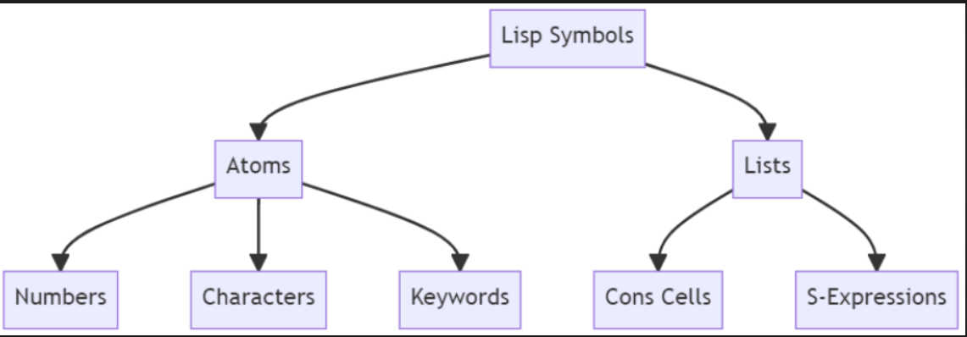

In Lisp, lists are a fundamental data structure and are internally represented in a way that allows for flexible and efficient manipulation. The internal representation of Lisp lists can vary slightly depending on the dialect of Lisp, but here’s a general overview:

Internal Representation of Lisp Lists
- Cons Cells: At the core of Lisp’s list representation are cons cells (or pairs). A cons cell is a data structure that contains two fields:
  - Car (Contents of the Address part of Register): This field holds the first element of the list (or the first cons cell in a pair).
  - Cdr (Contents of the Decrement part of Register): This field holds the rest of the list (or the second cons cell in a pair).
A list in Lisp is essentially a chain of cons cells where each cell points to the next cell in the sequence. The end of the list is typically indicated by a nil value, which represents an empty list or the end of the list.
For example, the Lisp list (a b c) is internally represented as:
(cons a (cons b (cons c nil)))

- Dotted Lists: In some cases, a list might not be properly terminated by nil. Such lists are called dotted lists and are represented as:
(a . b)
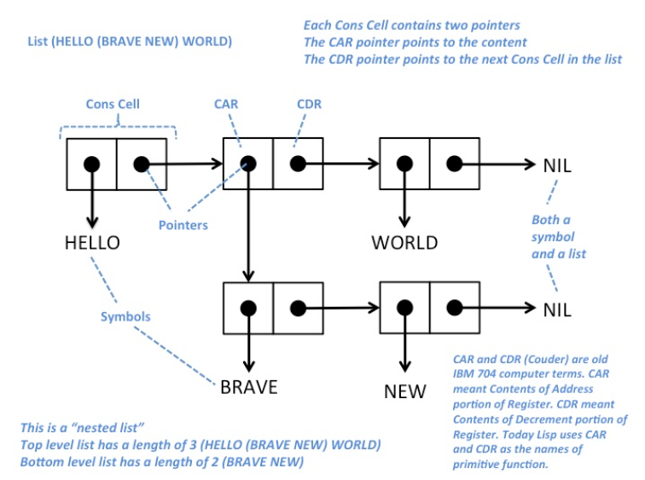
Here, a is the car and b is the cdr. Dotted lists are more general and can represent pairs where the second element is not a list.

In Lisp, nil is a special symbol that serves two primary purposes:
- Empty List: nil represents the empty list. When a list has no elements, it is represented as nil. For example, the list (a b c) is represented internally as (cons a (cons b (cons c nil))), and the empty list is simply nil.
- Boolean False: In Lisp, nil is also used to represent the boolean value false. In Lisp, any value that is not nil is considered true. So, nil is the only value that represents false in logical tests.

Dialects of Lisp
Different dialects of Lisp might have variations in their internal representation or additional abstractions, but the core concept of using cons cells to represent lists remains consistent. Some notable dialects include:
- Common Lisp: This is a standardized dialect of Lisp with a rich set of features and libraries. It uses cons cells to represent lists in the same way as described above.
- Scheme: A minimalist dialect of Lisp that also uses cons cells for lists but emphasizes a smaller, more consistent set of features compared to Common Lisp.
- Clojure: A modern Lisp dialect that runs on the JVM. It represents lists using immutable data structures, though the core concept of lists is still based on linked cons cells.
- Racket: A descendant of Scheme, Racket also uses cons cells for list representation but includes additional features and a more extensive standard library.

