Figuracion,John Glenn F.
2A1-1 BSCS

HEALTH CARE BILLING SYSTEM

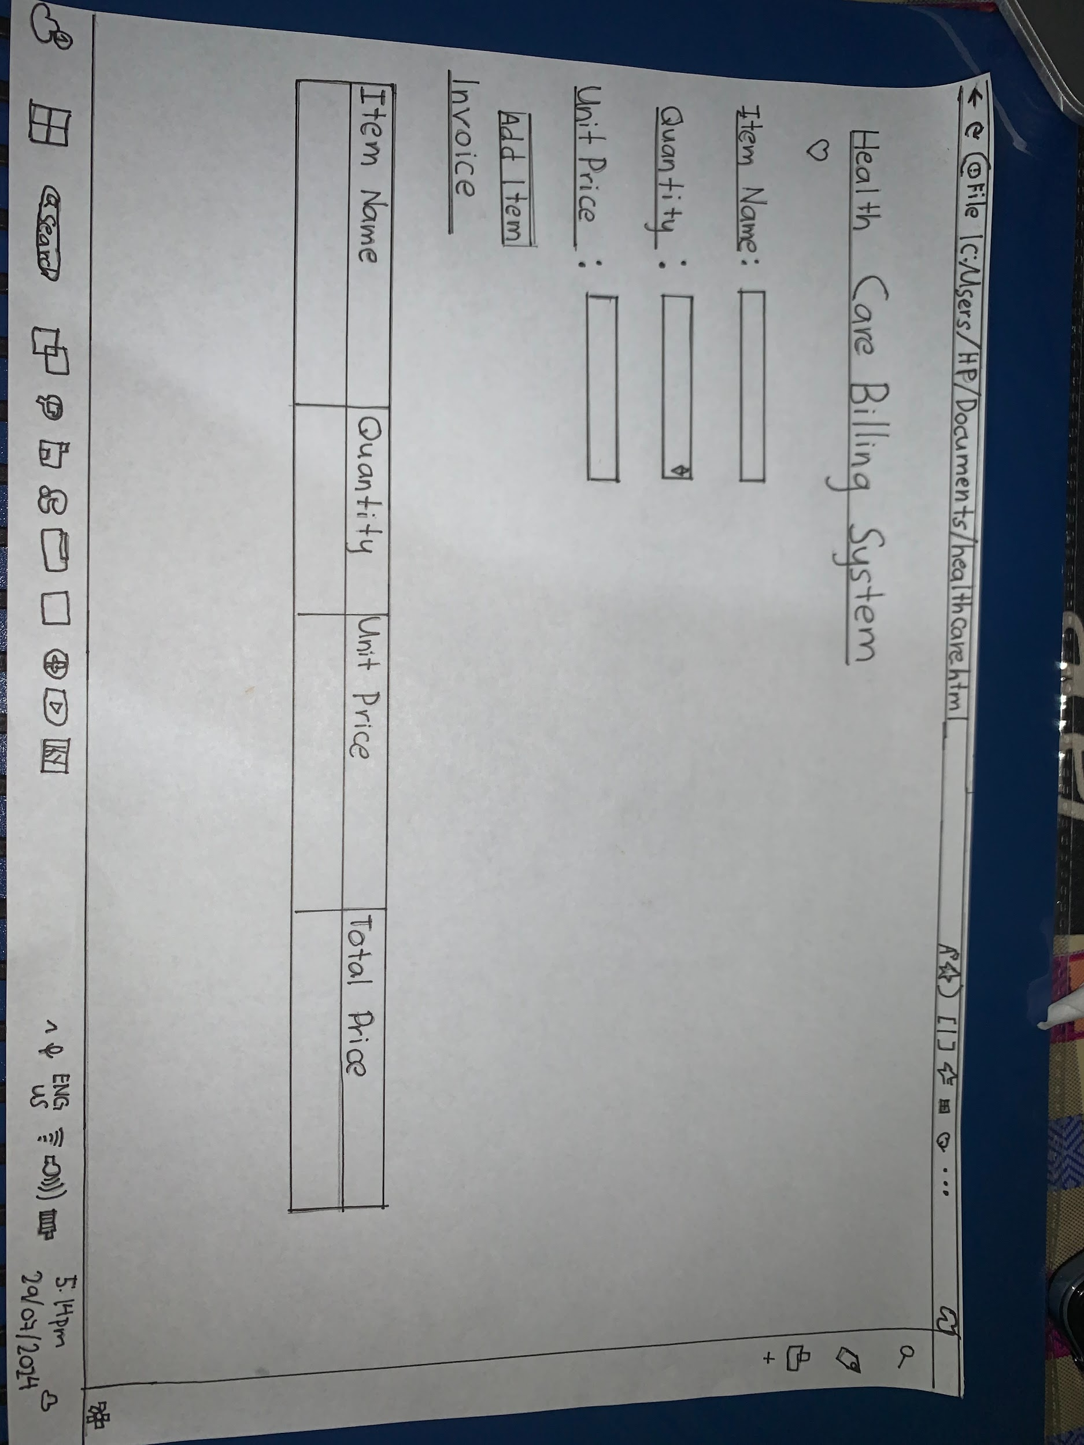
Figuracion John Glenn F.
Baito,Hannah Stephanie B.

