“The fast and the sorrow” –
Speech rate is affected by image induced mood
Dr. Achim Akademikermann
Analysis
Statistical analyses were conducted on speech rate (i.e. phoneme per second, henceforth PPS). To reduce the effect of outliers, for each participant and for each mood condition, PPS values outside of 2 standard deviations were excluded from the analysis. We excluded one student which did not match our inclusion criterion and participated due to a recruitment error (too old). We ran a linear mixed effects model on PPS predicted by the two-way interaction of mood and subject gender. We included random effects for speaker and experimental item. All data and code are available here: https://osf.io/cjaqx/
Results
There was a significant interaction between mood and gender (p = 0.02) with men speaking faster when exposed to sad images and women speaking faster when exposed to happy images (see Fig. 1).
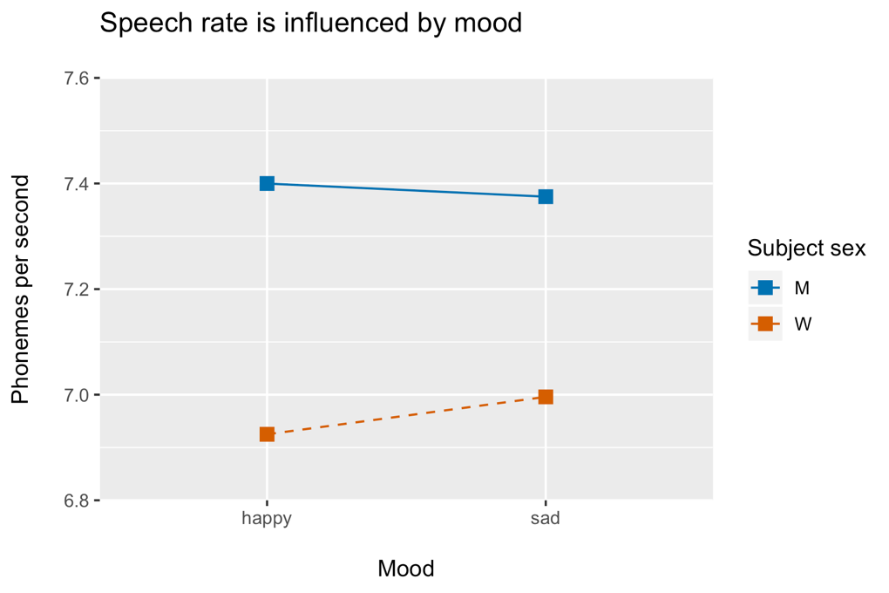
Figure 1: Mean speech rate (phonemes per second) as a function of mood induced by experimental images. Men exhibit more phonemes per second when describing a sad image, women exhibit more phonemes per second when describing a happy image.

E1: Go to our workshop materials and open the following folder:
Exercises/ReproduceThat/Group3

E2: Open the R script scrip03 in the subfolder scripts and try to run it. Does it run without errors? If not, what are the errors? Are you able to fix them?

E3: Try to reproduce the p value and the plot from the text above. Can you reproduce it? If not, why?

E4: Try to understand what has been done in this script. Can you follow? If not, why?

E5: What could have made this analysis more reproducible?

E6: Would you have analyzed the data differently?

