Mata Kuliah : PBO – TI – S1

Pertemuan : 1

Nama : Margareta Valencia

NIM : A11.2022.14704

**PRAKTIKUM 1**

**Tugas 1**

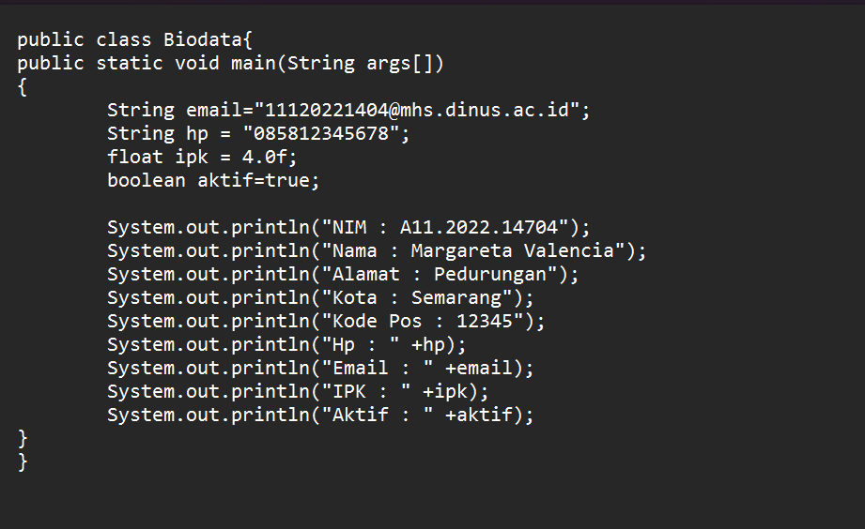Biodata.java

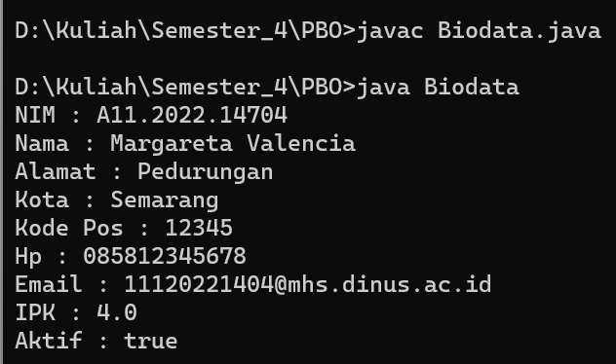

**Code :**

public class Biodata{

public static void main(String args[])

{

String email="11120221404@mhs.dinus.ac.id";

String hp = "085812345678";

float ipk = 4.0f;

boolean aktif=true;

System.out.println("NIM : A11.2022.14704");

System.out.println("Nama : Margareta Valencia");

System.out.println("Alamat : Pedurungan");

System.out.println("Kota : Semarang");

System.out.println("Kode Pos : 12345");

System.out.println("Hp : " +hp);

System.out.println("Email : " +email);

System.out.println("IPK : " +ipk);

System.out.println("Aktif : " +aktif);

}

}

**Tugas 2**

Luas dan Keliling

1. Persegi

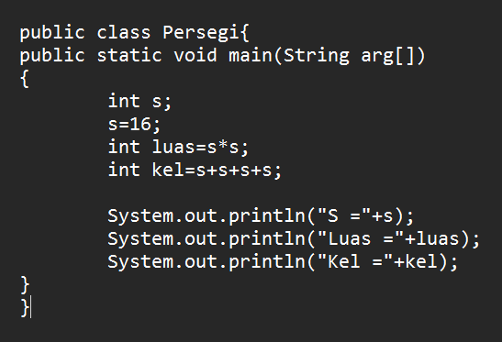

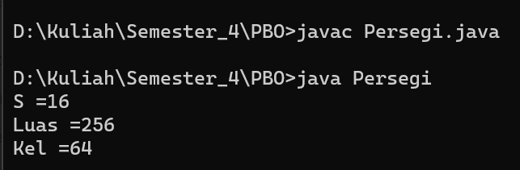

**Code :**

public class Persegi{

public static void main(String arg[])

{

int s;

s=16;

int luas=s*s;

int kel=s+s+s+s;

System.out.println("S ="+s);

System.out.println("Luas ="+luas);

System.out.println("Kel ="+kel);

}

}

1. Segitiga

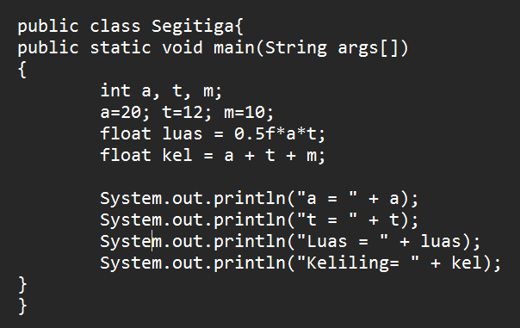

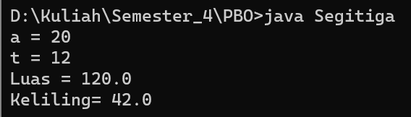

**Code :**

public class Segitiga{

public static void main(String args[])

{

int a, t, m;

a=20; t=12; m=10;

float luas = 0.5f*a*t;

float kel = a + t + m;

System.out.println("a = " + a);

System.out.println("t = " + t);

System.out.println("Luas = " + luas);

System.out.println("Keliling= " + kel);

}

}

1. Lingkaran

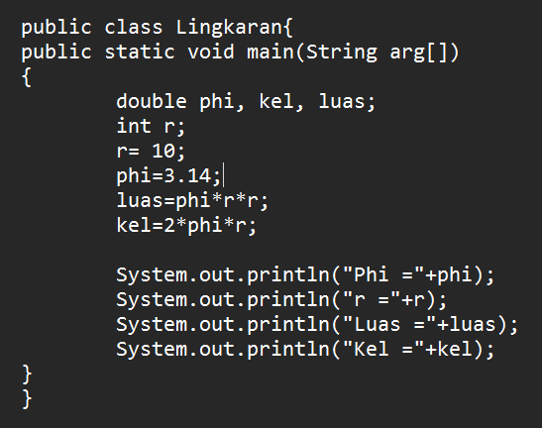

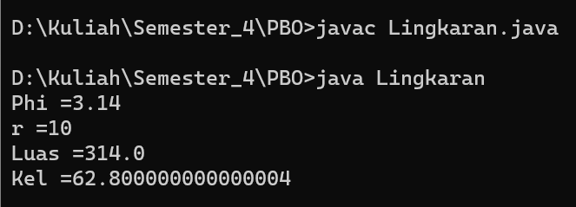

**Code :**

public class Lingkaran{

public static void main(String arg[])

{

double phi, kel, luas;

int r;

r= 10;

phi=3.14;

luas=phi*r*r;

kel=2*phi*r;

System.out.println("Phi ="+phi);

System.out.println("r ="+r);

System.out.println("Luas ="+luas);

System.out.println("Kel ="+kel);

}

}

1. Kubus

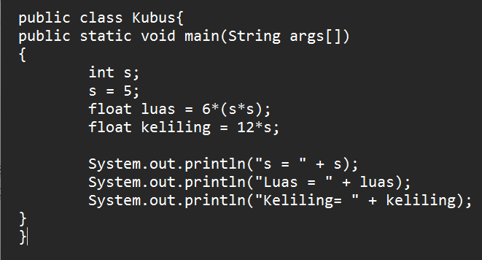

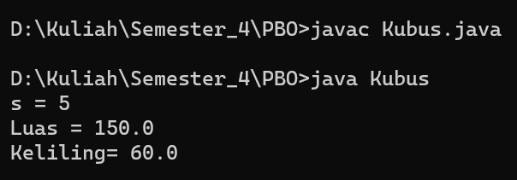

**Code :**

public class Kubus{

public static void main(String args[])

{

int s;

s = 5;

float luas = 6*(s*s);

float keliling = 12*s;

System.out.println("s = " + s);

System.out.println("Luas = " + luas);

System.out.println("Keliling= " + keliling);

}

}