Mata Kuliah : PBO – TI – S1

Praktikum : 2

Nama : Margareta Valencia

NIM : A11.2022.14704

**PRAKTIKUM 2**

**Latihan 1**

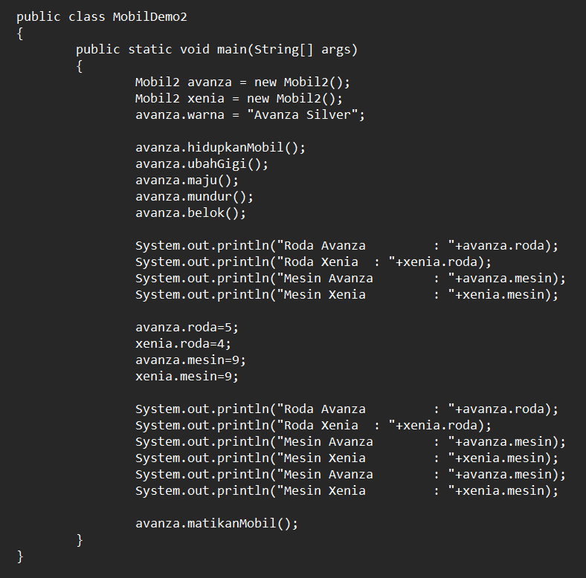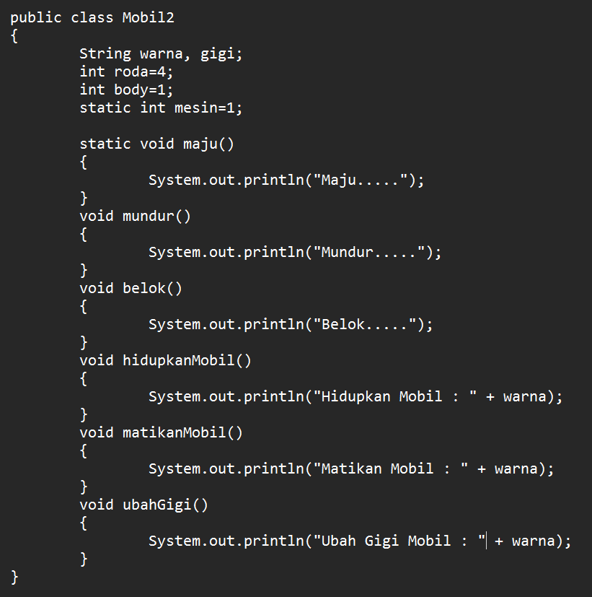Mobil2.java MobilDemo2.java

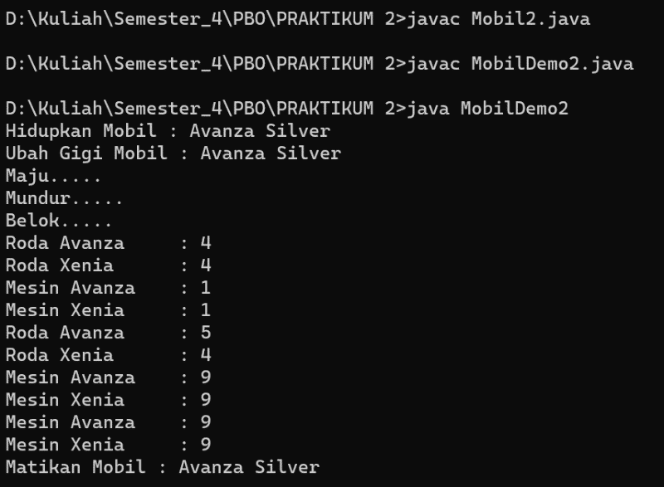

**Code Mobil2.java :**

public class Mobil2{

String warna, gigi;

int roda=4;

int body=1;

static int mesin=1;

static void maju(){

System.out.println("Maju.....");

}

void mundur(){

System.out.println("Mundur.....");

}

void belok(){

System.out.println("Belok.....");

}

void hidupkanMobil(){

System.out.println("Hidupkan Mobil : " + warna);

}

void matikanMobil(){

System.out.println("Matikan Mobil : " + warna);

}

void ubahGigi(){

System.out.println("Ubah Gigi Mobil : " + warna);

}

}

**Code MobilDemo2.java :**

public class MobilDemo2

{

public static void main(String[] args)

{

Mobil2 avanza = new Mobil2();

Mobil2 xenia = new Mobil2();

avanza.warna = "Avanza Silver";

avanza.hidupkanMobil();

avanza.ubahGigi();

avanza.maju();

avanza.mundur();

avanza.belok();

System.out.println("Roda Avanza : "+avanza.roda);

System.out.println("Roda Xenia : "+xenia.roda);

System.out.println("Mesin Avanza : "+avanza.mesin);

System.out.println("Mesin Xenia : "+xenia.mesin);

avanza.roda=5;

xenia.roda=4;

avanza.mesin=9;

xenia.mesin=9;

System.out.println("Roda Avanza : "+avanza.roda);

System.out.println("Roda Xenia : "+xenia.roda);

System.out.println("Mesin Avanza : "+avanza.mesin);

System.out.println("Mesin Xenia : "+xenia.mesin);

System.out.println("Mesin Avanza : "+avanza.mesin);

System.out.println("Mesin Xenia : "+xenia.mesin);

avanza.matikanMobil();

}

}

**Latihan 2**

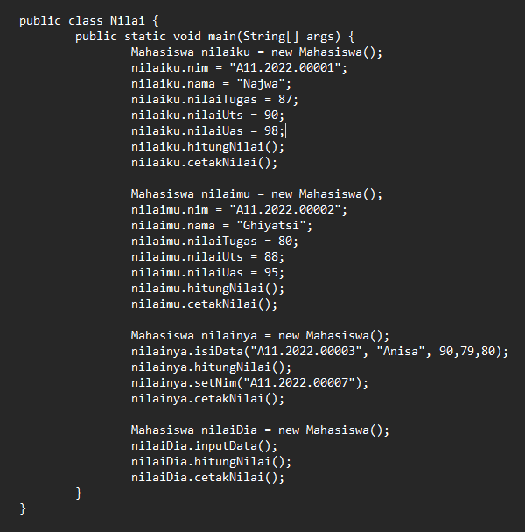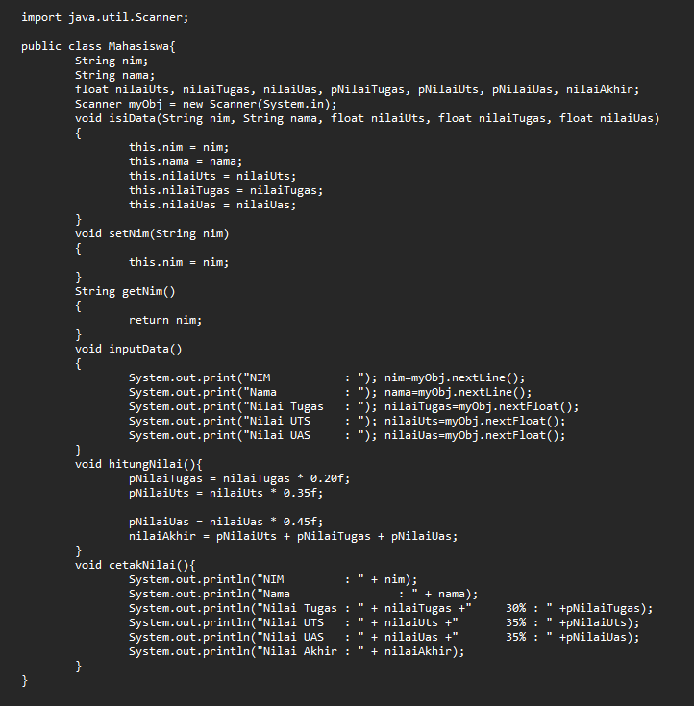Mahasiswa.java Nilai.java

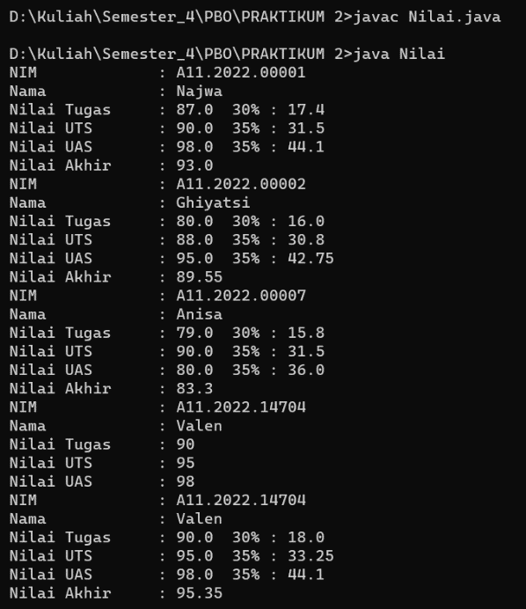

**Code Mahasiswa.java :**

import java.util.Scanner;

public class Mahasiswa{

String nim, nama;

float nilaiUts, nilaiTugas, nilaiUas, pNilaiTugas, pNilaiUts, pNilaiUas, nilaiAkhir;

Scanner myObj = new Scanner(System.in);

void isiData(String nim,String nama,float nilaiUts,floatnilaiTugas,float nilaiUas){

this.nim = nim;

this.nama = nama;

this.nilaiUts = nilaiUts;

this.nilaiTugas = nilaiTugas;

this.nilaiUas = nilaiUas;

}

void setNim(String nim){

this.nim = nim; }

String getNim(){

return nim; }

void inputData(){

System.out.print("NIM : "); nim=myObj.nextLine();

System.out.print("Nama : "); nama=myObj.nextLine();

System.out.print("Nilai Tugas : "); nilaiTugas=myObj.nextFloat();

System.out.print("Nilai UTS : "); nilaiUts=myObj.nextFloat();

System.out.print("Nilai UAS : "); nilaiUas=myObj.nextFloat();

}

void hitungNilai(){

pNilaiTugas = nilaiTugas * 0.20f;

pNilaiUts = nilaiUts * 0.35f;

pNilaiUas = nilaiUas * 0.45f;

nilaiAkhir = pNilaiUts + pNilaiTugas + pNilaiUas;

}

void cetakNilai(){

System.out.println("NIM : " + nim);

System.out.println("Nama : " + nama);

System.out.println("Nilai Tugas : " + nilaiTugas +"30% : " +pNilaiTugas);

System.out.println("Nilai UTS : " + nilaiUts +" 35% : " +pNilaiUts);

System.out.println("Nilai UAS : " + nilaiUas +"35% : " +pNilaiUas);

System.out.println("Nilai Akhir : " + nilaiAkhir);

}

}

**Code Nilai.java :**

public class Nilai {

public static void main(String[] args) {

Mahasiswa nilaiku = new Mahasiswa();

nilaiku.nim = "A11.2022.00001";

nilaiku.nama = "Najwa";

nilaiku.nilaiTugas = 87;

nilaiku.nilaiUts = 90;

nilaiku.nilaiUas = 98;

nilaiku.hitungNilai();

nilaiku.cetakNilai();

Mahasiswa nilaimu = new Mahasiswa();

nilaimu.nim = "A11.2022.00002";

nilaimu.nama = "Ghiyatsi";

nilaimu.nilaiTugas = 80;

nilaimu.nilaiUts = 88;

nilaimu.nilaiUas = 95;

nilaimu.hitungNilai();

nilaimu.cetakNilai();

Mahasiswa nilainya = new Mahasiswa();

nilainya.isiData("A11.2022.00003", "Anisa", 90,79,80);

nilainya.hitungNilai();

nilainya.setNim("A11.2022.00007");

nilainya.cetakNilai();

Mahasiswa nilaiDia = new Mahasiswa();

nilaiDia.inputData();

nilaiDia.hitungNilai();

nilaiDia.cetakNilai();

}

}