Mata Kuliah : PBO – TI – S1

Pertemuan : 3

Nama : Margareta Valencia

NIM : A11.2022.14704

**PRAKTIKUM 3**

**Latihan 1**

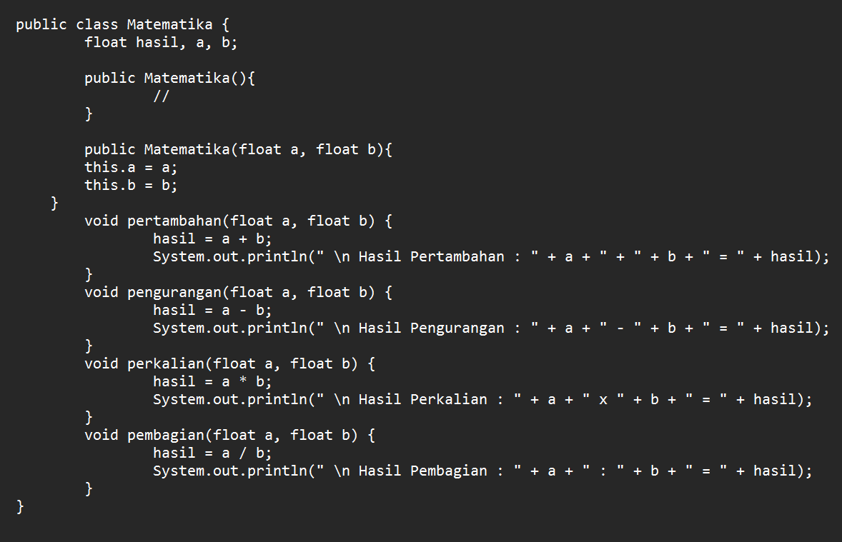 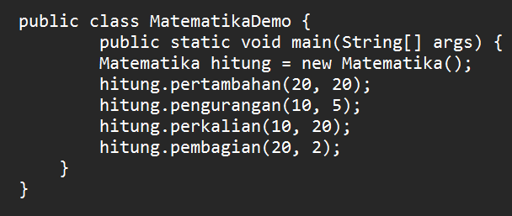

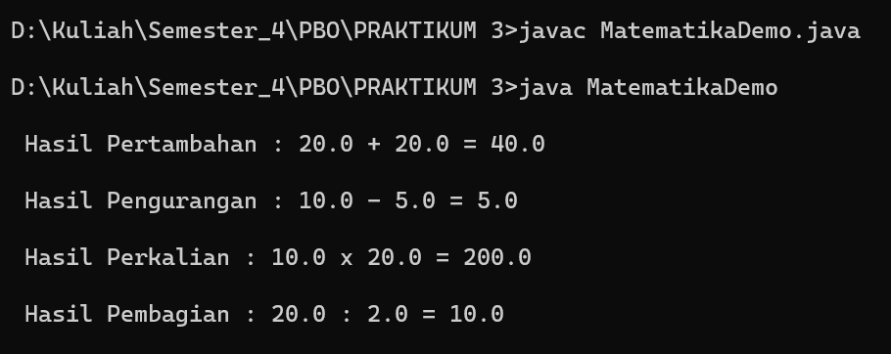

**Code Matematika.java :**

public class Matematika {

float hasil, a, b;

public Matematika(){

//}

public Matematika(float a, float b){

this.a = a;

this.b = b;

}

void pertambahan(float a, float b) {

hasil = a + b;

System.out.println(" \n Hasil Pertambahan : " + a + " + " + b + " = " + hasil);

}

void pengurangan(float a, float b) {

hasil = a - b;

System.out.println(" \n Hasil Pengurangan : " + a + " - " + b + " = " + hasil);

}

void perkalian(float a, float b) {

hasil = a * b;

System.out.println(" \n Hasil Perkalian : " + a + " x " + b + " = " + hasil);

}

void pembagian(float a, float b) {

hasil = a / b;

System.out.println(" \n Hasil Pembagian : " + a + " : " + b + " = " + hasil);

}

}

**Code MahasiswaDemo.java**

public class MatematikaDemo {

public static void main(String[] args) {

Matematika hitung = new Matematika();

hitung.pertambahan(20, 20);

hitung.pengurangan(10, 5);

hitung.perkalian(10, 20);

hitung.pembagian(20, 2);

}

}

**Latihan 2**

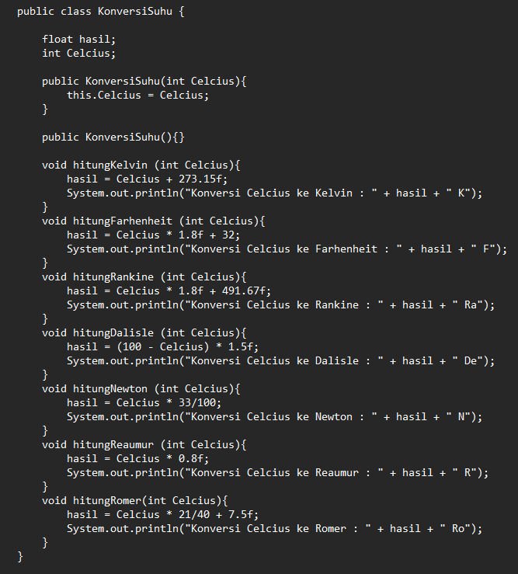 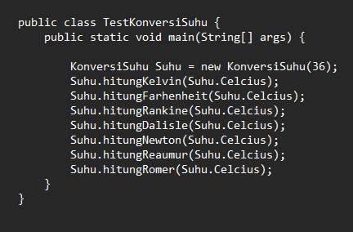

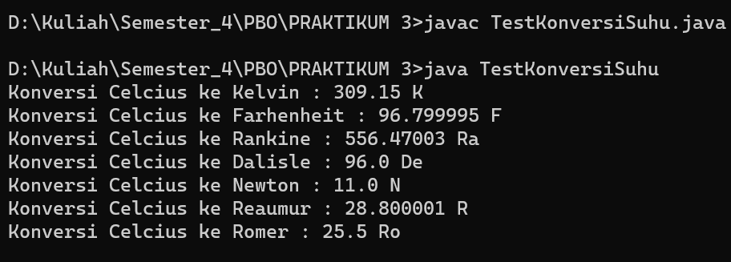

**Code KonversiSuhu.java :**

public class KonversiSuhu {

float hasil;

int Celcius;

public KonversiSuhu(int Celcius){

this.Celcius = Celcius;

}

public KonversiSuhu(){}

void hitungKelvin (int Celcius){

hasil = Celcius + 273.15f;

System.out.println("Konversi Celcius ke Kelvin : " + hasil + " K");

}

void hitungFarhenheit (int Celcius){

hasil = Celcius * 1.8f + 32;

System.out.println("Konversi Celcius ke Farhenheit : " + hasil + " F");

}

void hitungRankine (int Celcius){

hasil = Celcius * 1.8f + 491.67f;

System.out.println("Konversi Celcius ke Rankine : " + hasil + " Ra");

}

void hitungDalisle (int Celcius){

hasil = (100 - Celcius) * 1.5f;

System.out.println("Konversi Celcius ke Dalisle : " + hasil + " De");

}

void hitungNewton (int Celcius){

hasil = Celcius * 33/100;

System.out.println("Konversi Celcius ke Newton : " + hasil + " N");

}

void hitungReaumur (int Celcius){

hasil = Celcius * 0.8f;

System.out.println("Konversi Celcius ke Reaumur : " + hasil + " R");

}

void hitungRomer(int Celcius){

hasil = Celcius * 21/40 + 7.5f;

System.out.println("Konversi Celcius ke Romer : " + hasil + " Ro");

}

}

**Code TestKonversiSuhu.java :**

public class TestKonversiSuhu {

public static void main(String[] args) {

KonversiSuhu Suhu = new KonversiSuhu(36);

Suhu.hitungKelvin(Suhu.Celcius);

Suhu.hitungFarhenheit(Suhu.Celcius);

Suhu.hitungRankine(Suhu.Celcius);

Suhu.hitungDalisle(Suhu.Celcius);

Suhu.hitungNewton(Suhu.Celcius);

Suhu.hitungReaumur(Suhu.Celcius);

Suhu.hitungRomer(Suhu.Celcius);

}

}

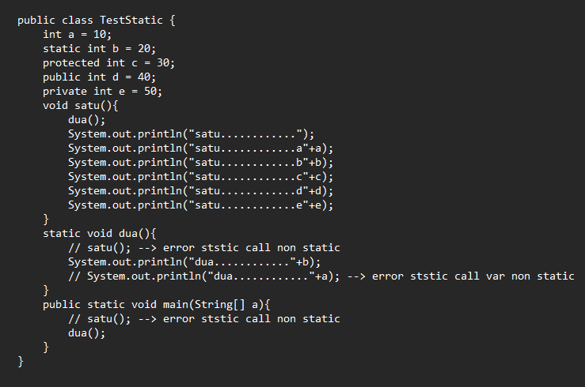**Latihan 3**

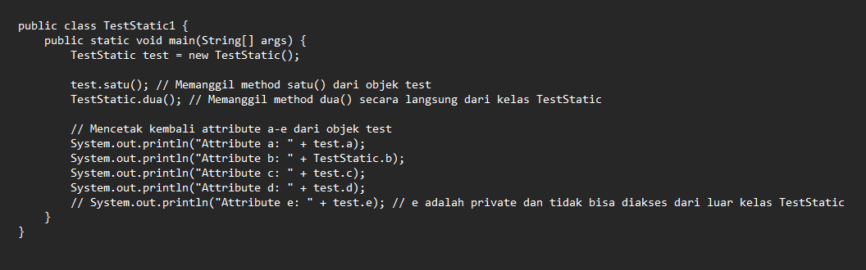

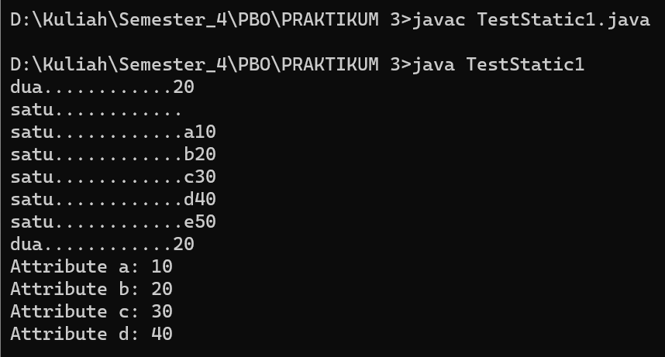

**Code TestStatic.java :**

public class TestStatic {

int a = 10;

static int b = 20;

protected int c = 30;

public int d = 40;

private int e = 50;

void satu(){

dua();

System.out.println("satu............");

System.out.println("satu............a"+a);

System.out.println("satu............b"+b);

System.out.println("satu............c"+c);

System.out.println("satu............d"+d);

System.out.println("satu............e"+e);

}

static void dua(){

// satu(); --> error ststic call non static

System.out.println("dua............"+b);

// System.out.println("dua............"+a); --> error ststic call var non static

}

public static void main(String[] a){

// satu(); --> error ststic call non static

dua();

}

}

**Code TestStatic1.java :**

public class TestStatic1 {

public static void main(String[] args) {

TestStatic test = new TestStatic();

test.satu(); // Memanggil method satu() dari objek test

TestStatic.dua(); // Memanggil method dua() secara langsung dari kelas TestStatic

// Mencetak kembali attribute a-e dari objek test

System.out.println("Attribute a: " + test.a);

System.out.println("Attribute b: " + TestStatic.b);

System.out.println("Attribute c: " + test.c);

System.out.println("Attribute d: " + test.d);

// System.out.println("Attribute e: " + test.e); // e adalah private dan tidak bisa diakses dari luar kelas TestStatic

}

}