Mata Kuliah : PBO – TI – SI

Pertemuan : 4

Nama : Margareta Valencia

NIM : A11.2022.14704

**PRAKTIKUM 4**

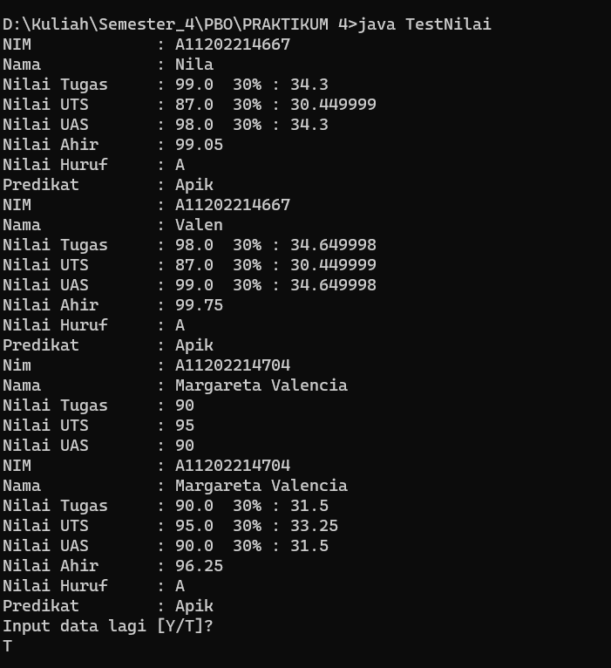**Struktur Kendali (IF)**

**Code Nilai.java :**

import java.util.Scanner;

public class Nilai {

String nim, nama, nHuruf, predikat ;

float nilaiUts, nilaiTugas, nilaiUas,pNilaiUts, pNilaiTugas, pNilaiUas, nilaiAkhir;

Scanner myObj = new Scanner(System.in);

void isiData(String nim, String nama, float nilaiUts, float nilaTugas, float nilaiUas){

this.nim=nim;

this.nama=nama;

this.nilaiTugas=nilaiTugas;

this.nilaiUts=nilaiUts;

this.nilaiUas=nilaiUas; }

void setNim(String nim){ this.nim=nim; }

String getNim(){ return nim; }

void inputData(){

System.out.print ("Nim : ");nim=myObj.nextLine();

System.out.print ("Nama : ");nama=myObj.nextLine();

System.out.print ("Nilai Tugas : "); nilaiTugas=myObj.nextFloat();

System.out.print ("Nilai UTS : ");nilaiUts=myObj.nextFloat();

System.out.print ("Nilai UAS : ");nilaiUas=myObj.nextFloat(); }

void hitungNilai(){

pNilaiUts=.35f*nilaiUts;

pNilaiTugas=.35f*nilaiUas;

pNilaiUas=.35f*nilaiUas;

nilaiAkhir=pNilaiTugas+pNilaiUts+pNilaiUas; }

void cetakNilai(){

System.out.println("NIM : "+nim);

System.out.println("Nama : "+nama);

System.out.println("Nilai Tugas : "+nilaiTugas+"30% : "+pNilaiTugas);

System.out.println("Nilai UTS : "+nilaiUts+" 30% : "+pNilaiUts);

System.out.println("Nilai UAS : "+nilaiUas+" 30% : "+pNilaiUas);

System.out.println("Nilai Ahir : "+nilaiAkhir);

System.out.println("Nilai Huruf : "+getNilHuruf(nilaiAkhir));

System.out.println("Predikat : "+getPredikat(nHuruf)); }

String getNilHuruf(float nilai){

if (nilai >= 85) {

nHuruf = "A";

} else if (nilai >= 80 && nilai < 85) {

nHuruf = "AB";

} else if (nilai >= 70 && nilai < 80) {

nHuruf = "B";

} else if (nilai >= 65 && nilai < 70) {

nHuruf = "BC";

} else if (nilai >= 60 && nilai < 65) {

nHuruf = "C";

} else if (nilai >= 40 && nilai < 60) {

nHuruf = "D";

} else {

nHuruf = "E";

} return nHuruf; }

String getPredikat(String huruf) {

switch (huruf) {

case "A":

predikat = "Apik"; break;

case "AB":

predikat = "Apik Baik"; break;

case "B":

predikat = "Baik"; break;

case "BC":

predikat = "Baik Cukup"; break;

case "C":

predikat = "Cukup"; break;

case "D":

predikat = "Dablek"; break;

default:

predikat = "Elek";

} return predikat;

}

}

**Code TestNilai.java :**

import java.util.Scanner;

import java.io.*;

public class TestNilai{

public static void main (String[] a){

String jawab="";

Scanner input = new Scanner(System.in);

Nilai nilaiku=new Nilai();

nilaiku.nim="A11202214667";

nilaiku.nama="Nila";

nilaiku.nilaiTugas=99;

nilaiku.nilaiUts=87;

nilaiku.nilaiUas=98;

nilaiku.hitungNilai();

nilaiku.cetakNilai();

Nilai nilaimu=new Nilai();

nilaimu.nim="A11202214704";

nilaiku.nama="Valen";

nilaiku.nilaiTugas=98;

nilaiku.nilaiUts=87;

nilaiku.nilaiUas=99;

nilaiku.hitungNilai();

nilaiku.cetakNilai();

do{

Nilai nilaiDia = new Nilai();

nilaiDia.inputData();

nilaiDia.hitungNilai();

nilaiDia.cetakNilai();

System.out.println("Input data lagi [Y/T]? ");

jawab=input.nextLine();

} while(jawab.equalsIgnoreCase("Y"));

}

}

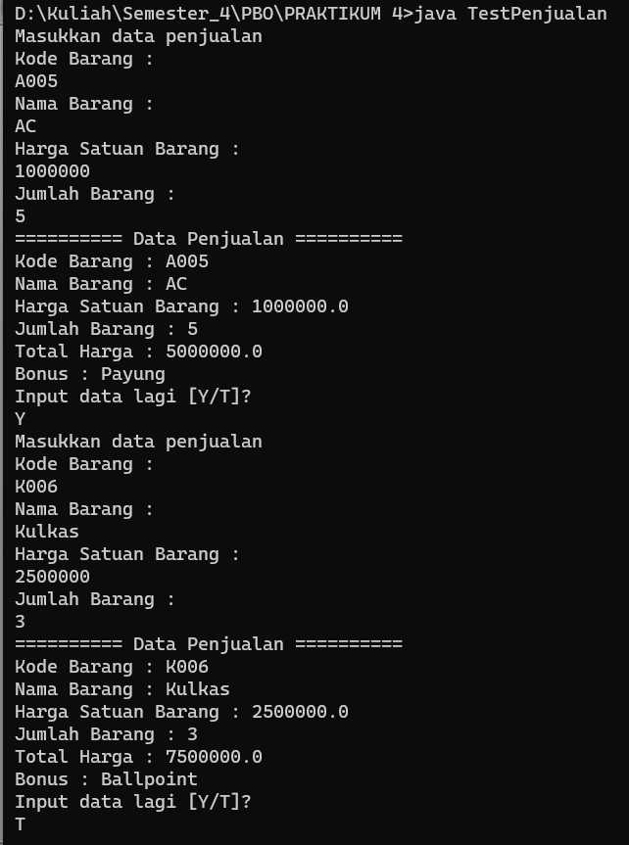**Latihan 1**

**Code Penjualan.java**

import java.util.Scanner;

public class Penjualan {

String kode, nama;

float harga;

double total;

int jumlah;

Scanner key = new Scanner(System.in);

public Penjualan() {

};

public void setData(String kode, String nama, float harga, int jumlah) {

this.kode = kode;

this.nama = nama;

this.harga = harga;

this.jumlah = jumlah;

}

void inputData(){

System.out.println("Masukkan data penjualan");

System.out.println("Kode Barang : ");

kode = key.nextLine();

System.out.println("Nama Barang : ");

nama = key.nextLine();

System.out.println("Harga Satuan Barang : ");

harga = key.nextFloat();

System.out.println("Jumlah Barang : ");

jumlah = key.nextInt();

}

void hitungTotal() {

total = harga * jumlah;

System.out.println("Total Harga : " + total);

}

String getBonus() {

String bonus = "";

if (total >= 500000 && jumlah > 5) {

bonus = "Setrika";

} else if (total >= 100000 && jumlah > 3) {

bonus = "Payung";

} else if (total >= 50000 && jumlah > 2) {

bonus = "Ballpoint";

} else

bonus = "tidak mendapatkan bonus";

return bonus;

}

void cetakNota() {

System.out.println("========== Data Penjualan ==========");

System.out.println("Kode Barang : " + kode);

System.out.println("Nama Barang : " + nama);

System.out.println("Harga Satuan Barang : " + harga);

System.out.println("Jumlah Barang : " + jumlah);

hitungTotal();

System.out.println("Bonus : " + getBonus());

}

}

**Code TestPenjualan.java**

import java.util.Scanner;

public class TestPenjualan {

public static void main(String[] args) {

Scanner input = new Scanner(System.in);

String inputLagi;

do {

Penjualan penjualan = new Penjualan();

penjualan.inputData();

penjualan.cetakNota();

System.out.println("Input data lagi [Y/T]? ");

inputLagi = input.nextLine();

} while (inputLagi.equalsIgnoreCase("Y"));

input.close();

}

}

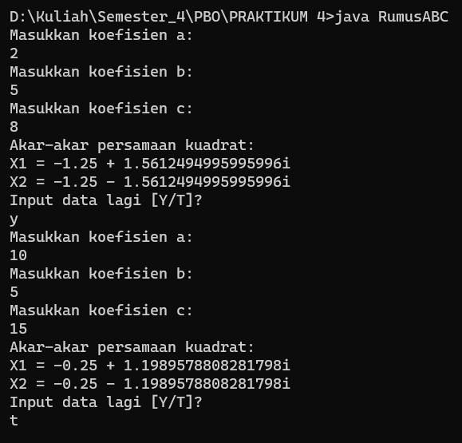**Latihan 2**

**Code RumusABC.java**

import java.util.Scanner;

public class RumusABC {

public static void main(String[] args) {

Scanner scanner = new Scanner(System.in);

char ulangi;

do {

System.out.println("Masukkan koefisien a:");

double a = scanner.nextDouble();

System.out.println("Masukkan koefisien b:");

double b = scanner.nextDouble();

System.out.println("Masukkan koefisien c:");

double c = scanner.nextDouble();

double D = b * b - 4 * a * c;

if (D > 0) {

double x1 = (-b + Math.sqrt(D)) / (2 * a);

double x2 = (-b - Math.sqrt(D)) / (2 * a);

System.out.println("Akar-akar persamaan kuadrat:");

System.out.println("X1 = " + x1);

System.out.println("X2 = " + x2);

} else if (D == 0) {

double x = -b / (2 * a);

System.out.println("Akar-akar persamaan kuadrat:");

System.out.println("X1 = X2 = " + x);

} else {

double realPart = -b / (2 * a);

double imaginaryPart = Math.sqrt(-D) / (2 * a);

System.out.println("Akar-akar persamaan kuadrat:");

System.out.println("X1 = " + realPart + " + " + imaginaryPart + "i");

System.out.println("X2 = " + realPart + " - " + imaginaryPart + "i");

}

System.out.println("Input data lagi [Y/T]?");

ulangi = scanner.next().charAt(0);

} while (ulangi == 'Y' || ulangi == 'y');

scanner.close();

}

}

**Latihan 3**

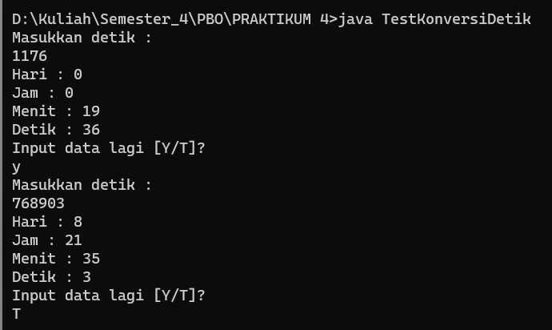

**Code KonversiDetik.java**

import java.util.Scanner;

public class KonversiDetik {

int detik;

int hasil;

Scanner key = new Scanner(System.in);

public KonversiDetik(int detik){

this.detik = detik;

}

public KonversiDetik(){}

void inputDetik(){

System.out.println("Masukkan detik : "); detik = key.nextInt();

}

void hari(){

hasil = detik/86400;

System.out.println("Hari : " + hasil);

}

void jam(){

hasil = (detik%86400)/3600;

System.out.println("Jam : " + hasil);

}

void menit(){

hasil = ((detik%86400)%3600)/60;

System.out.println("Menit : " + hasil);

}

void detik(){

hasil = ((detik%86400)%3600)%60;

System.out.println("Detik : " + hasil);

}

}

**Code TestKonversiDetik.java**

import java.util.Scanner;

public class TestKonversiDetik {

public static void main(String[] args) {

Scanner input = new Scanner(System.in);

String inputLagi;

do {

KonversiDetik konversi = new KonversiDetik();

konversi.inputDetik();

konversi.hari();

konversi.jam();

konversi.menit();

konversi.detik();

System.out.println("Input data lagi [Y/T]? ");

inputLagi = input.nextLine();

} while (inputLagi.equalsIgnoreCase("Y"));

input.close();

}

}