Mata Kuliah : PBO – TI – SI

Pertemuan : 5

Nama : Margareta Valencia

NIM : A11.2022.14704

**PRAKTIKUM 5**

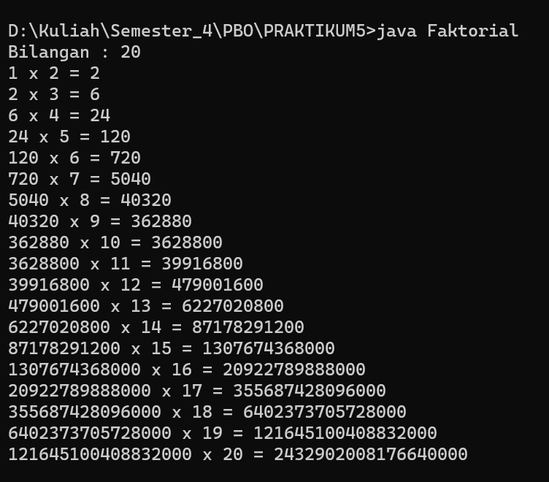**Latihan 1**

**Code Faktorial.java**

import java.util.Scanner;

public class Faktorial {

public static void main(String[] args) {

long fak=1;

int bil;

Scanner in=new Scanner(System.in);

System.out.print("Bilangan : ");

bil=in.nextInt();

for(int i=2;i<=bil;i++){

System.out.print(fak+" x " +i+" = ");

fak = fak *i;

System.out.println(fak);

}

}

}

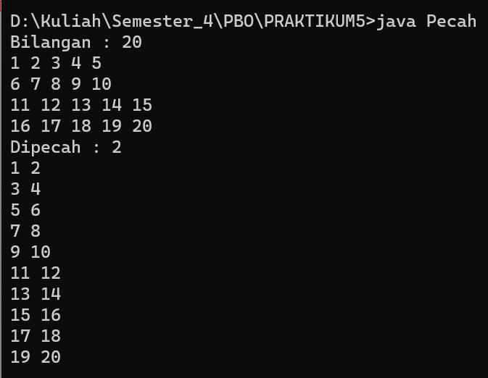**Latihan 2**

**Code Pecah.java**

import java.util.Scanner;

public class Pecah {

public static void main(String[] args) {

long fak=1;

int bil,p;

Scanner in=new Scanner(System.in);

System.out.print("Bilangan : ");

bil=in.nextInt();

for(int i=1;i<=bil;i++){

System.out.print(i+" ");

if(i%5==0)

System.out.println("");

}

System.out.print("Dipecah : ");

p=in.nextInt();

for(int i=1;i<=bil;i++){

System.out.print(i+" ");

if(i%p==0)

System.out.println("");

}

}

}

**ARRAY**

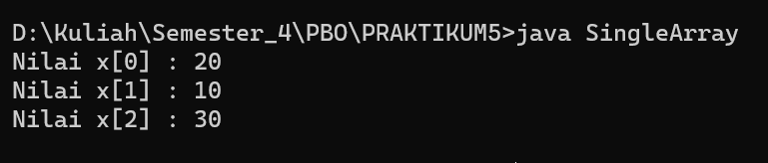

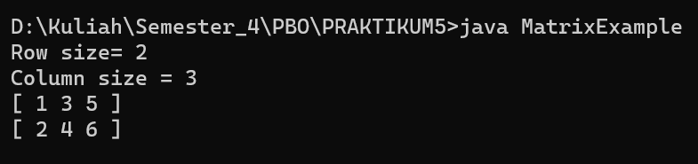

**Latihan 1**

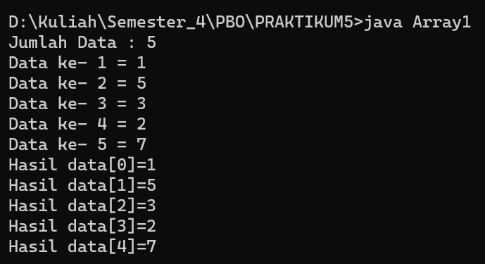

**Code Array1.java**

import java.util.Scanner;

public class Array1 {

public static void main(String[] args) {

int j;

int[] data;

Scanner in=new Scanner(System.in);

System.out.print("Jumlah Data : ");

j=in.nextInt();

data=new int[j];

for(int i=0;i<j;i++){

System.out.print("Data ke- " +(i+1)+" = ");

data[i]=in.nextInt();

}

//cetak

for(int i=0;i<j;i++){

System.out.println("Hasil data["+i+"]="+data[i]);

}

}

}

**Latihan 2**

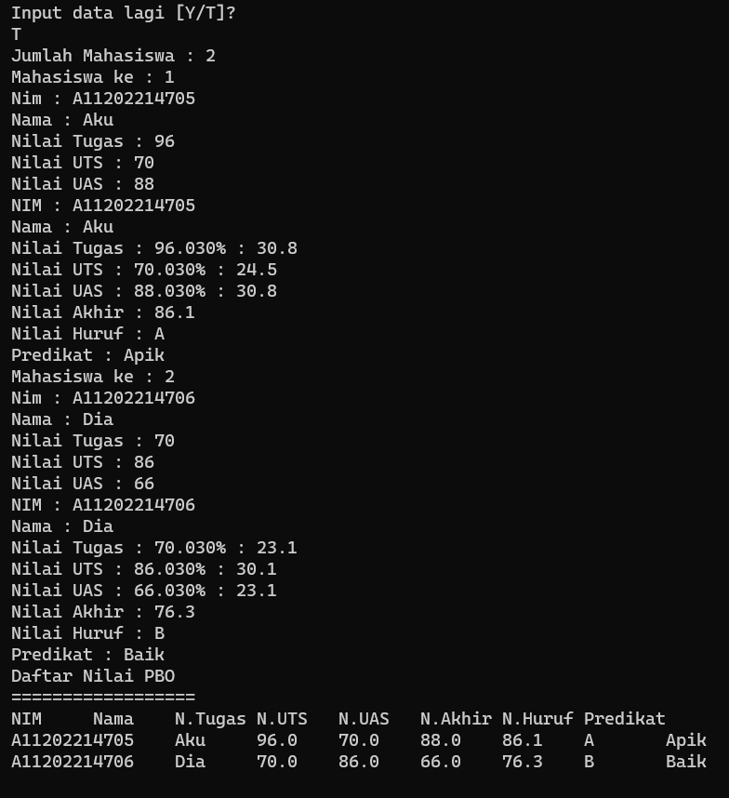

**Code Nilai.java**

import java.util.Scanner;

public class Nilai {

String nim, nama, nHuruf, predikat ;

float nilaiUts, nilaiTugas, nilaiUas,pNilaiUts, pNilaiTugas, pNilaiUas, nilaiAkhir;

Scanner myObj = new Scanner(System.in);

void isiData(String nim, String nama, float nilaiUts, float nilaTugas, float nilaiUas)

{

this.nim=nim;

this.nama=nama;

this.nilaiTugas=nilaiTugas;

this.nilaiUts=nilaiUts;

this.nilaiUas=nilaiUas;

}

void setNim(String nim){

this.nim=nim;

}

String getNim(){

return nim;

}

void inputData(){

System.out.print ("Nim : ");nim=myObj.nextLine();

System.out.print ("Nama : ");nama=myObj.nextLine();

System.out.print ("Nilai Tugas : ");nilaiTugas=myObj.nextFloat();

System.out.print ("Nilai UTS : ");nilaiUts=myObj.nextFloat();

System.out.print ("Nilai UAS : ");nilaiUas=myObj.nextFloat();

}

void hitungNilai(){

pNilaiUts=.35f*nilaiUts;

pNilaiTugas=.35f*nilaiUas;

pNilaiUas=.35f*nilaiUas;

nilaiAkhir=pNilaiTugas+pNilaiUts+pNilaiUas;

}

void cetakNilai(){

System.out.println("NIM : "+nim);

System.out.println("Nama : "+nama);

System.out.println("Nilai Tugas : "+nilaiTugas+"30% : "+pNilaiTugas);

System.out.println("Nilai UTS : "+nilaiUts+"30% : "+pNilaiUts);

System.out.println("Nilai UAS : "+nilaiUas+"30% : "+pNilaiUas);

System.out.println("Nilai Akhir : "+nilaiAkhir);

System.out.println("Nilai Huruf : "+getNilHuruf(nilaiAkhir));

System.out.println("Predikat : "+getPredikat(nHuruf));

}

String getNilHuruf(float nilai)

{

if (nilai >= 85)

nHuruf = "A";

else if (nilai >= 80 && nilai < 85)

nHuruf = "AB";

else if (nilai >= 70 && nilai < 80)

nHuruf = "B";

else if (nilai >= 65 && nilai < 70)

nHuruf = "BC";

else if (nilai >= 60 && nilai < 65)

nHuruf = "C";

else if (nilai >= 40 && nilai < 60)

nHuruf = "D";

else

nHuruf = "E";

return nHuruf;

}

String getPredikat(String huruf) {

switch (huruf) {

case "A":

predikat = "Apik";

break;

case "AB":

predikat = "Apik Baik";

break;

case "B":

predikat = "Baik";

break;

case "BC":

predikat = "Baik Cukup";

break;

case "C":

predikat = "Cukup";

break;

case "D":

predikat = "Dablek";

break;

default:

predikat = "Elek";

}

return predikat;

}

void judul() {

System.out.println("Daftar Nilai PBO");

System.out.println("==================");

System.out.println("NIM\tNama\tN.Tugas\tN.UTS\tN.UAS\tN.Akhir"+"\tN.Huruf\tPredikat");

}

void daftarNilai(){

System.out.println(nim+"\t"+nama+"\t"+nilaiTugas+"\t"+nilaiUts+"\t"+nilaiUas+"\t"+nilaiAkhir+"\t"+nHuruf+"\t"+predikat);

}

}

**Code TestNilai.java**

import java.util.Scanner;

import java.io.*;

public class TestNilai{

public static void main (String[] a){

String jawab="";

Scanner input = new Scanner(System.in);

Nilai nilaiku=new Nilai();

nilaiku.nim="A11202214667";

nilaiku.nama="Nila";

nilaiku.nilaiTugas=99;

nilaiku.nilaiUts=87;

nilaiku.nilaiUas=98;

nilaiku.hitungNilai();

nilaiku.cetakNilai();

Nilai nilaimu=new Nilai();

nilaimu.nim="A11202214704";

nilaiku.nama="Valen";

nilaiku.nilaiTugas=98;

nilaiku.nilaiUts=87;

nilaiku.nilaiUas=99;

nilaiku.hitungNilai();

nilaiku.cetakNilai();

do{

Nilai nilaiDia = new Nilai();

nilaiDia.inputData();

nilaiDia.hitungNilai();

nilaiDia.cetakNilai();

System.out.println("Input data lagi [Y/T]? ");

jawab=input.nextLine();

} while(jawab.equalsIgnoreCase("Y"));

System.out.print("Jumlah Mahasiswa : ");

int n=input.nextInt();

Nilai[] nilaibyk=new Nilai[n];

for(int i=0;i<n;i++){

System.out.println("Mahasiswa ke : "+(i+1));

nilaibyk[i]=new Nilai();

nilaibyk[i].inputData();

nilaibyk[i].hitungNilai();

nilaibyk[i].cetakNilai();

}

nilaibyk[0].judul();

for(int i=0;i<n;i++){

nilaibyk[i].daftarNilai();

}

}

}

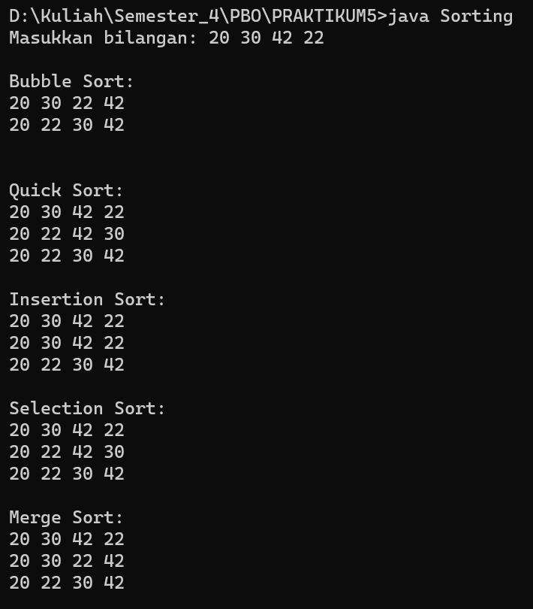**Latihan 3**

**Code Sorting.java**

import java.util.Scanner;

public class Sorting{

public static void main(String[] args) {

Scanner scanner = new Scanner(System.in);

System.out.print("Masukkan bilangan: ");

String input = scanner.nextLine();

String[] inputArr = input.split(" ");

int[] arr = new int[inputArr.length];

for (int i = 0; i < inputArr.length; i++) {

arr[i] = Integer.parseInt(inputArr[i]);

}

System.out.println("\nBubble Sort:");

Sorting.bubbleSort(arr.clone());

System.out.println("\nQuick Sort:");

Sorting.quickSort(arr.clone(), 0, arr.length - 1);

System.out.println("\nInsertion Sort:");

Sorting.insertionSort(arr.clone());

System.out.println("\nSelection Sort:");

Sorting.selectionSort(arr.clone());

System.out.println("\nMerge Sort:");

Sorting.mergeSort(arr.clone(), 0, arr.length - 1);

}

static void bubbleSort(int arr[]){

int n = arr.length;

for (int i = 0; i < n - 1; i++) {

for (int j = 0; j < n - i - 1; j++) {

if (arr[j] > arr[j + 1]) {

int temp = arr[j];

arr[j] = arr[j + 1];

arr[j + 1] = temp;

printArray(arr);

}

}

}

System.out.println();

}

static void swap(int[] arr, int i, int j){

int temp = arr[i];

arr[i] = arr[j];

arr[j] = temp;

}

static void quickSort(int[] arr, int low, int high){

if (low < high) {

int pivot = arr[high];

int i = (low - 1);

for(int j = low; j <= high - 1; j++) {

if (arr[j] < pivot) {

i++;

swap(arr, i, j);

printArray(arr);

}

}

swap(arr, i + 1, high);

quickSort(arr, low, i - 1);

quickSort(arr, i + 1, high);

}

}

public static void insertionSort(int arr[]){

int n = arr.length;

for (int i = 1; i < n; ++i) {

int key = arr[i];

int j = i - 1;

while (j >= 0 && arr[j] > key) {

arr[j + 1] = arr[j];

j = j - 1;

}

arr[j + 1] = key;

printArray(arr);

}

}

public static void selectionSort(int arr[]){

int n = arr.length;

for (int i = 0; i < n-1; i++){

int min_idx = i;

for (int j = i+1; j < n; j++)

if (arr[j] < arr[min_idx])

min_idx = j;

int temp = arr[min_idx];

arr[min_idx] = arr[i];

arr[i] = temp;

printArray(arr);

}

}

public static void merge(int arr[], int l, int m, int r){

int n1 = m - l + 1;

int n2 = r - m;

int L[] = new int[n1];

int R[] = new int[n2];

for (int i = 0; i < n1; ++i)

L[i] = arr[l + i];

for (int j = 0; j < n2; ++j)

R[j] = arr[m + 1 + j];

int i = 0, j = 0;

int k = l;

while (i < n1 && j < n2) {

if (L[i] <= R[j]) {

arr[k] = L[i];

i++;

}

else {

arr[k] = R[j];

j++;

}

k++;

}

while (i < n1) {

arr[k] = L[i];

i++;

k++;

printArray(arr);

}

while (j < n2) {

arr[k] = R[j];

j++;

k++;

printArray(arr);

}

}

public static void mergeSort(int arr[], int l, int r){

if (l < r) {

int m = l + (r - l) / 2;

mergeSort(arr, l, m);

mergeSort(arr, m + 1, r);

merge(arr, l, m, r);

}

}

static void printArray(int arr[]){

int n = arr.length;

for (int i = 0; i < n; ++i) {

System.out.print(arr[i] + " ");

}

System.out.println();

}

}

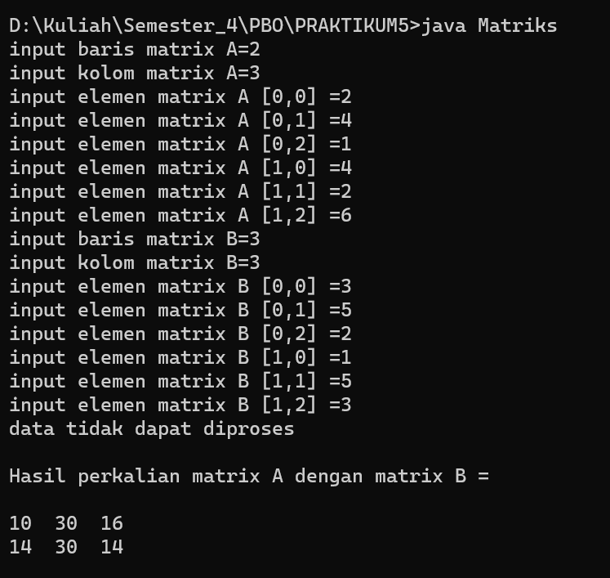**Latihan 4**

**Code Matriks.java**

import java.util.Scanner;

public class Matriks {

public static void main(String[] args) {

Scanner in = new Scanner(System.in);

int[][] A = new int[10][10];

int[][] B = new int[10][10];

int[][] C = new int[10][10];

int[][] D = new int[10][10];

int[][] E = new int[10][10];

int jlh = 0, hsl = 1, i, j, n, m, a, b, k;

System.out.print("input baris matrix A=");

n = in.nextInt();

System.out.print("input kolom matrix A=");

m = in.nextInt();

for (i = 0; i < n; i++) {

for (j = 0; j < m; j++) {

System.out.print("input elemen matrix A [" + i + "," + j + "] =");

A[i][j] = in.nextInt();

}

}

System.out.print("input baris matrix B=");

a = in.nextInt();

System.out.print("input kolom matrix B=");

b = in.nextInt();

for (i = 0; i < n; i++) {

for (j = 0; j < m; j++) {

System.out.print("input elemen matrix B [" + i + "," + j + "] =");

B[i][j] = in.nextInt();

}

}

if (n == a && m == b) {

System.out.println("Hasil penjumlahan matrik A\n");

for (i = 0; i < n; i++) {

for (j = 0; j < m; j++) {

C[i][j] = A[i][j] + B[i][j];

System.out.print(C[i][j] + " ");

}

System.out.println();

}

System.out.println("\nHasil transfos matrix C=\n");

for (i = 0; i < n; i++) {

for (j = 0; j < m; j++) {

D[i][j] = C[j][i];

System.out.print(D[i][j] + " ");

}

System.out.println();

}

} else

System.out.println("data tidak dapat diproses");

if (m == a) {

for (i = 0; i < n; i++) {

for (j = 0; j < b; j++) {

E[i][j] = 0;

for (k = 0; k < a; k++) {

E[i][j] = E[i][j] + (A[i][k] * B[k][j]);

}

}

}

System.out.println("\nHasil perkalian matrix A dengan matrix B =\n");

for (i = 0; i < n; i++) {

for (j = 0; j < b; j++) {

System.out.print(E[i][j] + " ");

}

System.out.println();

}

} else

System.out.println("data tidak bisa di proses");

}

}

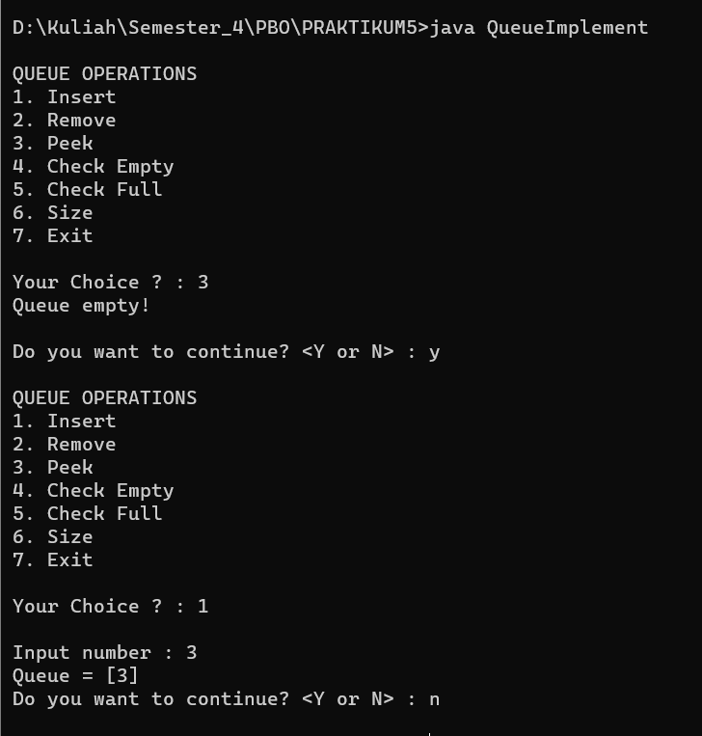**Code QueueImplement.java**

import java.util.LinkedList;

import java.util.Queue;

import java.util.Scanner;

public class QueueImplement {

public static void main(String[] args) {

QueueImplement mine = new QueueImplement();

mine.menu();

}

Queue<Integer> antrian = new LinkedList<>();

Scanner input = new Scanner(System.in);

int max = 5, top = 0;

public void insert() {

System.out.print("\nInput number : ");

antrian.add(input.nextInt());

this.top++;

}

public void pop() {

System.out.print("Select the data you want to delete : ");

antrian.remove(input.nextInt());

this.top--;

}

public void menu() {

String choose;

do {

System.out.println("\nQUEUE OPERATIONS");

System.out.println("1. Insert");

System.out.println("2. Remove");

System.out.println("3. Peek");

System.out.println("4. Check Empty");

System.out.println("5. Check Full");

System.out.println("6. Size");

System.out.println("7. Exit");

System.out.print("\nYour Choice ? : ");

int pilih = input.nextInt();

switch (pilih) {

case 1:

if (top < max) {

insert();

System.out.println("Queue = " + antrian);

} else {

System.out.println("Queue full!\n");

}

break;

case 2:

if (top != 0) {

System.out.println("Queue = " + antrian);

pop();

System.out.println("New Queue = " + antrian);

} else {

System.out.println("Queue empty!\n");

}

break;

case 3:

if (top != 0) {

System.out.println("First Data in the Queue = " + antrian.peek());

} else {

System.out.println("Queue empty!\n");

}

break;

case 4:

if (top == 0) {

System.out.println("Queue is empty");

} else {

System.out.println("Queue is not empty");

}

break;

case 5:

if (top == max) {

System.out.println("Queue full!\n");

} else {

System.out.println((max - top) + " more slot(s) available");

}

break;

case 6:

System.out.println("Size = " + antrian.size());

System.out.println("Queue = " + antrian);

break;

case 7:

input.close();

System.exit(0);

default:

System.out.println("Invalid input!\n");

break;

}

System.out.print("Do you want to continue? <Y or N> : ");

choose = input.next();

} while (choose.equalsIgnoreCase("Y"));

input.close();

}

}