SYSTEM CONCEPTUAL FRAMEWORK
ATLAS Role-Based System Flow
Superuser, Administrator, Teacher, Student User, and Guest
Prepared from the current ATLAS implementation • 5 October 2026
Scope note. In this framework, “User” means the registered Student role. Teacher is shown separately because it has additional resource-management and AI-review privileges. Guest means an unauthenticated visitor using guest access.

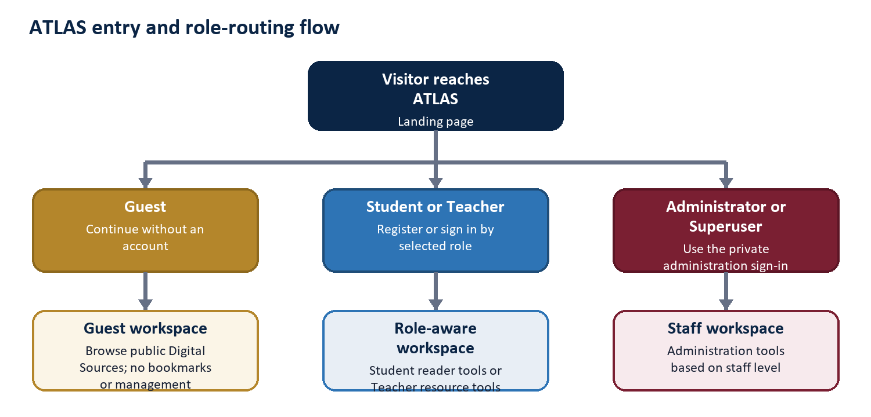
Figure 1. Entry and role-routing flow

1. Conceptual Framework
Framework logic. ATLAS receives a role and a request, validates the permitted path, performs the requested repository or administrative operation, and returns an output appropriate to that role. Every privileged branch is narrower than the branch above it unless the role is explicitly granted more authority.
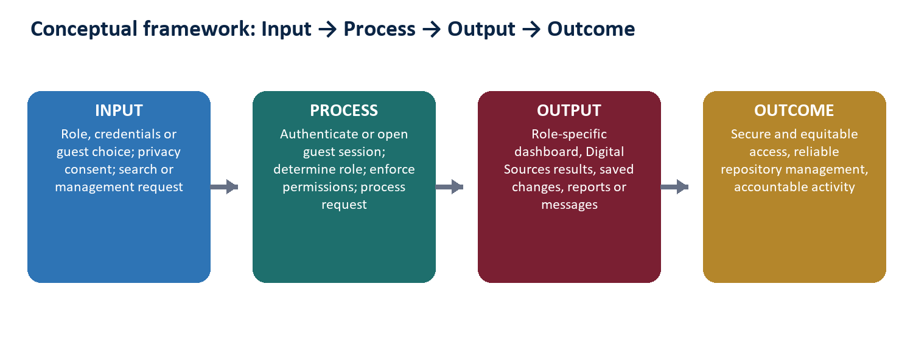
Figure 2. Input-Process-Output-Outcome model

Core control principles
- Role-aware entry: Student and Teacher use the public role-based registration and login flow; staff use the private administration route.
- Least privilege: Student and Guest are readers, Teacher manages resources, Administrator manages operational administration, and Superuser governs Administrators.
- Protected reading: resource abstracts are displayed inside ATLAS; the original uploaded file is not offered as a public download.
- Accountability: important creation, update, deletion, analysis, and administrative events can be retained for staff reporting and audit review.
- Privacy-aware usage: signed-in activity supports institutional reporting, while anonymous guest analytics depend on the visitor's analytics consent.

Role boundaries at a glance
Role | Entry | Primary workspace | Authority boundary
Guest | Guest choice | Public reader | No bookmarks or management
Student user | Public Student login | Reader dashboard | No content or staff administration
Teacher | Public Teacher login | Reader + resource tools | No users, announcements, reports, or admin control
Administrator | Private staff login | Staff portal + admin | Cannot create/manage Administrators
Superuser | Private root login | Full staff + governance | Highest application authority

2. Guest Flow
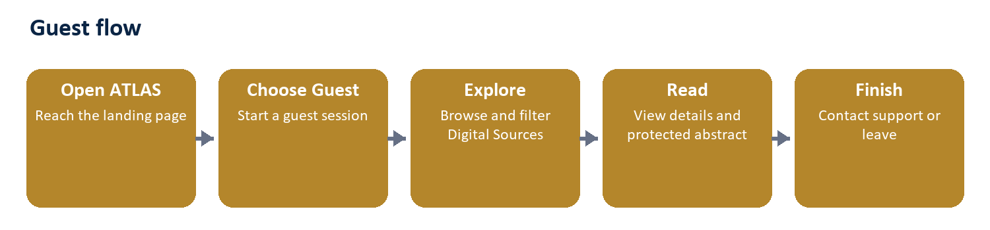
Figure: Guest workflow
Entry and identity. The visitor opens ATLAS and selects Guest. The system creates a guest session and opens the reader dashboard without requiring an account.
Main actions
- View the dashboard and public announcements.
- Browse, search, filter, and sort Digital Sources.
- Open resource details, see hard-copy availability, and read the protected resource abstract.
- Submit a support, feedback, or privacy-related contact message.
- Choose cookie preferences; anonymous usage analytics are stored only with analytics consent.
Boundary. A Guest cannot bookmark items, manage Digital Sources, use AI Detection, open staff reports, or administer accounts.
End state. The visitor leaves the site or later chooses Student or Teacher registration/sign-in for persistent account features.

3. Student (Registered User) Flow
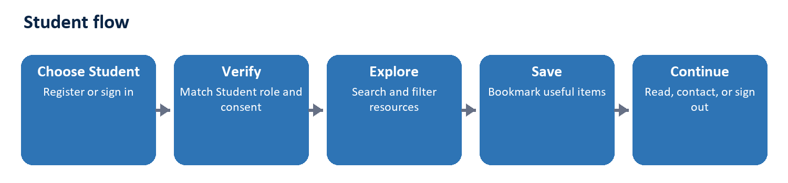
Figure: Student workflow
Entry and identity. The visitor selects Student, registers or signs in with email and password, accepts the current privacy terms, and passes role matching and email verification requirements.
Main actions
- Use the personalized dashboard and view recent Digital Sources and announcements.
- Search, filter, sort, and open repository items.
- Read protected resource abstracts and check hard-copy availability.
- Bookmark or remove resources and open the Favorites page.
- Update account email/password settings, contact support, or submit a data-deletion request.
Boundary. A Student cannot add, edit, or delete resources; cannot use AI Detection; and cannot access staff account, announcement, reporting, or Django administration tools.
End state. The Student's bookmarks and account settings persist for the next session; signing out returns the user to the public landing page.

4. Teacher Flow
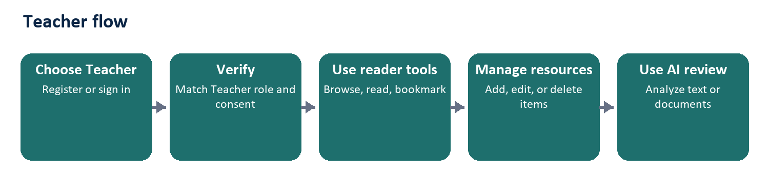
Figure: Teacher workflow
Entry and identity. The visitor selects Teacher, registers or signs in through the public role-aware form, accepts the privacy terms, and passes Teacher-role and email verification checks.
Main actions
- Perform every normal reader activity: browse, search, view details, read abstracts, bookmark, and contact support.
- Add a Digital Sources item with metadata, cover image, resource abstract, resource file, and hard-copy availability information.
- Edit or delete existing Digital Sources items; successful changes are recorded as activity.
- Use AI Detection on pasted text or an uploaded supported document and review the advisory result.
- Update the Teacher display name and normal account credentials.
Boundary. A Teacher is not a staff Administrator. The role cannot manage users, create announcements, publish content notices, view staff usage/audit reports, open the staff portal, or access Django administration.
End state. After resource or AI work, the Teacher returns to the reader-facing repository; saved repository changes become visible according to the normal catalog views.
AI result caution. AI Detection is an advisory writing-pattern review. Its result should support human review and should not be treated as sole proof for an academic or disciplinary decision.

5. Administrator Flow
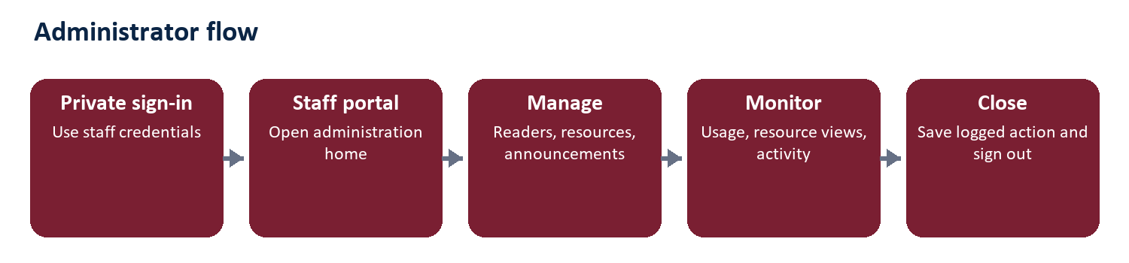
Figure: Administrator workflow
Entry and identity. The Administrator does not use the public Student/Teacher login. The account signs in through the private Django administration route using an active staff username or email and password.
Main actions
- Open the Administrator Home and the normal Django administration pages allowed by staff permissions.
- Create Student or Teacher accounts, search/filter the user directory, and delete non-staff reader accounts.
- Manage Digital Sources and use AI Detection.
- Draft, edit, publish, unpublish, and delete announcements.
- Review website usage, role activity, resource views, unresolved messages, and the administrative activity log.
- Change the Administrator's own username or password.
Boundary. A regular Administrator cannot create another Administrator, cannot manage another staff account's credentials, and cannot exercise Superuser-only governance. Direct access to Superuser-only actions is denied.
End state. Operational changes are saved and recorded where applicable. Staff sign-out returns to the private administration login instead of the public role selector.

6. Superuser Flow
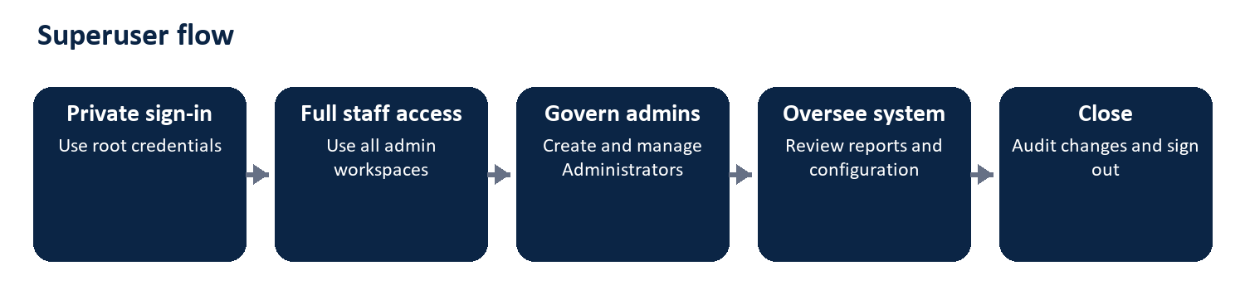
Figure: Superuser workflow
Entry and identity. The Superuser signs in through the same private administration route, but the system recognizes the account as the highest staff level.
Main actions
- Perform every Administrator operation across resources, users, announcements, AI Detection, reports, activity history, and Django administration.
- Create a regular Administrator after confirming the Superuser's own password.
- Edit another Administrator's username or password and oversee staff access.
- Review system-wide configuration, operational health, and audit evidence as the root authority.
Boundary. The Superuser retains the highest application authority and should use that access only for governance, security, and exceptional administration. Reader accounts remain separate from staff accounts.
End state. Administrator provisioning and sensitive account changes are recorded, then the Superuser signs out to the private administration login.

7. Authority and Feedback Loop
Hierarchy. Superuser → Administrator → Teacher → Student User → Guest represents increasing breadth of authority from right to left; it does not mean lower roles report directly to every higher role. Each role receives only the tools needed for its purpose.
- Guests and registered readers generate search, reading, bookmark, contact, and usage signals.
- Teachers maintain repository content and receive AI-review outputs while remaining outside staff administration.
- Administrators use operational reports and messages to maintain accounts, announcements, and Digital Sources.
- Superusers govern Administrator access and intervene in high-risk or system-level decisions.
- Published announcements and updated resources return to the reader-facing system, completing the feedback loop.

