SYSTEM CONCEPTUAL FRAMEWORK
ATLAS Role-Based System Flow
Superuser, Administrator, Teacher, Student User, and Guest
Prepared from the current ATLAS implementation • 5 October 2026
Scope note. In this framework, “User” means the registered Student role. Teacher is shown separately because it has additional resource-management and AI-review privileges. Guest means an unauthenticated visitor using guest access.

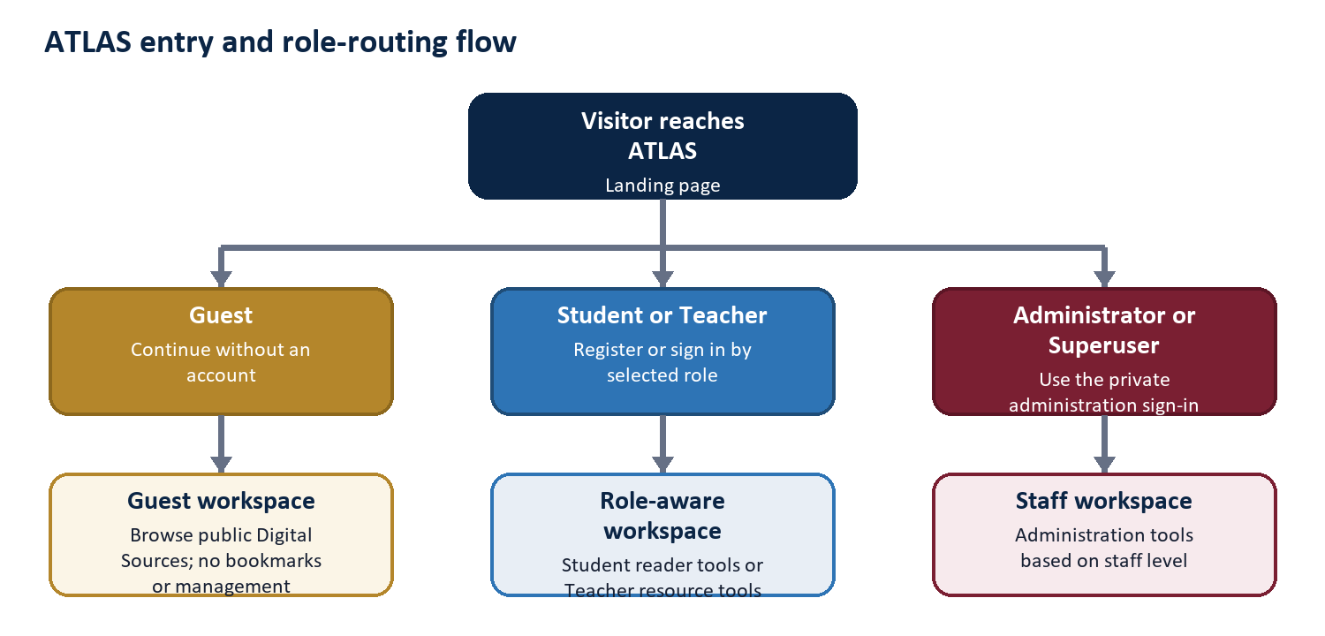
Figure 1. Entry and role-routing flow

1. Conceptual Framework
Framework logic. ATLAS receives a role and a request, validates the permitted path, performs the requested repository or administrative operation, and returns an output appropriate to that role. Every privileged branch is narrower than the branch above it unless the role is explicitly granted more authority.
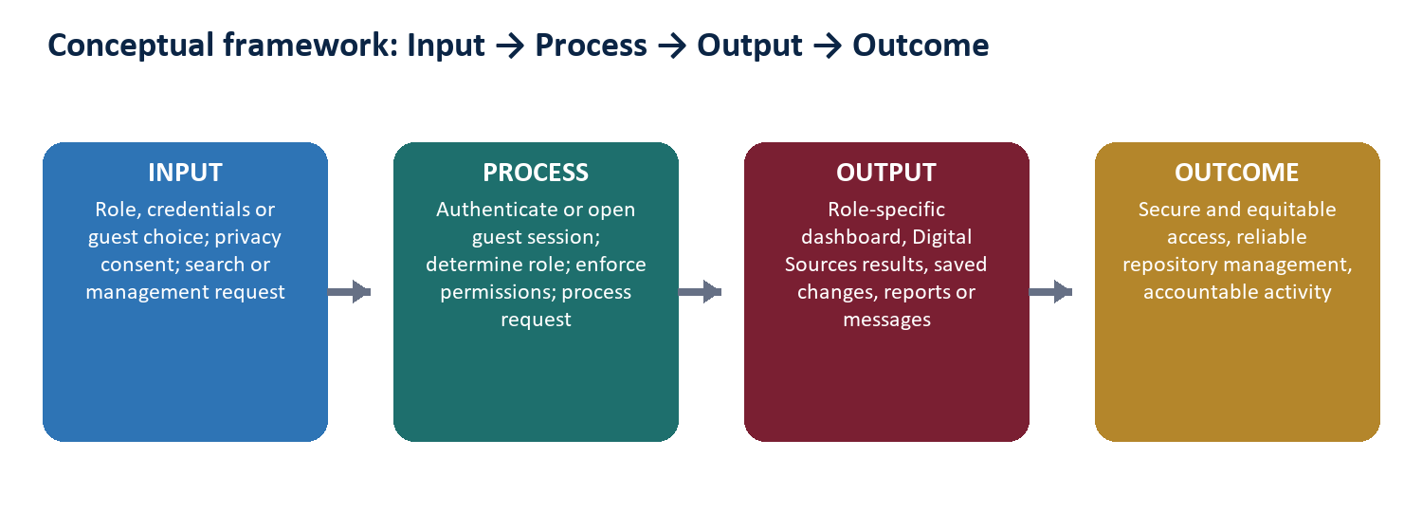
Figure 2. Input-Process-Output-Outcome model

Core control principles
- Role-aware entry: Student and Teacher use the public role-based registration and login flow; staff use the private administration route.
- Least privilege: Student and Guest are readers, Teacher manages resources, Administrator manages operational administration, and Superuser governs Administrators.
- Protected reading: resource abstracts are displayed inside ATLAS; the original uploaded file is not offered as a public download.
- Accountability: important creation, update, deletion, analysis, and administrative events can be retained for staff reporting and audit review.
- Privacy-aware usage: signed-in activity supports institutional reporting, while anonymous guest analytics depend on the visitor's analytics consent.

Role boundaries at a glance
Role | Entry | Primary workspace | Authority boundary
Guest | Guest choice | Public reader | No bookmarks or management
Student user | Public Student login | Reader dashboard | No content or staff administration
Teacher | Public Teacher login | Reader + resource tools | No users, announcements, reports, or admin control
Administrator | Private staff login | Staff portal + admin | Cannot create/manage Administrators
Superuser | Private root login | Full staff + governance | Highest application authority

