SYSTEM CONCEPTUAL FRAMEWORK
ATLAS Role-Based System Flow
Superuser, Administrator, Teacher, Student User, and Guest
Prepared from the current ATLAS implementation • 5 October 2026
Scope note. In this framework, “User” means the registered Student role. Teacher is shown separately because it has additional resource-management and AI-review privileges. Guest means an unauthenticated visitor using guest access.

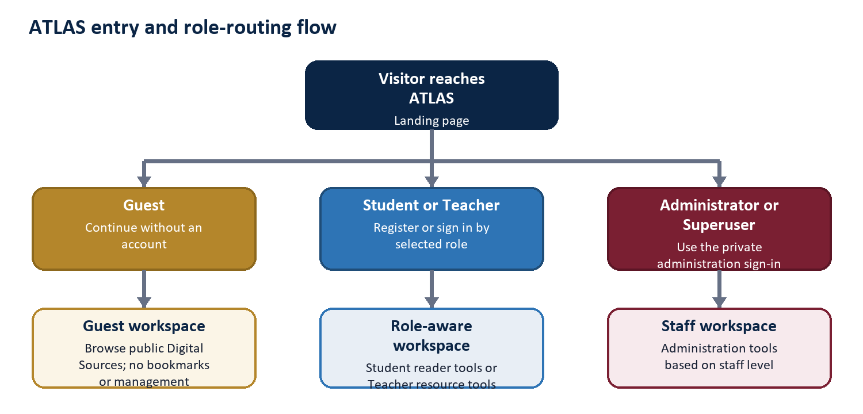
Figure 1. Entry and role-routing flow

1. Conceptual Framework
Framework logic. ATLAS receives a role and a request, validates the permitted path, performs the requested repository or administrative operation, and returns an output appropriate to that role. Every privileged branch is narrower than the branch above it unless the role is explicitly granted more authority.
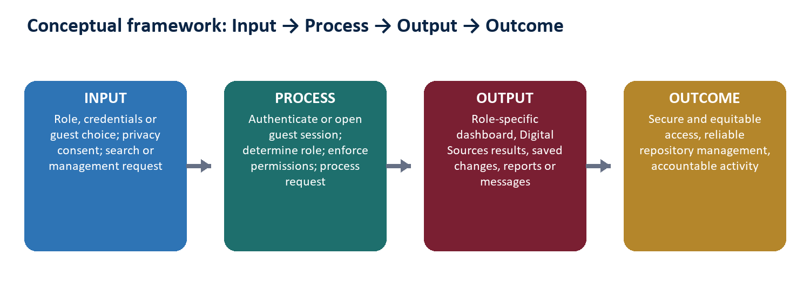
Figure 2. Input-Process-Output-Outcome model

Core control principles
- Role-aware entry: Student and Teacher use the public role-based registration and login flow; staff use the private administration route.
- Least privilege: Student and Guest are readers, Teacher manages resources, Administrator manages operational administration, and Superuser governs Administrators.
- Protected reading: resource abstracts are displayed inside ATLAS; the original uploaded file is not offered as a public download.
- Accountability: important creation, update, deletion, analysis, and administrative events can be retained for staff reporting and audit review.
- Privacy-aware usage: signed-in activity supports institutional reporting, while anonymous guest analytics depend on the visitor's analytics consent.

Role boundaries at a glance
Role | Entry | Primary workspace | Authority boundary
Guest | Guest choice | Public reader | No bookmarks or management
Student user | Public Student login | Reader dashboard | No content or staff administration
Teacher | Public Teacher login | Reader + resource tools | No users, announcements, reports, or admin control
Administrator | Private staff login | Staff portal + admin | Cannot create/manage Administrators
Superuser | Private root login | Full staff + governance | Highest application authority

2. Guest Flow
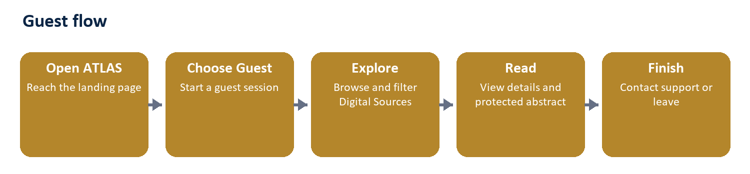
Figure: Guest workflow
Entry and identity. The visitor opens ATLAS and selects Guest. The system creates a guest session and opens the reader dashboard without requiring an account.
Main actions
- View the dashboard and public announcements.
- Browse, search, filter, and sort Digital Sources.
- Open resource details, see hard-copy availability, and read the protected resource abstract.
- Submit a support, feedback, or privacy-related contact message.
- Choose cookie preferences; anonymous usage analytics are stored only with analytics consent.
Boundary. A Guest cannot bookmark items, manage Digital Sources, use AI Detection, open staff reports, or administer accounts.
End state. The visitor leaves the site or later chooses Student or Teacher registration/sign-in for persistent account features.

3. Student (Registered User) Flow
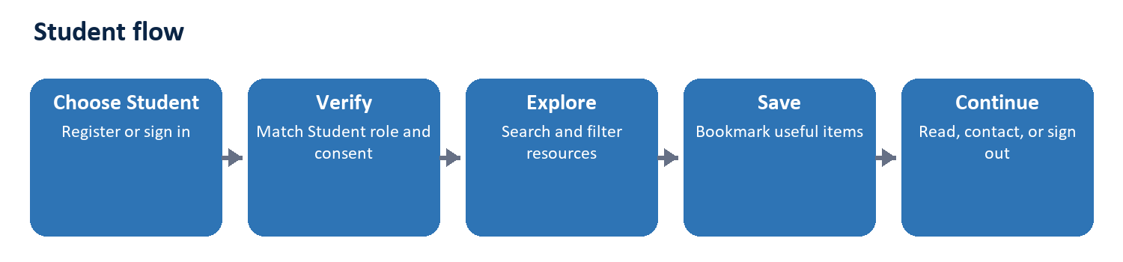
Figure: Student workflow
Entry and identity. The visitor selects Student, registers or signs in with email and password, accepts the current privacy terms, and passes role matching and email verification requirements.
Main actions
- Use the personalized dashboard and view recent Digital Sources and announcements.
- Search, filter, sort, and open repository items.
- Read protected resource abstracts and check hard-copy availability.
- Bookmark or remove resources and open the Favorites page.
- Update account email/password settings, contact support, or submit a data-deletion request.
Boundary. A Student cannot add, edit, or delete resources; cannot use AI Detection; and cannot access staff account, announcement, reporting, or Django administration tools.
End state. The Student's bookmarks and account settings persist for the next session; signing out returns the user to the public landing page.

4. Teacher Flow
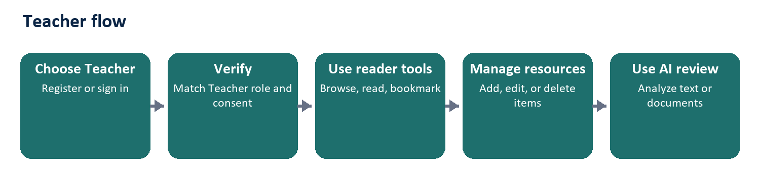
Figure: Teacher workflow
Entry and identity. The visitor selects Teacher, registers or signs in through the public role-aware form, accepts the privacy terms, and passes Teacher-role and email verification checks.
Main actions
- Perform every normal reader activity: browse, search, view details, read abstracts, bookmark, and contact support.
- Add a Digital Sources item with metadata, cover image, resource abstract, resource file, and hard-copy availability information.
- Edit or delete existing Digital Sources items; successful changes are recorded as activity.
- Use AI Detection on pasted text or an uploaded supported document and review the advisory result.
- Update the Teacher display name and normal account credentials.
Boundary. A Teacher is not a staff Administrator. The role cannot manage users, create announcements, publish content notices, view staff usage/audit reports, open the staff portal, or access Django administration.
End state. After resource or AI work, the Teacher returns to the reader-facing repository; saved repository changes become visible according to the normal catalog views.
AI result caution. AI Detection is an advisory writing-pattern review. Its result should support human review and should not be treated as sole proof for an academic or disciplinary decision.

