SYSTEM CONCEPTUAL FRAMEWORK
ATLAS Role-Based System Flow
Superuser, Administrator, Teacher, Student User, and Guest
Prepared from the current ATLAS implementation • 5 October 2026
Scope note. In this framework, “User” means the registered Student role. Teacher is shown separately because it has additional resource-management and AI-review privileges. Guest means an unauthenticated visitor using guest access.

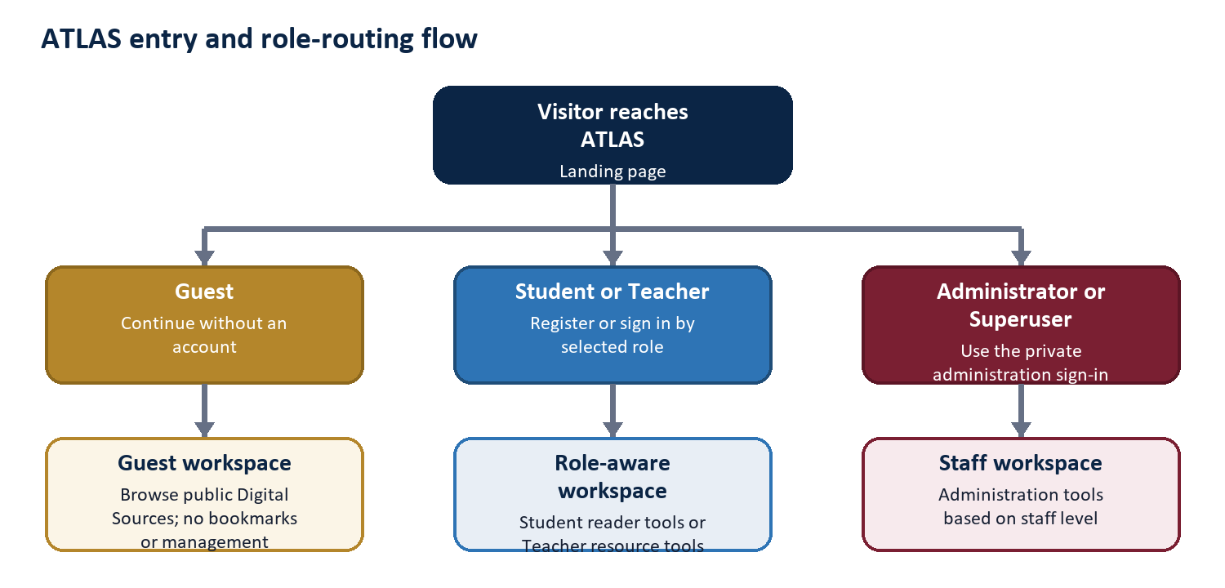
Figure 1. Entry and role-routing flow

