**MARGARET M. FURR** (757) 374-3566 | margaretmfurr@gmail.com | https://margaretmf.github.io/

**Writer and researcher who loves people, technology, and art to unfold creative solutions for social change.**

**WRITER: I EXPRESS CLARITY THROUGH WRITING WHEN ARTICULATING INSIGHTS IN REPORTS TO STAKEHOLDERS.**

**VIBRANT WORLD | Writer and News Reviewer** January 2018 – Present

*Write over 15 blog posts per year on the future, data and technology, the social world, and the news to express thoughts on trends in the world. Review news and books to critique writing.*

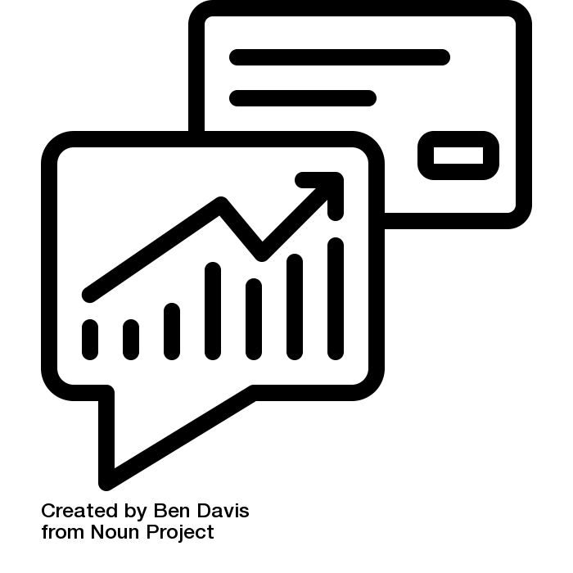

**EVERFI | White Paper Writer** April 2016 – June 2019

*Published three white papers covering insights to engage partners with original views on education.*

**COMPASS PRO BONO | Client Story Writer** October 2016 – May 2019

*Wrote research-based stories to cover the challenges and opportunities facing three nonprofit clients.*

**QUALITATIVE RESEARCHER: I APPLY A LOVE FOR CONNECTING WITH STAKEHOLDERS IN INTERVIEWS.**

**DC BREASTFEEDING CENTER | Systems Researcher** January – May 2019

*Wrote interview questions and emailed community members to prepare for interviews. Interviewed*

*eight system actors to understand how organizations help breastfeeding mothers.*

**COMPASS PRO BONO | Qualitative Researcher** October 2016 – May 2019

*****Developed conversation guides to prepare for partnering with clients. Led focus groups and 20*

*interviews and gathered information on organizations’ staff and stakeholders to gain insights that aid*

*in developing strategic recommendations for the clients.*

**DESIGN FOR THE HOMELESS | Design Researcher** February – March 2019

*Reached out to potential people to connect with to implement the project. Interviewed five community members experiencing homelessness and summarized the information from interviews to support designers committed to prototyping tools.*

**BLUESTONE LOGIC | Systems Researcher and Designer Intern** December 2015 – January 2016

*Analyzed project management system applying MECE principles, interviewed system stakeholders, and led user research sessions to gather and to prioritize ideal system requirements.*

**QUANTITATIVE RESEARCHER: I LEVERAGE ENTHUSIASM FOR UNDERSTANDING PATTERNS AND LOGIC IN DATA.**

**EVERFI | Data Analyst** April 2016 – June 2019

**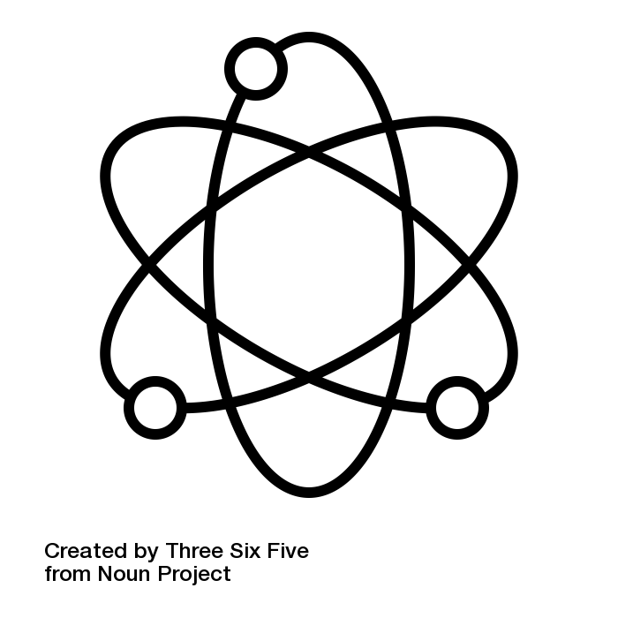***Wrote survey and assessment questions to test product users’ attitudes and behaviors. Managed up to 2,000 statistical insights on product users’ responses to surveys to prove social return on investment to business clients. Visualized the results of statistical analyses on over 50,000 students to inform efficacy research. Developed dashboards with tools to provide canned reports to stakeholders. Worked cross-functionally in the organization to generate technology platform requirements. Produced ideas for how to create metadata (tags and categories) to improve survey and assessment data management. Managed technical knowledge using online tools (Atlassian, Google Drive) to ensure understanding of work across teams.*

**DATAKIND | Data Ambassador** Summer 2015 – June 2019

*Scoped out projects with non-profit clients to understand project goals and product user needs. Coordinated tasks for a community of citizen scientists to complete at offline events twice per year to*

*deliver data science products to non-profit clients. Collaborated twice per year with citizen scientists in*

*developing maps, machine learning features, a complexity score, and merged data to build tools for*

*clients.*

**COMPASS PRO BONO | Strategic Alignment Consultant** October 2016 – May 2019

*Interpreted data aligned with client’s goals to deliver strategy recommendations to non-profits.*

*Managed a kit of resources used to develop a database of records for the non-profit community.*

**EDUCATION**

**UNIVERSITY OF VIRGINIA | MS, Data Science** July 2014 – December 2015

**UNIVERSITY OF VIRGINIA | BA, History** August 2010 – May 2014