**GitHub Username**: <https://github.com/margaretmwaura>

Self Help Group App

Description

It is an application that is meant to coordinate activities and bring out transparency when it comes to contributions. Users will be in a position to see how much they have contributed , view scheduled events and share their ideas in the chat room..

Intended User

The intended users are the members of the self help groups

Features

There are two versions of the application:

1. The admin version
2. The Member version

The admin version has the following features

1. Creation of an account using their phone numbers
2. Editing their profile information
3. Viewing and adding upcoming events
4. Viewing their contributions
5. Updating details of the users contribution and details
6. Reading and writing in the admin chat room
7. Reading and writing in the general chat room

The member version has the following features

1. Creation of an account using their phone numbers
2. Editing their profile information
3. Viewing upcoming events
4. Viewing their contributions
5. Reading in the admin chat room
6. Reading and writing in the general chat room

User Interface Mocks

Welcome Activity

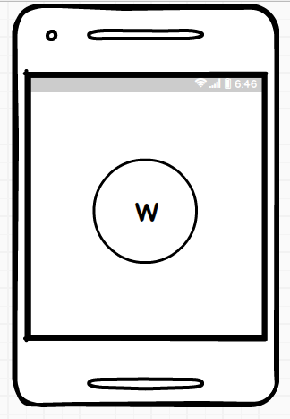

Create Account Page

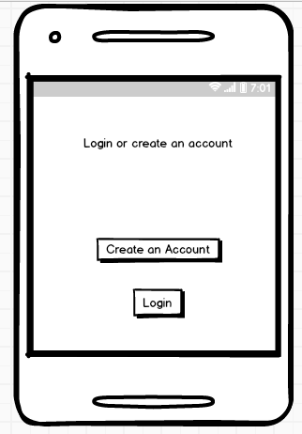

Enter Phone Number Page

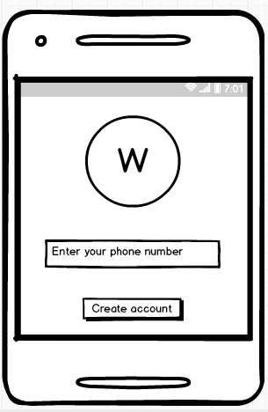

Verify Phone number page

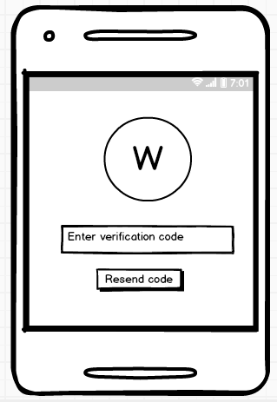

Admin Account Page

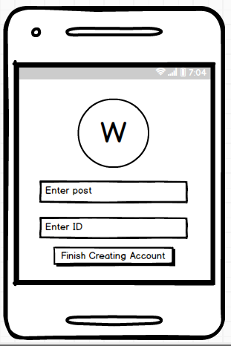

Member Account page

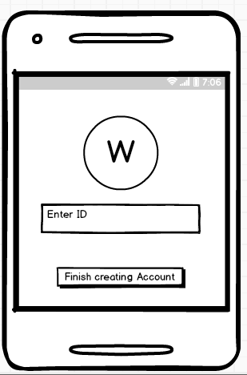

User Profile page

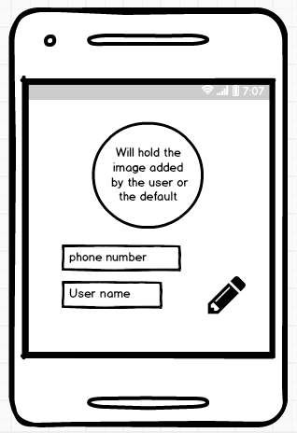

User details page

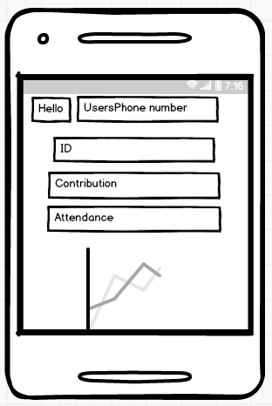

Member event page

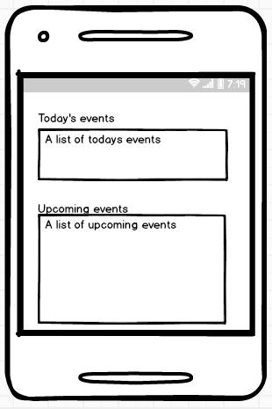

Admin event page

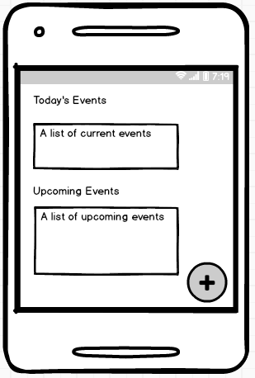

Admin All details page

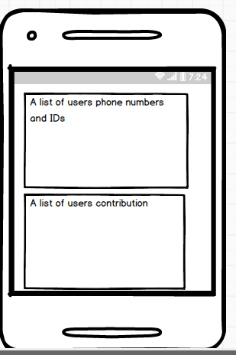

Admin and general chat room

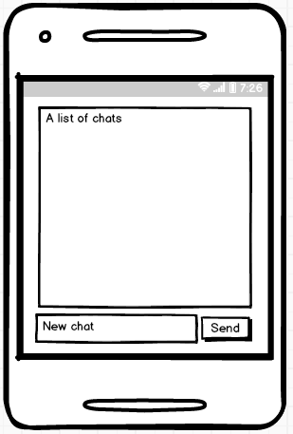

Key Considerations

**How will your app handle data persistence?**

All data in about the user, his/her contributions, and the chats will be stored in firebase.

The user information and the user ID will be stored in a file so that there is easy access without accessing it over a network

The file that the admin creates that contains the user’s details will be stored in the admin’s device storage.

**Describe any edge or corner cases in the UX.**

There are none.

**Describe any libraries you’ll be using and share your reasoning for including them.**

Picasso was used for the user’s photo.

Hellocharts library is used for creating of the line graph.

CircleImageView library in order to have a circular image View for the profile image.

ItextPdf library to enable creation of the details pdf.

**Describe how you will implement Google Play Services or other external services.**

Describe which Services you will use and how.

Next Steps: Required Tasks

This is the section where you can take the main features of your app (declared above) and break them down into tangible technical tasks that you can complete one at a time until you have a finished app.

**Task 1: Project Setup**

Write out the steps you will take to setup and/or configure this project. See previous implementation guides for an example.

* Use gradle to create the two versions of the application.
* In order to use firebase in the application, create a project in the firebase console and configure the project android version to have the package name of the project.
* Download the Json file from firebase and add it to the project.
* Add all the firebase database sdk , firebase auth

**Task 2: Implement UI for Each Activity and Fragment**

For the Admin version

Build the UI for the splash screen. It should have a logo.

Build the splash screen activity and incorporate animation in it for the logo and the welcome words.

Create the check class activity. This class will have code necessary to check if the splash screen has been displayed, and if it has it prevents the splash screen from being displayed again and the create account activity becomes the launcher activity.

Build the UI for the create activity class.

Build the create activity class.

The UI should have an edit text where the user should enter their phone number and a button which is meant to submit the phone number that is to create an account

Build the UI for the verification activity class.

Build the verify phone number activity class.

A verification code will be sent which will be used for the verification of the phone number

Build the UI for the creating the admin account.

Build the create admin account class.

The UI should have the edit text for the admin’s post and the ID of the admin. There should be a button for the submission of the two strings.

Build the UI for the navigation drawer including all the necessary items in the menu activity. The menu xml should have all the icons that are to be navigated from the navigation drawer.

Build the navigation drawer class that is to have code necessary to aid in the navigation of the various activities associated with the ID of the various icons.

Build the profile layout.

Build the class of the profile layout. The layout should be displaying the phone number used for account creation and the username of the account holder.

Build the details layout.

Build the class of the details layout. The details class gets data from firebase and displays it on the layout. Data being displayed includes the ID of the user and the contributions. The values of the contributions are then mapped on to a line graph.

Build the events layout.

Build the events layout class. It displays the added events that are in the database. Events that correspond to the current date are displayed in the current events recycler view and the rest in the upcoming events recycler View. The float action button allows the admin to add new events. When it is clicked bottom sheet navigation shows allowing the user to enter the details of the desired event.

Build the all details layout.

Build the all details layout class. The layout should have two recycler views displaying. The first displays the basic details of the user, which is their phone number and their ID. The next displays the contributions of the users. On tapping on a user’s details, the dialog layout shows allowing the admin to edit the details of a user, for example their contribution.

Build the admin chat room layout.

Build the admin chat room layout class. The admin will have the ability to read and write to the chat room. This chat room is meant for matters sensitive to the group.

Build the general chat room layout.

Build the general chat room layout class. The admin will have the ability to read and write to the chat room. This chat room is meant for all users who feel like they have an issue of concern they want to raise.

For the Member version

Build the UI for the splash screen. It should have a logo.

Build the splash screen activity and incorporate animation in it for the logo and the welcome words.

Create the check class activity. This class will have code necessary to check if the splash screen has been displayed, and if it has it prevents the splash screen from being displayed again and the create account activity becomes the launcher activity.

Build the UI for the create activity class.

Build the create activity class.

The UI should have an edit text where the user should enter their phone number and a button which is meant to submit the phone number that is to create an account

Build the UI for the verification activity class.

Build the verify phone number activity class.

A verification code will be sent which will be used for the verification of the phone number

Build the UI for the creating the member account.

Build the create member account class.

The UI should have the edit text for the ID of the member. There should be a button for the submission of the two strings.

Build the UI for the navigation drawer including all the necessary items in the menu activity. The menu xml should have all the icons that are to be navigated from the navigation drawer.

Build the navigation drawer class that is to have code necessary to aid in the navigation of the various activities associated with the ID of the various icons.

Build the profile layout.

Build the class of the profile layout. The layout should be displaying the phone number used for account creation and the username of the account holder.

Build the details layout.

Build the class of the details layout. The details class gets data from firebase and displays it on the layout. Data being displayed includes the ID of the user and the contributions. The values of the contributions are then mapped on to a line graph.

Build the events layout.

Build the events layout class. It displays the added events that are in the database. Events that correspond to the current date are displayed in the current events recycler view and the rest in the upcoming events recycler View.

Build the admin chat room layout.

Build the admin chat room layout class. The member will have the ability to read the chats in chat room. Build the general chat room layout.

Build the general chat room layout class. The member will have the ability to read and write to the chat room. This chat room is meant for all users who feel like they have an issue of concern they want to raise.

**Task 3: Your Next Task**

Create the admin class, the member class, the contribution class, the chat class and their associated adapters.

This is to allow data to be displayed on the recycler view.

**Task 4: Your Next Task**

Create the intent service that will enable all background activities to be carried out in a different thread.

**Task 5: Your Next Task**

Create the firebase live data and the userViewModel class to enable retrieving of data from firebase.

**Task 6: Your Next Task**

To enable notifications and their display create the UserFirebaseMessaging service and the notification broadcast receiver. The UserFirebaseMessaging Service onreceive method will be triggered every time a firebase message has been received.

The notification broadcast receiver will be used in the creation of the notification.