Task 1.

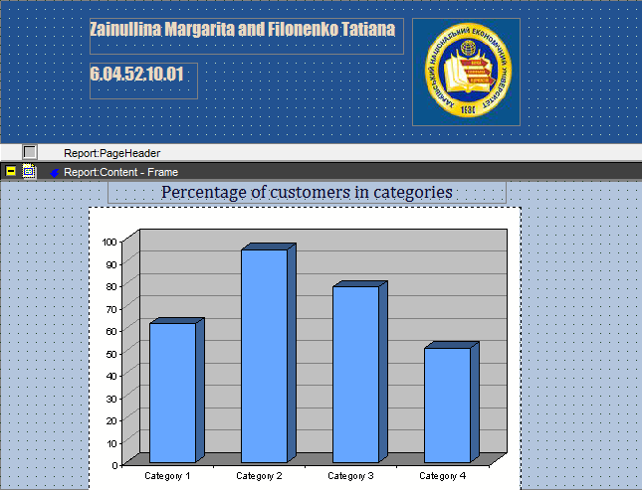

2.

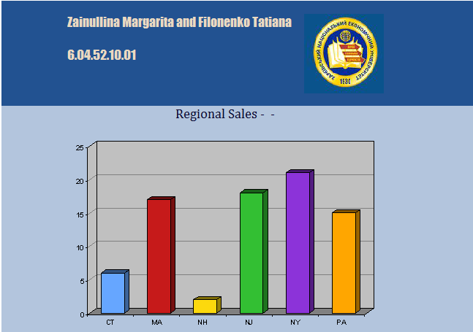

3. 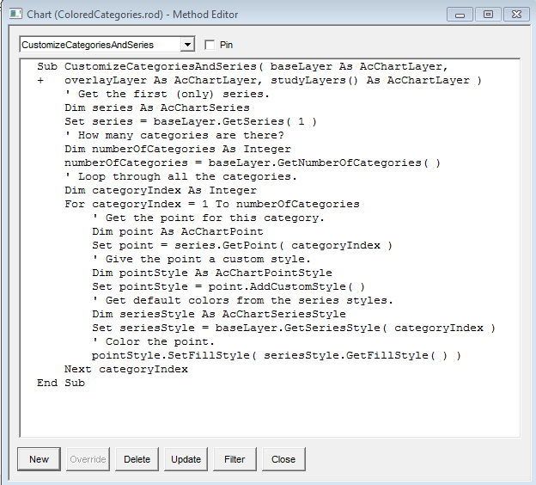

5. Provide the answer: what does function BuildFromRow

We override the ResizeBy() subproc for the control that's going to hold the

variable-length, variable-number-of-lines string we want to display with

code to determine how many lines worth of data we have, and resize the

control to fit the data. We override the BuildFromRow() function of the

control to call the ResizeBy subproc, because if we wait until the Finish()

function, it's too late. We then override the BuildFromRow() function of

the frame that contains the control that changes size, and resize the frame

to correspond to the change in the control. Again, we pick the

BuildFromRow() function because of the timing of the construction of the

objects at runtime.

**ColoredCategories Example**

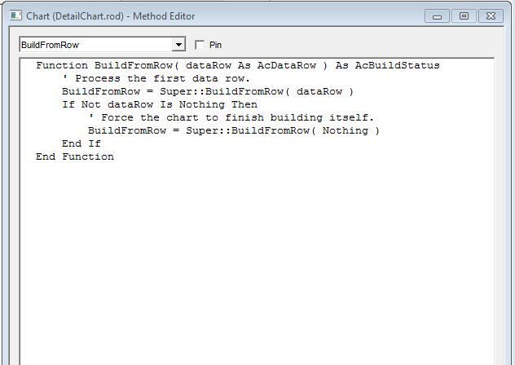

**Task #2**

