### **Code Generation using pseudo codes from research papers**

* In the initial dump, I was not able to locate any papers with pseudo codes in them manually. So I was suggested by sir to look for a recent dump and I visited <https://arxiv.org/archive/cs> for recent CS related papers.
* More specifically I looked at papers related to data structures and algorithms( <https://arxiv.org/list/cs.DS/current> ). Examination of those papers presented me with the following issues we need to address:
  + Most papers have pseudo codes but no links or references to code implementations for them.
  + The pseudo code does not contain sufficient information ( Description of some notations used, etc) to generate the code.
  + Some papers have both pseudo code and code implementation links but not in a easily extractable format
  + Some code implementation repositories have a lot of files and folders. How will we test the correctness of code generated?

**Some paper study**

* + **Paper pdf** : <https://arxiv.org/pdf/2308.00501>
    - The pseudo code has links to theorems and lemmas mentioned in the papers.

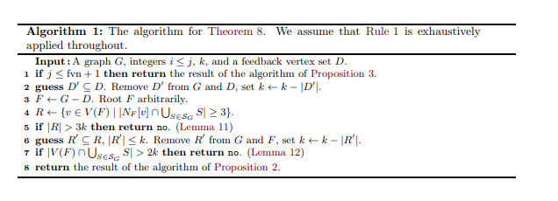

* + - The source code has repo link mentioned : <https://git.tu-berlin.de/akt-public/bfvd-kernel>

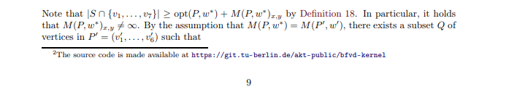

* + **Paper pdf** : <https://arxiv.org/pdf/2308.00503> , <https://arxiv.org/pdf/2308.00555> .
    - They have lots of pseudo codes but no code implementation link provided.
  + **Paper pdf** : <https://arxiv.org/pdf/2308.00925.pdf>
    - This has both pseudo code and source code link ( <https://sciences.usca.edu/math//textasciitilde%20mathdept/rli/LCSSeqSStr/LCSS.pdf> ) (which does not work ) but not easily extractable

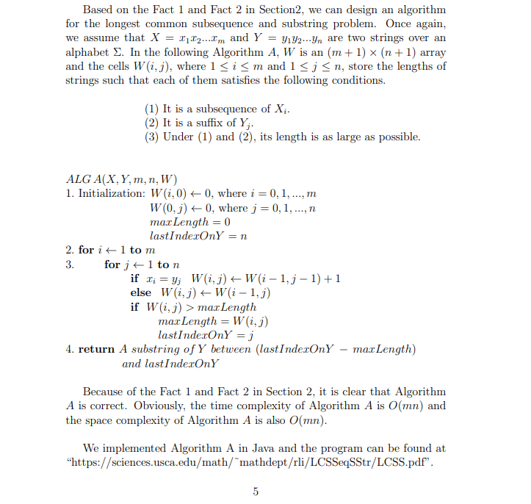

* + **Paper pdf** : <https://arxiv.org/pdf/2308.03578>
    - It has pseudocodes and code link (<https://github.com/google-research/google-research/tree/master/terahac> ) but it does not work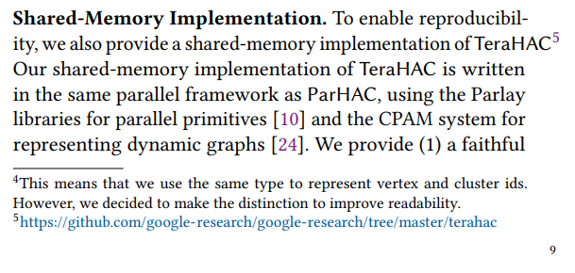
  + **Paper pdf** : <https://arxiv.org/pdf/2308.01037>
    - It has both pseudo code and code link but the code repo ( <https://gitlab.com/moccalib/applications/randfunm-networks> ) is complex Interpret